COMP2396B Tutorial 7

**GUI, Event handling, Swing components**

**Question 1**

Write a Java program with GUI that contains a rectangle. Add 4 buttons controlling the rectangle.

Requirements:

* A drawing panel which draws a rectangle.
* A panel which contains 4 buttons:
  + A button to move the rectangle left.
  + A button to move the rectangle right.
  + A button to make the rectangle smaller.
  + A button to make the rectangle bigger.

Example GUI:

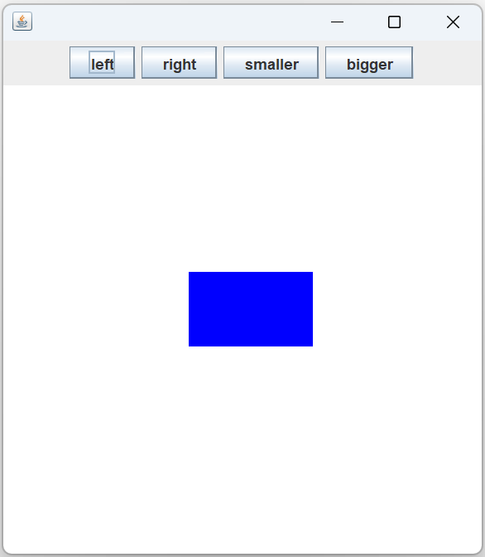

**Question 2**

Write a Java program with GUI that calculates your age as described below:

Requirement:

* A TextField for inputting the current year.
* A TextField for inputting the year of your birth.
* A Label to display your calculated age.
* A Button for confirming the input information. When it is clicked, the age is calculated by $current_year – year_of_birth$. The result is then displayed on a label.

You can design the layout as following:

Hints:

* To retrieve the current text contained by a TextField, call the getText() of the TextField object. It will return the text in String.
* To update the text displayed by a Label, call setText(String) of the Label object.
* To align a UI element in the center, set the layout constraint to **BorderLayout.CENTER**.

Answer 1

Animation.java

|  |
| --- |
| **import** javax.swing.*;  **import** java.awt.*;  **import** java.awt.event.*;  **public** **class** Animation {  **int** x = 150;  **int** y = 150;  **int** width = 100;  **int** height = 60;  MyAnimPanel animPanel;  **public** **static** **void** main(String[] args) {  Animation gui = **new** Animation();  gui.go();  }  **public** **void** go() {  JFrame frame = **new** JFrame();  frame.setDefaultCloseOperation(JFrame.***EXIT_ON_CLOSE***);  JPanel panel = **new** JPanel();  JButton buttonLeft = **new** JButton("left");  JButton buttonRight = **new** JButton("right");  JButton buttonSmaller = **new** JButton("smaller");  JButton buttonBigger = **new** JButton("bigger");  buttonLeft.addActionListener(**new** LeftListener());  buttonRight.addActionListener(**new** RightListener());  buttonSmaller.addActionListener(**new** SmallerListener());  buttonBigger.addActionListener(**new** BiggerListener());  panel.add(buttonLeft);  panel.add(buttonRight);  panel.add(buttonSmaller);  panel.add(buttonBigger);  animPanel = **new** MyAnimPanel();  frame.add(animPanel, BorderLayout.***CENTER***);  frame.add(panel, BorderLayout.***NORTH***);  frame.setSize(400, 450);  frame.setVisible(**true**);  animPanel.repaint();  }  **class** LeftListener **implements** ActionListener {  **public** **void** actionPerformed(ActionEvent event) {  x -= 40;  animPanel.repaint();  }  } // close inner class  **class** RightListener **implements** ActionListener {  **public** **void** actionPerformed(ActionEvent event) {  x += 40;  animPanel.repaint();  }  } // close inner class  **class** BiggerListener **implements** ActionListener {  **public** **void** actionPerformed(ActionEvent event) {  x -= 10;  y -= 10;  width += 20;  height += 20;  animPanel.repaint();  }  } // close inner class  **class** SmallerListener **implements** ActionListener {  **public** **void** actionPerformed(ActionEvent event) {  x += 10;  y += 10;  width -= 20;  height -= 20;  animPanel.repaint();  }  } // close inner class  **class** MyAnimPanel **extends** JPanel {  **public** **void** paintComponent(Graphics g) {  g.clearRect(0, 0, **this**.getWidth(), **this**.getHeight());  g.setColor(Color.***BLUE***);  g.fillRect(x, y, width, height);  }  }  } |

Answer 2

Sample Solution

AgeCalculator.java

|  |
| --- |
| **import** java.awt.*;  **import** java.awt.event.*;  **import** javax.swing.*;  **public** **class** AgeCalculator **implements** ActionListener {  JTextField currentYearTextField = **new** JTextField(4);  JTextField birthdayYearTextField = **new** JTextField(4);  JLabel result = **new** JLabel("Your age: ");  **public** **static** **void** main(String[] args) {  AgeCalculator t = **new** AgeCalculator();  t.go();  }  **public** **void** go() {  JFrame frame = **new** JFrame("My Age Calculator");  frame.setDefaultCloseOperation(JFrame.***EXIT_ON_CLOSE***);  JPanel panel_north = **new** JPanel();  panel_north.setLayout(**new** BoxLayout(panel_north, BoxLayout.***Y_AXIS***));  JPanel panel_current_year = **new** JPanel();  panel_current_year.add(**new** JLabel("Please enter the current year: "));  panel_current_year.add(currentYearTextField);  JPanel panel_birth_year = **new** JPanel();  panel_birth_year.add(**new** JLabel("Please enter the year of your birth: "));  panel_birth_year.add(birthdayYearTextField);  panel_north.add(panel_current_year, BorderLayout.***CENTER***);  panel_north.add(panel_birth_year, BorderLayout.***CENTER***);  // panel_current_year.setBorder(BorderFactory.createLineBorder(Color.orange));  // panel_birth_year.setBorder(BorderFactory.createLineBorder(Color.orange));  // panel_north.setBorder(BorderFactory.createLineBorder(Color.red));  JPanel panel_west = **new** JPanel();  panel_west.add(result);  // panel_west.setBorder(BorderFactory.createLineBorder(Color.blue));  JPanel panel_east = **new** JPanel();  JButton confirm = **new** JButton("Confirm");  confirm.addActionListener(**this**);  panel_east.add(confirm);  // panel_east.setBorder(BorderFactory.createLineBorder(Color.black));  frame.add(panel_north, BorderLayout.***NORTH***);  frame.add(panel_west, BorderLayout.***WEST***);  frame.add(panel_east, BorderLayout.***EAST***);  frame.setSize(500, 200);  frame.setVisible(**true**);  }  **public** **void** actionPerformed(ActionEvent event) {  **int** cur = Integer.*parseInt*(currentYearTextField.getText());  **int** bd = Integer.*parseInt*(birthdayYearTextField.getText());  result.setText("Your age: " + String.*valueOf*(cur - bd));  }  } |

Remarks:

**panel_north**

**panel_east**

**panel_west**

**panel_current_year**

**panel_birth_year**