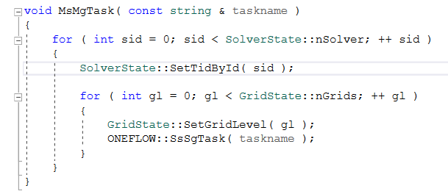
按照消息的标识执行具体的任务。
void InitializeSolver()
{
ONEFLOW::MsMgTask( "INIT_FLOWFIELD" );
}
比如初始化流场对所有相关solver进行初始化动作。
void MG::Run()
{
TimeSpan * timeSpan = new TimeSpan();
while ( SimuIterState::Running() )
{
Iteration::outerSteps ++;
ctrl.currTime += ctrl.pdt;

//Inner loop
Iteration::innerSteps = 0;
while ( ! SolverState::Converge() )
{
Iteration::innerSteps ++;

this->SolveInnerIter();
}
this->OuterProcess( timeSpan );
}
delete timeSpan;
}

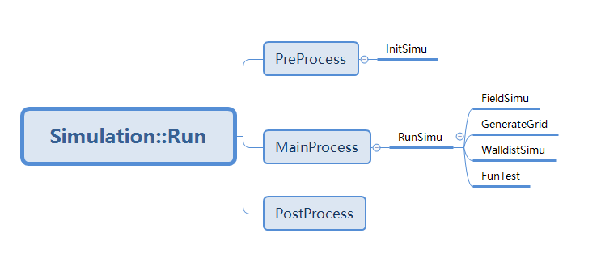
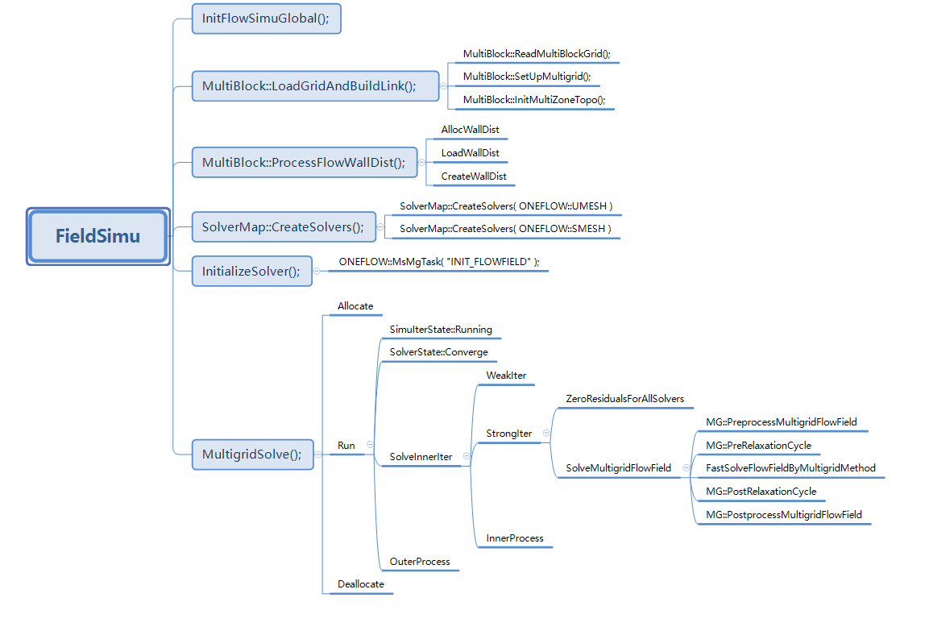
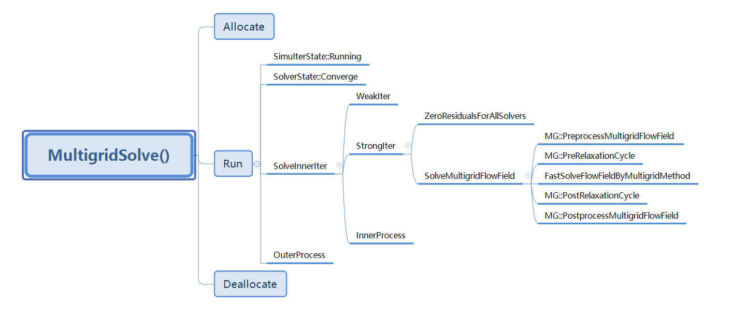

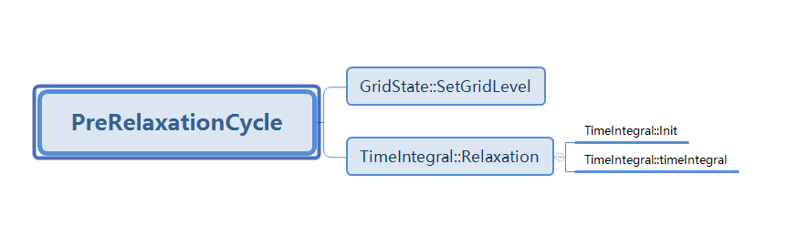
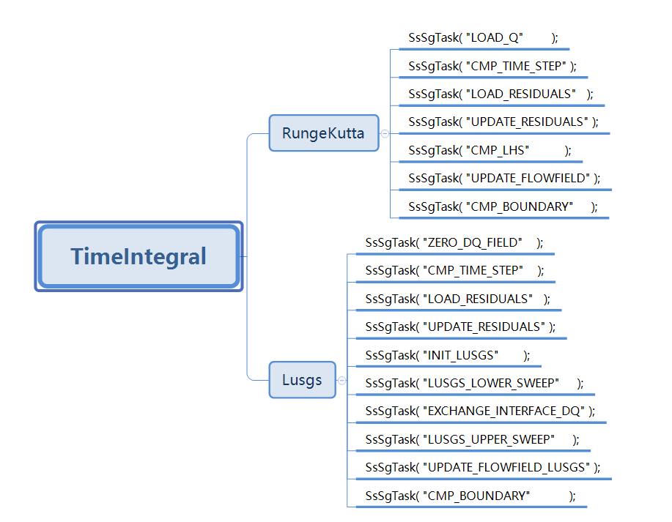

Rhs.cpp
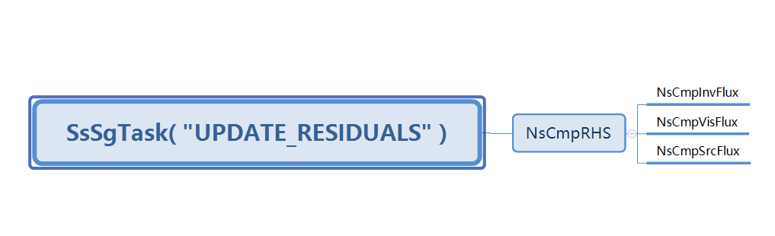
TurbRhs.cpp
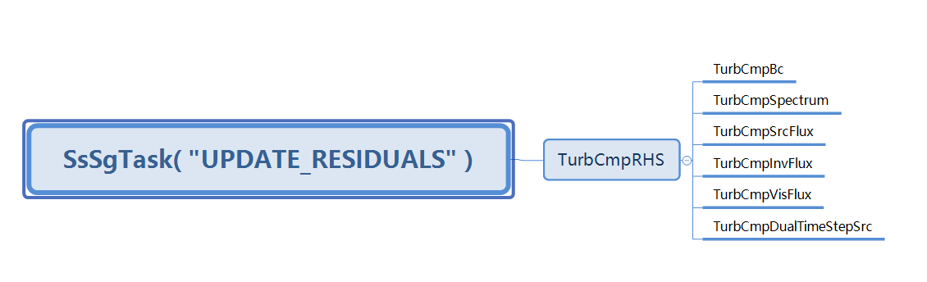
NsCmpInvFlux:所在文件：{UNsInvFlux.cpp}
NsCmpVisFlux:所在文件：{UNsVisFlux.cpp}
NsCmpDualTimeStepSrc所在文件：{UUnsteady.cpp}

TurbCmpBc所在文件：{UTurbBcSolver.cpp}
TurbCmpSpectrum所在文件：{UTurbSpectrum.cpp}
TurbCmpSrcFlux所在文件：{UTurbSrcFlux.cpp}
TurbCmpInvFlux所在文件：{UTurbInvFlux.cpp}
TurbCmpVisFlux所在文件：{UTurbVisFlux.cpp}
TurbCmpDualTimeStepSrc所在文件：{UTurbUnsteady.cpp}

