1. sudo apt-get install openssh-server

2.修改系统时间

sudo dpkg-reconfigure tzdata 选择上海

1.备份源文件

sudo cp /etc/apt/sources.list /etc/apt/sources_init.list

sudo chmod -R 777 /etc/apt/sources.list

sudo apt-get update

sudo apt-get upgrade

2. sudo mkdir /usr0

sudo chmod -R 777 /usr0

#jdk 1.8  
export JAVA_HOME=/usr0/java/jdk1.8.0_181  
export JRE_HOME=${JAVA_HOME}/jre    
export CLASSPATH=.:${JAVA_HOME}/lib:${JRE_HOME}/lib    
export PATH=${JAVA_HOME}/bin:$PATH

# 添加如下参数

vm.max_map_count = 655360

fs.file-max=655360

path.data: /usr0/data/elasticsearch/data

path.logs: /usr0/data/elasticsearch/log

network.host: 0.0.0.0

# 对修改内容生效

sysctl -p

起进程

前台起 可以看到log

./elasticsearch

成功了在后台起

./elasticsearch -d

关进程

Jps

Kill -9

vim /you_path/logstash-6.3.0/config/test.conf

# 没有这个文件则创建，创建什么文件名无所谓，后面会根据这个文件来启动logstash

input {

file {

path => ["/usr0/data/temp"]

codec => json {

charset => "UTF-8"

}

}

}

output {

elasticsearch {

hosts => ["192.168.254.26:9200"]

index => "lalala-%{+YYYY.MM.dd}"

document_type => "test"

#user => "elastic"

#password => "changeme"

}

}

修改jvm

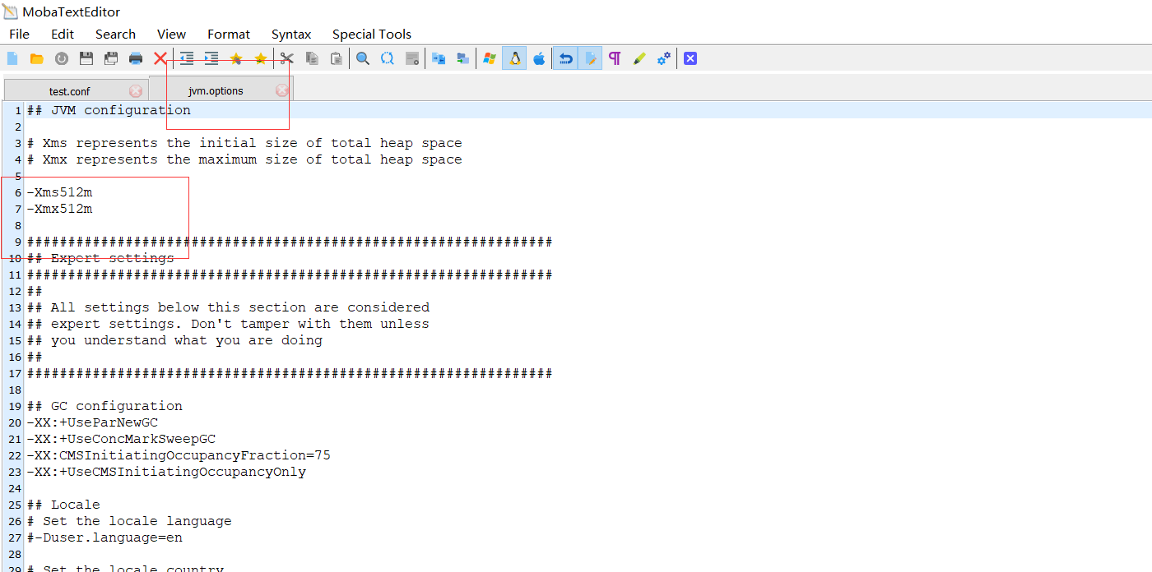

试着启动一下 ./logstash -e 'input{ stdin{} } output{ stdout{} }'

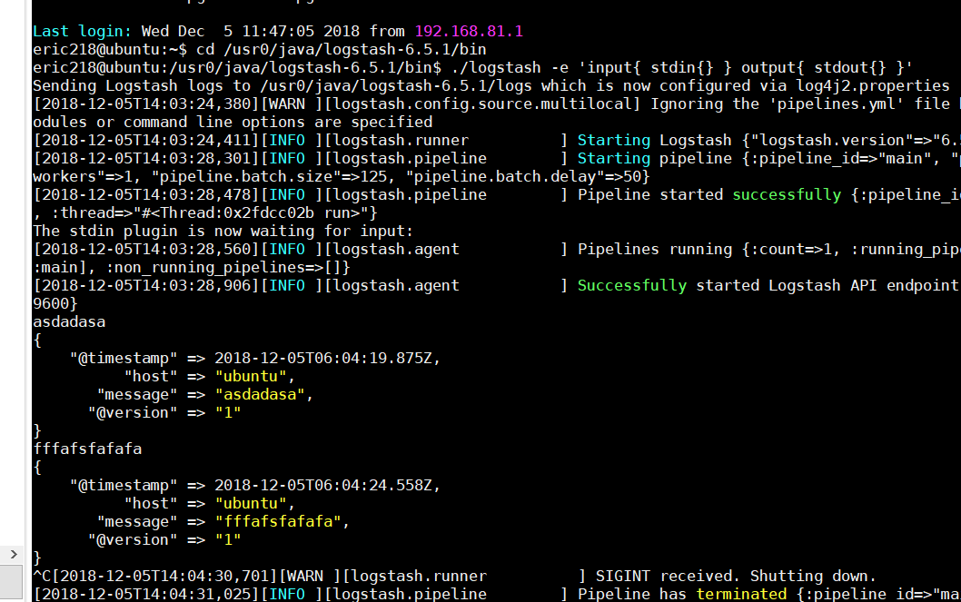

成功

nohup ./bin/logstash -f config/test.conf &> run.log &

./kibana -H 0.0.0.0 &> run.log &

nohup ./bin/kibana -H 0.0.0.0 &> run.log &

测试

/usr0/java/logstash-6.5.1/bin/logstash -t -f /usr0/java/logstash-6.5.1/config test.conf

前台运行多一个&

/usr0/java/logstash-6.5.1/bin/logstash -f /usr0/java/logstash-6.5.1/config/test.conf &

/usr0/java/kibana-6.5.1-linux-x86_64/bin/kibana -H 0.0.0.0 &

后台运行

nohup /usr0/java/logstash-6.5.1/bin/logstash -f /usr0/java/logstash-6.5.1/config/test.conf &> run.log &