看version:

node –v，npm -c

1.改源 看源cnpm -v

npm install -g cnpm --registry=https://registry.npm.taobao.org

安装库node_modules

3. npm i/cnpm i

Debug

3. npm start

如需发布到 tomcat下，vue.config.js- baseUrl:

4. npm run build

**Ubuntu下安装并配置FastDFS**

<https://blog.csdn.net/softwave/article/details/54017095>

apt-get install git

进入libfastcommon目录，依次执行脚本：

./make.sh

./make.sh install

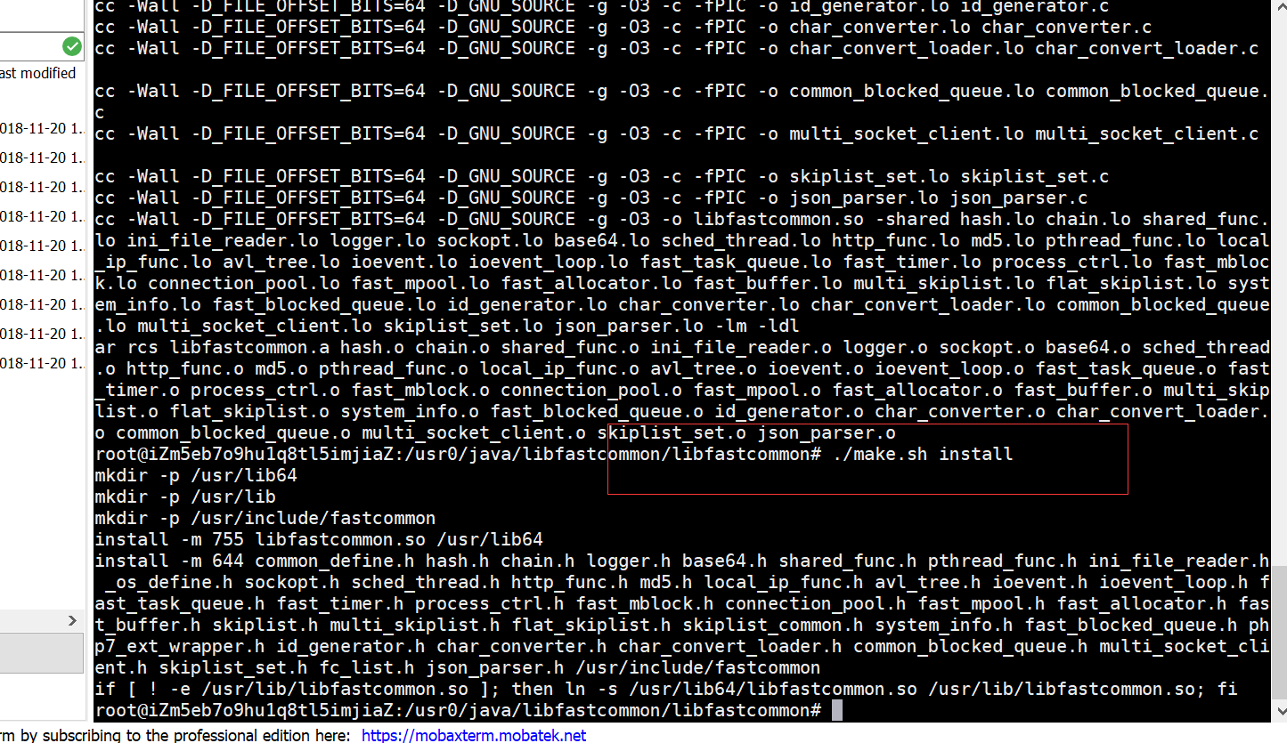

https://blog.csdn.net/softwave/article/details/54017095

sudo apt-get install gcc

转移lib

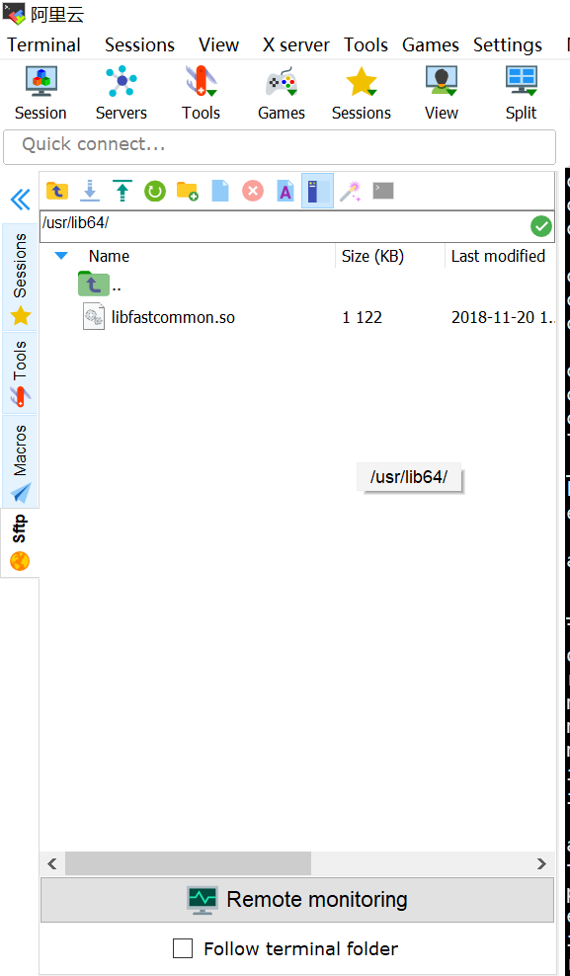

export LD_LIBRARY_PATH=/usr/lib64

ln -s /usr/lib64/libfastcommon.so /usr/local/lib/libfastcommon.so

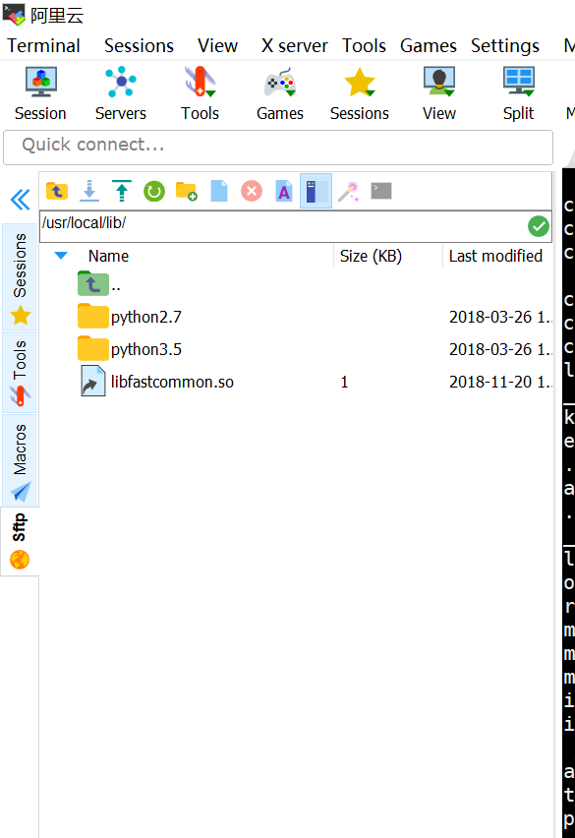

下载、解压并安装FastDFS

<https://github.com/happyfish100/fastdfs/releases>

tar zxvf fastdfs-5.05.tar.gz -C ../

cd /usr0/java/fastdfs-5.05/

./make.sh

./make.sh install

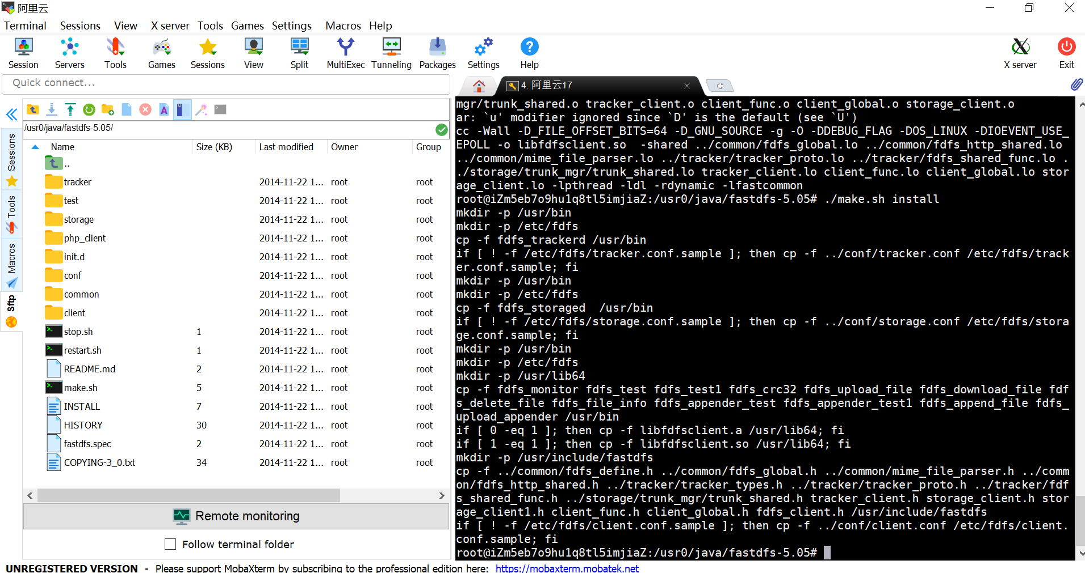

**/etc/fdfs**

tracker.conf

:

chmod 777 tracker.conf.sample 该文件

chmod -R 777 fdfs/ 改文件名权限

启动

/usr/bin/fdfs_trackerd /etc/fdfs/tracker.conf

/usr/bin/fdfs_storaged /etc/fdfs/storage.conf

记得开阿里端口2222

下载http.conf

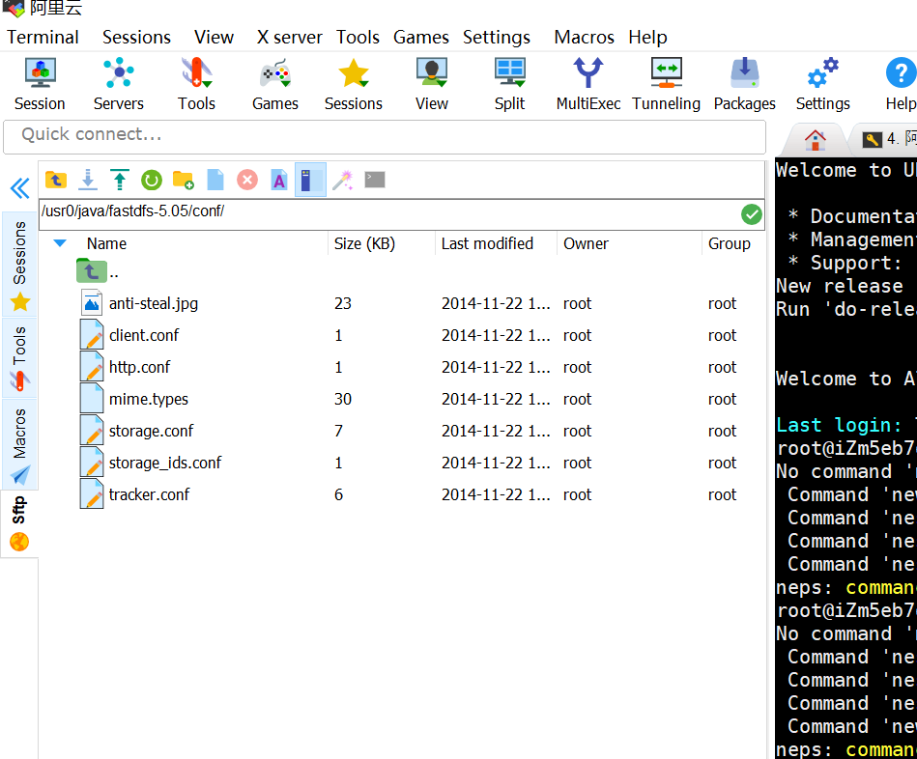

放到etc/fdfs

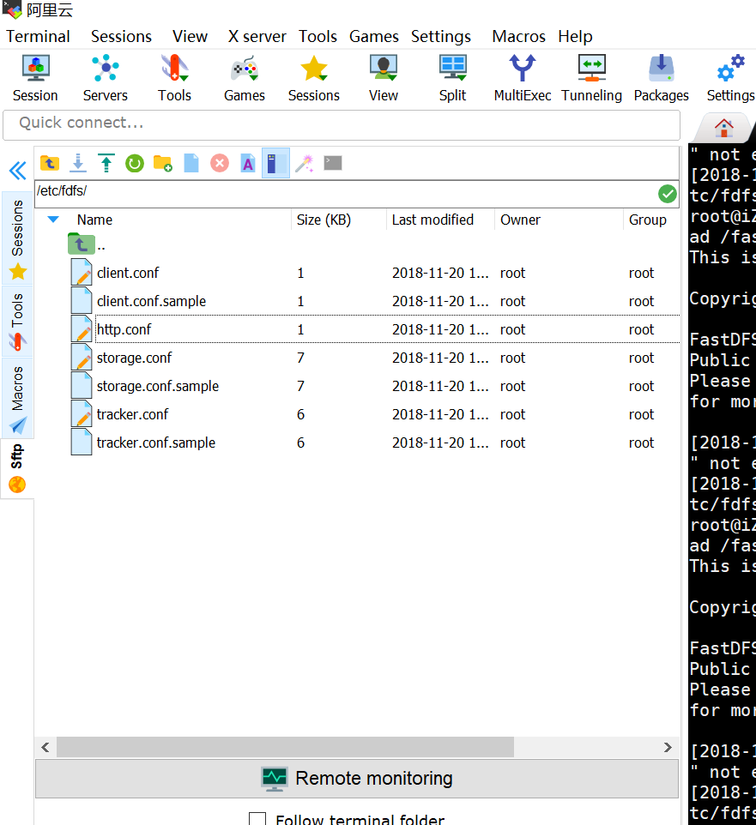

测试

fdfs_test /etc/fdfs/client.conf upload /home/eric218/b.jpg

<http://192.168.2.132/group1/M00/00/00/wKgChFvW2TmAUorCAABDs0xV0dA922.jpg>

停止

/usr/bin/fdfs_trackerd /etc/fdfs/tracker.conf restart

/usr/bin/fdfs_storaged /etc/fdfs/storage.conf restart

fdfs_test /etc/fdfs/client.conf upload /home/eric218/b.jpg

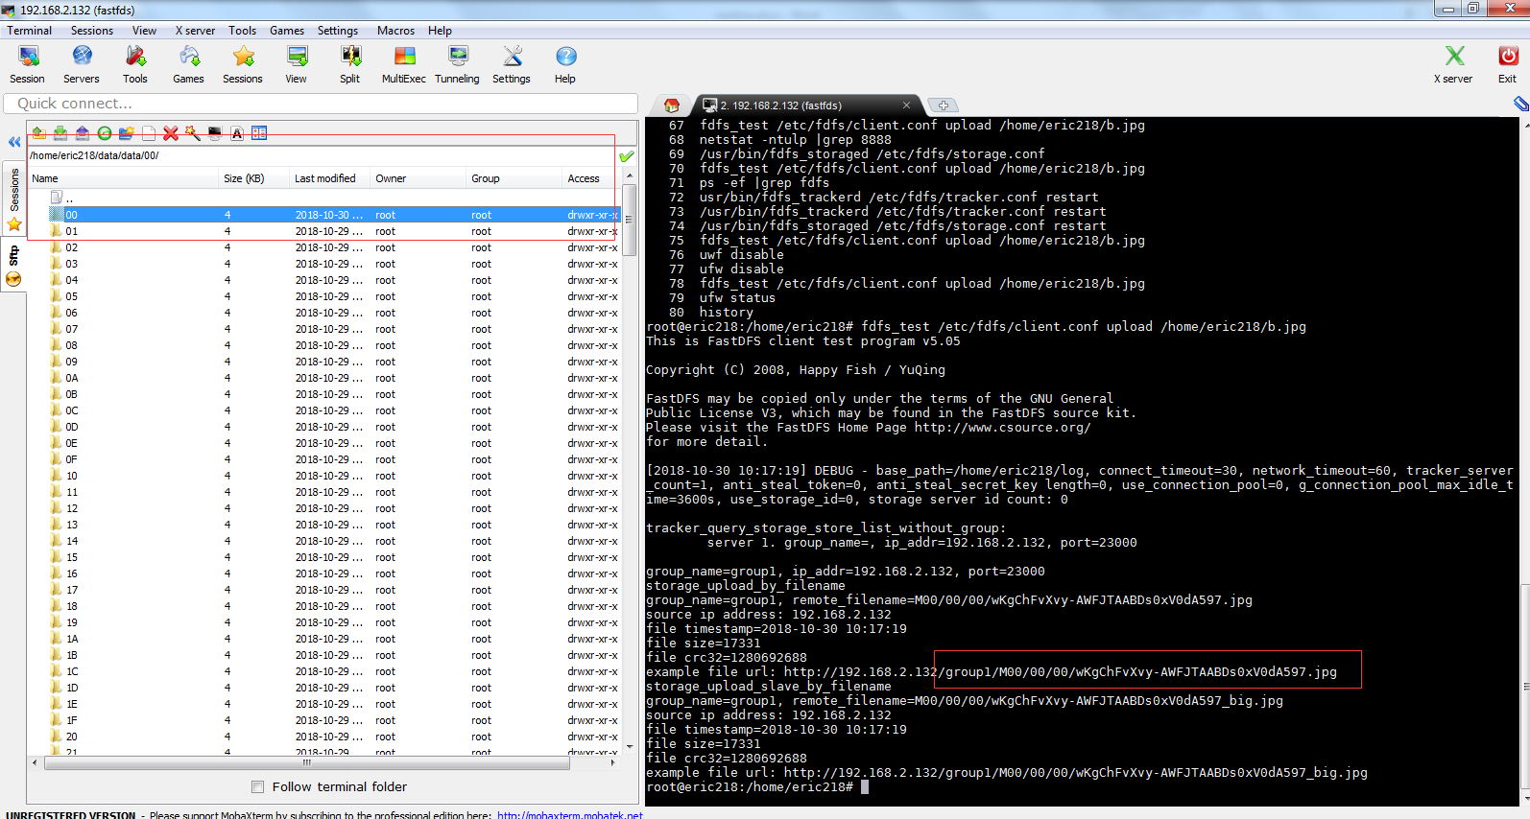

/usr/sbin/nginx：主程序

/etc/nginx：存放配置文件

/usr/share/nginx：存放静态文件

/var/log/nginx：存放日志

apt-get install nginx

nginx -t

/usr/sbin/nginx -s reload

重启 nginx

/etc/init.d/nginx reload

server {

listen 6090;

server_name localhost;

#access_log logs/host.access.log main;

root /fastdfs_upload/data/data/;

}