启动springboot

做链接

ln -s /devlop1/boot/fan_api_web_service-0.0.1-SNAPSHOT.jar /etc/init.d/fan_api_web_service

ln -s /devlop1/boot/fan_api_admin_service-0.0.1-SNAPSHOT.jar /etc/init.d/fan_api_admin_service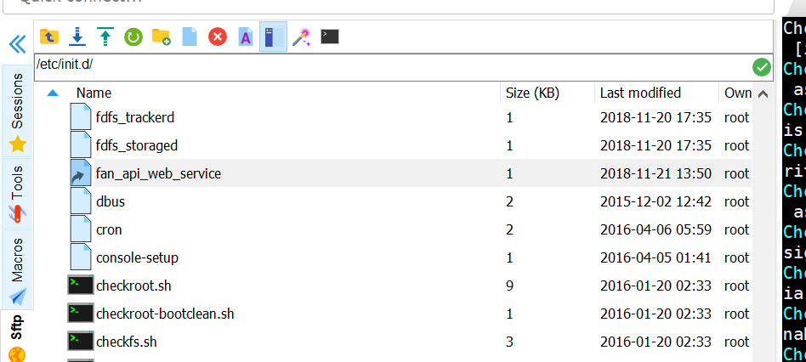

chmod -R 777 /devlop1/boot/

/etc/init.d/fan_api_web_service start

/etc/init.d/fan_api_admin_service start

/etc/init.d/fan_api_web_service stop

/etc/init.d/fan_api_web_service restart

查看log

/var/log/

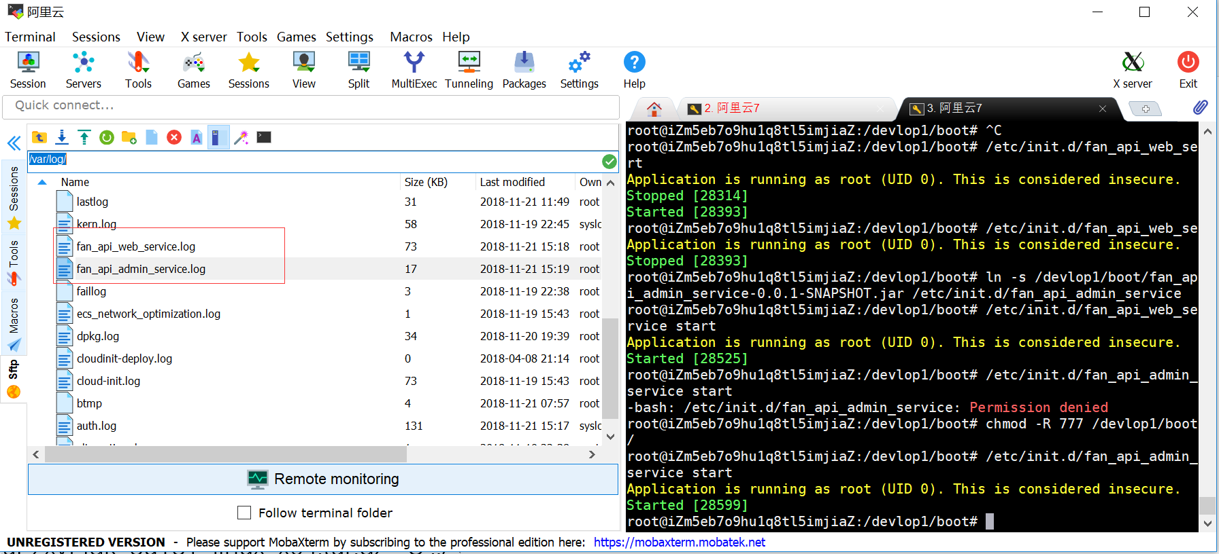

unzip genealogy-web1.zip

移动文件夹: mv dist /usr0/java/apache-tomcat-8.5.35/webapps/

删除非空文件夹 rm -rf 目录名

往前一步解压

tar zxvf jdk-8u181-linux-x64.tar.gz -C ../

复制整个文件夹

cp -R jdk1.8.0_181 /usr0/java

删除

rm -rf 目录名

配置文件生效

source /etc/profile

更新源

apt-get update

#jdk 1.8  
export JAVA_HOME=/usr0/java/jdk1.8.0_181  
export JRE_HOME=${JAVA_HOME}/jre    
export CLASSPATH=.:${JAVA_HOME}/lib:${JRE_HOME}/lib    
export PATH=${JAVA_HOME}/bin:$PATH  
  
#node  
export NODE_HOME=/usr0/web/node-v8.12.0-linux-x64  
export PATH=$NODE_HOME/bin:$PATH

1.sudo su

su eric218

sudo vim /etc/apt/sources.list

换阿里源

查看机器版本

deb http://mirrors.aliyun.com/ubuntu/ bionic main restricted universe multiverse

deb-src http://mirrors.aliyun.com/ubuntu/ bionic main restricted universe multiverse

deb http://mirrors.aliyun.com/ubuntu/ bionic-security main restricted universe multiverse

deb-src http://mirrors.aliyun.com/ubuntu/ bionic-security main restricted universe multiverse

deb http://mirrors.aliyun.com/ubuntu/ bionic-updates main restricted universe multiverse

deb-src http://mirrors.aliyun.com/ubuntu/ bionic-updates main restricted universe multiverse

deb http://mirrors.aliyun.com/ubuntu/ bionic-backports main restricted universe multiverse

deb-src http://mirrors.aliyun.com/ubuntu/ bionic-backports main restricted universe multiverse

deb http://mirrors.aliyun.com/ubuntu/ bionic-proposed main restricted universe multiverse

deb-src http://mirrors.aliyun.com/ubuntu/ bionic-proposed main restricted universe multivers

sudo apt-get install lrzsz

[root@eric218:/usr/local/lib/jdk1.8](mailto:root@eric218:/usr/local/lib/jdk1.8)

解压：tar zxvf

删除非空文件夹 rm -rf 目录名

mv jdk-8u181-linux-x64.tar.gz tools

vim bash.bashrc

#set oracle jdk environment  
export JAVA_HOME=/usr/local/lib/java/jdk1.8.0_181

export JRE_HOME=${JAVA_HOME}/jre

export CLASSPATH=.:${JAVA_HOME}/lib:${JRE_HOME}/lib

export PATH=${JAVA_HOME}/bin:$PATH

source bash.bashrc

source /etc/profile

安装基础包:

sudo apt-get install build-essential