testing:
- login dengan username willy
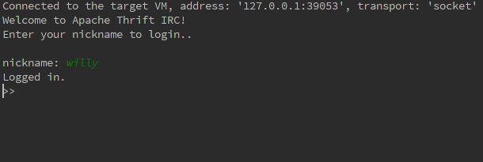
- login dengan username eric
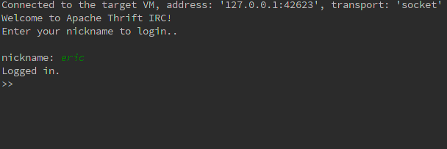
- eric join channela
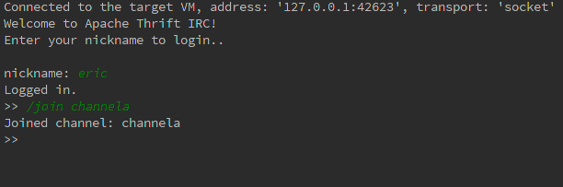
- willy join channela
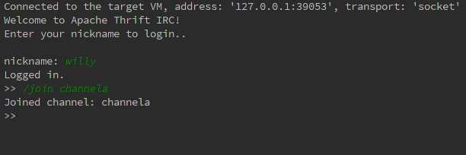
- eric kirim pesan ke channela "halo willy di channel a"
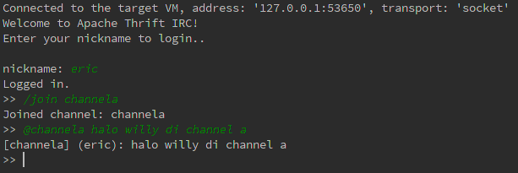
- willy kirim pesan ke channela "halo eric di channel a"
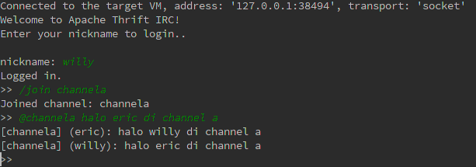
- eric join channelb
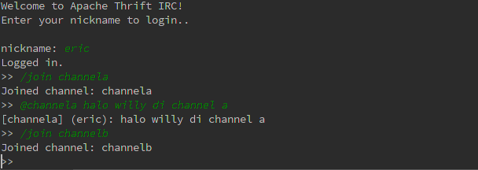
- eric kirim pesan ke channelb "halo channelb"
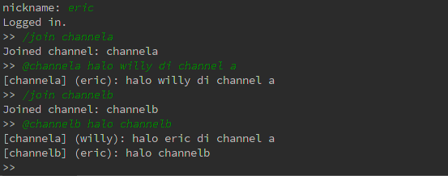

- eric kirim pesan ke semua channel "hallo semua channel"
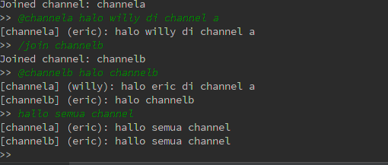

- willy kirim pesan ke channela "halo channela"
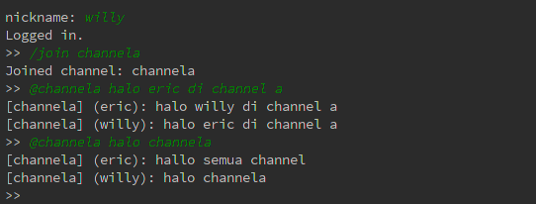

- willy ganti nickname jadi willy1
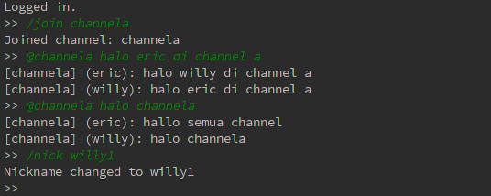

- eric ganti nickname jadi eric1
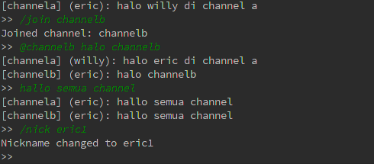

- willy1 kirim pesan ke channela "saya ganti nickname"
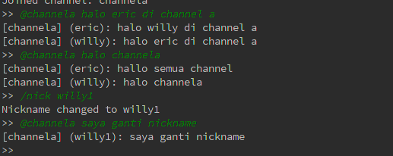

- eric1 kirim pesan ke channela "saya ganti nickname"
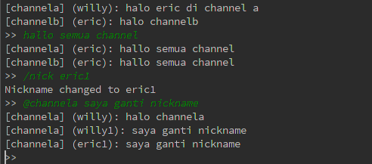

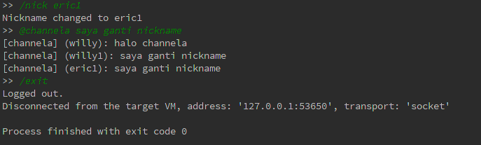
- eric logout

- willy logout
