Project’s Name:
World’s Tale

Author:
Eric Xavier

Gameplay Style:
Simulation, RPG e Strategy

Brief of the Game’s Story:
Follow the story of the characters and pick the best decision your belive be the best for the character, while you keep in mind each choice can change the flow of the battle, and of the events whose gonna happening on the progression of the story, like unlock a weapon, a skill or another character for your army, as the continuation of the game, the player will enter in combat, where he need the best strategy to lead his army to guide for the victory, to win the battle, the player need to complete the mission gave on the start of the battle or conquer the enemy base.

Main Details of gameplay:
- Choose the options of actions, where can change the flow of the missions or story
  - As the story to be told to the player by using images and text, sometimes it will happen where 2 options will show for player to chose, where they can mean an action on the story or be a speech of the player avatar, sometimes the options can be an option to change the flow of the story whose is being telling to the player until now;
  - Some battles can have something like kind of event whose allow to change the flow of the battle, IE: there an enemy character becoming your ally on the battle, or avoid to kill an enemy and later he become the player ally, or mission for be fulfilled and as a reward give the player a weapon or unlock a side story;
  - Some of the actions can happen when the story is being told for the player and with the player can pick any of they and the actions can actually generate an event on the battle where can make more hard or easy, but is possible to unlock side stories for the player be able to play it.
- Evolution of the characters:
  - Each character gain experience points after a battle, even if the battle ends with the enemy not being defeated, the player char will receive a little of experience points, and in case of the battle being a victory for the player character, he win more experience than a draw on the battle, allowing the character raise his level and winning points on his stats and skill points;
  - Each character will have his own skill tree and the player will have the total freedom on chose what skill he want for that character will have it;
  - Using the gatcha mechanic, the player will gain passives skills to equip in your characters to the due of need it or the strategy for the battle.
- Pick the best skills for the battles:
  - The player need to use the skills of character or passive to help on the battle, because it can help to increase the damage on the battle or cause damage on nearby enemies or be used to generate buff or debuff;
  - For that the player need to equip your characters with the skills he believe be the rights one to help him to reach the victory on the battle.
- Protect your base and conquer the enemy’s base or fulfill the conditions to clear the battle:
  - With the idea to avoid the defeat, the players must plan each character must move, each skill will use it, how to stop the advance of the incoming enemy, by moving the your army in strategics points on the map, thinking on how to achieve of the victory.
- Plan every action of your army:
  - The player will have all freedom he wants to build and place on the best place where you think will be best spot for your strategies;
  - Use the passive’s skills and the skill tree to defeat the enemies or do a huge damage to the enemy unit;
  - Use healing’s skills or raise your units status or decrease the enemy units status to make the battle more easy the battle and increase the probability of surviving of the army when it become the enemy turn.
- Follow the story of the game:
  - Read the story who is being telling and see images whose tell the about what is happening about the moment the player is following;
  - Unlock side stories to know more about the universe of the game and unlock more ways to increase and upgrade your army or change the flow of the story being told.

Target market:
The game is focused for a long range of ages, it is for teenagers to adults, where they want to play a game with a focus on create strategies and management of resources on a fantasy story where include religion and myths of the world.

Similar games:
Fire Emblem’s series, Bomberman Wars, Advance War, Xcom, Xadrez, Mario Rabbids Kingdom Battle, Final Fantasy Tatics, Skycraper, Disgaea’s series, Alchemist

Story:
Since from dawn of times, it existed an equilibrium among humans and guardians, and searching for power for the purpose to rule the world, and some of this selected humans was capable to acquire this power, reaching to the level of divines and that specific group of people start to leading the human’s army, and with that the started the slaughter of the guardians, calling they as monsters, and due this new power humans turned the tables of the game for they favor, killing, sealing and destroying the guardians, without a way to survive on same reality, the guardians had to run away sealing the way of humans enter on limbo where was the place the Goddess’s key was hide and protect from humans to not allow they get the key who would allow to rule the world, with the past of the years the hunt didn't stop, many guardians was killed with humans believing that would gave they access to Limbo, seeing the desperate situation the guardians reached, the Goddess as her dying act decide to reincarnate the soul of the dragon who the Gods most fear of it, in a human body awaiting to the millennial war finally end.

Mecanics:
- Player will get new characters on the way he advance on the story;
- The characters whose the player have it are classified as guardians, spirits;
- A spirit isnt playable until be summoned by a guardian;
- 1 Guardian can summon to 4 spirits, but 1 by turn, if the guardian be defeated the spirit will be removed from the battle until be summoned again;
- Guardians who are equipped with a spirit, it have his status raised;
- On the story it will happen events where the player need to chose an action who he prefer to do, that action can change the flow of the battle or the story being told;
- The player will chose a model to be your avatar to be playing, that avatar will allow the player assume the role of strategist of the player’s army and will have participation on the story and the battles;
- All characters have more than 1 weapon class;
- The battle follow the rule of rock, paper, scissors, in other words, 1 weapon have the advantage against 1 type of weapon, but is weak to another type of weapon;
- There 4 class of weapons, the red class is a joint of swords, arcane magic and red seal stone, the blue class is a joint of lance, black magic and blue seal stone, the green class is a joint of axe, nature magic and green seal stone, and the gray class where is a joint of bow, staff and daggers;
- Each unit is divided with movement class where exist infantry whose walk 5 spaces, but when enter on jungle or ruins it loses 2 spaces of movement, cavalry whose walk 8 spaces, but when enter on jungle it lose 3 spaces of movement but it cannot enter on ruins, fliers whose walk 6 spaces and doesn’t have penalty on enter in space with some structure like jungle or ruins and the heavy infantry whose walk 3 spaces and when enter on jungles or ruins it lose 2 spaces;
- A unit can change your weapon before the action of attack, and will stay with it until the end turn of the opponent, unless a unit with a skill who allows another unit to move again, so the unit can attack again and chose another weapon if the player want;
- the weapon change system can be only used before of a use of magic or attacking, after that the unit will become unable to make a new movement until the next turn or if the movement skill be used;
- A unit with a skill who allows another unit move again cant be used to make another unit move if the other unit have a skill with the same effect equipped;
- An attack or magic can be only used only when an enemy is on the range of the attack zone, whose is located until the limit of movement zone;
- Attacks are divided in short range and distant, being magic type only classified as long range attack only;
- The magic skills have a longer range for strike and can hit more than 1 enemy unit just like the healing skills;
- Healers use heal due the staff, but the target must be on the heal zone, whose is located until the limit of the steps zone of the unit;
- Each unit have his own skill tree;
- Every unit have 6 slots for external skills;;
- The player can win external skills or summon then using battle points;
- When used an external skill, the player lose one from your bank, with that in mind the player can have a lot of the same skill;
- The external skill are divided in 4 types, movement, buff, debuff and construction;
- The player can pick the external skills he desire for a unit before the battle start or let it prepared, because the configuration is saved from battle to battle;
- When a unit change his weapon there a chance for the unit type of movement be change as well, as sample when an infantry change his weapon for a heavy weapon then that make his movement type become a heavy infantry type;
- In the story, there a chance of an event picking an option, where it need for the player to pick one of the options, and that options can be change the way of the battle or the story;
- In the battle, it can happen for the player need to interact with his allies, enemies or scenery, it can change the way the battle or the story is going;
- To win, the player need to defeat all the enemies in his turn or destroy all enemies headquarters, and the same condition can be happen to be the player defeat as well;
- All units who was defeated in a fight it will return after 4 turns to the headquarters of his army;
- Each headquarters recharge 10 of hp of the unit who is in the headquarter or near of it;
- The headquarters allow a unit to teleport from another headquarters who belongs to the army of the unit, but for it the spaces surround the headquarters must be not occupied by an ally or an enemy, that happens with the enemy as well;
- When a unit declare an attack to a headquarter, the unit who made that action cannot do another action on the same turn and the headquarters will lose 1 hp of the total capacity of hit, the damage caused on the headquarters cannot restore the damage, when the hp become 0 the headquarters will become to the same army as the unity who destroyed;
- If a unit of the player be defeated in field, the same have a countdown for his return to battle, if the player win the battle, the unit will be fallen until the end of the countdown he was one the past battle.
- The units have energy and gain experience when they defeat an enemy, in case it didn't finished the unit will receive a small part of the experience, in case of healers, they will get experience when it heals as well;
- The units have a fear system, where they find the condition in field or battle, the unit will act different from the expected, as sample if the unit have a problem with light, and the unit be attacked by an attack of the light type, the unit will not be able to counter it;
- The units have 5 attributes who make him, they are HP whose indicate the unit life, ATK who is the attack points, DEF who is the defense points, SPD who indicate the speed point, RES indicate the resistance for magic attacks;
- The calculation for the battles have 2 categories, and the formulae for the damage calculate follows next:
  - Physic:
    - (Unit Atk * Skill * WT) – Unit Enemy Def
  - Magic:
    - (Unit Atk * Skill * WT) – Unit Enemy Res
      - Assuming this values for Skill:
        - Vantage = 1,2x
        - Neutral = 1x
        - Disadvantage = 0,8x
      - Assuming this values for Weapon Triangle(WT)
        - Vantage = 1,5x
        - Neutral = 1x
        - Staff = 0,5x

Game play:
The player can chose between 2 type of avatars to represent they on the story, and the player will choose the initial equipment for the avatar, along side for some of the units for his army.
The game will tell the story with text, and some times images or video will help to tell the story to allow the player to know about what is happening, and will happen to the player need to pick an option to choose to determinate what will happen on the story/battle, as sample if the player decide it to help someone who showed on the story it will get some events who allow to jump to final fight on th chapter, if not it will bring to a fight where need to help a NPC but the it will have less HP due the player took more time to get there unless if the player had chosen to help from the begin of the story the npc would have the full HP bar on that battle. Sometimes the player may need to use a unit to interact with some character on the battle field.
The battles in the game work as the following: the player must guide a unit from point “A” to point “B”, where point “B” can be a location, an enemy, a base, etc., to move a unit the player must select a unit, when selecting the unit he will load the number of steps that the unit can walk on, and the number of steps can decrease according to the field in which the unit is located, the types of classes can be verified in the unit movement table (Table 1).

Class | Number of Steps | Forests | Bases or Ruins
Infantry | 5 | 3 | 3
Heavy Infantry | 3 | 1 | 1
Riding | 8 | 5 | 0
Flying | 6 | 6 | 6
Chart 1: Movement of Units

At the end of the step area the attack zone is found, and each attack a required distance for the attack or counter attack is carried out and following the rule of scissors and paper, each weapon belongs to a class and that class has advantages on one class and weakness on another class, where it can be seen in the table of the attack zone of the units (Table 2).

Weapons Class | Type of Weapon | Attack zone | Attack Type | Weakness | advantage
Red | Sword | 1 | Physical | Blue | Green
Red | Arcane Magic | 2 | Magic | Blue | Green
Red | Seal Stone | 1 | Magic | Blue | Green
Blue | Lance | 1 | Physical | Green | Red
Blue | Black magic | 2 | Magic | Green | Red
Blue | Seal Stone | 1 | Magic | Green | Red
Green | Axe | 1 | Physical | Red | Blue
Green | Natural Magic | 2 | Magic | Red | Blue
Green | Seal Stone | 1 | Magic | Red | Blue
Grey | Bow | 2 | Physical | Not applicable | Not applicable
Grey | Staff | 2 | Magic | Not applicable | Not applicable
Grey | Dagger | 2 | Physical | Not applicable | Not applicable
Chart 1: Units Attack Zone
The player can change the weapon equipped in his unit while his unit is available for movement or before attacking. For this, the player sees the menu where he indicates equipment, when accessing he can choose which weapon is available in his menu, and unit may have more than one type of weapon of the same or different class, and that some units undergo a change in their movement class (table 1).
Fights only occur between a player's unit against an NPC unit, so there is no possibility of having 2 units fighting at the same time against just one, so at the end of a battle, another unit may come to battle with the unit previous one that was being attacked.
In addition to attacking units in the field, there are bases to be attacked, so a unit can attack a base if it is not occupied by an enemy unit.
The conditions for the victory of the fight lead to the fact that the player must destroy all 3 enemy bases, or be able to defeat all the opponent's units before they return to the battle again.
At the end of the battle the player receives battle points, where they can be used to summon skills.
The skills are cumulative, because when used in battle it will be removed from the player's inventory, and certain skills may not be possible to be equipped in some units because they do not fit the class of the equipped unit.
When participating in the battle or winning the unit gains experience to pass the level, when the unit moves to the next level its status will automatically increase, however the player will be able to choose which skill he will acquire in the character's skill tree.

Hardware:
For the game to work, it is necessary that the player has a smartphone with Android 4 or higher operating system or have an iPhone 6 or higher for the game to work.

Controls:
Due to the development of the game being for smartphones, all that is needed is to use the player's fingers to select the components of the game, buttons, characters.
The act of pressing is used to select or press a button, as an example the player presses the spell button to open the list of spells, or press a unit in the game to be able to perform a movement on the selected character.
Swiping is used to scroll through lists, such as the list of past chapters or the list of spells or scroll through the character's skill tree.
When selecting a character, the player must just drag on the screen the point where he wants to place the character on the map or drag to an enemy to be able to start the combat.

Cameras:
Only the battle mode has the camera function being the same view from above where it allows the player to observe the entire field, being that it is not fixed so having the player to drag the screen to be able to see the rest of the field due to the size be larger than the player's display shows it as shown in figure 13. Regardless of the battle mode the storytelling and the selection menu has a fixed camera where only the components move, different from what happens on the battlefield.

Figura 1: Campo de batalha
Fonte: Próprio

Characters:
The characters that the player will be able to interact and control are divided into 3 race types, Guardian (monsters), Spirits and Gods (Gods and demigods).
The only difference to the issue of enemies is that a new race is added to Humans, for the sake of making history, this race is a faithful follower of the Gods that aim at human supremacy, a different view from the goal that the avatar seeks to create.
Guardians are mystical or mythological creatures known to different cultures, where it is a race used by both the player and the enemy, but both are called guardians and the enemy will be called monsters, in table 3 you can see which race and status of a guardian that will be controlled by the player.

Table 1: Eric Technical Sheet
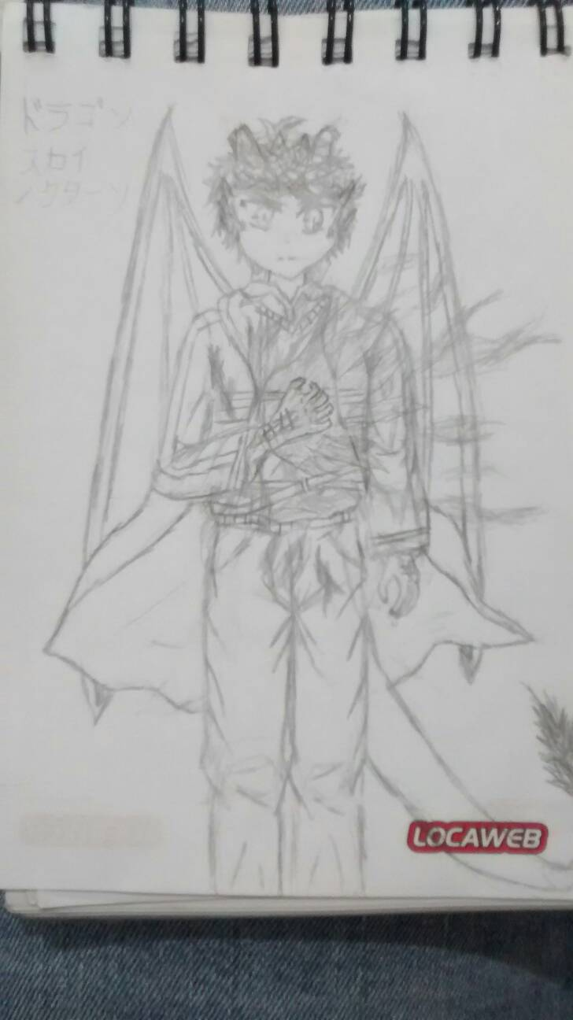 | Name | Eric | Title | Dragon Reincarnation
 | Weapons
 | Sword | Murasame, GrandArk, Excalibur |  | HP
 | Axe | Soul Synphony |  | ATK +
 | Seal Stone | Dragon Stone blue |  | DEF +
 | Bow | CaladBorg |  | SPD ++
 | Dagger | Sekki, Dark Ruler |  | RES --
 | Nat Mag | Ice
 | Drk Mag | Soul, Ice Stxy
 | Main | Murasame | Purpose | End the holy war
 | Fear | Light
 | Fear | Being surrounded
Fonte: Desenho e ficha técnica feitos pelo autor

Spirits are a race composed of warriors and famous people from different histories, legends and myths that exist in human culture, and for them to be able to manifest themselves, they need a powerful soul that helps them to establish in physical reality, in table 2 we have another character controlled by the player who has his historical origin from the Arthurian legends of the United Kingdom.

Table 2: Viviane Technical File
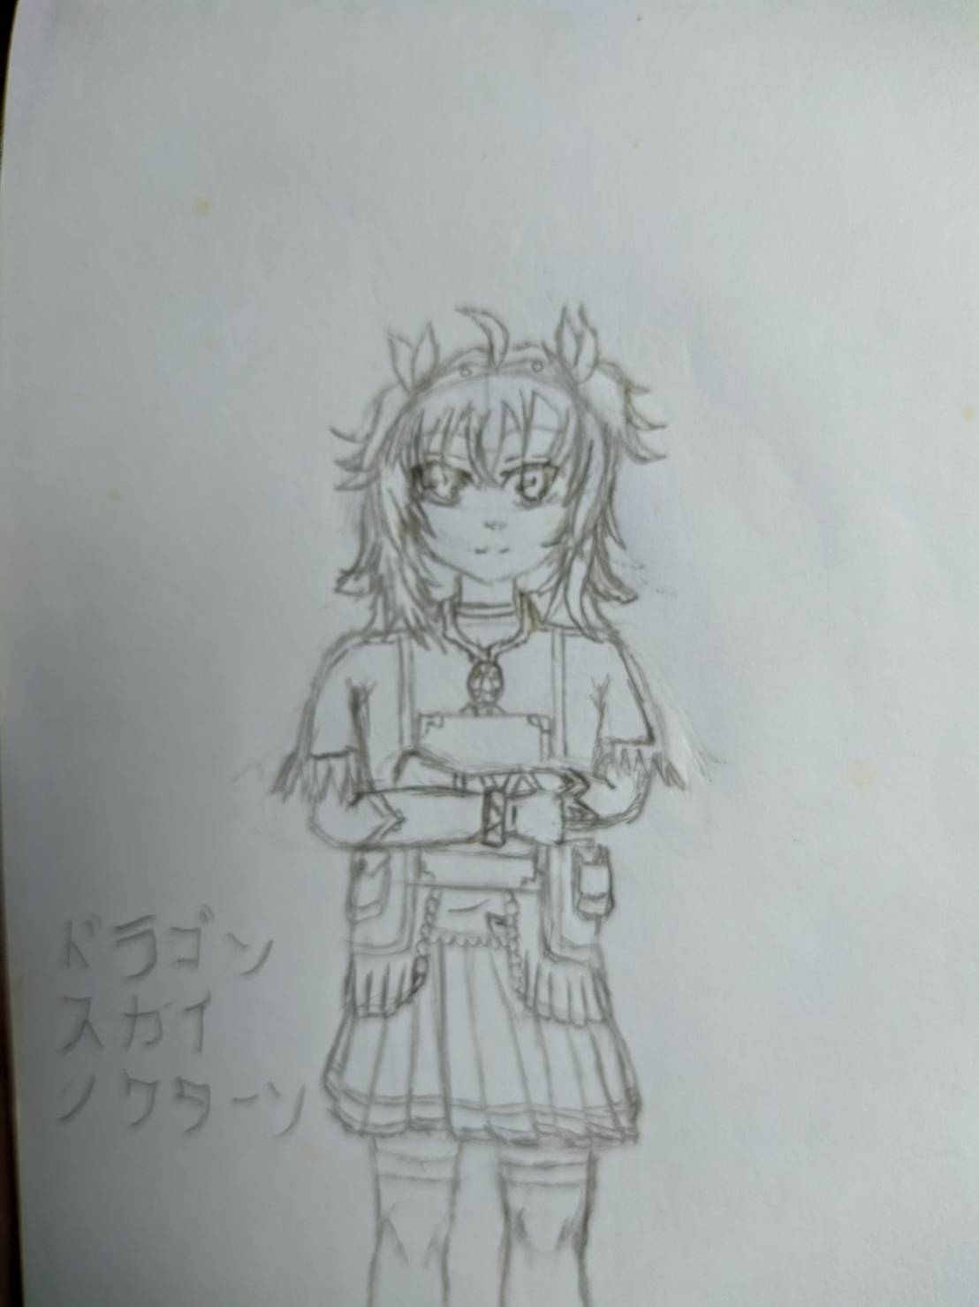 | Name | Viviane | Title | Lady of the Lake
 | Weapons
 | Sword | Excalibur |  | HP
 | Seal Stone | Dragon Stone blue |  | ATK
 | Bow | Hunter of Camelot |  | DEF --
 | Staff | Saint of Camelot |  | SPD ++
 | Nat Mag | Florest of Avalon |  | RES ++
 | Drk Mag | Darkness of Avalon |  | Spiritual Connection
 | Arc Mag | Light of Avalon |  | Eric
 | Main | Light of Avalon | Purpose | Follow the path created by the new bearer of the holy sword
 | Fear | Church
 | Fear | Knights
Fonte: Desenho e ficha técnica feitos pelo autor

The gods, on the other hand, are the race that seeks human supremacy throughout history, so a good part of them is against the existence of the guardians which leads to the fact that they are directly the enemy of the player, it is clear that there are some exceptions in this distinct group and each to the player being able to release the events necessary to allow him to release to his army, in table 5 there is a token of a goddess that can be released to the player's army in case the player manages to release Amateratsu in his army, if the player has not been able to obtain what is needed to unlock, he will have more chances to obtain, that is if they have the necessary achievements to be able to acquire.
Table 2: Sakuya Technical Sheet
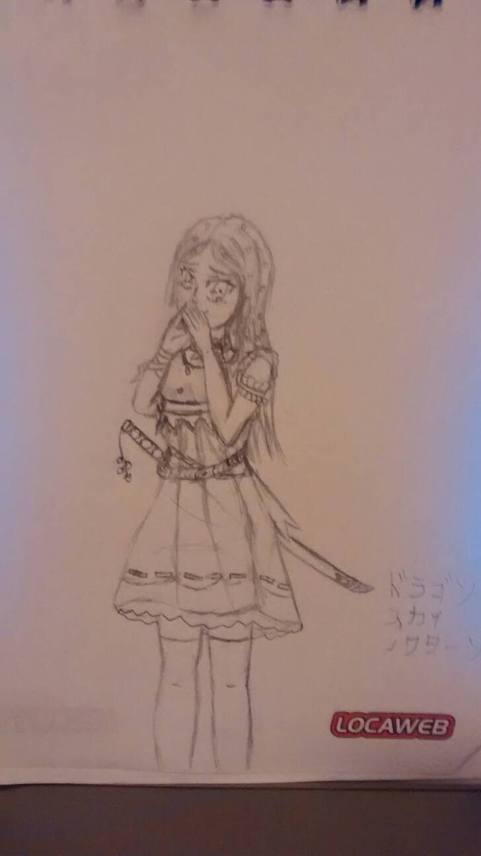 | Name | Sakuya | TitleGoddess of cherry blossoms | Goddess of cherry blossoms
 | Weapons
 | Sword | The beauty of sakura, Fuji relic |  | HP -
 | Arc Mag | Fuji Energy |  | ATK ++
 | Nat Mag | Sakura Blizzard, Chinka Taisai |  | DEF -
 |  |  |  | SPD ++
 |  |  |  | RES +
 | Main | The beauty of sakura | Purpose | Follow Amaterasu to change the world
 | Fear | Ice, Snow
 | Fear | Fire
Fonte: Desenho e ficha técnica feitos pelo autor

The humans in the game is just to generate greater volume in the enemy army, so there will be some relatively important human in the game, as everyone will have a more balanced status with that of the player to balance the battle, of the existing classes in the game, humans are the only race that the player will not be able to play or release.

Character Actions:
- Walk:
  - Since the camera view is from above, it is stated that the movement follows the 4 cardinal positions, it is not possible to walk diagonally because the field is divided into squares as in chess;
- Attack:
  - To attack, the character needs to find the enemy at the limit of his line of movement as shown in Chart 2;
- Skills:
  - To use skills the character needs to have it enabled and check if the enemy is on the damage line, and these skills can be used around the character or more distant;
- Summon up:
  - Characters with a spirit allocated as a partner can use summoning to bring them on the field;
- Weapon exchange:
  - If the characters have more than one weapon released, they can switch before entering combat;
All moves are used by the player and the AI ​​without distinction, if the selected characters have the correct conditions to execute.

Scenarios:
Knowing a little about the characters already allows us to have a notion that the game takes place on planet Earth, in several cities, temples, regions, due to the idea of ​​the game, as it can be divided into 2 dimensions the physical dimension where humans live and the most abundant in the game.
In the physical dimension the player will be inserted to enter cities, fight in them and find some enemies and future allies, because part of the story occurs in the physical dimension, because although the gods control the world, the gods would not risk destroying the humanity that generates the source of their powers, so they interact to acquire more followers and build more statues and temples (figure 2) to increase their influence and be more praised, so that a meeting can occur anywhere in the globe, as examples, cities, forests, ruins, mountanhas.
Figure 2: Exemplo para realidade física: templo
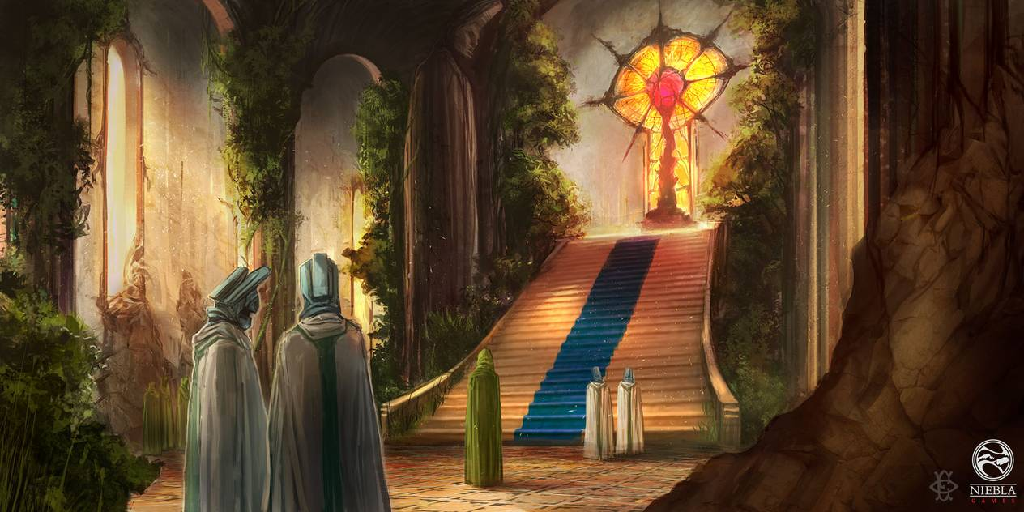Fonte: https://www.deviantart.com/000fesbra000/art/Templo-Voces-del-Ocaso-478163799

The second is the spiritual dimension, she was responsible for separating the two dimensions preventing the interaction between spirits and humans, due to the events that occurred in the game this dimension will be broken, making small parts only exist in the world, some examples for this dimension it would be the limbo, divine kingdoms, underworld among others.
Despite being fragmented, the spiritual dimension is the most dangerous part in the game, as it is the kingdom claimed by the gods of its territory, several wars occurred in the past in which it made this zone that was controlled by the goddess to be fragmented, previously humans had great power spiritual which allowed them to enter and leave this dimension easily, thus generating a great war between the gods and their followers to take on that dimension after the murder of the Goddess, thus causing the destruction of that dimension and being separated into several kingdoms that reside the gods, the limbo (figure 3) which is the place where the last guardians are hidden is located in a remote part of the underworld, which is controlled by Hades.

Figura 3: Exemplo para a dimensão espiritual: limbo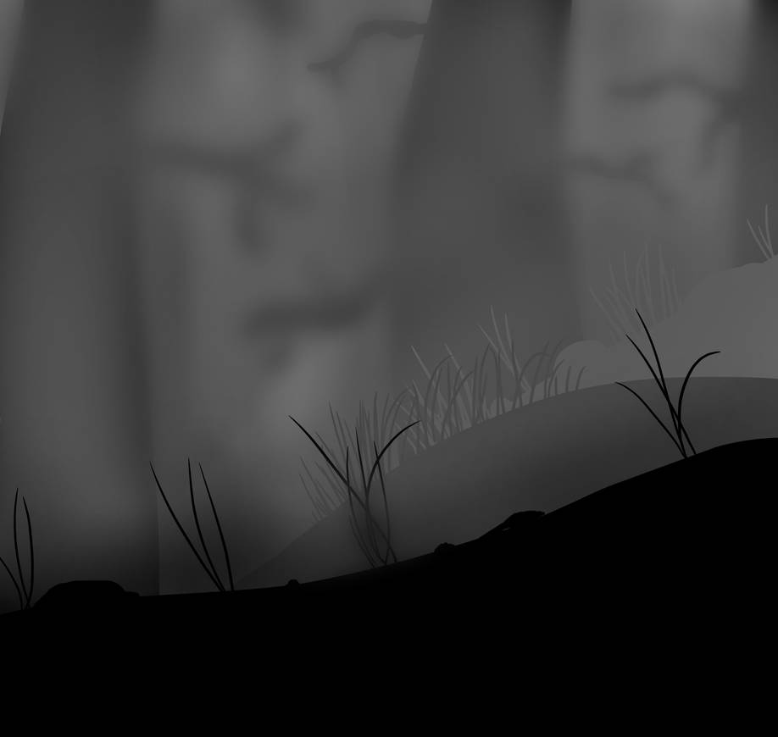
Fonte: https://www.deviantart.com/gentleluger/art/Limbo-esque-Hill-453346781

Although this dimension is fragmented, humans have become unable to enter this dimension due to the loss of spiritual power, so for a normal human to enter it, it is necessary for a portal to be open, for that it is necessary that someone with great spiritual power and with this ability to be able to accomplish this feat, for others it is only necessary the ability to create portals or enter one of the few fragmented parts that are scattered around the world to enter the spiritual dimension.

Interface:
Main menu: the game will consist of a normal screen with a press-to-continue phrase and a background image, when pressing the main menu (figure 4) it will be loaded, there will be a button with the past chapters and the current one that the player finds himself, inside it has more buttons that show which section the player is in, as well as shows the sections already made by the player.
At the bottom there is a bar with some icons, they are the summon icons, characters and configuration, when pressing each of the icons the player will be taken to a different page corresponding to the pressed icon.
Figura 4: Menu Principal

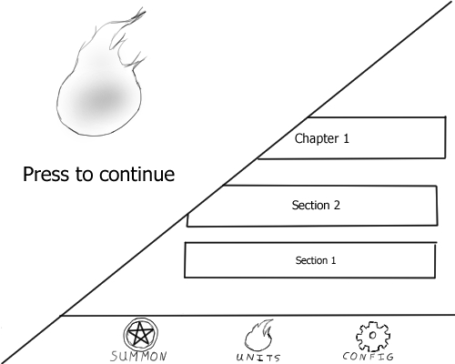Fonte: Próprio

Character: In this screen (figure 5) the player is able to see the selected character at the bottom and his information, at the top of the screen has a pencil button, which when pressed allows to see some images of the character, with attack pose among others , below the image button we have the icon indicating the type of movement of the character.
At the bottom there is a plaque that contains the name and title of the character's race, below it there is a box that contains the equipment and the skills of movement, critical and passive, next to it there is another box that contains the status of the character it is described in the character sheet, and located above the status box is the box of allied spirits.
In the lower part of the screen is a bar with some icons that will redirect the player to the respective screen of the selected icon, the icons found there are the skills tree, equipment and passive skils.
Figura 5: Tela do personagem
Fonte: Próprio

Skills tree: On this screen (figure 6) we can see the character's name, and below icons with skills to select, pressing a box shows a description about the selected skill and shows how to learn it, at the top of the screen there is a button to return to the character screen.
Figura 6: Skill Tree
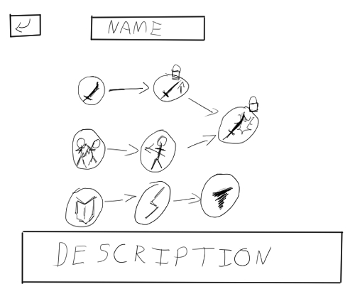Fonte: Próprio

Character equipment: on this screen we can see the character's name as well as buttons with the equipment, movement skill, critical skill, and passive skills A, B, C, below them we have a box that will describe about the selected item and show a button that allows the player to choose to exchange the selected item. At the top of the screen there is a return button on the character's screen.
Figura7: Tela de equipamento
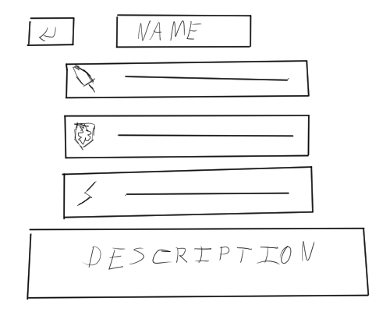Fonte: Próprio

Equipment exchange: On this screen (figure 8) we have a box with the current equipment and below another box with the other equipment that the character has learned and equipment to learn too, and in them they have the description and the price to be able to learn, and in the bottom of the screen has two buttons to confirm and cancel the action and at the top a button to return to the previous screen.
Figura 8: Troca de equipar equipamentos
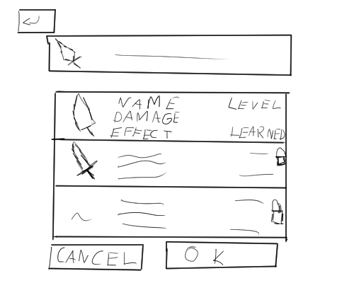Fonte: Próprio

Passive Skill Exchange: On this screen (figure 9) we have a box with the current skill and below another box with the other skills that the character has equipped and other skills to be equipped, and in them they have the description and the quantity that the player has , and at the bottom of the screen there are two buttons to confirm and cancel the action and at the top a button to return to the previous screen.
Figura 9: Trocar e equipar skills passivas
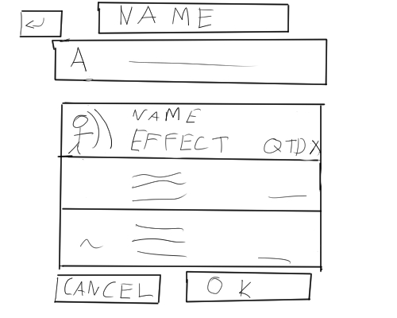Fonte: Próprio
Skills Summon: In this screen (figure 10) is the summon screen, it has a banner with the skills and shows the description of the skills' use with the greatest degree of rarity, then two buttons with the amount of summons that the player to do between once or ten times, and below a list of all the skills of the game, containing their description as well, and at the top of the screen there is a button to return to the previous screen.
Figura 10: Tela de Summon
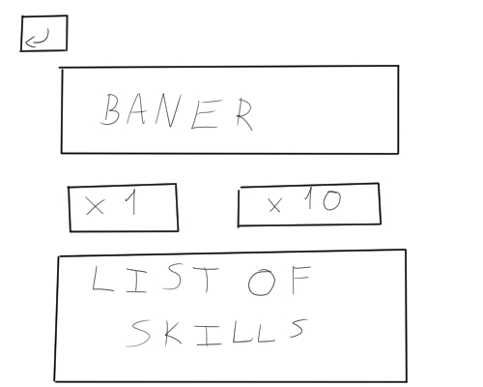Fonte: Próprio

Battlefield: On this screen (figure 11) is the game's battlefield, at the top of the screen has the configuration button, the field is all checkered with some forest elements, rivers and other elements to indicate that this area can change the character's movement.
There are 2 castles indicating the player's base with each one with a summoning sigil of the player's characters.
In the lower part there is a menu bar with the buttons to change equipment, check the map, activate a native skill of the character and summon a spirit.

Figura 11: Campo de batalha
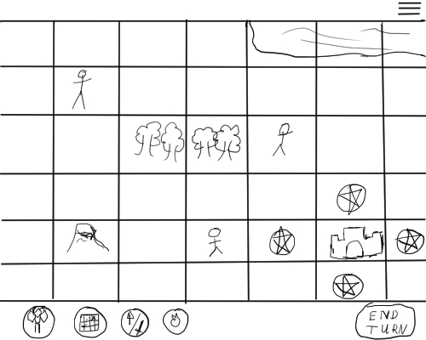Fonte: Próprio

Technology and tools
Animation:
The use of the technique known as Sprites is used to build the animations of the game, this technique consists of drawing a character several times making a continuous movement, so each drawing the doll is making a movement, and in the next doll it will continue the previous movement and so on until the cycle of movement ends, in other words, if each drawing was placed on a block of sheets and each sheet has an image of the doll, when you take this block and pass the sheets quickly you can see that the doll will move like an animation. An example of the technique can be seen in figure 12, where you can see the running process of character X from Capcom's Megaman X game.
Figura 12: Sprite de Corrida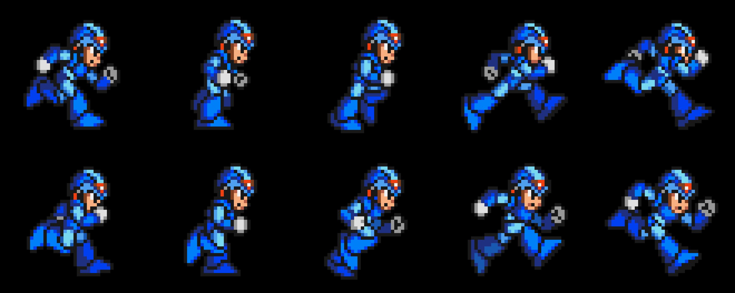
Fonte: https://producaodejogos.com/piskel-guia-para-pixel-art-e-sprites-animados/

When this image is loaded into the software to develop games, it is able to recognize the properties of the image and generate the animation correctly for the game, just that it is correctly programmed in the game.

Development tool: Godot
Godot (figure 14) is software for developing open source games, known as the engine, Godot is a powerful tool being able to allow creators to create games with 2D-style and 3D-style graphics, with powerful features to allow of the developer to create games freely, its functionality to create resembles other famous engines like Unreal, Unity, Game Maker among others.
Despite carrying powerful functions this engine is simple, fast and light for a tool with a great power for development unlike Unity, which is also a powerful engine with several features but heavy in the sense of memory and processing. Besides that its community on the internet is extremely large, already having many materials for anyone to be able to venture into game development.

Figura 13: Display do Godot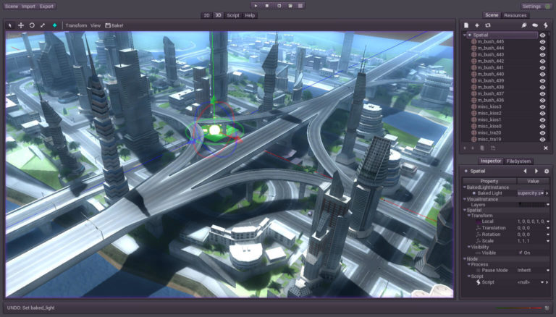
Fonte: https://producaodejogos.com/godot-engine/

Because for game development Godot uses a script to develop the game's behavior, different from other engines, that each scene uses at least 1 different script so it can cause a problem when joining them, Godot works in a different way, because he uses a system of nodes, so each main scene has a child generating sub scenes in different files and so when joining them they did not present any problems in this process, as they all come from the same master scene.

Music
For audio effects, such as music and sounds, it will be all provided with free sound libraries, so all the sounds found in the games, are available for free by third parties for someone to use in their projects, being clear that it will depend on the type of license of the sound being requested, so some music authors ask to be mentioned in the game credit, below you can find some links to access the pages of some free sound libraries.
- http://soundimage.org/
- http://incompetech.com/
- http://www.freesound.org/
- http://freemusicarchive.org/

Script:
The script has a great role for games as it helps in delimiting the elements and content that will be presented in the game, and for this project the script is used to help the beginning of the player's adventure as well as delimitation of the content to be created and it also helps to define the route situation that the project has defined.
To create a script there are several tools to perform the construction as an example to summarize the story and after defining the summary, divide the summary into three arcs, usually called initial, development and final, but the technique used for this project was used known as “The Hero’s Journey”, which consists of 12 steps to build the project’s narrative.
Bearing in mind that to create the script that is available below, not all steps have been used, as the story told so far only addresses the beginning of the game, so there is still no need to use all steps. The steps used in the moment of daily life until the refusal of procrastination, despite giving the impression that there may be more steps involved they were not presented because the protagonist the other elements to compose the whole story, and at the moment that the final script was finished the protagonist was arriving at the mentor's meeting.

Fonte: https://blog.terapiadebolso.com.br/os-12-passos-da-jornada-do-heroi-representacao-psicologica/
Figura 14: Os doze passos da jornada do herói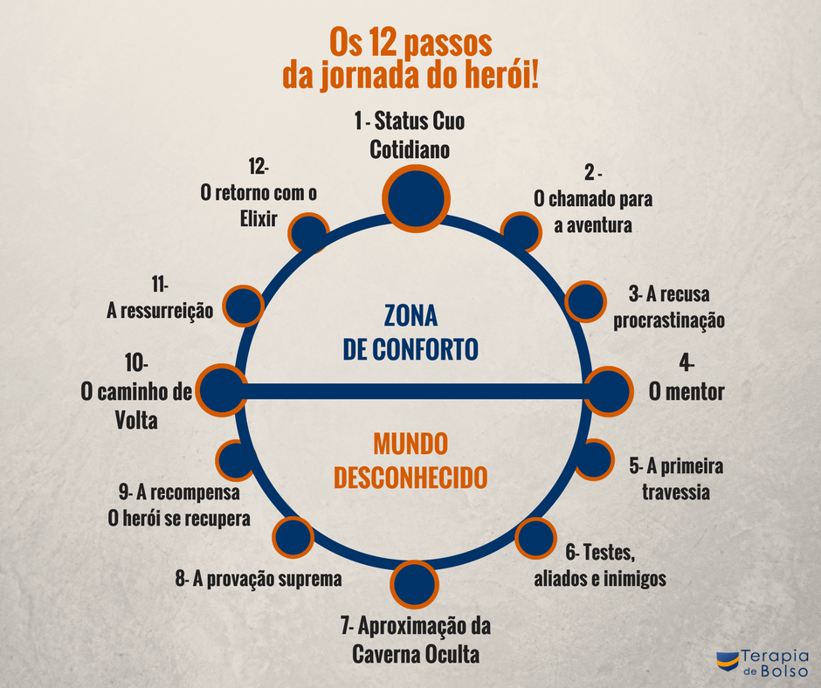
É It is possible to notice that the system of choices for the player can make during the game, and that it also changes the route that the protagonist will follow, thus changing some events or facts throughout the story.

draft for the script:
- It begins by telling a little bit about the past and how it got to the point that the next vessel for the goddess's soul is found;
- The beginning is in Japan, where the avatar, Eric and Yuzuki are in Japan, when Eric hears a strange and loud sound accompanied by 2 guardians, when asking the avatar about the sound, Eric and the two guardians understand that the sound comes from spiritual side;
- When notifying the source of the sound it is possible that the sound becomes more self and shows news about what is happening in the world shows that supernatural entities begin to appear in the world;
- Monsters attack the group where the two guardians are visible to everyone, when an arrow is directed at the avatar. Eric protects the avatar, being seriously injured, so Eric projects his soul out of his body while one of the guardians heals him;
- The player's first choice is made now, where he chooses which of the 3 weapons Eric will start, the game will start the tutorial allowing the player to use Eric and one of the guardians.
- After this battle another fight will take place, but Eric's body is healed and will be protecting the avatar and Yuzuki while Eric's soul and the two guardians battle against the enemies;
- At the end of the fight, those involved in the battle begin to theorize what was going on, and are asked by the avatar and Yuzuki about what was happening and what was what attacked them, in the midst of the questioning a crack in the dimension close to the location that they meet and a giant hand pulls them into another dimension;
- Upon realizing where they finally stop being pulled, they are introduced to limbo, the avatar hears a female voice, in the place where the last resistance to protect the last relic left by the goddess, where they find another guardian already wounded by the war that is happening at the limbo;
- After knowing the current situation it is decided what will be done now, because given the direction of the war it is only a matter of time for the annihilation of the guardians, for that Eric is forced to break the strength implanted in his soul and assume the your role as guardian;
- Eric separates from the group, the avatar goes to the fortress where the goddess's soul is, during this half time it is explained what may be happening in the human world, during this period the avatar knows Eric's past and why it was necessary to break the seal of your soul;
- Upon arriving at the fortress, it is seen that the situation is not favorable to the guardians, as the fortress is almost falling into the hands of the Greek heroes, upon entering the fortress the avatar meets the few survivors of the guardians and the goddess soul that they are protecting;
- By understanding the situation of the guardians, the avatar will help build a strategy to save a little time, some of the guardians are injured in combat thus causing the fortress to be invaded, at that moment the avatar will choose between fighting or fleeing:
  - A:
  - if you choose to fight the avatar will have his first fight after absorbing the goddess' soul by mistake, after some battles some Greek heroes will appear in the battle causing problems for the guardians, forcing them to retreat, to the place where Eric is breaking his seal;
  - Along the way you will face some enemy troops to the place, when you reach the meeting place, there you will find Eric in the middle of the ritual to break the seal, in that the guardians must wait for the ritual to end, so during this period they must protect themselves it, until the end, during the battles Perseus, Heracles and Achilles will arrive at the place;
  - While the fights are taking place it is shown what is going on inside Eric's soul, where he is fighting the light part for control of his power;
  - A shock wave will pass by the place where everyone is fighting, thereby making the player distracted and Perseus seizing the chance to kill the player, to avoid this event Tanathos will sacrifice his life to protect the new receptacle of the goddess, and with that Eric goes to wake up, and Perseus fearing the worst tries to kill Eric;
  - B:
  - If you choose to flee, the guardians will take the goddess's soul and flee to the place where Eric is breaking the seal, on the way some battles will take place until the avatar reaches its destination;
  - When the player arrives he will see that the ritual is still taking place and will continue to wait for the end, facing some enemies;
  - While the fights are taking place it is shown what is going on inside Eric's soul, where he is fighting the light part for control of his power;
  - Some battles still take place until Perseus, Heracles and Achilles threaten to kill Eric if the goddess's soul is not delivered, so the avatar will try to deliver to save Eric's life, however when the heroes see the soul they try to kill the avatar however Tanathos saves the avatar and warns the avatar that they are going to kill everyone, regardless of whether the soul is delivered or not, upon learning of it the avatar absorbs the soul of the goddess and a new battle ensues until the first shock wave appears and Perseus fearing for worse tries to kill Eric;
- When Perseus tries to kill Eric he will awaken with his power, seeing the current situation of his friends Eric will advance on enemies while Tanathos with his last strength will open the portal to the living world, thus initiating a battle of Eric against the heroes while protecting your friends;
- In this battle Eric Achilles will let his guard down, and since the divine Achilles power comes from the blood of Eric's past life, he withdraws the powers granted by his blood, doing mortal Achilles again and causing him to lose his confidence. The guardians pass by and wait for Eric to pass too;
- Distracted by what happened, Eric seizes the chance to escape, Perseu blinded by the fury over what happened to his brother, Eric goes upside down, thus restarting the fight, to create a chance of victory for Eric who is at his limit, so he uses magic in Achilles making Heracles go to protect his brother and Perseus to look the other way due to concern, creating an opening for Eric to use his power that his past life has taught him to destroy gods, and with a direct hit he kills Perseus;
- Seeing this, Herácles is possessed by hatred and anger and goes on top of Eric, who only uses Heracles' gallows to fly out into the portal and as soon as the remaining guardians pass, they close the portal, concluding the flight from limbo;
- With the portal closed somewhere hidden in Japan, the guardians are recovering, but the guardian general is badly injured which could lead to her death, so Yuzuki tells the general to merge with her to avoid her death, despite knowing the risks she is willing to face them due to the kindness and compassion she had with the guardians when she learned everything that happened to them, while the two begin the ritual the others try to evaluate what will be the next step to be done;
- While they are making assessments of the next steps the emperor of Japan with some subjects appears before them saying that he has come to talk, but death sees that the soul of the emperor and the subjects is different from normal and asks to reveal themselves and let the humans go;
- Surprised to have been discovered, the leader makes the gesture to get out of the human bodies they were using, however some of the subjects say not to get out so that they would lose the bodies they would lose the value of victims for them to use when they need to;
- Despite the protests the subjects all do and it is revealed that Amaterasu and his brothers and some other gods are before them, and that he comes to propose to work together to promote a better world for humans, thus making the avatar choose, in cooperating with Amaterasu and betray the guardians or refuse the offer:
  - A) accept the proposal:
  - In view of this vision the avatar will confront the guardians as they would not allow the gods to obtain the soul of the goddess, and even if the avatar tries to argue to see that it would be the best option it will still lead to yet another fight between the avatar and the guardians:
    - Avatar victory case:
      - If the avatar decides to try to convince the guardians instead of killing:
      - A)
        - The avatar will try to convince to protect humans, however the guardians refuse to comply with this request and no matter what, then tired of talking, the god under Amaterasu's command will try to kill, so Yuzuki will awaken and protect the guardians, although the avatar tries to ask for her help to convince the guardians to join her, she will run away and take the guardians away.
        - B)
        - The avatar will try to convince to protect the humans, but the guardians refuse to comply with this request and no matter what, then tired of talking, the god under Amaterasu's command will try to kill, seeing that he didn't succeed, the avatar will try protect the guardians, so the god will not accept the betrayal he is doing and will try to end the avatar and the guardians, however Yuzuki will awaken to help the avatar. Yuzuki and the avatar manage to keep the guardians protected for a short time due to the difference in numbers, before the final blow to the defeat of the guardians, the gods are surprised with a betrayal;
        - Despite this decision to end the guardians, the gods do not expect the betrayal to come from their superiors, as Amaterasu and his brothers protect the guardians and see the other gods and flee with the guardians.
      - If the avatar decides to kill the guardians:
        - Deciding to kill the guardians because they represent a threat to humanity, the avatar decides for himself to finish everything on his own, and when he tries to deliver the final blow Yuzuki will awaken and protect the guardians, with Yuzuki awakened she will take the guardians though.
    - Avatar defeat case:
      - Eric is prepared for the final blow to the avatar, but Eric runs out of mana and is unable to finish.
        - Avatar decides to side with the guardians:
          - When he sees Eric in a weakened state, the avatar has the chance to finish him off, standing up to finish the fight, the guardians protect him and Yuzuki protects everyone in order to avoid more deaths. willing to protect humanity wonders why he would be willing to exchange his friends for the humanity that caused much pain and suffering for those who helped them in the past and decides to protect the guardians, so revolted by the betrayal of the avatar Takemikazuchi trying to destroy the guardians, however they are saved by Amaterasu and his brothers.
        - The avatar is on the side of the gods:
          - Being unable to carry out the final blow, Takemikazuchi will finish off the guardians, but the goddess’s soul is unstable and a shock wave with a flash appears at the moment leaving everyone stunned, and at that moment Yuzuki awakens and flees the place with the guardians, while the avatar is passed out surrounded by the gods.
    - The avatar is on the side of the guardians:
      - In case of defeat:
        - All the guardians are at the limit of their forces but they are not able to defeat the gods and with that moment the gods use to kill all the last guardians, however Yuzuki awakens and protects the guardians, and with her awakening, Amaterasu and her brothers manage the little time needed to free the gods on the spot and help the guardians to escape.
      - In case of victory:
        - Despite being extremely tired the guardians are able to deal with the gods who are in the place, but in a turn of events the gods are betrayed by Amateratsu and his brothers who stand in front of the guardians that they have been waiting for this moment since they lost their freedom of guardians and were forced to become minions of Izanagi, and with this moment of amazement on the side of the gods Amateratsu uses magic to stun the gods and she and her brothers take all the guardians and flee the place.
Character sheets
Below will be presented some more character sheets of the game to introduce other characters involved in the story, all of which are possible to be released for the player to use in his army.
Tabela 2: Ficha Técnica Mikoto
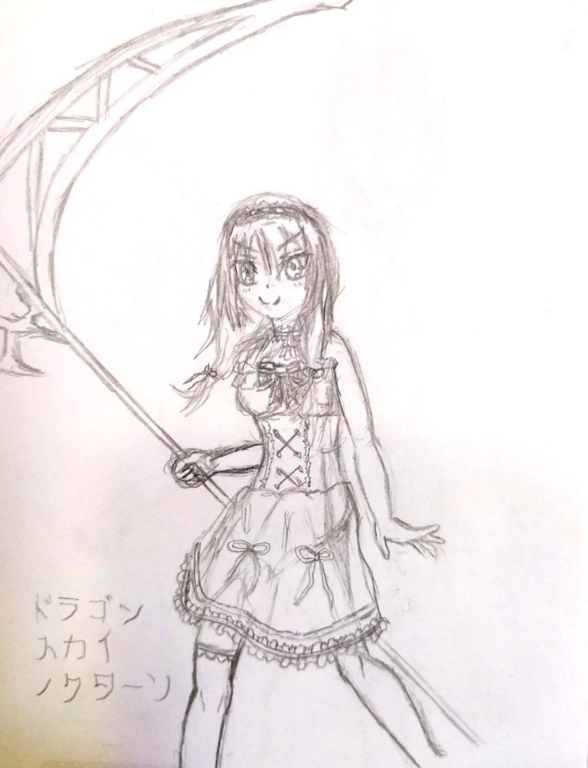 | Name | Mikoto | Tittle | Death
 | Weapon
 | Sword | Muramasa |  | HP +
 | Axe | Death Scythe |  | ATK ++
 | Seal Stone | Death Stone red |  | DEF +
 | Bow | Shinigami Arc |  | SPD -
 | Staff | Last Wish |  | RES -
 | Nat Mag | Heaven'll whell
 | Neg Mag | Reaper's Touch
 | Main | Death Scythe | Purpose | Prevent others from suffering the same as she did in the past.
 | Fear | Fire
 | Fear | Church
Fonte: Desenho e ficha técnica feitos pelo autor
Quadro 3: Ficha Técnica Kurumi
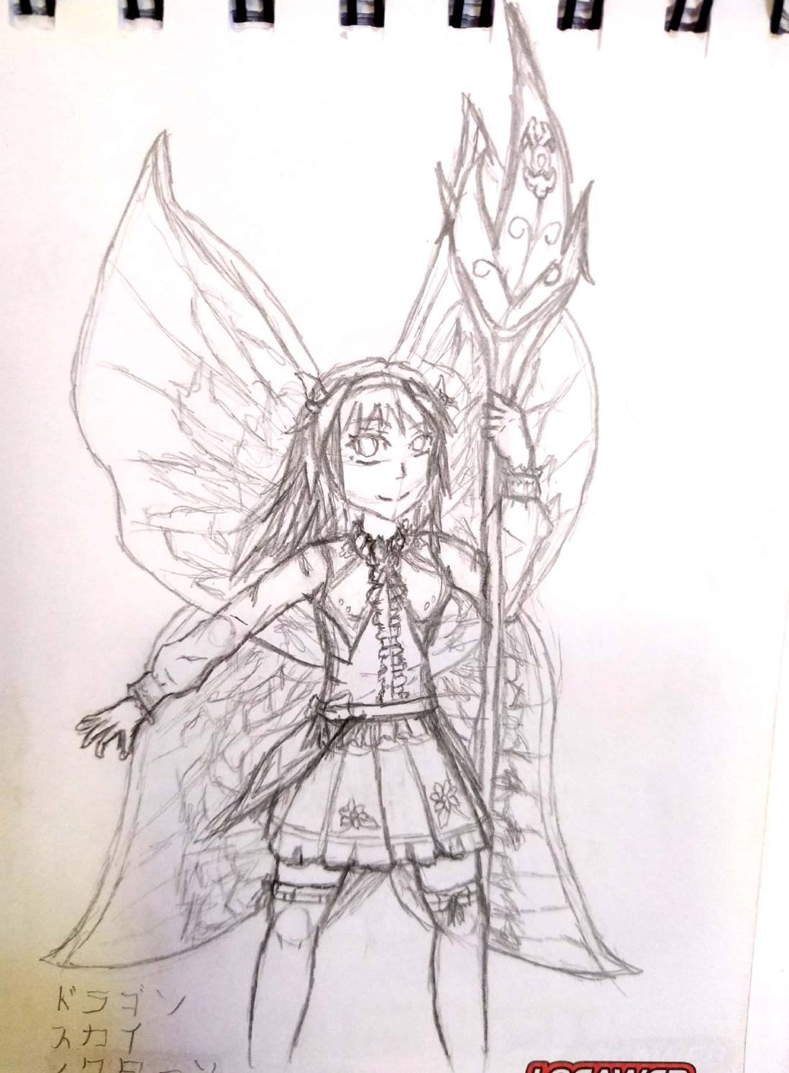 | Name | Kurumi | Title | Queen of fairies
 | Weapon
 | Sword | Fairy Sword |  | HP +
 | Lance | Titania's spear |  | ATK ++
 | Arc Mag | Fairy Magic |  | DEF -
 | Bow | Uranu's moon |  | SPD -
 | Staff | Fairy Blessing |  | RES ++
 | Nat Mag | Summer Memory
 | Main | Titania's spear | Purpose | Prevent others from suffering the same as she did in the past.
 | Fear | Fire
 | Fear | Church
Fonte: Desenho e ficha técnica feitos pelo autor

Quadro 4: Ficha Técnica Lia
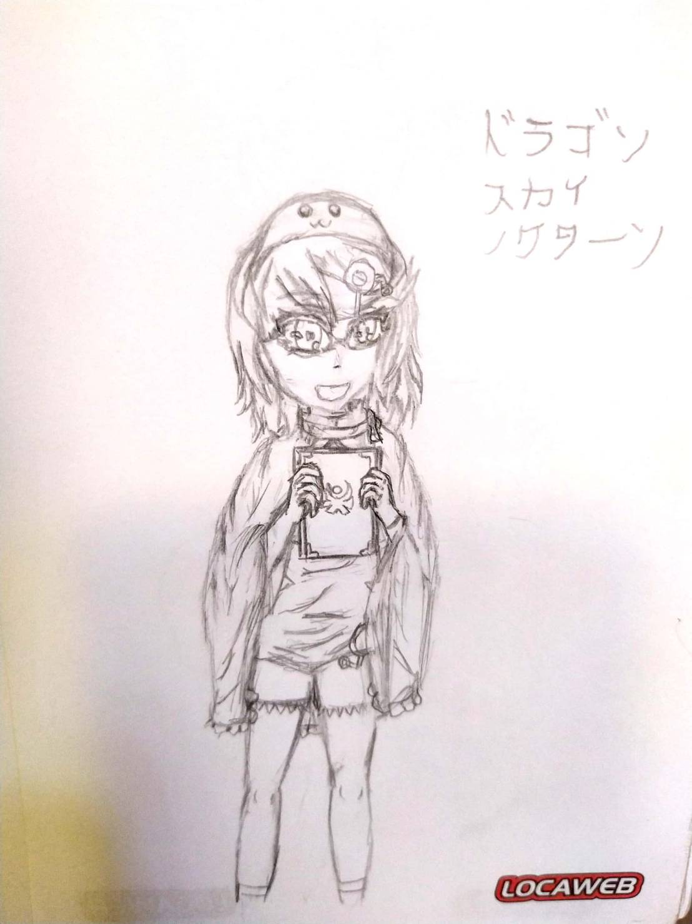 | Name | Lia | Title | Teru Teru Bozu
 | Weapons
 | Arc Mag | Teru teru blessing, Human wish |  | HP
 | Nat Mag | Weather's Call |  | ATK ++
 | Nat Mag | Last Wish |  | DEF --
 | Staff | Umbrella |  | SPD +
 |  |  |  | RES ++
 | Main | Weather's Call | Purpose | Perform your task as teru bozu under the training of your master
 | Fear | Alone
 | Fear | Death
Fonte: Desenho e ficha técnica feitos pelo autor

Quadro 5: Ficha técnica Anabel
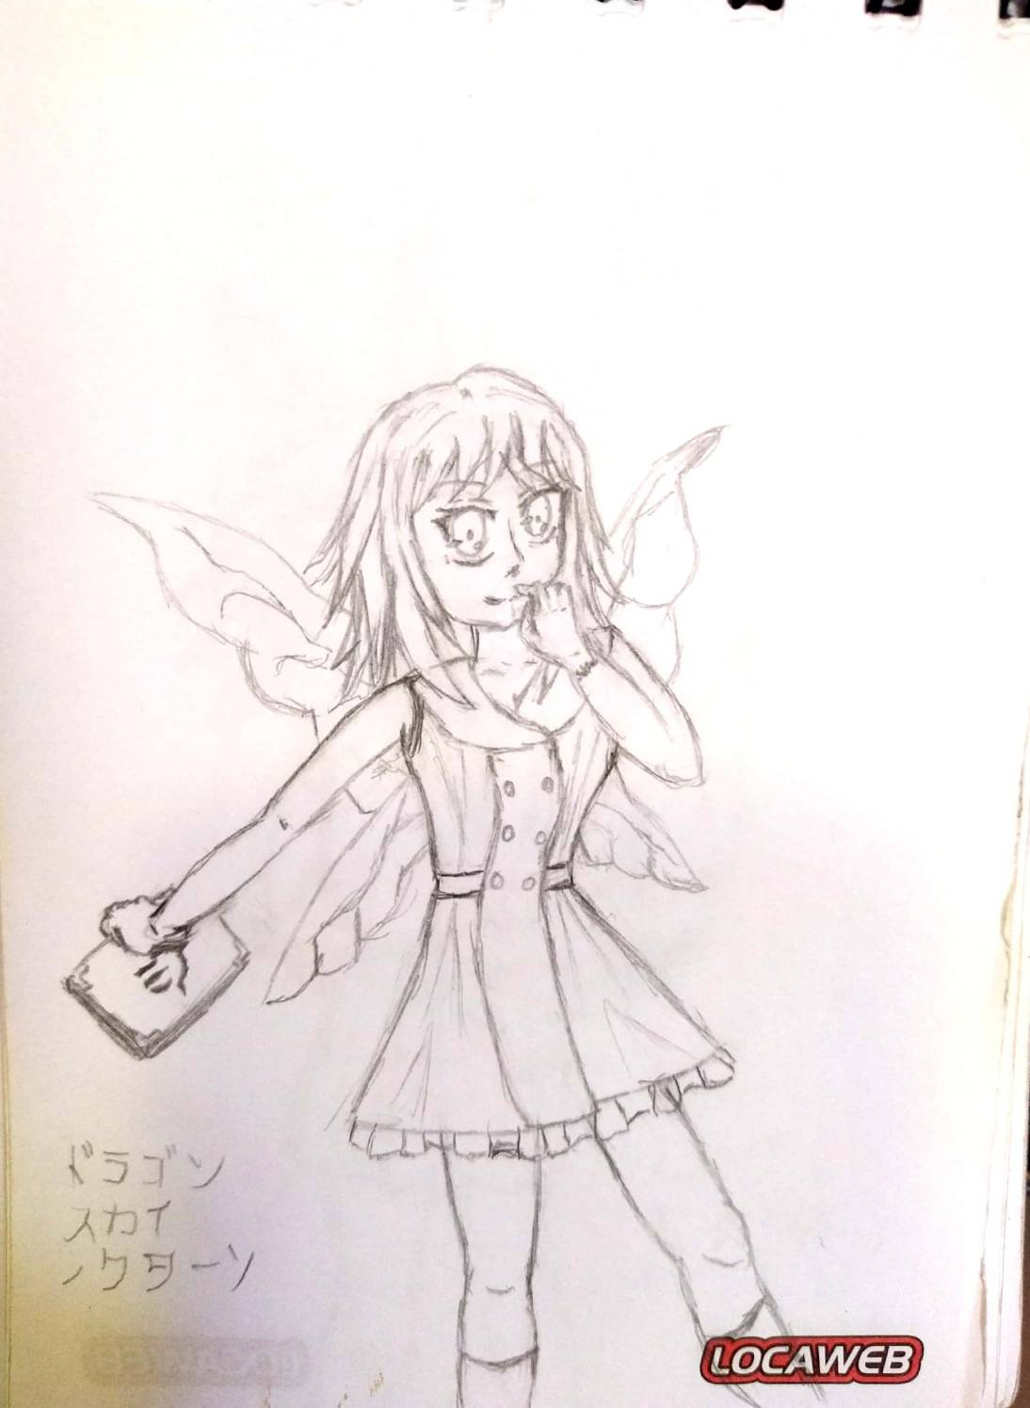 | Name | Anabel | title | Fairy Queen's Right Hand
 | Weapon
 | Sword | Graywandir, gambanteinn |  | HP
 | Nat Mag | Nature Wishes, Fairy Heart, Grace of Titania |  | ATK +
 | Dagger | Whisper |  | DEF -
 |  |  |  | SPD ++
 |  |  |  | RES ++
 | Main | Nature Wishes | Purpose | Help titania to protect the remaining guardians
 | Fear | Curses
 | Fear | Church
Fonte: Desenho e ficha técnica feitos pelo autor
Quadro 6: Ficha técnica Aqua
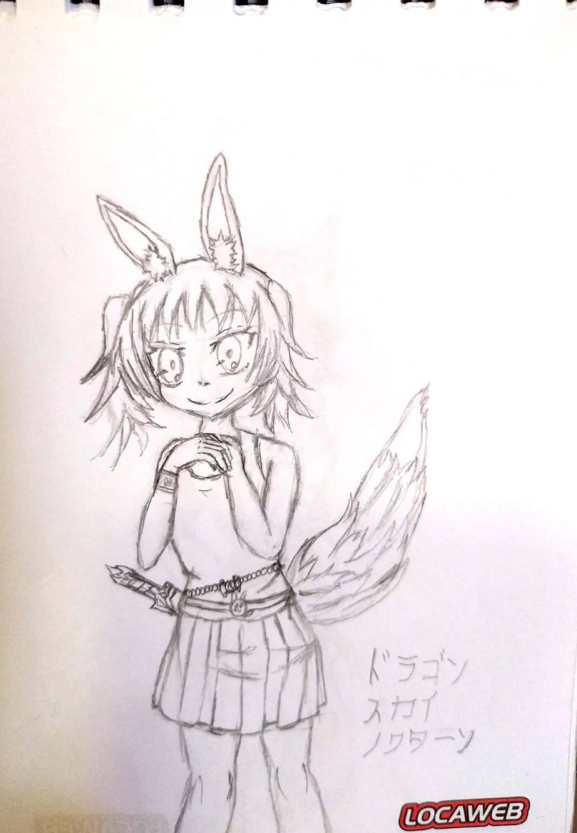 | Name | Aqua | Título | Spirit of a cat rabbit
 | Weapon
 | Sword | The Claw |  | HP ++
 | Nat Mag | Grace of Nature, Bless of cat rabbit |  | ATK +
 | Neg Mag | Records of Guardians |  | DEF --
 | Arc Mag | Spirit of cat bunny |  | SPD ++
 | Dagger | Knife of spirits |  | RES
 | Bow | The huntress of Artemis
 | Main | The huntress of Artemis | Purpose | Helping Artemis to create a more peaceful and just world
 | Fear | Curses
 | Fear | Water
Fonte: Desenho e ficha técnica feitos pelo autor

Quadro 7: Ficha técnica Artemis
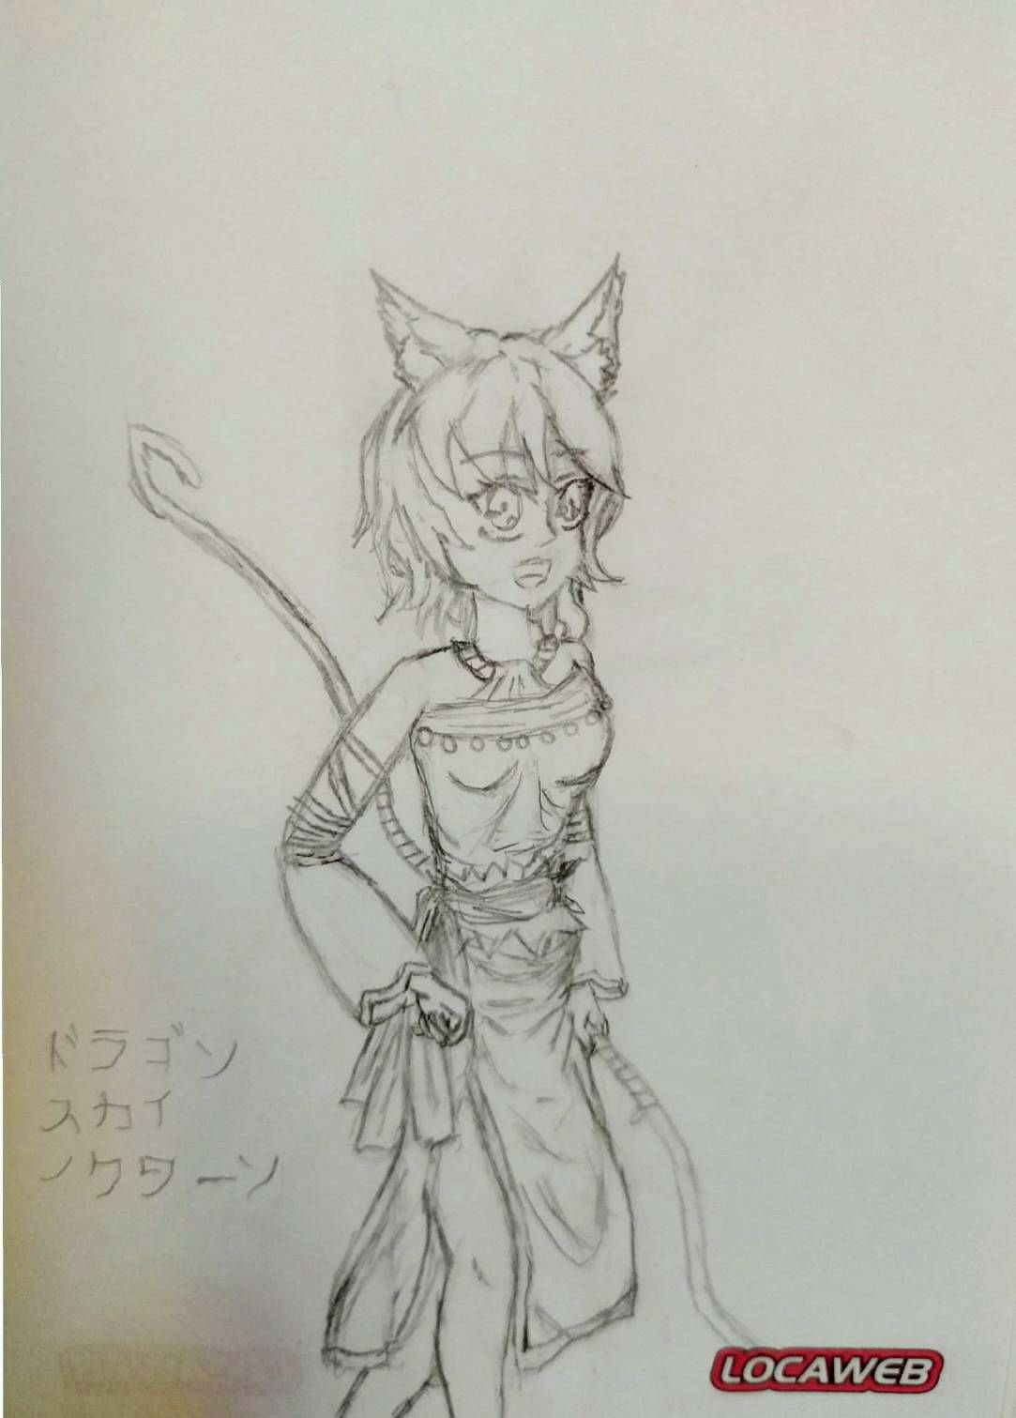 | Name | Artemis | Title | Moon goddess
 | Weapons
 | Sword | Daughter of Moon |  | HP +
 | Arc Mag | Moonlight |  | ATK ++
 | Bow | The Huntress, Moon Bow |  | DEF -
 | Dagger | Peace Seeker |  | SPD ++
 |  |  |  | RES -
 | Main | The Huntress | Purpose | Creating a Better World
 | Fear | Hera
 | Fear | Male gods
Fonte: Desenho e ficha técnica feitos pelo autor

