Project’s Name:
World’s Tale

Author:
Eric Xavier

Gameplay Style:
Simulation, RPG e Strategy

Brief of the Game’s Story:
Follow the story of the characters and pick the best decision your belive be the best for the character, while you keep in mind each choice can change the flow of the battle, and of the events whose gonna happening on the progression of the story, like unlock a weapon, a skill or another character for your army, as the continuation of the game, the player will enter in combat, where he need the best strategy to lead his army to guide for the victory, to win the battle, the player need to complete the mission gave on the start of the battle or conquer the enemy base.

Main Details of gameplay:
- Choose the options of actions, where can change the flow of the missions or story
  - As the story to be told to the player by using images and text, sometimes it will happen where 2 options will show for player to chose, where they can mean an action on the story or be a speech of the player avatar, sometimes the options can be an option to change the flow of the story whose is being telling to the player until now;
  - Some battles can have something like kind of event whose allow to change the flow of the battle, IE: there an enemy character becoming your ally on the battle, or avoid to kill an enemy and later he become the player ally, or mission for be fulfilled and as a reward give the player a weapon or unlock a side story;
  - Some of the actions can happen when the story is being told for the player and with the player can pick any of they and the actions can actually generate an event on the battle where can make more hard or easy, but is possible to unlock side stories for the player be able to play it.
- Evolution of the characters:
  - Each character gain experience points after a battle, even if the battle ends with the enemy not being defeated, the player char will receive a little of experience points, and in case of the battle being a victory for the player character, he win more experience than a draw on the battle, allowing the character raise his level and winning points on his stats and skill points;
  - Each character will have his own skill tree and the player will have the total freedom on chose what skill he want for that character will have it;
  - Using the gatcha mechanic, the player will gain passives skills to equip in your characters to the due of need it or the strategy for the battle.
- Pick the best skills for the battles:
  - The player need to use the skills of character or passive to help on the battle, because it can help to increase the damage on the battle or cause damage on nearby enemies or be used to generate buff or debuff;
  - For that the player need to equip your characters with the skills he believe be the rights one to help him to reach the victory on the battle.
- Protect your base and conquer the enemy’s base or fulfill the conditions to clear the battle:
  - With the idea to avoid the defeat, the players must plan each character must move, each skill will use it, how to stop the advance of the incoming enemy, by moving the your army in strategics points on the map, thinking on how to achieve of the victory.
- Plan every action of your army:
  - The player will have all freedom he wants to build and place on the best place where you think will be best spot for your strategies;
  - Use the passive’s skills and the skill tree to defeat the enemies or do a huge damage to the enemy unit;
  - Use healing’s skills or raise your units status or decrease the enemy units status to make the battle more easy the battle and increase the probability of surviving of the army when it become the enemy turn.
- Follow the story of the game:
  - Read the story who is being telling and see images whose tell the about what is happening about the moment the player is following;
  - Unlock side stories to know more about the universe of the game and unlock more ways to increase and upgrade your army or change the flow of the story being told.

Target market:
The game is focused for a long range of ages, it is for teenagers to adults, where they want to play a game with a focus on create strategies and management of resources on a fantasy story where include religion and myths of the world.

Similar games:
Fire Emblem’s series, Bomberman Wars, Advance War, Xcom, Xadrez, Mario Rabbids Kingdom Battle, Final Fantasy Tatics, Skycraper, Disgaea’s series, Alchemist

Story:
Since from dawn of times, it existed an equilibrium among humans and guardians, and searching for power for the purpose to rule the world, and some of this selected humans was capable to acquire this power, reaching to the level of divines and that specific group of people start to leading the human’s army, and with that the started the slaughter of the guardians, calling they as monsters, and due this new power humans turned the tables of the game for they favor, killing, sealing and destroying the guardians, without a way to survive on same reality, the guardians had to run away sealing the way of humans enter on limbo where was the place the Goddess’s key was hide and protect from humans to not allow they get the key who would allow to rule the world, with the past of the years the hunt didn't stop, many guardians was killed with humans believing that would gave they access to Limbo, seeing the desperate situation the guardians reached, the Goddess as her dying act decide to reincarnate the soul of the dragon who the Gods most fear of it, in a human body awaiting to the millennial war finally end.

Mecanics:
- Player will get new characters on the way he advance on the story;
- The characters whose the player have it are classified as guardians, spirits;
- A spirit isnt playable until be summoned by a guardian;
- 1 Guardian can summon to 4 spirits, but 1 by turn, if the guardian be defeated the spirit will be removed from the battle until be summoned again;
- Guardians who are equipped with a spirit, it have his status raised;
- On the story it will happen events where the player need to chose an action who he prefer to do, that action can change the flow of the battle or the story being told;
- The player will chose a model to be your avatar to be playing, that avatar will allow the player assume the role of strategist of the player’s army and will have participation on the story and the battles;
- All characters have more than 1 weapon class;
- The battle follow the rule of rock, paper, scissors, in other words, 1 weapon have the advantage against 1 type of weapon, but is weak to another type of weapon;
- There 4 class of weapons, the red class is a joint of swords, arcane magic and red seal stone, the blue class is a joint of lance, black magic and blue seal stone, the green class is a joint of axe, nature magic and green seal stone, and the gray class where is a joint of bow, staff and daggers;
- Each unit is divided with movement class where exist infantry whose walk 5 spaces, but when enter on jungle or ruins it loses 2 spaces of movement, cavalry whose walk 8 spaces, but when enter on jungle it lose 3 spaces of movement but it cannot enter on ruins, fliers whose walk 6 spaces and doesn’t have penalty on enter in space with some structure like jungle or ruins and the heavy infantry whose walk 3 spaces and when enter on jungles or ruins it lose 2 spaces;
- A unit can change your weapon before the action of attack, and will stay with it until the end turn of the opponent, unless a unit with a skill who allows another unit to move again, so the unit can attack again and chose another weapon if the player want;
- the weapon change system can be only used before of a use of magic or attacking, after that the unit will become unable to make a new movement until the next turn or if the movement skill be used;
- A unit with a skill who allows another unit move again cant be used to make another unit move if the other unit have a skill with the same effect equipped;
- An attack or magic can be only used only when an enemy is on the range of the attack zone, whose is located until the limit of movement zone;
- Attacks are divided in short range and distant, being magic type only classified as long range attack only;
- The magic skills have a longer range for strike and can hit more than 1 enemy unit just like the healing skills;
- Healers use heal due the staff, but the target must be on the heal zone, whose is located until the limit of the steps zone of the unit;
- Each unit have his own skill tree;
- Every unit have 6 slots for external skills;;
- The player can win external skills or summon then using battle points;
- When used an external skill, the player lose one from your bank, with that in mind the player can have a lot of the same skill;
- The external skill are divided in 4 types, movement, buff, debuff and construction;
- The player can pick the external skills he desire for a unit before the battle start or let it prepared, because the configuration is saved from battle to battle;
- When a unit change his weapon there a chance for the unit type of movement be change as well, as sample when an infantry change his weapon for a heavy weapon then that make his movement type become a heavy infantry type;
- In the story, there a chance of an event picking an option, where it need for the player to pick one of the options, and that options can be change the way of the battle or the story;
- In the battle, it can happen for the player need to interact with his allies, enemies or scenery, it can change the way the battle or the story is going;
- To win, the player need to defeat all the enemies in his turn or destroy all enemies headquarters, and the same condition can be happen to be the player defeat as well;
- All units who was defeated in a fight it will return after 4 turns to the headquarters of his army;
- Each headquarters recharge 10 of hp of the unit who is in the headquarter or near of it;
- The headquarters allow a unit to teleport from another headquarters who belongs to the army of the unit, but for it the spaces surround the headquarters must be not occupied by an ally or an enemy, that happens with the enemy as well;
- When a unit declare an attack to a headquarter, the unit who made that action cannot do another action on the same turn and the headquarters will lose 1 hp of the total capacity of hit, the damage caused on the headquarters cannot restore the damage, when the hp become 0 the headquarters will become to the same army as the unity who destroyed;
- If a unit of the player be defeated in field, the same have a countdown for his return to battle, if the player win the battle, the unit will be fallen until the end of the countdown he was one the past battle.
- The units have energy and gain experience when they defeat an enemy, in case it didn't finished the unit will receive a small part of the experience, in case of healers, they will get experience when it heals as well;
- The units have a fear system, where they find the condition in field or battle, the unit will act different from the expected, as sample if the unit have a problem with light, and the unit be attacked by an attack of the light type, the unit will not be able to counter it;
- The units have 5 attributes who make him, they are HP whose indicate the unit life, ATK who is the attack points, DEF who is the defense points, SPD who indicate the speed point, RES indicate the resistance for magic attacks;
- The calculation for the battles have 2 categories, and the formulae for the damage calculate follows next:
  - Physic:
    - (Unit Atk * Skill * WT) – Unit Enemy Def
  - Magic:
    - (Unit Atk * Skill * WT) – Unit Enemy Res
      - Assuming this values for Skill:
        - Vantage = 1,2x
        - Neutral = 1x
        - Disadvantage = 0,8x
      - Assuming this values for Weapon Triangle(WT)
        - Vantage = 1,5x
        - Neutral = 1x
        - Staff = 0,5x

Game play:
The player can chose between 2 type of avatars to represent they on the story, and the player will choose the initial equipment for the avatar, along side for some of the units for his army.
The game will tell the story with text, and some times images or video will help to tell the story to allow the player to know about what is happening, and will happen to the player need to pick an option to choose to determinate what will happen on the story/battle, as sample if the player decide it to help someone who showed on the story it will get some events who allow to jump to final fight on th chapter, if not it will bring to a fight where need to help a NPC but the it will have less HP due the player took more time to get there unless if the player had chosen to help from the begin of the story the npc would have the full HP bar on that battle. Sometimes the player may need to use a unit to interact with some character on the battle field.
As batalhas do jogo funciona da seguinte maneira o jogador deve guiar uma unidade de um ponto “A” até o ponto “B”, sendo que este ponto “B” pode ser um local, um inimigo, uma base, etc, para locomover uma unidade o jogador deve selecionar uma unidade, ao selecionar a unidade vai carregar a quantidade de passos que está unidade pode andar, sendo que a quantidade de passos pode sofrer decréscimos de acordo com o campo em a unidade se encontra, os tipos de classes podem ser verificados na tabela de movimentação das unidades(Quadro 1).

Classe | Número de Passo | Florestas | Bases ou Ruínas
Infantaria | 5 | 3 | 3
Infantaria pesada | 3 | 1 | 1
Montaria | 8 | 5 | 0
Alados | 6 | 6 | 6
Quadro 1: Movimentação das Unidades

Ao final da área de passo é encontrado a zona de ataque, e cada ataque uma distância requirida para o ataque ou o contra ataque seja realizado e seguindo a regra de jogo de papel e tesoura cada arma pertence a uma classe e que essa classe possui vantagens sobre uma classe e fraqueza sobre outra classe, onde pode ser verificado na tabela da zona de ataque das unidades(Quadro 2).

Classe de Armas | Tipo de arma | Zona de ataque | Tipo de Ataque | Fraquezas | Vantagens
Vermelho | Espada | 1 | Físico | Azul | Verde
Vermelho | Magia Arcana | 2 | Magico | Azul | Verde
Vermelho | Seal Stone | 1 | Magico | Azul | Verde
Azul | Lança | 1 | Físico | Verde | Vermelho
Azul | Magia Negra | 2 | Magico | Verde | Vermelho
Azul | Seal Stone | 1 | Magico | Verde | Vermelho
Verde | Machado | 1 | Físico | Vermelho | Azul
Verde | Magia Natural | 2 | Magico | Vermelho | Azul
Verde | Seal Stone | 1 | Magico | Vermelho | Azul
Cinza | Arco | 2 | Físico | Não se aplica | Não se aplica
Cinza | Cajado | 2 | Magico | Não se aplica | Não se aplica
Cinza | Adaga | 2 | Físico | Não se aplica | Não se aplica
Quadro 2: Zona de Ataque das Unidades
O jogador pode realizar a troca de arma equipada em sua unidade enquanto sua unidade estiver disponível para movimento ou antes de atacar, para isso o jogador vê o menu onde indica equipamento, ao acessar ele poderá escolher que arma disponível em seu menu, sendo que uma unidade pode ter mais de um tipo de arma da mesma ou diferente classe, e que algumas unidades sofrem uma mudança em sua classe de movimento (quadro 1).
As lutas só ocorrem entre uma unidade do jogador contra uma unidade do NPC, sendo assim não existe a possibilidade de ter 2 unidades lutando ao mesmo tempo contra uma apenas, sendo assim ao término de uma batalha, outra unidade pode a vir batalhar com a unidade anterior que estava sendo atacada.
Além de atacar as unidades em campo, existem bases para serem atacadas, sendo assim uma unidade pode atacar uma base se a mesma não estiver ocupada por uma unidade inimiga.
As condições para a vitória da luta se leva ao fato de que o jogador deve destruir todas as 3 bases do inimigo, ou se capaz de derrotar todas as unidades do adversário antes delas retornarem para a batalha novamente.
Ao término da batalha o jogador recebe pontos de batalhas, onde elas podem ser utilizadas para realizar summon de skills.
As skill são cumulativas, pois quando utilizadas em batalha será retirado do inventário do jogador, sendo que certas skill não pode ser possível de ser equipada em algumas unidades devido que elas não se encaixa na classe da unidade equipada.
Ao participar da batalha ou vencer a unidade ganha experiência para passar de nível, quando a unidade passar para o próximo nível seus status vão aumentar automaticamente, porém o jogador poderá escolher qual habilidade ele vai adquirir na árvore de habilidades do personagem.

Hardware:
Para o funcionamento do jogo, é necessário que o jogador possua um smartfone com o sistema operacional Android 4 ou maior ou ter um Iphone 6 ou maior para o funcionamento do jogo.

Controles:
Devido ao desenvolvimento do jogo ser para smartphones, tudo que é necessário é de utilizar os dedos do jogador para selecionar os componentes do jogo, sendo eles botões, personagens.
O ato de pressionar é utilizado para selecionar ou apertar um botão, como exemplo o jogador apertar o botão de magias para abrir a lista de magias, ou apertar uma unidade no jogo para poder realizar um movimento no personagem selecionado.
O ato de deslizar é utilizado para percorrer listas, como a lista dos capítulos passados ou a lista de magias ou percorrer a árvore de habilidades do personagem.
Ao selecionar um personagem o jogador deve apenas arrastar na tela o ponto onde quer posicionar o personagem no mapa ou arrastar para um inimigo para poder iniciar o combate.

Câmeras:
Somente o modo de batalha apresenta a função de câmera sendo a mesma vista de cima onde permite ao jogador observar o campo inteiro, sendo que a mesma não é fixa assim tendo que o jogador arraste a tela para poder ver o restante do campo devido o tamanho ser maior que o display do jogador o mostre como mostrado na figura 13. Independente do modo de batalha o contar da história e o menu de seleção possui uma câmera fixa onde apenas os componentes se move, diferente do que ocorre no campo de batalha.

Figura 1: Campo de batalha
Fonte: Próprio
Personagens:
Os personagens que o jogador vai poder interagir e controle são divididos em 3 tipos raça, Guardião (monstros), Espíritos e Deuses (Deuses e semideuses).
A única diferença para a questão dos inimigos é que uma nova raça é acrescentada os Humanos, por questão de enrendo da história essa raça é uma seguidora fiel dos Deuses que visam a supremacia humana, uma visão diferente do objetivo que o avatar busca em criar.
Os guardiões são criaturas misticas ou mitológicas conhecidas pelas diversas culturas, onde é uma raça utilizada tanto pelo jogador quanto pelo inimigo, mais ambas são chamadas de guardiões e pelo inimigo será chamado de monstros, no quadro 3 é pode ver qual a raça e o status de um guardião que será controlado pelo jogador.

Quadro 3: Ficha Técnica Eric
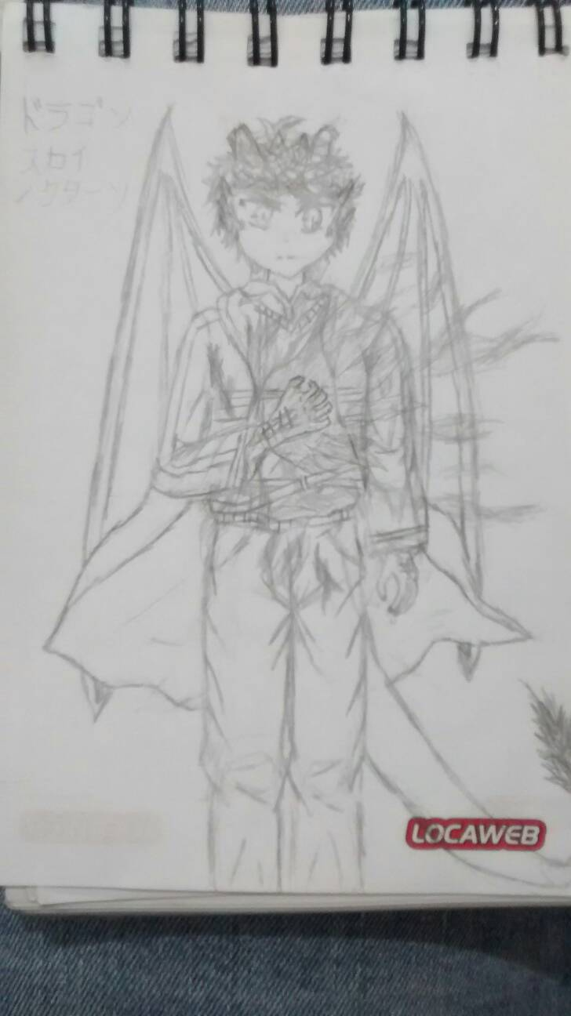 | Nome | Eric | Título | Reencarnação do Dragão
 | Armas
 | Espada | Murasame, GrandArk, Excalibur |  | HP
 | Machado | Soul Synphony |  | ATK +
 | Seal Stone | Dragon Stone blue |  | DEF +
 | Arco | CaladBorg |  | SPD ++
 | Adaga | Sekki, Dark Ruler |  | RES --
 | Mag Nat | Ice
 | Mag Neg | Soul, Ice Stxy
 | Principal | Murasame | Proposito | Acabar com a guerra sagrada
 | Medos | Luz
 | Medos | Estar cercado
Fonte: Desenho e ficha técnica feitos pelo autor

Os espíritos são uma raça composta por guerreiros e pessoas famosas vindo de diversas histórias, lendas e mitos que existe na cultura humana, sendo que para eles poderem se manifestar são necessário de uma alma poderosa que os auxilia em estabelecer na realidade física, no quadro 4 temos outro personagem controlado pelo jogador que possui sua origem histórica das lendas Arturianas do Reino Unido.

Quadro 4: Ficha Técnica Viviane
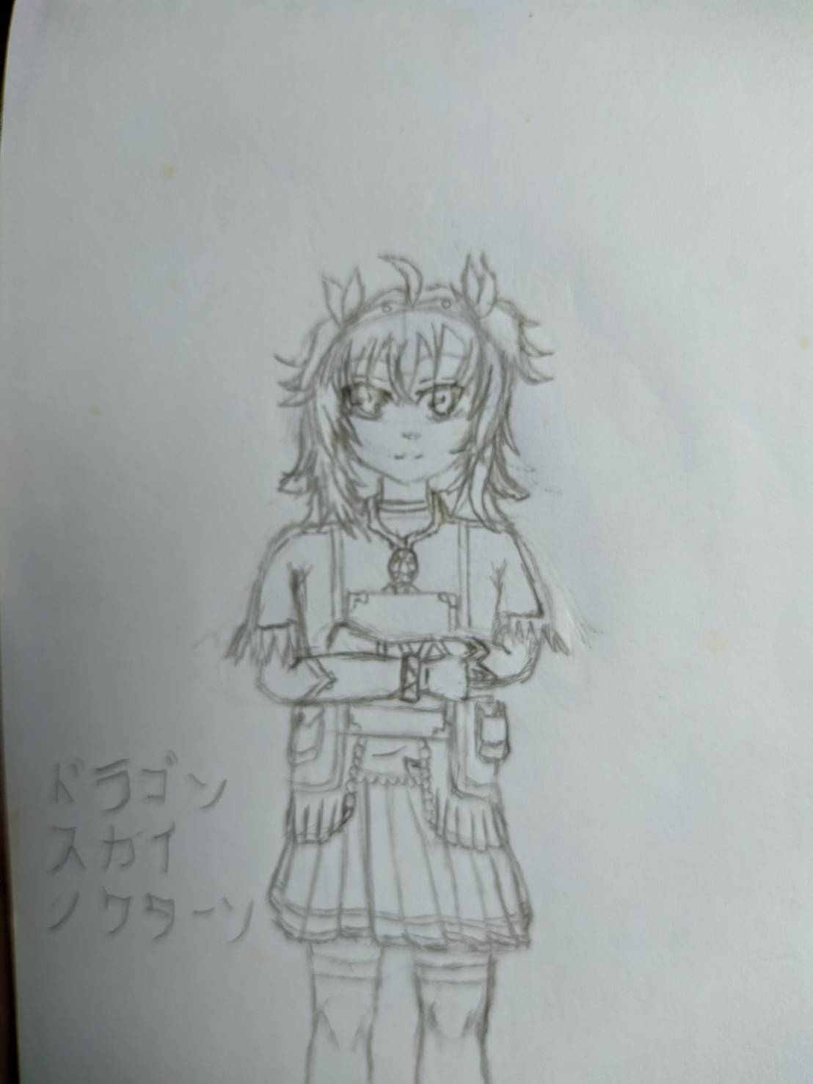 | Nome | Viviane | Título | Dama do Lago
 | Armas
 | Espada | Excalibur |  | HP
 | Seal Stone | Dragon Stone blue |  | ATK
 | Arco | Hunter of Camelot |  | DEF --
 | Cajado | Saint of Camelot |  | SPD ++
 | Mag Nat | Florest of Avalon |  | RES ++
 | Mag Neg | Darkness of Avalon |  | Conexão Espiritual
 | Mag Arc | Light of Avalon |  | Eric
 | Principal | Light of Avalon | Proposito | Acompanhar o caminho criado pelo novo portador da espada sagrada
 | Medos | Igreja
 | Medos | Cavaleiros
Fonte: Desenho e ficha técnica feitos pelo autor

Já os deuses é a raça que busca a supremacia humana em toda a história, sendo assim boa parte deles é contra a existência dos guardiões o que leva ao fato de serem diretamente o inimigo do jogador, é claro que existem algumas exceções neste grupo distinto e cada ao jogador ser capaz de liberar os eventos necessários para permitir liberar ele para o seu exército, no quadro 5 se encontra a ficha de uma deusa que pode ser liberada para o exército do jogador no caso que o jogador consiga liberar Amateratsu no seu exército, caso o jogador não tenha conseguido obter o que é necessário para desbloquear, ele terá mais chances para obter, isto é se eles estiver com as conquistas necessárias para poder adquirir.
Tabela 5: Ficha Técnica Sakuya
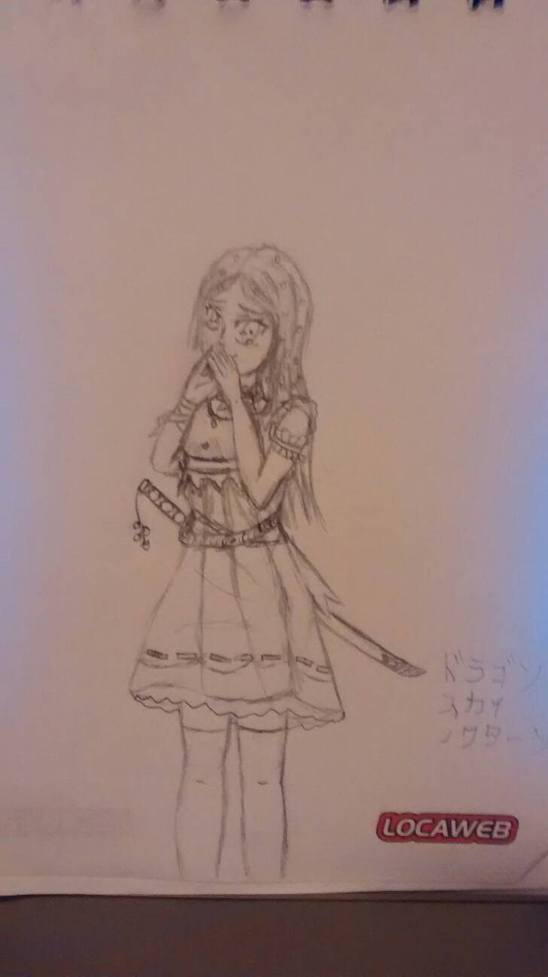 | Nome | Sakuya | Título | Deusa das flores de cerejeiras
 | Armas
 | Espada | The beauty of sakura, Fuji relic |  | HP -
 | Mag Arc | Fuji Energy |  | ATK ++
 | Mag Nat | Sakura Blizzard, Chinka Taisai |  | DEF -
 |  |  |  | SPD ++
 |  |  |  | RES +
 | Principal | The beauty of sakura | Proposito | Seguir Amaterasu para mudar o mundo
 | Medos | Gelo, neve
 | Medos | Fogo
Fonte: Desenho e ficha técnica feitos pelo autor

Os humanos no jogo é apenas para gerar maior volume no exército inimigo, sendo assim não vai ter algum humano relativamente importante no jogo, pois todos vão possuir um status mais equilibrado com o do jogador para dar equilibro na batalha, das classes existentes no jogo, os humanos são a única raça que o jogador não poderá jogar ou liberar.

Ações dos Personagens:
- Andar:
  - Sendo que a visão da câmera é por cima então é afirmado que a movimentação segue as 4 posições cardiais, não sendo possível andar em diagonal devido ao campo ser dividido em quadrados como no xadrez;
- Atacar:
  - Para atacar, o personagem necessita encontrar o inimigo no limite da sua linha de movimentação como demonstrado no Quadro 2;
- Skills:
  - Para utilizar skills o personagem necessita possuir ela habilitada e verificar se o inimigo se encontra na linha de dano, sendo que essas skills podem ser utilizadas ao redor do personagem ou mais distantes;
- Invocar:
  - Personagens com um espírito alocado como parceiro pode usar a invocação para trazer eles em campo;
- Troca de Arma:
  - Se os personagens possuírem mais de uma arma liberada, eles podem trocar antes de entrar em combate;
Todos os movimentos são utilizados pelo jogador e pela IA sem distinção, se os personagens selecionados tiverem com as condições corretas para executar.

Cenários:
Ao conhecer um pouco sobre os personagens já permite ter uma noção que o jogo se passa no planeta Terra, em diversas cidades, templos, regiões, devido a ideia do jogo, pois pode ser dividido em 2 dimensões a dimensão física onde humanos habitam e a mais abundante no jogo.
Na dimensão física o jogador estará inserido a entrar em cidades, batalhar nelas e encontrar alguns inimigos e futuros aliados, pois parte da história ocorre na dimensão física, pois apesar de os deuses controlar o mundo, os deuses não arriscariam em destruir a humanidade que lhe gera a fonte dos seus poderes, sendo assim os mesmos interagem para adquirir mais seguidores e construírem mais estátuas e templos (figura 14) para aumentar sua influência e serem mais louvados, assim podendo ocorrer um encontro em qualquer parte do globo terrestre, como exemplos, cidades, florestas, ruínas, mountanhas.
Figura 2: Exemplo para realidade física: templo
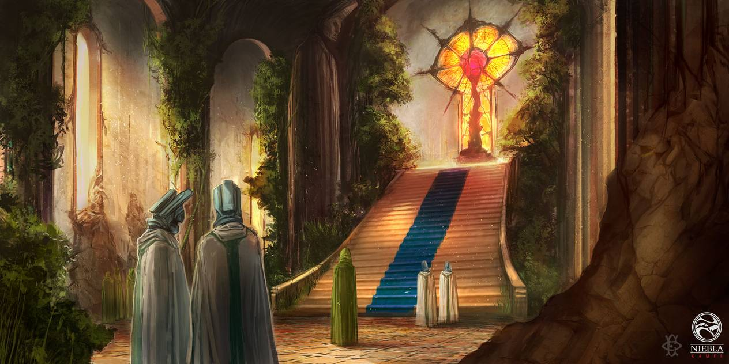Fonte: https://www.deviantart.com/000fesbra000/art/Templo-Voces-del-Ocaso-478163799

A segunda é a dimensão espiritual, ela era a responsável em separar as duas dimensões impedindo a interação entre os espíritos e humanos, devido aos eventos ocorridos no jogo essa dimensão vai ser quebrada fazendo que pequenas partes apenas exista no mundo, alguns exemplos para essa dimensão seria o limbo, reinos divinos, submundo entre outros.
Apesar de fragmentada, a dimensão espiritual é a parte mais perigosa no jogo, pois é o reino clamado pelos deuses de seu território, diversas guerras ocorreram no passado em que fez essa zona que era controlada pela deusa ser fragmentado, antigamente os humanos possuíam grande poder espiritual o que os permitiam entrar e sair dessa dimensão facilmente, sendo assim gerando uma grande guerra entre os deuses e seus seguidores para assumir essa dimensão após o assassinato da Deusa, sendo assim causando a destruição dessa dimensão e sendo separada em diversos reinos que residem os deuses, o limbo (figura 15) que é o local que os últimos guardiões estão escondidos é localizado em uma remota parte do submundo, que é controlado por Hades.

Figura 3: Exemplo para a dimensão espiritual: limbo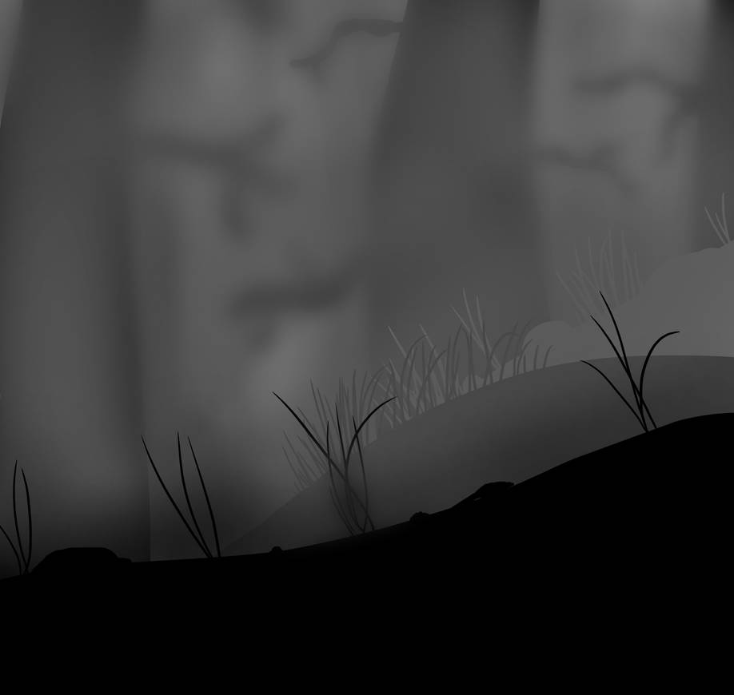
Fonte: https://www.deviantart.com/gentleluger/art/Limbo-esque-Hill-453346781
Apesar dessa dimensão estar fragmentada, os humanos se tornaram incapazes de entrar nesta dimensão devido a perda do poder espiritual, sendo assim para um humano normal entrar nela é necessário que um portal estar aberto, para isso é necessário que alguém com grande poder espiritual e com essa habilidade para poder realizar este feito, para os demais é apenas necessário a habilidade de criar portais ou entrar em uma das poucas partes fragmentadas que estão espalhadas pelo mundo para entrar na dimensão espiritual.

Interface:
Menu principal: o jogo vai compor de uma tela normal com uma frase de aperte para continuar e uma imagem de fundo, ao pressionar o menu principal (figura 16) vai ser carregado, nela vai ter um botão com os capítulos passados e o atual que o jogador se encontra, dentro dele tem mais botões que mostram qual a seção que o jogador se encontra, assim como mostra a seções já feitas pelo jogador.
Na parte inferior se encontra uma barra com alguns ícones, elas são os ícones de summon, personagens e configuração, ao apertar cada um dos ícones o jogador vai ser levado para uma página diferente correspondente ao ícone pressionado.
Figura 4: Menu Principal

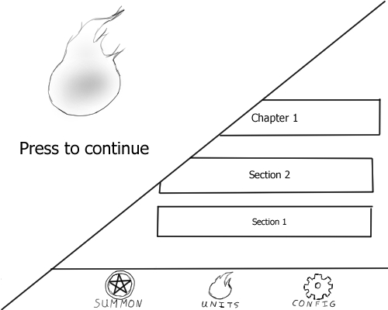Fonte: Próprio

Personagem: Nesta tela (figura 17) o jogador é capaz de ver o personagem selecionado no fundo e suas informações, ao topo da tela tem um botão de um lápis, que quando pressionado permite ver algumas imagens do personagem, com pose de ataque entre outros, abaixo do botão de imagens temos o ícone indicando o tipo de movimento do personagem.
Na parte inferior tem uma placa que contem o nome e o título da raça do personagem, logo abaixo tem uma box que contem o equipamento e as skills de movimento, critico e as passivas, ao lado tem outra box que contem o status do personagem que é descrito na ficha do personagem, e localizado acima da box de status se encontra a box de espíritos aliados.
na parte mais baixa da tela é encontrado uma barra com alguns ícones que vai redirecionar o jogador para a tela respectiva do ícone selecionado, os ícones encontrados lá são a árvore de skills, equipamento e as skils passivas.
Figura 5: Tela do personagem
Fonte: Próprio

Árvore de skills: Nesta tela (figura 18) podemos ver o nome do personagem, e abaixo ícones com skills para selecionar, ao apertar uma box mostra uma descrição sobre a skill selecionada e mostra como pode aprender ela, no topo da tela tem um botão para retornar para a tela de personagem.
Figura 6: Skill Tree
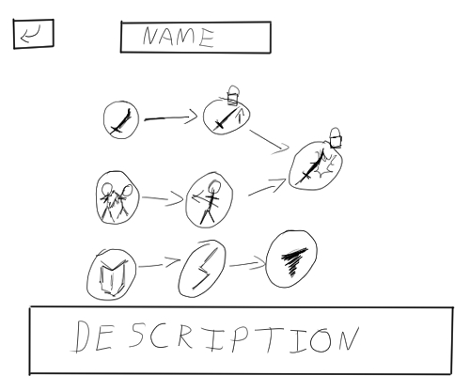Fonte: Próprio

Equipamento de personagem: nessa tela podemos ver o nome do personagem assim como botões com o equipamento, skill de movimento, skill critica, e as skills passivas A, B, C, abaixo delas temos uma box que vai descrever sobre o item selecionado e mostra um botão que permite que o jogador possa escolher em trocar o item selecionado. No topo da tela tem um botão de retornar na tela do personagem.
Figura7: Tela de equipamento
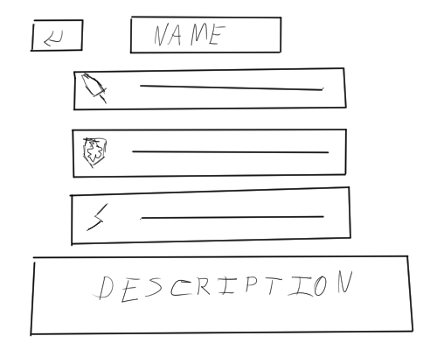Fonte: Próprio

Troca de equipamentos: Nesta tela (figura 20) temos uma box com o equipamento atual e abaixo outra box com os outros equipamentos que o personagem possui aprendido e equipamentos para aprender também, e nelas possuem a descrição e o preço para poder aprender, e no fundo da tela tem dois botões para confirmar e cancelar a ação e no topo um botão para retornar para a tela anterior.
Figura 8: Troca de equipar equipamentos
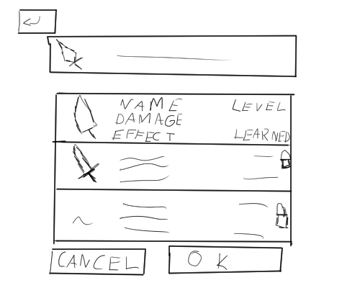Fonte: Próprio

Troca de Skill Passivas: Nesta tela (figura 21) temos uma box com a skill atual e abaixo outra box com as outras skills que o personagem possui equipada e outras skills para ser equipadas, e nelas possuem a descrição e a quantidade que o jogador possui, e no fundo da tela tem dois botões para confirmar e cancelar a ação e no topo um botão para retornar para a tela anterior.
Figura 9: Trocar e equipar skills passivas
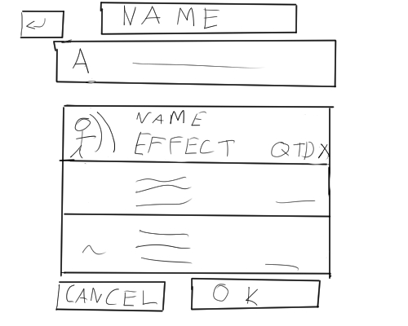Fonte: Próprio
Summon de Skills: Nesta tela (figura 22) é a tela de summon, nela tem um banner com a skills e mostra a descrição de uso das skills com o maior grau de raridade, logo em seguida dois botões com a quantidade de summons que o jogador que fazer entre uma vez ou dez vezes, e abaixo uma lista de todas as skills do jogo, contendo sua descrição também, e no topo da tela tem um botão para retornar para a tela anterior.
Figura 10: Tela de Summon
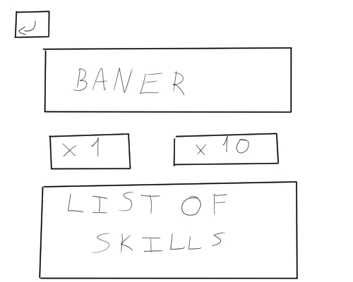Fonte: Próprio

Campo da Batalha: Nesta tela (figura 23) é o campo de batalha do jogo, no topo da tela tem o botão de configuração, o campo é todo quadriculado com alguns elementos de florestas, rios entre outro elemento para indicar que está área pode alterar a movimentação do personagem.
Existe 2 castelos indicando a base do jogador com cada uma com um sigil de invocação dos personagens do jogador.
Na parte mais baixa tem uma barra de menu com os botões de trocar de equipamento, verificar o mapa, ativar uma skill nativa do personagem e invocar um espírito.

Figura 11: Campo de batalha
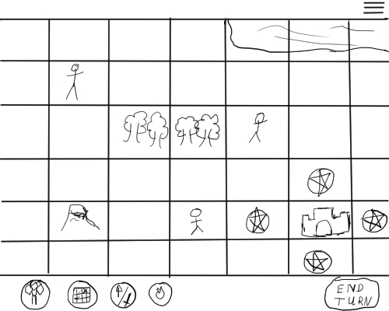Fonte: Próprio

Tecnologia e ferramentas
Animação:
O uso da técnica conhecida como Sprites é utilizada para construir as animações do jogo, está técnica consiste em desenhar um personagem várias vezes realizando um movimento contínuo, então cada desenho o boneco está realizando um movimento, e no próximo boneco o mesmo vai dar continuidade ao movimento anterior e assim sucessivamente até que o ciclo do movimento termine, em outras palavras, se cada desenho fosse colocado em um bloco de folhas e cada folha possui uma imagem do boneco, ao pegar este bloco e passar as folhas rapidamente pode ver que o boneco vai se mexer como em uma animação. Um exemplo da técnica pode ser visto na figura 12, onde pode ver o processo de corrida do personagem X do jogo Megaman X da Capcom.
Figura 12: Sprite de Corrida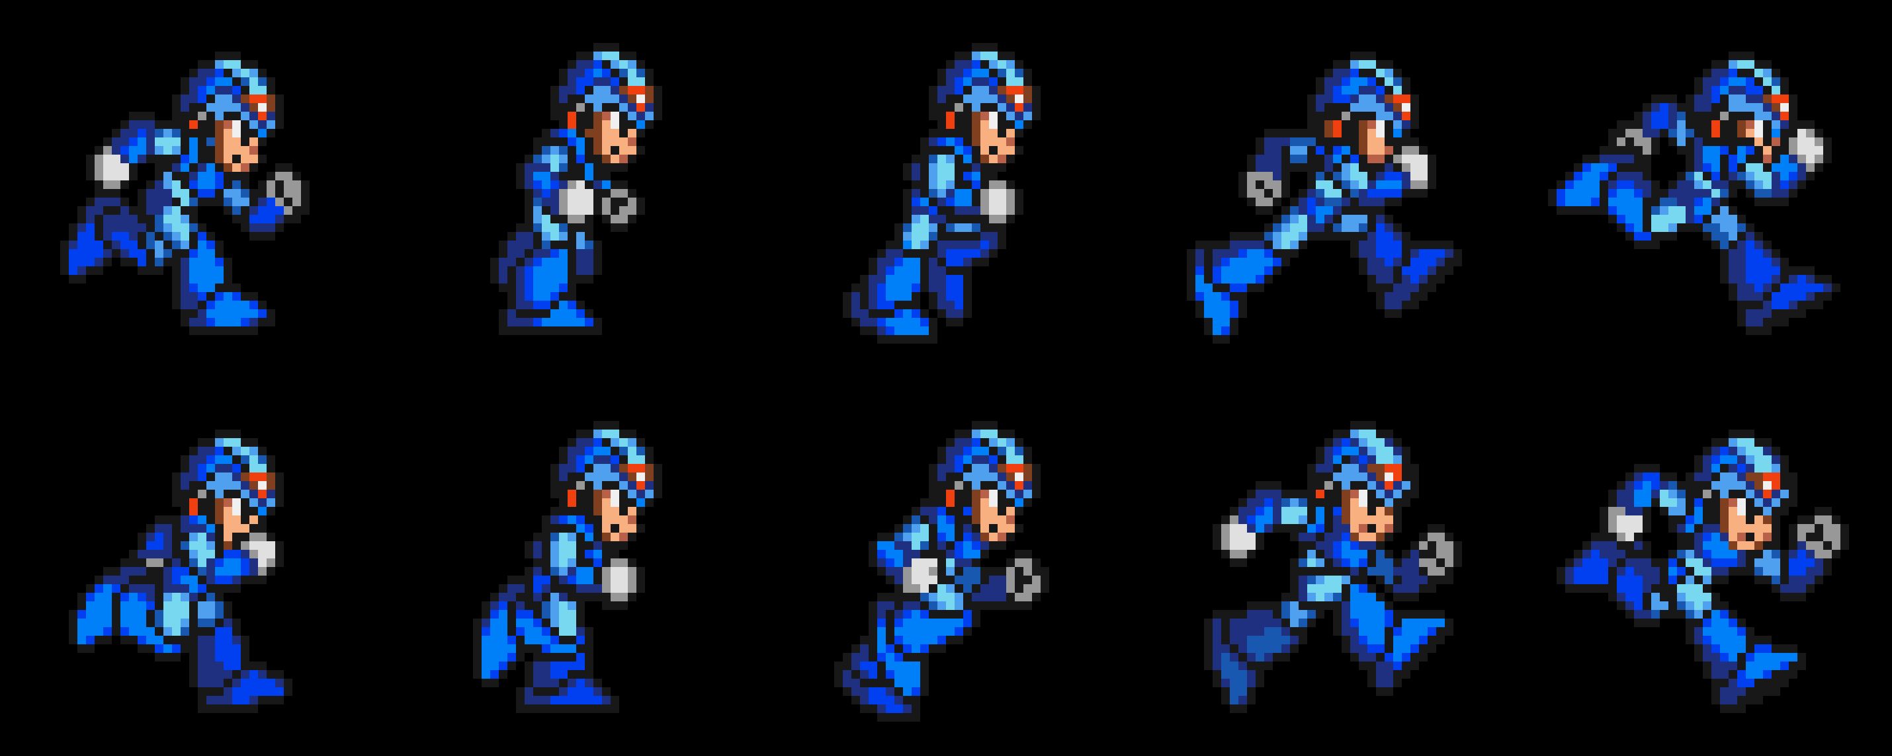
Fonte: https://producaodejogos.com/piskel-guia-para-pixel-art-e-sprites-animados/
Quando está imagem for carregado no software para desenvolver jogos, o mesmo é capaz de reconhecer as propriedades da imagem e gerar a animação corretamente para o jogo, apenas basta que seja programado corretamente no jogo.

Ferramenta de desenvolvimento: Godot
O Godot (figura 14) é um software para desenvolvimento de jogos de código aberto, conhecido como engine, o Godot é uma ferramenta poderosa sendo capaz de permitir aos criadores criarem jogos com gráficos no estilo 2D quanto no estilo 3D, com recursos poderosos para permitir do desenvolvedor criar jogos livremente, sua funcionalidade para criar se assemelha a outras engines famosas como Unreal, Unity, Game Maker entre outros.
Apesar de carregar funções poderosas esta engine é simples, rápida e leve para uma ferramenta com um grande poder para desenvolvimento ao contrário da Unity, que também é uma engine poderosa com vários recursos porém pesada no sentido de memória e processamento. Além de que sua comunidade na internet é extremamente grande, já possuindo muitos materiais para qualquer um poder se aventurar no desenvolvimento de jogos.

Figura 13: Display do Godot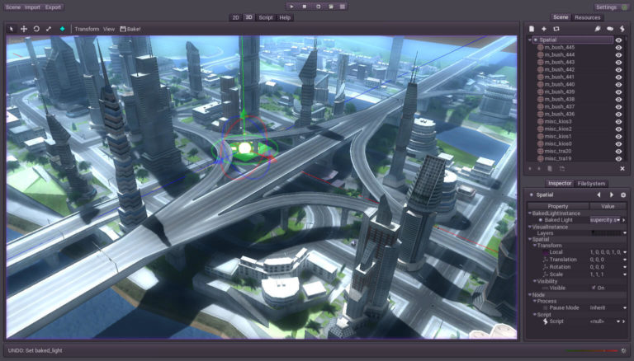
Fonte: https://producaodejogos.com/godot-engine/

Pois para o desenvolvimento de jogos o Godot utiliza de script para desenvolver o comportamento do jogo, diferente de outras engines, que cada cena utiliza pelo menos 1 script diferente assim podendo causar problema ao unir elas, o Godot trabalha de uma maneira diferente, pois ele utiliza um sistema de nós, sendo assim cada cena principal tem um filho gerando subcenas em diferentes arquivos e assim quando as uni-las os mesmos não apresentaram problemas neste processo, pois todos vem da mesma cena mestre.

Musicas
Para os efeitos de áudio, como músicas e sons, será toda provida de bibliotecas gratuitas de sons, sendo assim todos os sons encontrados no jogos, são disponíveis por terceiros de forma gratuita para que alguém utilize em seus projetos, sendo claro que vai depender do tipo da licença do som que está sendo solicitado, assim alguns autores da música pede para ser mencionado no crédito do jogo, a seguir pode se encontrar alguns links acessar as páginas de algumas bibliotecas de sons gratuitos.
- http://soundimage.org/
- http://incompetech.com/
- http://www.freesound.org/
- http://freemusicarchive.org/

Roteiro:
O roteiro tem um grande papel para os games pois auxilia na delimitação dos elementos e conteúdo que vão ser apresentado no jogo, e para este projeto o uso roteiro é utilizado para no auxílio do início da aventura do jogador assim como delimitação dos conteúdos a serem criados e também ajuda a deixar definidos a situação de rotas que o projeto tem definido.
Para criar um roteiro existem várias ferramentas para realizar a construção como exemplo a de resumir a história e depois de definir o resumo, divida o resumo em três arcos, geralmente chamados inicial, desenvolvimento e final, mas a utilizada para este projeto foi utilizada a técnica conhecida como “A jornada do herói”, onde consiste em 12 passos para construir a narrativa do projeto.
Tendo em vista que para criar o roteiro que está disponível a seguir, não foi utilizado todos os passos, pois a história contada até o momento apenas aborda o início do jogo, então ainda não há necessidade de utilizar todos os passos. Os passos utilizados no momento do cotidiano até a recusa da procrastinação, apesar de dar a impressão que pode haver mais passos envolvidos eles não foram apresentados pois o protagonista os outros elementos para compor toda a história, sendo que no momento que foi terminado o final roteiro o protagonista estava chegando no encontro do mentor.

Fonte: https://blog.terapiadebolso.com.br/os-12-passos-da-jornada-do-heroi-representacao-psicologica/
Figura 14: Os doze passos da jornada do herói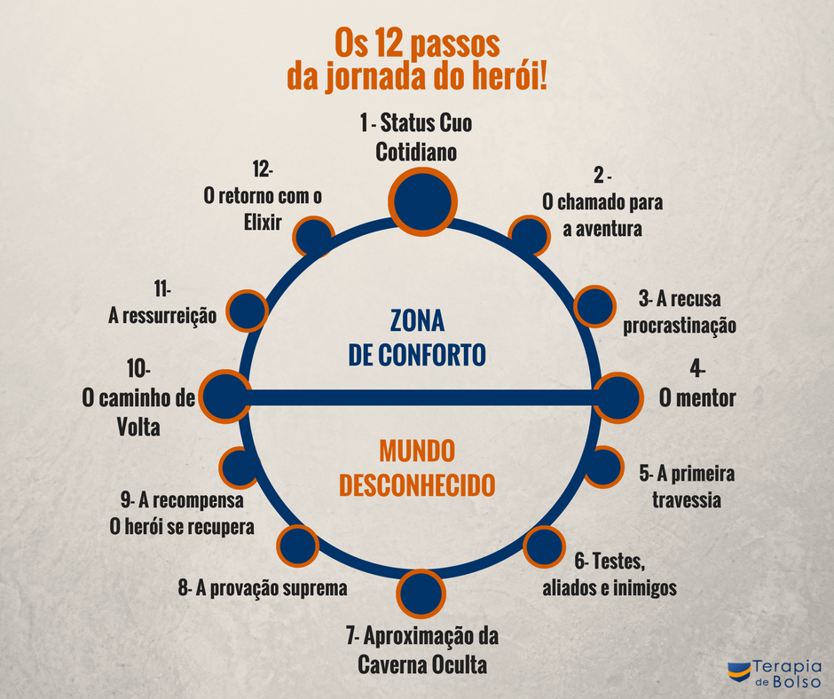
É possível notar que o sistema de escolhas para o jogador pode fazer durante o jogo, e que o mesmo também altera qual a rota que o protagonista vai seguir, assim mudando alguns eventos ou fatos no decorrer da história.

Script para o roteiro:
- Começa contando um pouco do passado e como chegou ao ponto que o próximo receptáculo para a alma da deusa se encontra;
- O começo é no japão, onde o avatar, Eric e Yuzuki estão no japão, quando Eric ouve um som estranho e alto e acompanhado de 2 guardiões, ao perguntar ao avatar sobre o som, Eric e os dois guardiões compreende que o som venho do lado espiritual;
- Ao notificar a origem do som é possível que o som fica mais auto e mostra notícias sobre oque está ocorrendo no mundo mostra que entidades sobrenaturais começam a aparecer no mundo;
- Monstros atacam o grupo onde os dois guardiões estão visíveis a todos, quando uma flecha se direciona ao avatar. Eric protege o avatar, sendo ferido gravemente, assim o Eric projeta a sua alma fora do seu corpo enquanto um dos guardiões o cura;
- A primeira escolha do jogador é feita agora, onde ele escolhe qual das 3 armas Eric vai iniciar, o jogo vai iniciar o tutorial permitindo o jogador usar Eric e um dos guardiões.
- Após essa batalha outra briga vai acontecer, porém o corpo do Eric está curado e vai ficar protegendo o avatar e Yuzuki enquanto a alma de Eric e os dois guardiões batalham contras os inimigos;
- Ao término do combate, os envolvidos na batalha começam a teorizar o que estava ocorrendo, e são questionados pelo avatar e Yuzuki sobre o que estava acontecendo e o que era aquilo que os atacaram, no meio dos questionamentos uma rachadura na dimensão próximo ao local que eles se encontram e uma mão gigante os puxam para uma outra dimensão;
- Ao se derem conta onde que finamente param de serem puxados são apresentados ao limbo, o avatar escuta uma voz feminina, no local onde a última resistência para proteger a última relíquia deixada pela deusa, onde eles encontram mais um guardião já ferido pela guerra que está acontecendo no momento no limbo;
- Após conhecer a atual situação é decidido o que vai ser feito de agora, pois dado aos rumos da guerra é apenas questão de tempo para a aniquilação dos guardiões, para isso Eric é obrigado a quebrar a força o selo implantado em sua alma e assumir o seu papel como guardião;
- Eric se separa do grupo, o avatar vai para a fortaleza onde a alma da deusa se encontra, durante este meio período é explicado o que pode estar acontecendo no mundo humano, durante este período o avatar conhece o passado do Eric e o porque era necessário em quebrar o selo de sua alma;
- Ao chegar na fortaleza, é visto que a situação não é favorável aos guardiões, pois a fortaleza está quase caindo nas mãos dos heróis gregos, ao adentrar na fortaleza o avatar encontra com os poucos sobreviventes dos guardiões e da alma da deusa que os mesmos estão protegendo;
- Ao compreender a situação dos guardiões o avatar ira ajudar a montar uma estratégia para ganhar um pouco de tempo, alguns dos guardiões ficam feridos em combate assim fazendo a fortaleza ser invadida, nesse momento o avatar vai escolher entre lutar ou fugir:
  - A:
  - se escolher lutar o avatar tera sua primeira luta após absorver a alma da deusa por engano, após algumas batalhas alguns heróis gregos vão aparecer na batalha causando problemas para os guardiões, os forcando a recuar, para o local onde Eric está quebrando o seu selo;
  - Pelo caminho enfrentará algumas tropas inimigas até o local, ao chegar no local de encontro, lá vão encontrar o Eric no meio do ritual para quebrar o selo, nisso os guardiões devem aguardar o término do ritual, então durante este período os mesmos devem protegê-lo, até o término, durante as batalhas Perseu, Herácles e Aquiles vão chegar no local;
  - Enquanto as lutas estão ocorrendo é mostrado o que está acontecendo dentro da alma de Eric, onde ele está lutando contra a parte a luz pelo controle do seu poder;
  - Uma onde de choque vai passar pelo local onde todos estão lutando, com isso fazendo o jogador se distrair e Perseu aproveitar a chance para matar o jogador, para evitar este acontecimento Tanathos ira sacrificar sua vida para proteger o novo receptáculo da deusa, e com isso Eric vai despertar, e Perseu temendo pelo pior tenta matar Eric;
  - B:
  - Se escolher fugir os guardiões vão pegar a alma da deusa e fugir para o local onde Eric está quebrando o selo, no caminho algumas batalhas vão ocorrer até que o avatar chegue ao destino;
  - Quando chegar o jogador vai ver que o ritual ainda está ocorrendo e continuara a espera do término, enfrentando alguns inimigos;
  - Enquanto as lutas estão ocorrendo é mostrado o que está acontecendo dentro da alma de Eric, onde ele está lutando contra a parte a luz pelo controle do seu poder;
  - Algumas batalhas ainda ocorrem até que Perseu, Herácles e aquiles ameaçam em matar Eric se não for entregue a alma da deusa, então o avatar vai tentar entregar para salvar a vida de Eric, porém quando os heróis veem a alma eles tentam matar o avatar porém o Tanathos salva o avatar e avisa o avatar que eles vão matar todos, independente da alma for entregue ou não, ao saber disso o avatar absorve a alma da deusa e uma nova batalha acontece ate que a primeira onda de choque surge e Perseu temendo pelo pior tenta matar Eric;
- Quando Perseu tentar matar Eric o mesmo vai despertar com seu poder, ao ver a situação atual de seus amigos Eric vai avançar nos inimigos enquanto Tanathos com sua última força vai abrir o portal para o mundo vivo, assim iniciando uma batalha de Eric contra os heróis enquanto protege os seus amigos;
- Nessa batalha Eric aquiles vai baixar a guarda, e como o poder divino de aquiles vem do sangue da vida passada de Eric, o mesmo retira os poderes concedido pelo seu sangue, fazendo aquiles mortal novamente e fazendo ele perder sua confiança. Os guardiões passam pelo perto e ficam a espera de Eric passar também;
- Distraído com o ocorrido, Eric aproveita a chance para fugir, Perseu cego pela fúria sobre o que ocorreu com seu irmão parte para cima de Eric, assim recomeçando a briga, para criar uma chance de vitória para Eric que está em seu limite, então ele usa uma magia em aquiles fazendo Herácles indo proteger seu irmão e Perseu olhar para o outro lado devido a preocupação, criando uma abertura para Eric usar seu poder que sua vida passado o ensinou para destruir deuses, e com um golpe certeiro ele mata Perseu;
- Ao ver isso Herácles fica possuído pelo ódio e raiva e parte para cima de Eric, que apenas usa da forca de Herácles para sair voando para dentro do portal e assim que passar os guardiões restantes fecham o portal, concluindo a fuga do limbo;
- Com o portal fechado em algum local escondido no Japão, os guardiões estão se recuperando, porém a general dos guardiões está bem ferida o que poderia levar ela a morte, então Yuzuki diz para a general se fundir a ela para evitar sua morte, apesar de saber dos riscos a mesma está disposta a enfrentá-los devido a gentileza e compaixão que teve com os guardiões ao saber tudo que ocorreu a eles, enquanto as duas começam o ritual os demais tenta avaliar qual será o próximo passo a ser feito;
- Enquanto eles estão fazendo avaliações dos próximos passos o imperador do Japão com alguns súditos aparece diante deles dizendo que veio para conversar, porém morte vê que a alma do imperador e dos súditos está diferente do normal e pede para se revelarem e deixarem os humanos partirem;
- Surpresos por terem sido descobertos o líder faz o gesto para saírem dos corpos humanos que eles estavam usando, porém alguns dos súditos diz para não saírem pois assim eles perderiam os corpos perderiam o valor de vítimas para eles usarem quando precisarem;
- Apesar dos protestos os súditos todos fazem e é revelado que Amaterasu e seu irmãos e alguns outros deuses estão diante deles, e que vem propor em trabalhar juntos para promover um mundo melhor para os humanos, assim fazendo que o avatar escolha, em cooperar com Amaterasu e trair os guardiões ou recusar a oferta:
  - A) aceitar a proposta:
  - Diante desta visão o avatar vai entrar em confronto com os guardiões pois os mesmos não permitiriam que os deuses obtenham a alma da deusa, e mesmo que o avatar tente argumentar para verem que seria a melhor opção ainda vai levar a mais uma briga entre o avatar e os guardiõe:
    - Caso de vitória do avatar:
      - Se o avatar decidir em tentar convencer os guardiões em vez de matar:
      - A)
        - O avatar vai tentar convencer a proteger os humanos, porém os guardiões se recusam a atender este pedido e não importa o que, então cansado de conversar, o deus sob o comando de Amaterasu vai tentar matar, então Yuzuki vai despertar e proteger os guardiões, apesar de o avatar tentar pedir a ajuda dela para convencer os guardiões a juntar de seu lado, ela ira fugir e levar os guardiões embora.
        - B)
        - O avatar vai tentar convencer a proteger os humanos, porém os guardiões se recusam a atender este pedido e não importa o que, então cansado de conversar, o deus sob o comando de Amaterasu vai tentar matar, ao ver que não conseguiu o avatar vai tentar proteger os guardiões, sendo assim o deus não vai aceitar a traição que o mesmo está fazendo e tentara acabar com o avatar e os guardiões, porém Yuzuki despertara para ajudar o avatar. Yuzuki e o avatar consegue manter protegidos os guardiões por pouco tempo devido à diferença dos números, antes do golpe final para a derrota dos guardiões, os deuses são surpreendidos com uma traição;
        - Apesar de esta decido em acabar com os guardiões, os deuses não esperam que a traição venha de seus superiores, pois Amaterasu e seus irmãos protege os guardiões e verem os outros deuses e fogem com os guardiões.
      - Se o avatar decidir matar os guardiões:
        - Decidido em matar os guardiões porque eles representam uma ameaça para a humanidade, o avatar resolve por si mesmo em finalizar tudo por conta própria, e quando tentar ao dar o golpe final Yuzuki vai despertar e proteger os guardiões, com Yuzuki despertada ela vai levar os guardiões embora.
    - Caso de derrota do avatar:
      - Eric está preparado para o golpe final no avatar, porém Eric fica sem mana e é incapaz de finalizar.
        - Avatar decide ficar do lado dos guardiões:
          - Ao ver Eric em um estado enfraquecido o avatar tem a chance de terminar com ele, ao ficar de pé para finalizar a luta os guardiões o protege e Yuzuki protege a todos a fim de evitar mais mortes, ao ver essa cena o avatar vê se está disposto em proteger a humanidade se pergunta o porque estaria disposto em trocar seus amigos pela humanidade que causou muita dor e sofrimento para aqueles que os ajudaram no passado e decide em proteger os guardiões, assim revoltado com a traição do avatar Takemikazuchi tentar destruir os guardiões, porém eles são salvos por Amaterasu e seus irmãos.
        - O avatar fica do lado dos deuses:
          - Sendo incapaz de realizar o golpe final, Takemikazuchi vai finalizar os guardiões, porém a alma da deusa fica instável e uma onda de choque com um clarão aparece no momento deixando a todos atordoados, e nesse momento Yuzuki desperta e foge do local com os guardiões, enquanto o avatar fica desmaiado rodeados pelos deuses.
    - O avatar fica do lado dos guardiões:
      - Em caso de derrota:
        - Todos os guardiões estão no limite de suas forcas porém não são capazes de derrotar os deuses e com esse momento os deuses usam para matar todos os últimos guardiões, porém Yuzuki desperta e protege os guardiões, e com o despertar dela, Amaterasu e seus irmãos consegue o pouco de tempo necessário para livrarem os deuses no local e ajudar os guardiões a fugirem.
      - Em caso de vitória:
        - Apesar de estarem extremamente cansados os guardiões consegue lidar com os deuses que se encontra no local, porém em uma virada de eventos os deuses são traídos por Amateratsu e seus irmãos que ficam na frente dos guardiões que eles esperavam por esse momento desde que perderam a sua liberdade de guardiões e foram obrigados a se tornarem lacaios de Izanagi, e com este momento de espanto pelo lado dos deuses Amateratsu usa uma magia para atordoar os deuses e ela e seus irmãos pegam todos os guardiões e fogem do local.
Fichas dos personagens
Abaixo será apresentado mais algumas fichas de personagens do jogo para apresentar outros personagens envolvidos na história, sendo todos eles possíveis de serem liberados para o jogador usar em seu exército.

Tabela 6: Ficha Técnica Mikoto
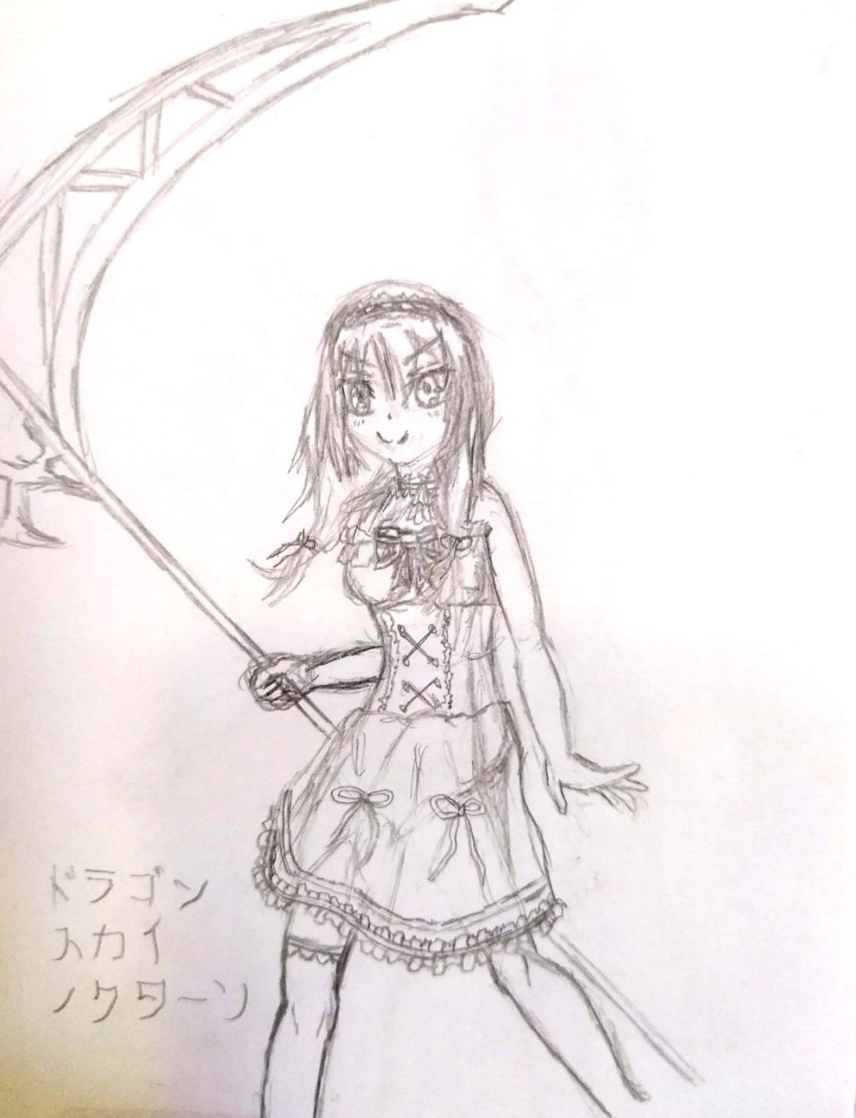 | Nome | Mikoto | Título | Morte
 | Armas
 | Espada | Muramasa |  | HP +
 | Machado | Death Scythe |  | ATK ++
 | Seal Stone | Death Stone red |  | DEF +
 | Arco | Shinigami Arc |  | SPD -
 | Cajado | Last Wish |  | RES -
 | Mag Nat | Heaven'll whell
 | Mag Neg | Reaper's Touch
 | Principal | Death Scythe | Proposito | Evitar que os outros sofram o mesmo que ela no passado.
 | Medos | Fogo
 | Medos | Igreja
Fonte: Desenho e ficha técnica feitos pelo autor
Quadro 7: Ficha Técnica Kurumi
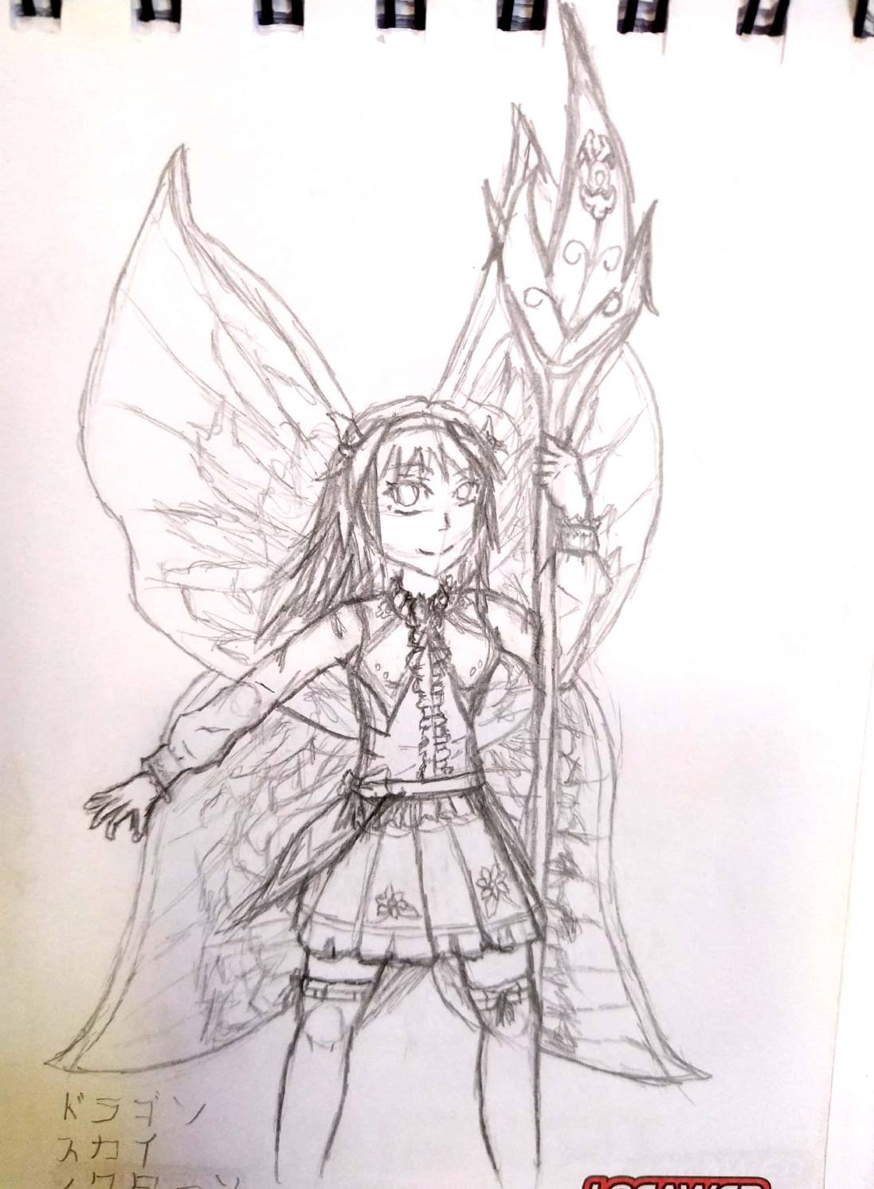 | Nome | Kurumi | Título | Rainha das fadas
 | Armas
 | Espada | Fairy Sword |  | HP +
 | Lança | Titania's spear |  | ATK ++
 | Mag Arc | Fairy Magic |  | DEF -
 | Arco | Uranu's moon |  | SPD -
 | Cajado | Fairy Blessing |  | RES ++
 | Mag Nat | Summer Memory
 | Principal | Titania's spear | Proposito | Evitar que os outros sofram o mesmo que ela no passado.
 | Medos | Fogo
 | Medos | Igreja
Fonte: Desenho e ficha técnica feitos pelo autor

Quadro 8: Ficha Técnica Lia
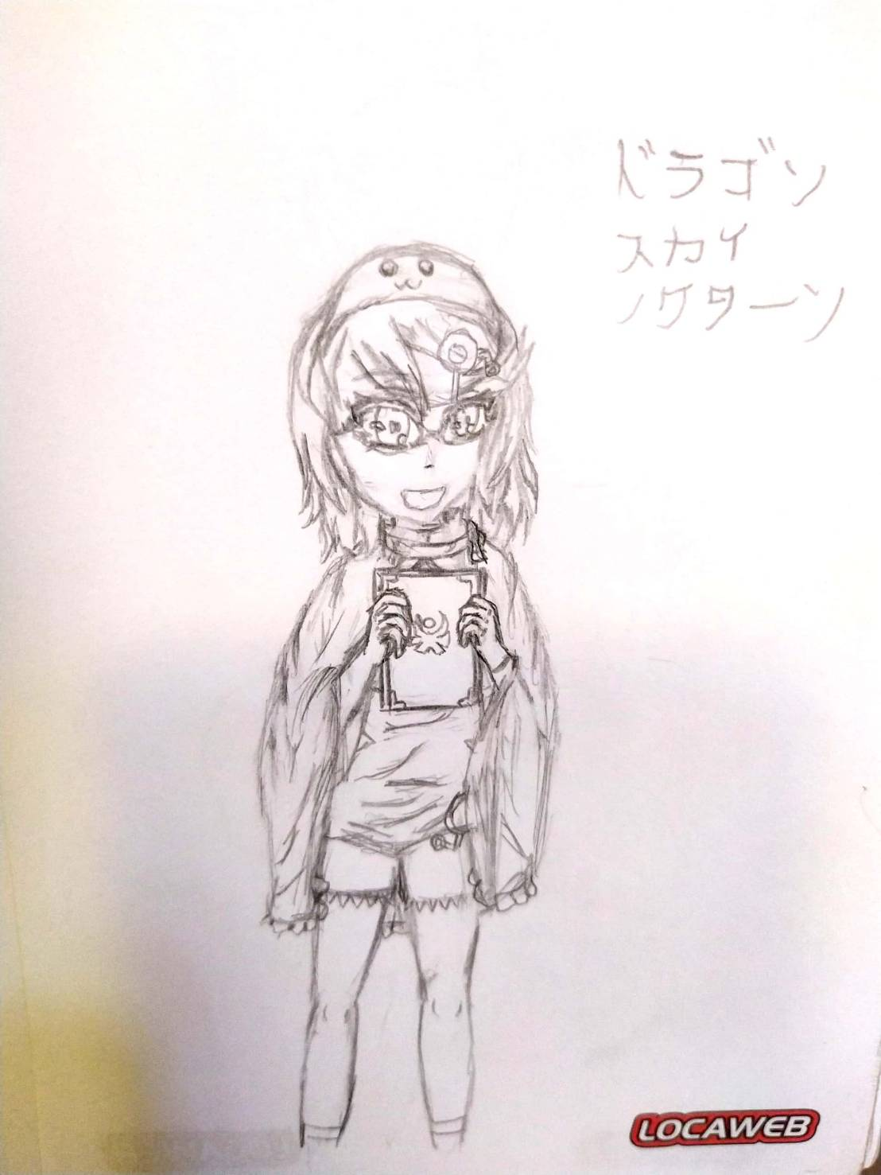 | Nome | Lia | Título | Teru Teru Bozu
 | Armas
 | Mag Arc | Teru teru blessing, Human wish |  | HP
 | Mag Nat | Weather's Call |  | ATK ++
 | Mag Nat | Last Wish |  | DEF --
 | Cajado | Umbrella |  | SPD +
 |  |  |  | RES ++
 | Principal | Weather's Call | Proposito | Realizar sua tarefa como teru bozu sob o treinamento de seu mestre
 | Medos | Sozinha
 | Medos | Morte
Fonte: Desenho e ficha técnica feitos pelo autor

Quadro 9: Ficha técnica Anabel
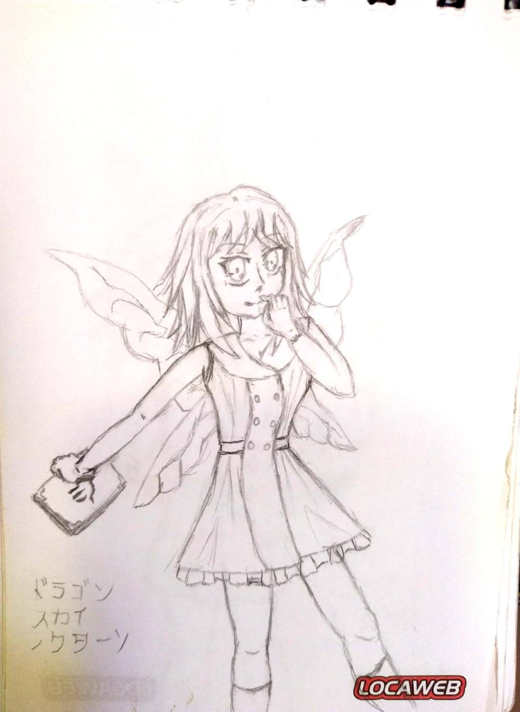 | Nome | Anabel | Título | Mão direita da Fada Rainha
 | Armas
 | Espada | Graywandir, gambanteinn |  | HP
 | Mag Nat | Nature Wishes, Fairy Heart, Grace of Titania |  | ATK +
 | Adaga | Whisper |  | DEF -
 |  |  |  | SPD ++
 |  |  |  | RES ++
 | Principal | Nature Wishes | Proposito | Ajudar titânia para proteger os guardiões remanescentes
 | Medos | Maldições
 | Medos | Igreja
Fonte: Desenho e ficha técnica feitos pelo autor
Quadro 10: Ficha técnica Aqua
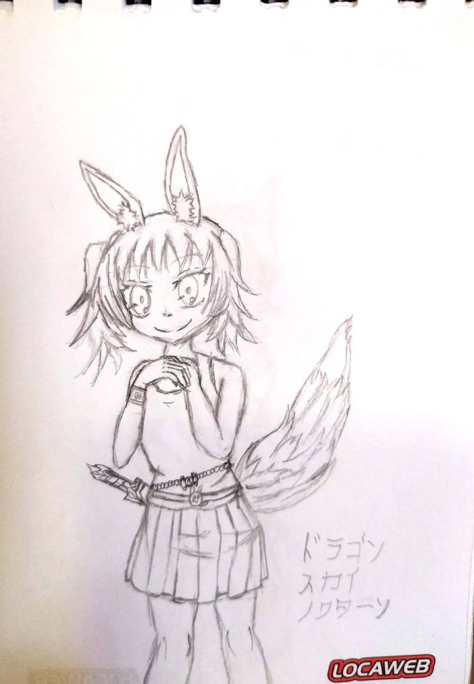 | Nome | Aqua | Título | Espirito de um coelho gato
 | Armas
 | Espada | The Claw |  | HP ++
 | Mag Nat | Grace of Nature, Bless of cat rabbit |  | ATK +
 | Mag Neg | Records of Guardians |  | DEF --
 | Mag Arc | Spirit of cat bunny |  | SPD ++
 | Adaga | Knife of spirits |  | RES
 | Arco | The huntress of Artemis
 | Principal | The huntress of Artemis | Proposito | Ajudar Artemis a criar um mundo mais pacífico e justo
 | Medos | Maldições
 | Medos | Água
Fonte: Desenho e ficha técnica feitos pelo autor

Quadro 11: Ficha técnica Artemis
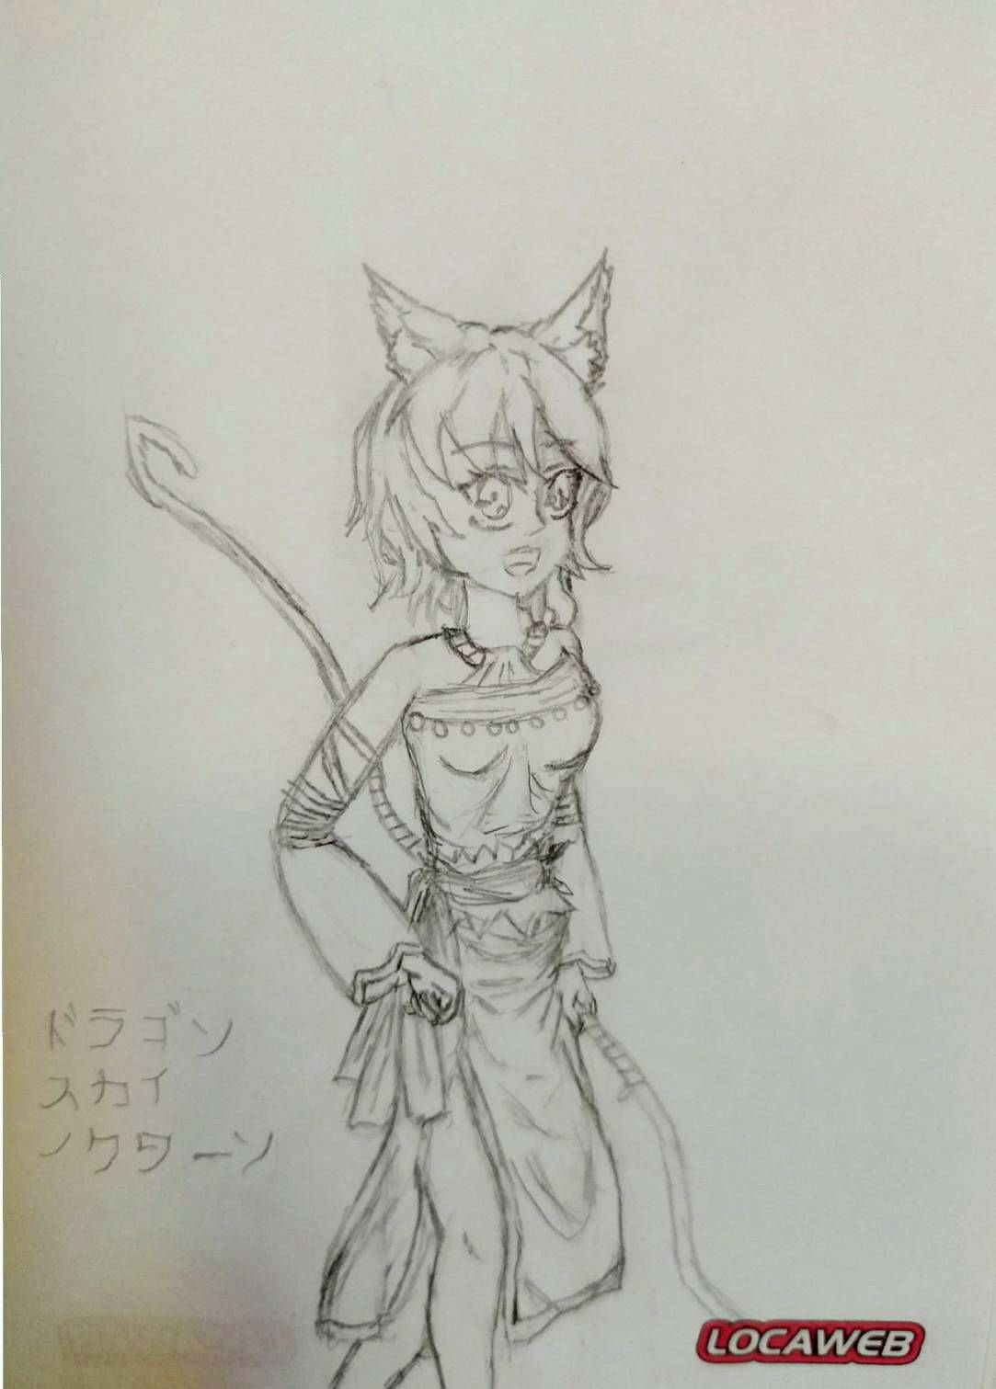 | Nome | Artemis | Título | Deusa da Lua
 | Armas
 | Espada | Daughter of Moon |  | HP +
 | Mag Arc | Moonlight |  | ATK ++
 | Arco | The Huntress, Artemis Bow |  | DEF -
 | Adaga | Peace Seeker |  | SPD ++
 |  |  |  | RES -
 | Principal | The Huntress | Proposito | Criar um mundo Melhor
 | Medos | Hera
 | Medos | Deuses Homens
Fonte: Desenho e ficha técnica feitos pelo autor

