

**UNIT: Object-Oriented Programming.**

**Course: BBIT**

**Cat Assignment**

**Question 1.**

**a). Five rules observed when naming identifiers in C++ program.**

i). An identifier must start with an alphabetic character.

ii). Must be unique within a given scope of the program taking the case sensitivity of the language into consideration.

iii). No blank space between other characters.

iv). The only special symbol that may be used in an identifier is the underscore (_) and it must be used with other colours.

v). Keywords cannot be used to name an identifier.

**c).(i) Explain the term function as used in programming**

Function is a named self contained block of statements designed to perform a particular task when invoked from another part of the program

(ii) Write a program to implement a function named findAvg that receives three parameter values ,calculate and display the mean of the three data items .

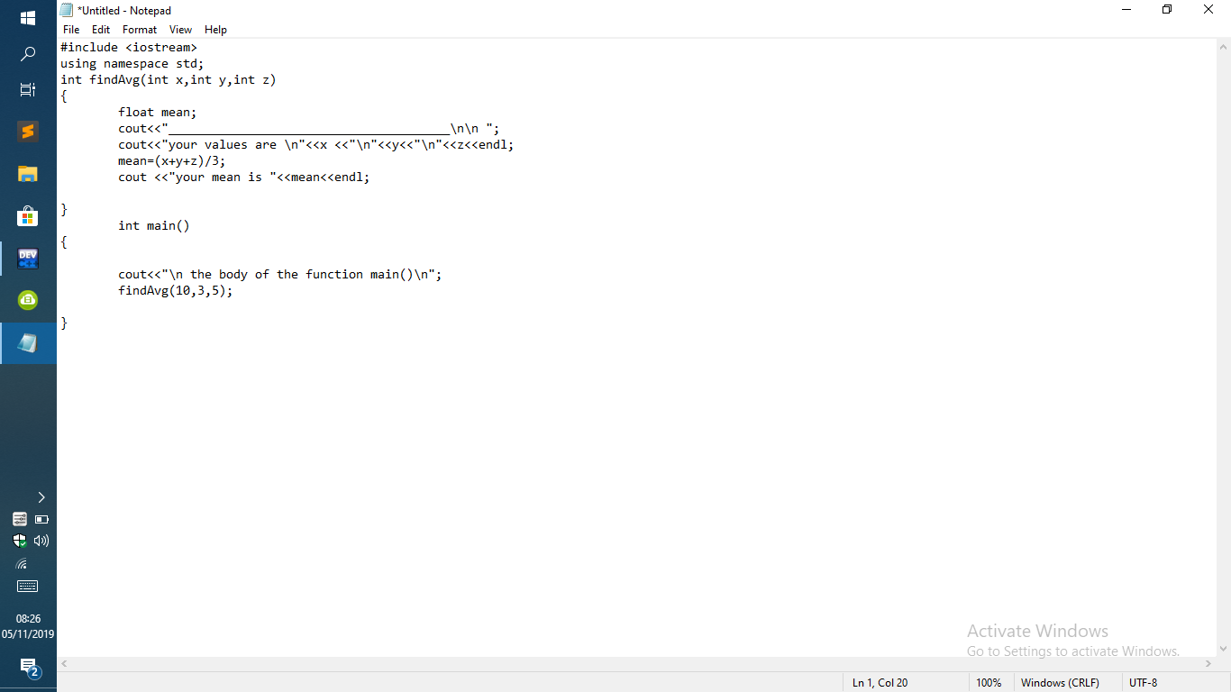

**Question 2.**

**a). Explain the term array as used in programming**

Array is a named collection of memory locations used for temporary storage of data items of the same type.

**AND use examples to demonstrate the declaration and static initialization of;**

**a one-dimensional array**

syntax:

int num [5] = {5,7,8,7,19};

**a two-dimensional array**

syntax:

datatype arrayName [][] = {{list of row 1 elements},{list of row 2 elements},{list of row 3 elements},{list of row N elements}};

**b). With aids of diagrams describe the logical operational difference between a while loop and a do….. while loop**

The while statement

Use this statement when you want a certain action to be executed repeatedly as long as a certain condition remains true.

Block of statements to execute as long

While condition **T** as that condition remains TRUE

?

**F**

The do……… while statement

Use this statement when you want a certain action to be executed ones, then repeatedly as long as a condition remains true.

Block of statements

to execute

do **T**

while condition

?

**F**

c. Write a programm that prompts the user for the length, width and height of a solid cuboid, computes and outputs both the valume and total surface area of the cuboid.

