**TMAC/2024-25/Vol I/IC01 Date: {date}**

**Internship Completion Certificate**

This is to certify that **{firstName} {lastName}** has successfully completed the internship program at our company in the role of **{courseName}**, from **{fromDate}** to **{toDate}**.

{description}

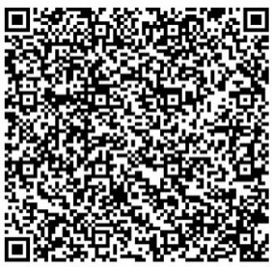

**Parveen Kumari**  
CEO Cum Director Technical  
Totem Management and Consultancy Pvt Limited