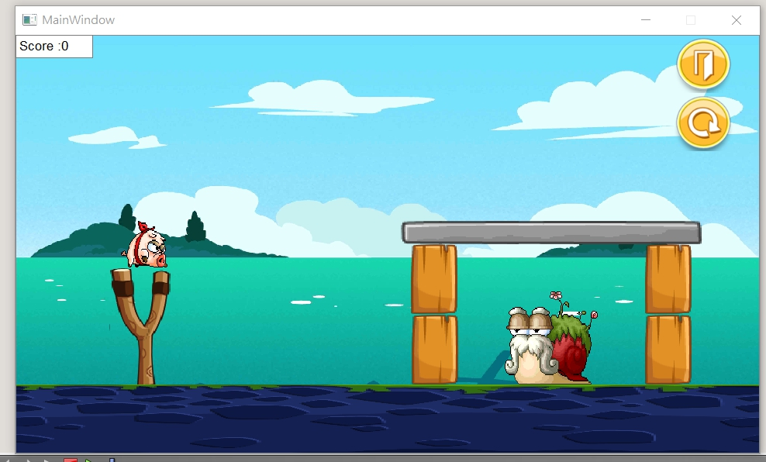

功能:一般的小豬

功能:當射出去後按一下,他會變身成鋼鐵肥肥,重量增加一倍

功能:當射出去之後,按一下會往下墜

功能:當射出去之後,按一下他會變大

UML Diagram

|  |
| --- |
| MainWindow |
| -scene: QgaphicsScene* - superbird2:subird1 * - text:QTextEdit *  -timer: QTimer - superbird3:subird1 * - shoot:building *  - birdie:Bird * - superbird4:subird2 * - build:building *  - birdie1:Bird * - superbird5:subird2 * - build1:building *  - superbird:subird * -restart:QPushButton * - build2:building *  - superbird1:subird * - exi :QPushButton * - build3:building *  - build4:building * - ha:bg * - ti:QTimer *  - biti:QTimer * - biti1:QTimer * - biti2:QTimer *  - biti3:QTimer * -int timecheck - timecheck1:int  - orix :int - oriy :int - rex:int  - rey:int - mx:int - my:int  - vx:int - vy:int - test:int  - test1:int - laugh:int - int timerclose  -score:int |
| +<<ecplict>>MainWindow(parent:QWight*=0):void -<<slot>> checkbird2():void  +~MainWindow() -<<slot>> checkbird3():void  +showEvent(QShowEvent*):void  +eventFilter(QObject*,event:QEvent):bool  +closeEvent(QCloseEvent*):void  -<<slots>> tick():void  -<<slot>>QUITSLOT():void  -<<slot>> QUIT():void  -<<slot>> NEW():void  -<<slot>> advance():void  -<<slot>> checkbird():void  -<<slot>> checkbird1():void |

|  |
| --- |
| GameItem |
| #g_body:b2Body*  #g_pixmap: QgaphicsScene*  #g_size:QSizeF  #g_world:b2World*  #g_worldsize:static QSizeF  #g_windowsize:static QSizeF |
| +GameItem(world:b2World*)  +~GameItam()  +setGlobalSize(worldsize:QSizeF,windowsize:QSizeF):static void  +<<slots>>paint():void |

|  |
| --- |
| Bird |
| +Bird(x:float,y:float,radius:float,timer:QTimer*,  Pixmap:QPixmap,world:b2World*,  scene:QGraphicScene*,density:float)  +setLinearVelocity(velocity:b2Vec2):void  +disapp():bool |

|  |
| --- |
| Land |
| +Land(x:float,y:float,w:float,h:float,  Pixmap:QPixmap,world:b2World*,  scene:QGraphicScene*) |

|  |
| --- |
| bad |
| +pig(x:float,y:float,radius:float,timer:QTimer*,  Pixmap:QPixmap,world:b2World*,  scene:QGraphicScene*, density:float)  +setLinearVelocity(velocity:b2Vec2):void  +getvelocity(): bool |

|  |
| --- |
| building |
| +Obstacle(x:float,y:float,radius:float,  timer:QTimer*,  Pixmap:QPixmap,world:b2World*,  scene:QGraphicScene*,density:float)  +setLinearVelocity(velocity:b2Vec2):void |

|  |
| --- |
| superbird |
| +yellowbird(x:float,y:float,radius:float,timer:QTimer*,  Pixmap:QPixmap,world:b2World*,  scene:QGraphicScene*,density float)  + setLinearVelocity(b2Vec2 velocity): void  +supergo():virtual void  +disapp():bool |

|  |
| --- |
| Superbird1 |
| +yellowbird(x:float,y:float,radius:float,timer:QTimer*,  Pixmap:QPixmap,world:b2World*,  scene:QGraphicScene*,density float)  + setLinearVelocity(b2Vec2 velocity): void  +supergo():virtual void  +disapp():bool |

|  |
| --- |
| Superbird2 |
| +yellowbird(x:float,y:float,radius:float,timer:QTimer*,  Pixmap:QPixmap,world:b2World*,  scene:QGraphicScene*,density float)  + setLinearVelocity(b2Vec2 velocity): void  +supergo():virtual void  +disapp():bool |