|  |
| --- |
| Btn |
| <<constructor>>+Btn(); |

|  |
| --- |
| clock |
| <<constructor>>+clock();  +passtimer(*timer:QTimer):void  +appear(time:int) :void  +*timer1:QTimer  + time:int  +count():void |

|  |
| --- |
| MainWindow |
| -Ui::MainWindow *ui; |
| <<constructor>>+explicit MainWindow(*parent = 0: QWidget);  <<destructor>>+~MainWindow();  +*scene:Scene  +settingBg():void |

|  |
| --- |
| Scene |
| <<constructor>>+Scene();  +Init():void  +mousePressEvent(*event: QGraphicsSceneMouseEvent):void  +keyPressEvent(*event: QKeyEvent):void  +keyReleaseEvent(*event: QKeyEvent):void  +gene():void  +gameInit():void  +initTimer():void  +bgRecover():void  +bgChange():void  +bgChange1():void  +timeout():void  +gameend():void  +*btnstart:Btn  +*btnback:Btn  +*btncheck:Btn  +*btnrestart:Btn  +*btnexit:Btn  +*btndrum:slot  +*btndrum1:slot  +*cl:clock  +*cl2:clock  +*timer:QTimer  +*timer1:QTimer  +*timer2:QTimer  +*sco:score  +*timecheck:int  +btn_w:int  +btn_h:int  +check_w:int  +check_h:int  +restart_w:int  +restart_h:int  +exit_w:int  +exit_h:int  +back_w:int  +back_h:int  +screenMode:int  +timetime:int  +si:int  +<int> ran:QList  +<slot *> object:QList  +countslot():void |

|  |
| --- |
| Score |
| <<constructor>>+score();  +prscor():void  +result():void  +sc:int  +check:int |

|  |
| --- |
| Slot |
| <<constructor>>+slot();  +x_speed:int  +advance(phase:int):void  +setX_speed(speed:int):void |



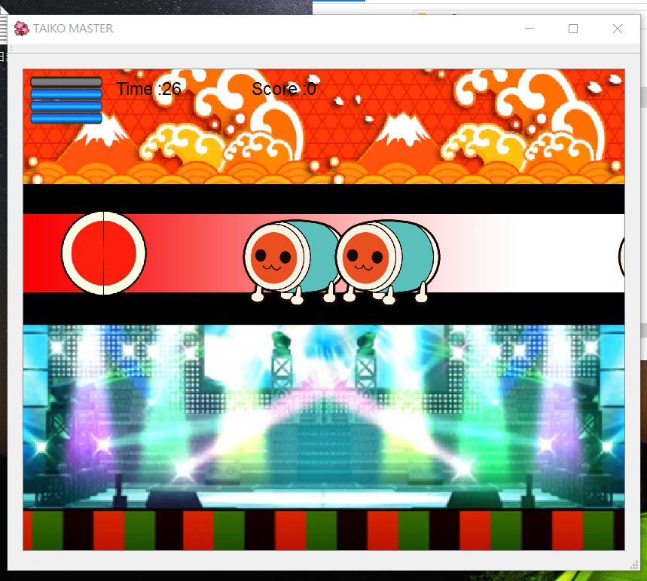

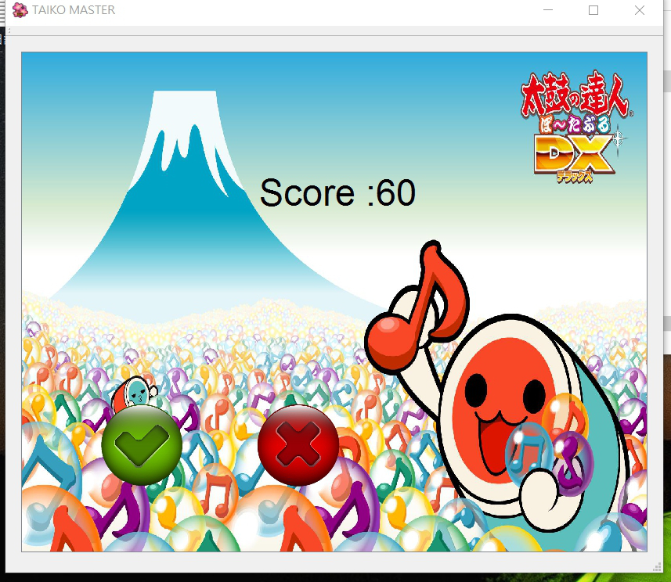

:按K

:按J

用一個繼承QGraphicsScene的class來構築整個程式,主要的function為內建的void *mousePressEvent*(QGraphicsSceneMouseEvent *event)和void *keyPressEvent*(QKeyEvent *event),一個是滑鼠的一個是鍵盤的,在相對條件觸發後會呼叫其他的function,有變換場景的,有遊戲初始的,因應不同的畫面和不同的按鈕,然後會視需求而增加class並且讓她繼承QGraphicsTextItem,當作一個物件使用,無論是倒數計時,記分板,Timer等等