**PA1 Report**

**電機三 梁正 B08901169**

1. **Running Time**



1. 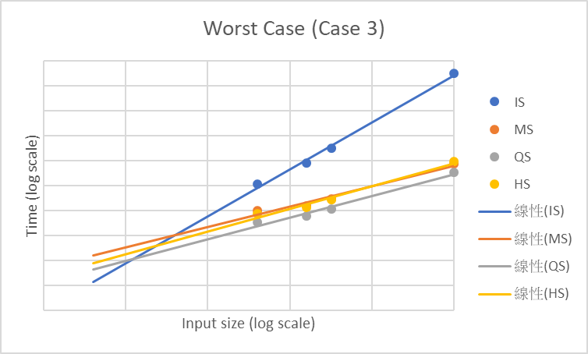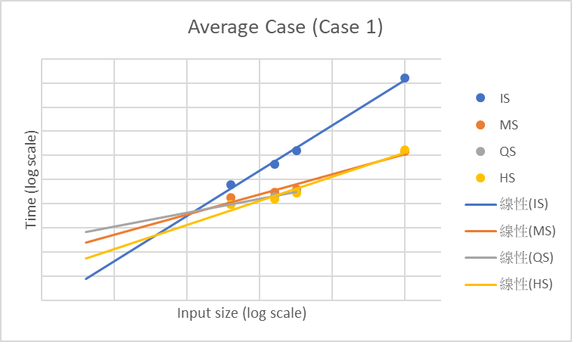**Results (on EDA Union 6)** 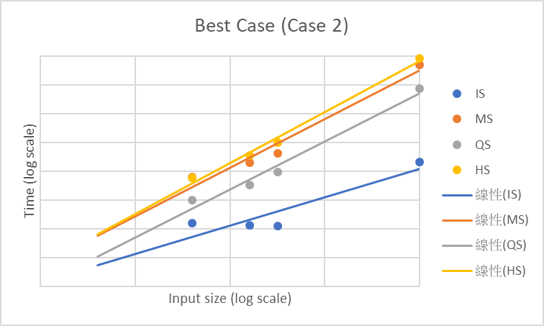

MS/HS:

$slope=\frac{\log\left(nlog\left(n\right)\right)}{\log\left(n\right)}$ for all cases

QS:

∵ use randomized quicksort

∴ $slope=\frac{\log\left(nlog\left(n\right)\right)}{\log\left(n\right)}$ for all cases

IS:

Case1, $slope=\frac{\log\left(n^{2}\right)}{\log\left(n\right)}=2$

Case2, $slope=\frac{\log\left(n^{2}\right)}{\log\left(n\right)}=2$

Case3, $slope=\frac{\log\left(n\right)}{\log\left(n\right)}=1$