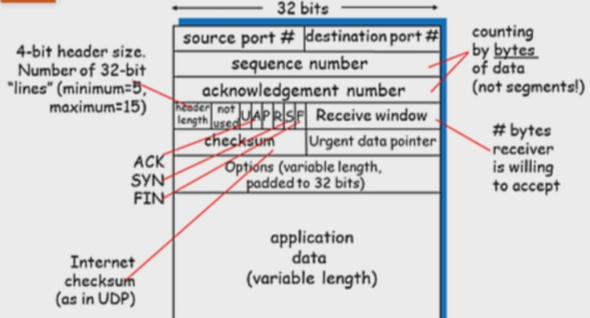D = D0/(1-U); EstRTTn = (1-α)\*EstRTTn-1 + α\*SmpRTT, α=.125;DevRTTn=(1-β)\*DevRTTn-1+β(SmpRTT-EstRTT), β=.25; TimeoutInterval = EstRTT + 4\*DevRTT; AIMD with SlowStart on TCP; FBT = bL/R, RTT = Pd\*2

Application layer: data. Transport layer: application to application segments. Network layer: Host to Host, datagram. Link layer: adjacent nodes Node to Node, frame. Physical layer: ,.

TCP Segment structure.UDP 8byte header, TCP 20byte min header, TCP setup and teardown (3way handshake SYN>SynACK<ACK>, closing connection FIN>FINACK<FIN<FINACK>) TCP fairness per connection.

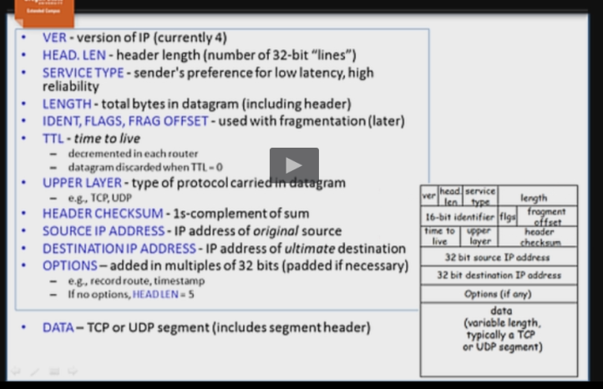Virtual Circuit Network vs. Datagram by virtue of network; IP is a network layer protocol; Accepts TCP/UDP segments; best effort host to host delivery. possible to have a queueing delay at the output port of a router due to transmission rate limitations on the output port link: if several datagrams were switched to the same output port, they will have to wait for access to the transmission medium. Packet loss can also occur, if the buffer overflows.

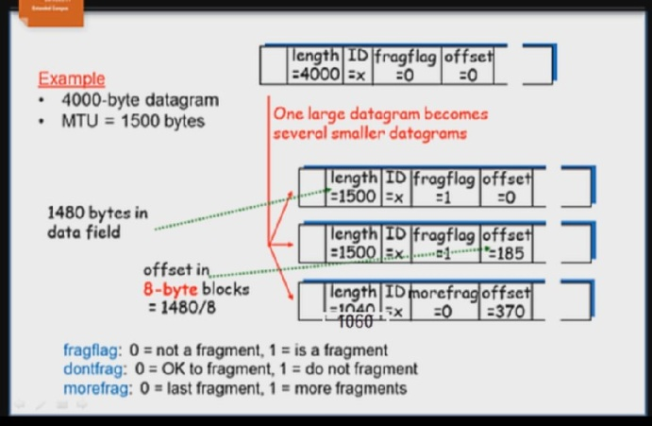possible to have a queueing delay at the input port of a router due to head-of-line blocking or output port contention: if the datagram at the front of the line in the input port queue cannot be transferred to the output port because there isalready a transfer occurring to, or a full queue at, the desired port. This would cause a delay in transferring the HOL datagram to its output port. Packet loss can occur here as well, if the input buffer overflows. Max datagram size is 65495 (65535-20-20).

A 2400-byte datagram (with ID #422) encounters a router with an MTU of 700 bytes. The amount in the payload of the IP datagram = 2400 – 20 = 2380. (Length – IP header) The maximum size of data field in each fragment = 700 – 20 = 680 (MTU – IP header). Thus the number of required fragments clg{(2400−20)/(700−20)} = 4 (Note: the 2380 bytes of data includes a TCP or UDP header, but that doesn’t matter, since IP just sees it as “payload”.) Length Each fragment except the last one will be of size 700 bytes (including IP header). The last datagram will be of size 360 bytes (including IP header). Excluding headers, 680 + 680 + 680 + 340 = 2380 ID# Each fragment will have Identification number 422 more-fragments flag Each of the first 3 fragments will have more-fragments = 1; the last fragment will have more-fragments = 0 offset The offsets of the 4 fragments will be 0, 85, 170, 255. NOTE: the destination host will multiply the fragment offset values by 8 to get the byte number.)

ICMP built on top of IP to provide error correction mechanisms, carried in IP datagram as payload. 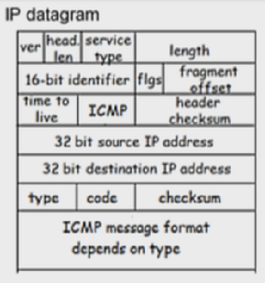Allows messages Router to Router//Router to Source Host//Source Host to Destination Host//Destination Host to Source Host

IPv6 Changes from IPv4: – Address space: 128-bit – Support for audio and video - “flow labels” allow AV applications to establish appropriate connections – Fragmentation no longer allowed - drop packet if too big – Checksum removed to reduce processing time - already done at transport and link layers - Optional headers (outside of base header) - indicated by “Next Header” field - easily add new headers for new features - ICMPv6: new version of Internet Control Message Protocol - additional message types - more effective inter-router collaboration

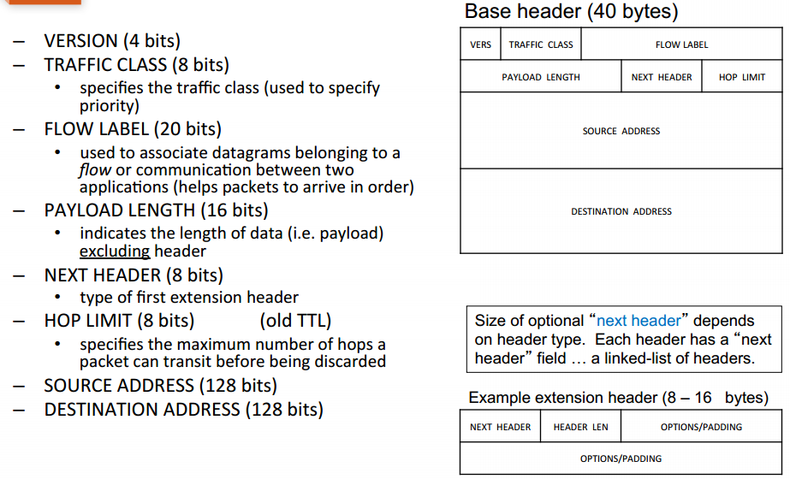responsibilities of the link layer-Providing hardware addresses (usable between adjacent nodes)-Encapsulation of network-layer datagram into link-layer frame.-Medium access control (air, wire, …)-Possible collision avoidance/detection/resolution (part of access control)-Possibly reliability (ACKs, error detection/correction, etc…)

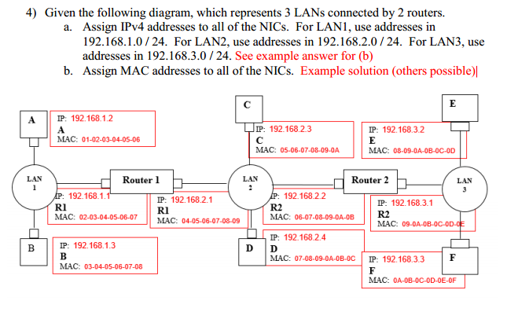Link layer has multiple hosts connected together. Multiple Access protocols result. Address Resolution Protocol is used to get MAC addresses associated with IP addresses.

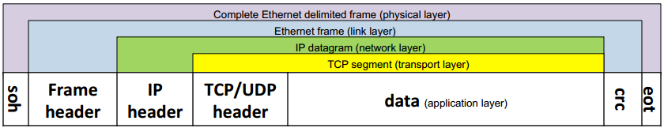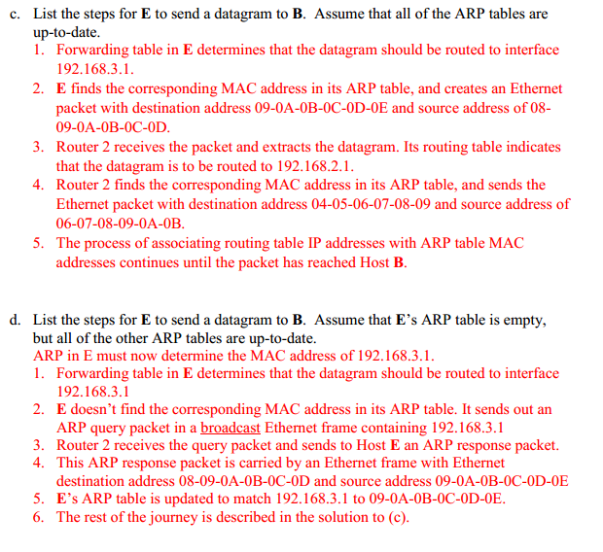BUS, RING, STAR (switch)  
Ethernet uses CSMA/CD network diameter requirement to prevent two nodes ‘sensing’ a free medium and starting transmission at close to the same time. the purpose of the Ethernet “preamble” is used to synchronize clocks sender and receiver clocks. It is also used to signal the beginning of the rest of the Ethernet frame (since the clocks won’t always synchronize in the same amount of cycles). the Ethernet “type” identifies the network-layer protocol used in the datagram contained in the payload section. errors detected in Ethernet A CRC check over the information in the frame is used to detect errors, but there is no error correction.   
DON’T FORGET THE SOH AND EOH AT THE START & END

Exponentiontial backoff 2^k\*512-1\*bit-time

Wireless Mobility Terms

a. Home Network: The registered “home network” in which the home agent resides.

b. Home Agent: The entity in the home network which performs mobility functions for 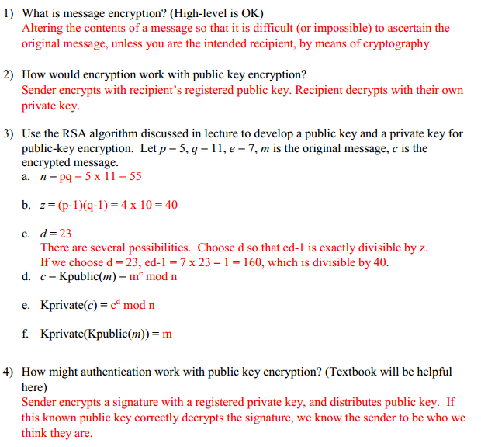the device

c. Permanent Address: Address in home network, which will always correspond to the device.

d. Visited Network: Network which mobile device is currently in (assuming it is not in the home network).

e. Foreign Agent: Entity in the visited network which performs mobility functions for the device.

f. Care-of Address: Address in the visited network which is registered to the mobile device.

g. Correspondent: Entity attempting to communicate with the mobile device.