Assignment: Week 5 Visualizations Activity

Erica Peng

2023-09-08

## R Markdown

This is an R Markdown document. Markdown is a simple formatting syntax for authoring HTML, PDF, and MS Word documents. For more details on using R Markdown see <http://rmarkdown.rstudio.com>.

When you click the **Knit** button a document will be generated that includes both content as well as the output of any embedded R code chunks within the document. You can embed an R code chunk like this:

## Including Plots

You can also embed plots, for example:

## country confederation population_share tv_audience_share  
## Length:173 Length:173 Min. :0.0000 Min. :0.0000   
## Class :character Class :character 1st Qu.:0.0000 1st Qu.:0.0000   
## Mode :character Mode :character Median :0.1000 Median :0.1000   
## Mean :0.1775 Mean :0.2376   
## 3rd Qu.:0.2000 3rd Qu.:0.3000   
## Max. :1.0000 Max. :2.4000   
## gdp_weighted_share  
## Min. :0.0000   
## 1st Qu.:0.0000   
## Median :0.0000   
## Mean :0.2659   
## 3rd Qu.:0.2000   
## Max. :4.2000

We have data about 191 countries. Only 18 have a population share of greater than 1.0. The distribution of this is shown below:

## Including Plots

# Create a histogram of one variable (e.g., 'mpg')  
hist(filtered$population_share, main = "Histogram of population_share", xlab = "population_share", ylab = "Frequency")

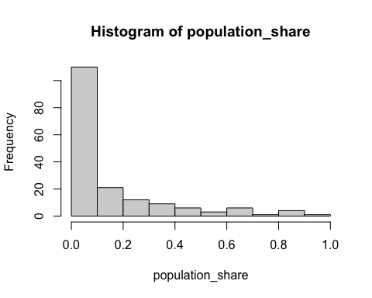

# Create a scatterplot of two variables (e.g., 'mpg' vs. 'hp')  
plot(filtered$population_share, mtcars$gdp_weighted_share, main = "Scatterplot of population_share vs. gdp_weighted_share",   
 xlab = "population_share", ylab = "gdp_weighted_share")

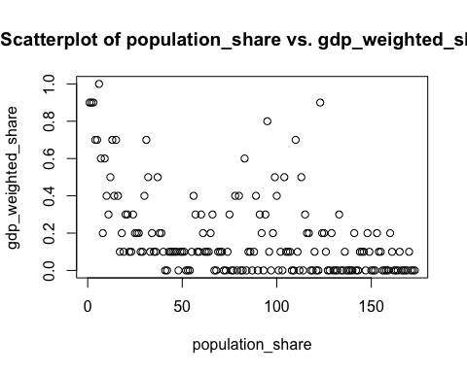 Note that the echo = FALSE parameter was added to the code chunk to prevent printing of the R code that generated the plot.