**Linux Firewall Exploration- Task 3**

Completed by Eric Adamian

VirtualBox IP addresses:

|  |  |  |  |
| --- | --- | --- | --- |
| Virtual machine: | MachineA | MachineB | MachineC |
| IP address: | 10.0.2.21 | 10.0.2.22 | 10.0.2.23 |

**Task 3: Evading Egress Filtering**

**Task 3.a: Telnet to Machine B through the firewall**

Explanation: Using an SSH tunnel to telnet to Machine B through a firewall (ensure firewall is enabled before beginning: sudo ufw enable)

**Step 1:** Block telnet connection from Machine A to external machines, such as Machine B and Machine C (Machine A)

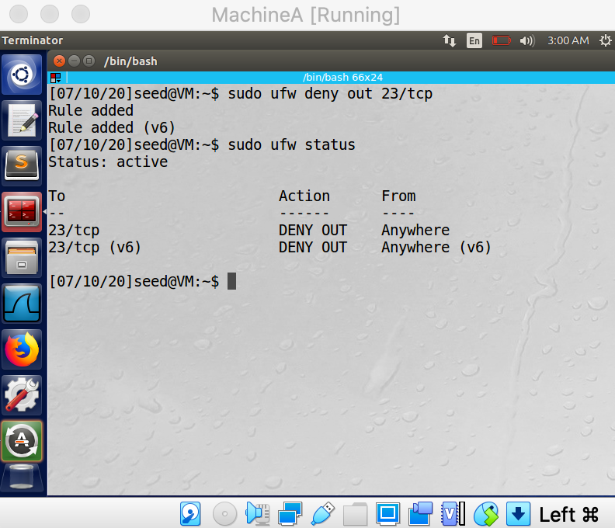

**Step 2:** Create SSH tunnel connection from Machine C to Machine B (Machine A); telnet through localhost’s port 8000 will transfer TCP packets from Machine B to Machine C (Machine A)

**Step 3:** Telnet to localhost on Machine A; when the connection is established, it is essentially doing a telnet from Machine A to Machine C (Machine A)

**Observation**: Machine A was able to indirectly telnet to Machine C; **SSH tunnel was successfully implemented**

**Task 3.b: Connect to Facebook using SSH Tunnel.**

Explanation: Using SSH dynamic port forwarding to connect to an external website (www.facebook.com)

**Step 4:** Edit Firefox settings on VM with manual proxy configurations (Machine A)

**Step 5:** Attempt to open www.facebook.com (Machine A)

**Step 6:** After failing to access the website, connect Machine A to Machine B using SSH tunnel (Machine A)

**Step 7:** Reattempt to login to www.facebook.com on the same machine (Machine A)

**Observation**: Machine A was able connect to external website with manually inputted proxy settings; **SSH tunnel successfully enabled using dynamic port forwarding**