1. I used Tableau for all visualization in this question.
2. Closing Price vs Date line graph using Tableau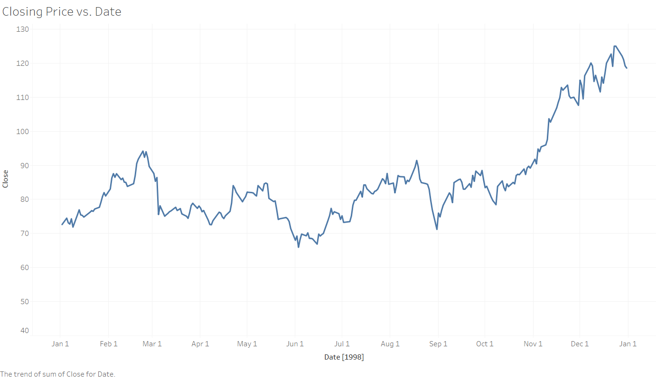
3. Volume vs Exact Dates bar graph

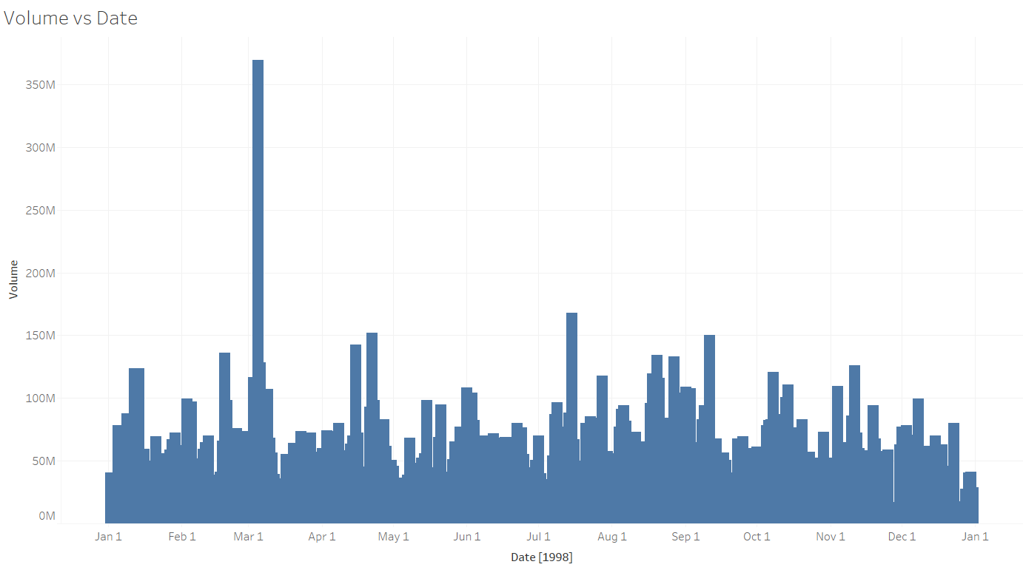

1. Histogram of daily stock Volume, using a bin size of 5,000,000

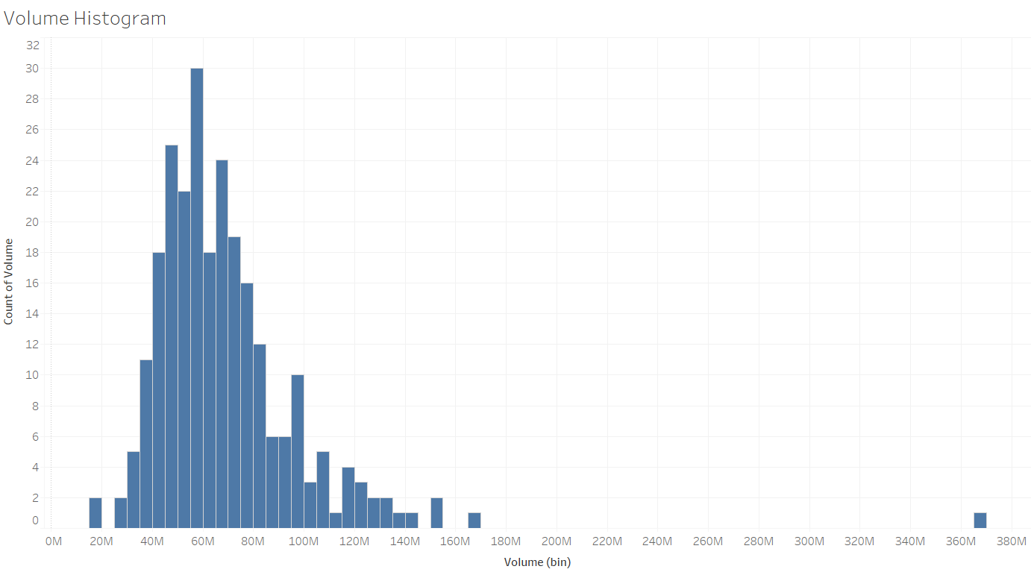

1. Scatter plot volume vs daily price

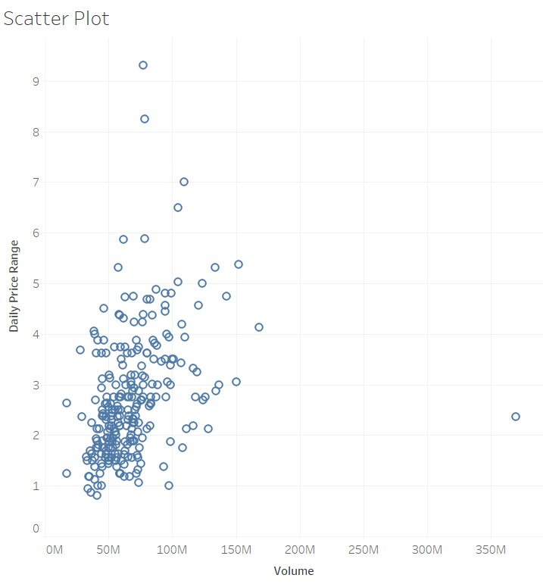

1. I used Tableau for all graphs in this question.
2. Histogram of error. This graph shows a normal distribution. It normalizes around the Error bin 0.0, meaning there is no error.

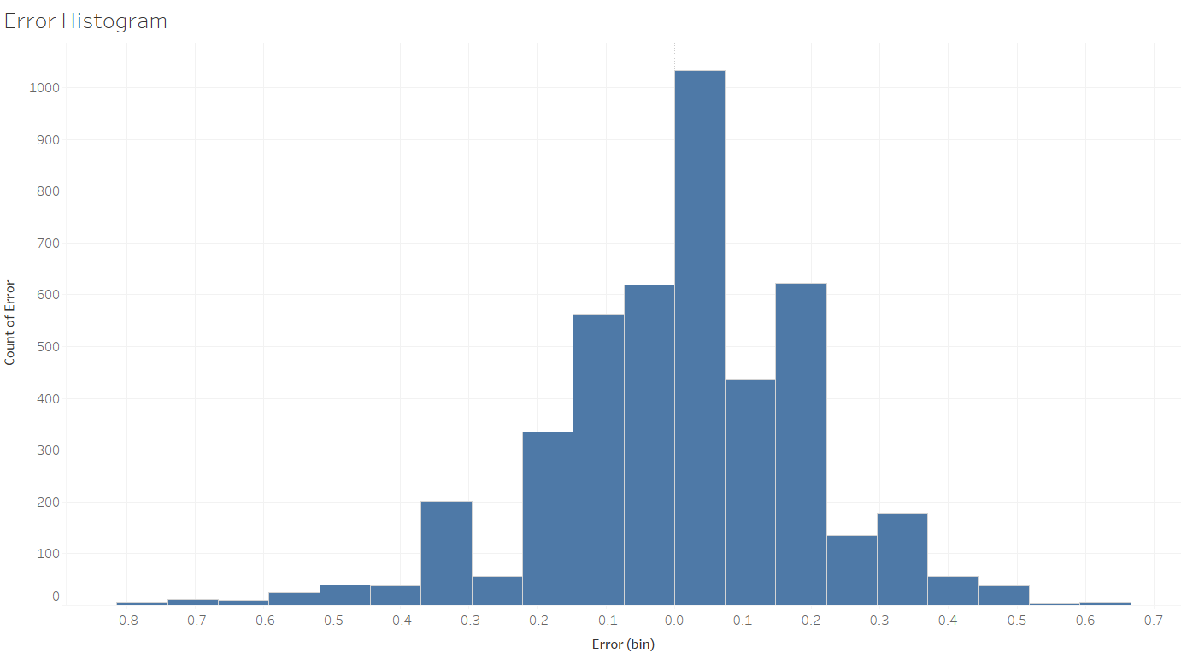

1. Bar graph of median error by Test: Color, volume, and slope had the highest median Error in the perception testing. Since the error calculation is a subtraction it appears that the color is negative error, but this means that the response was lower than the true value.

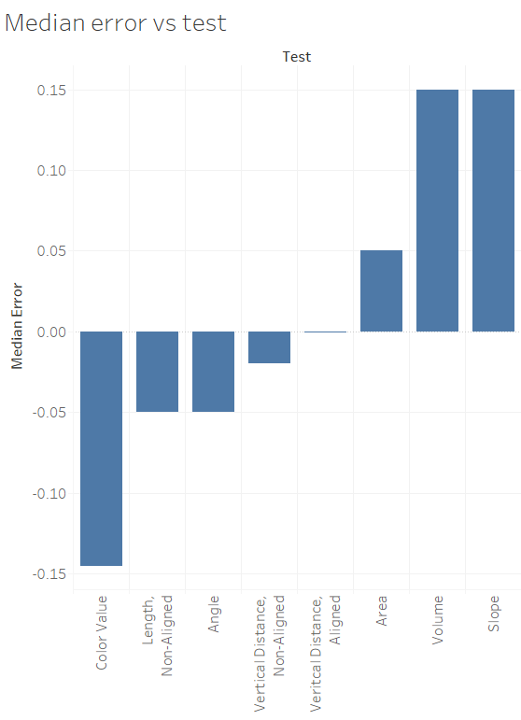

1. Bar graph of Standard deviation of error by test: This graph shows a better representation since all the values are positive. Slope once again has the highest standard deviation of error, meaning in the slope test had the widest distribution of response errors.

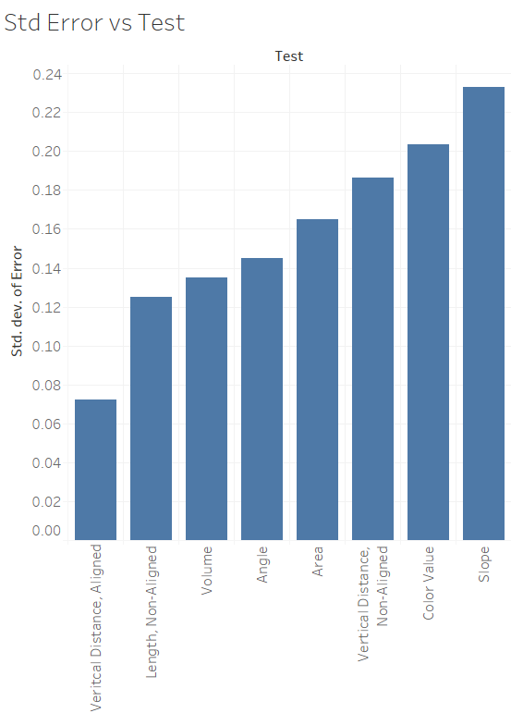

1. Absolute error by test bar graph: This is a better representation of the median error, because all the values are positive. In this graph you can easily see that slope and color value have the highest error values.

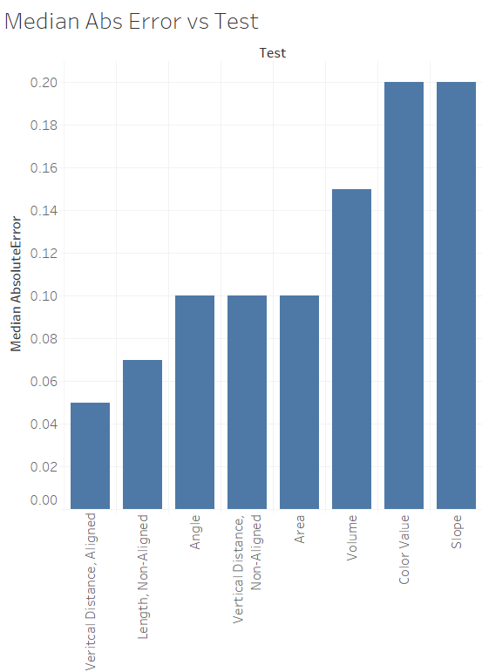

1. I used R for all graphs in this question.
   1. Scatter plot of Height vs Weight.

R code: ggplot(data=mydata, aes(x=Height.in, y=Weight.lbs, color = Sex)) + geom_point(size=1.5)

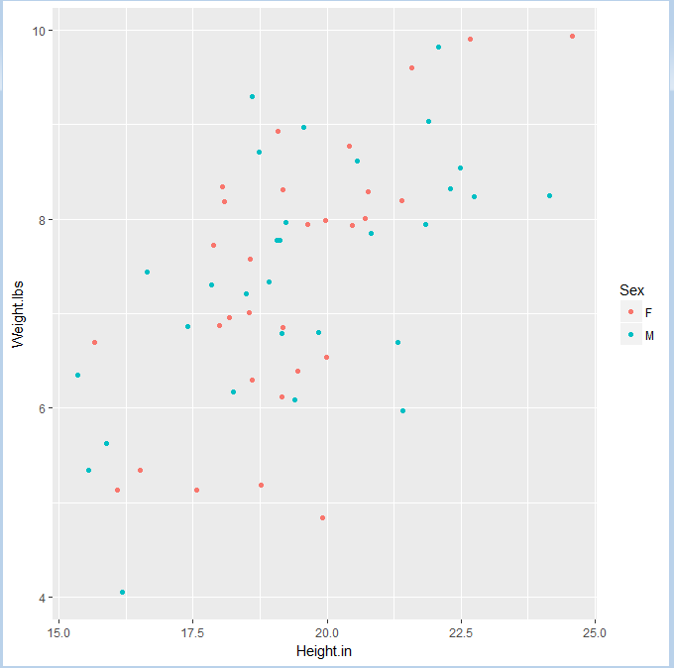

* 1. Scatter plot of height vs weight with trend lines

R Code: ggplot(data=mydata, aes(x=Height.in, y=Weight.lbs, color = Sex)) + geom_point(size=1.5) + geom_smooth(method=lm,se=FALSE)

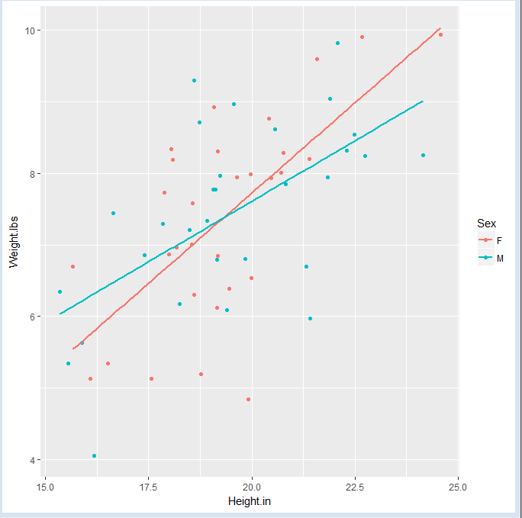

* 1. I chose to use two different colors to differentiate between the male and female data points. These two colors are very different from each other and easy to distinguish. I also chose to use solid line for the trend, and keep the different colors. This allows you to quickly see the difference between the male and female data points. I chose not to start the axis at 0 since none of the data points are near that value. Using the defaulted ranges, you can see the trend lines easily.

1. I used Tableau for the graphs in this question.

Treemap based on price with subdivions of Make and model.

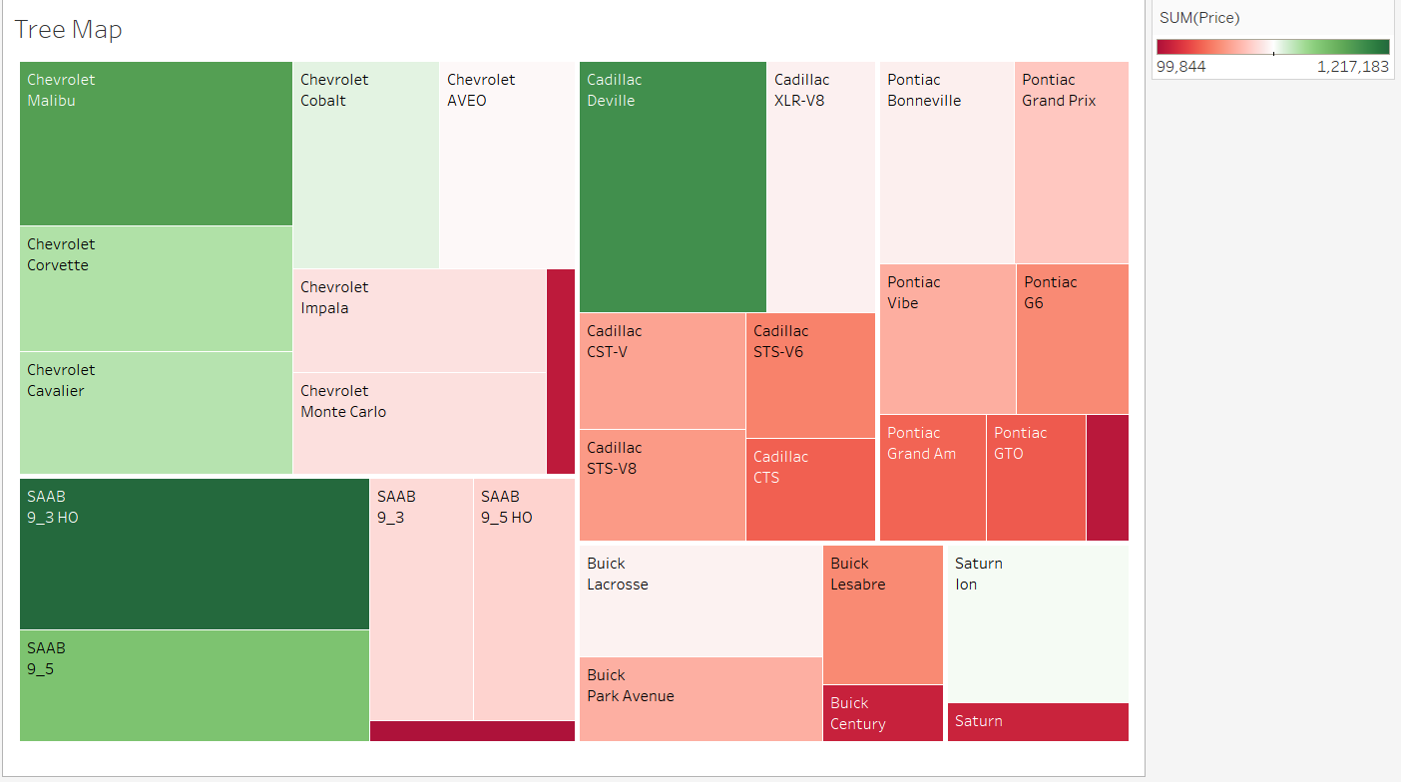

b. Bubble Chart

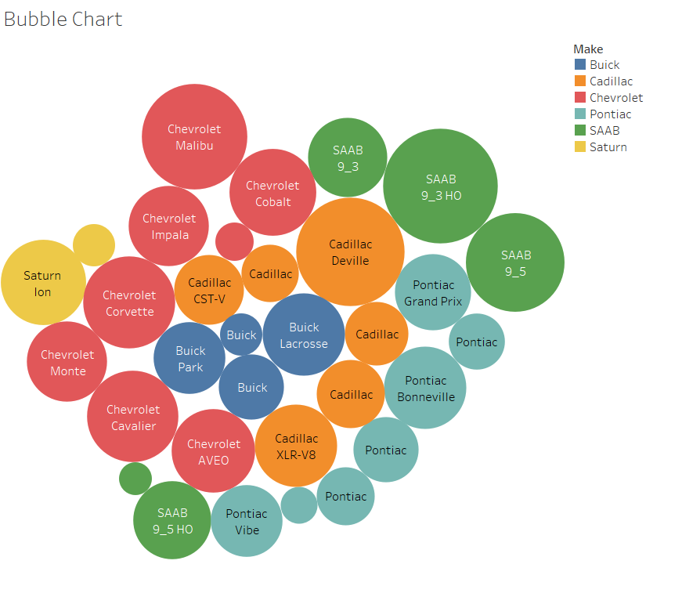

I think that the bubble chart is clearer with differentiating the Makes of the cars. Each make is a difference color, which stands out. In the tree map, the colors are based on the Price values, not the makes. This higher the price the larger the box is and the greener the box. The tree map does a better job of keeping all the groups together. For , all of the Chevrolet boxes are in the top left, all the SAAB boxes in the bottom left and so on. This makes it easier to see compare all the models within each make of car. It also allows you to compare the Makes of cars to each other as a whole.

5. I used Tableau for the graphs in this question.

a. Population growth over the years for each reservation

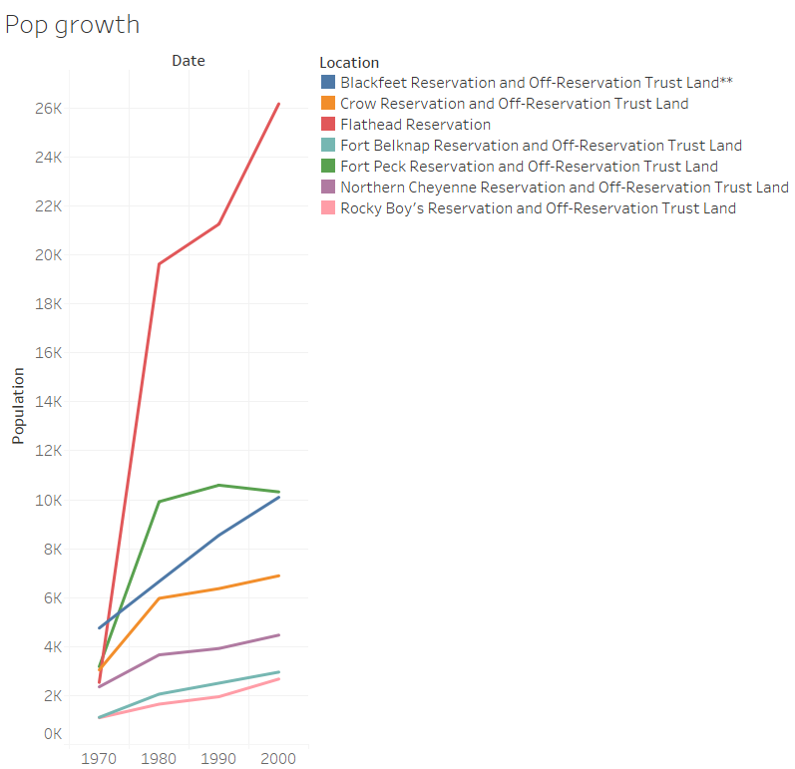

b. Total reservation population subdivide into the reservations.

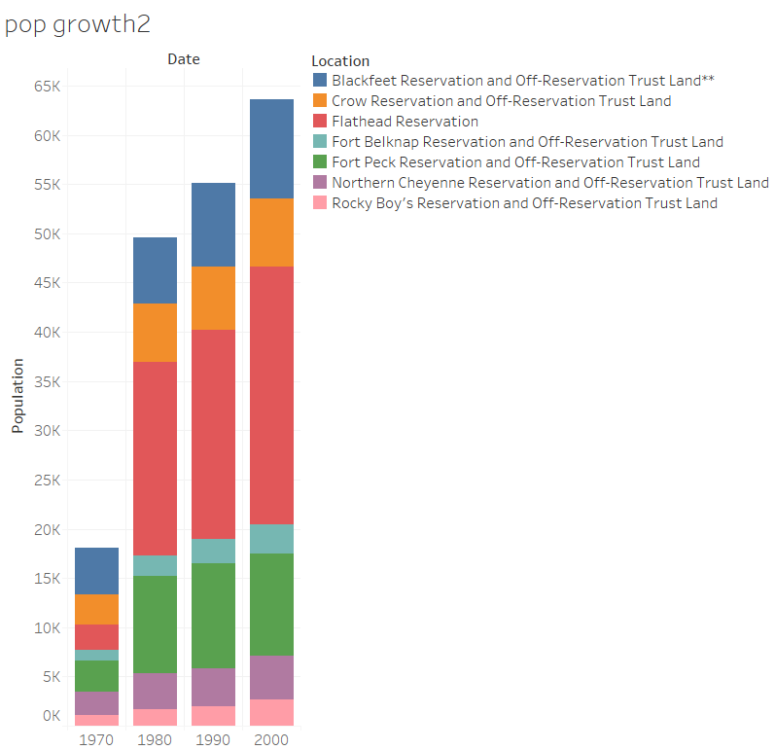

c. Population distribution over the years by reservation

