**STUDY NOTEBOOK LEARNING MODULE 4 – 7**

**LEO GLENN P. EVASCO**

**School Principal I**

**MODULE 4: LEARNING DELIVERY MODALITIES IMPLEMENTATION PLANNING**

***Lesson 1: ASSESSING THE READINESS OF LEARNERS, TEACHERS AND PARENTS***

ACTIVITY 1.

1. Reflection on Readiness Checklist for Learners, Teachers and Parents.

Readiness Checklist for Learners, Teachers and Parents determines the preparedness of the said stakeholders for the upcoming school year during this pandemic. This is to identify each aspect of learning process on what factor that would be needing explicit intervention and program planning.

1. Accomplish the Readiness Checklist, including the action steps/intervention section.

This checklist will allow you to look into factors that might affect the implementation of your LDM. More importantly, it should inform your interventions to make them more targeted.

Tick the space that corresponds to your answer.

|  |  |  |  |
| --- | --- | --- | --- |
| **FOR THE LEARNERS: HAVE YOU CHECKED YOUR LEARNERS’** | **YES** | **PARTIALLY** | **NO** |
| 1. Psychosocial preparedness for the opening of classes? |  | ✓ |  |
| 1. Health status? | ✓ |  |  |
| 1. Reading level? | ✓ |  |  |
| 1. Level of learning independence? | ✓ |  |  |
| 1. Learning environment in terms of study space, home conditions and immediate environment? |  | ✓ |  |
| 1. Learning resources? |  | ✓ |  |

|  |  |  |  |
| --- | --- | --- | --- |
| **FOR THE TEACHERS: HAVE YOU CHECKED YOUR TEACHERS’** | **YES** | **PARTIALLY** | **NO** |
| 1. Psychosocial preparedness for the opening of classes? |  | ✓ |  |
| 1. Health status? | ✓ |  |  |
| 1. Teaching resources such as materials, devices, internet access? |  | ✓ |  |

|  |  |  |  |
| --- | --- | --- | --- |
| FOR THE PARENTS: HAVE YOU CHECKED THE PARENTS’ | YES | PARTIALLY | NO |
| 1. Psychosocial preparedness for the opening of classes? |  | ✓ |  |
| 1. Health status? | ✓ |  |  |
| 1. Confidence level to guide/support the learning of their child/ward? |  | ✓ |  |
| 1. Time available to guide/support the learning of their child/ward? |  | ✓ |  |
| 1. Reading level? | ✓ |  |  |
| 1. Learning support resources such as materials, devices, internet access? |  | ✓ |  |
| 1. Home conditions and immediate environment? |  | ✓ |  |

**ACTION PLAN/INTERVENTION**

For the items that you have checked PARTIALLY or NO, indicate the action steps that you will take to improve the readiness of your learners, teachers and parents.

|  |  |  |
| --- | --- | --- |
| **WHAT DO YOU PLAN TO DO (INTERVENTION?)** | **WHEN?** | **WHO WILL BE RESPONSIBLE?** |
| Psychosocial Preparedness Seminar for Teachers, Parents and Learners | Before the opening of classes | Guidance Office |
| Teachers’ Orientation and Seminar regarding the learning resources that will be utilized to the preferred learning modality of the learners. | Before the opening of classes | School Admin and Faculty |
| Students’ Orientation and Seminar regarding the learning resources that will be utilized to the preferred learning modality of the learners. | Before the start of classes | School Admin and Faculty |

ACTIVITY 2: LAC Session

Narrative Report on the LAC Session about MODULE 4: LEARNING DELIVERY MODALITIES IMPLEMENTATION PLANNING

**NARRATIVE REPORT**

Date: July 28, 2020

Time: 8:00 – 9:00 AM

Platform: Google Meet

**Topics**

* LDMC1 Session 4 Orientation of the LDMs

* Module 4 LDM Implementation and Presentation

* Module 5A LDM TA and Coaching

* Module 5B Establishing and Managing the TA

This session was focused on the possible Learning Modalities. A video was also presented for better understanding of the possible process to be conducted in this New Normal. She explained the step-by-step on how to answer the different activities given after presenting the modules related with the topics. Participants were asked to answer a Readiness Checklist if the school is prepared and ready for the upcoming opening of classes. They were also asked to differentiate the key concepts regarding Instructional Supervision, Coaching and Technical Assistance. The next activities focus on action plan about Technical Assistance needed in the school and made an LDM Implementation plan of the chosen modality. With the collaboration of the teachers in the department, they were able to finish all the activities within the day because of the chosen the Real-Time system.

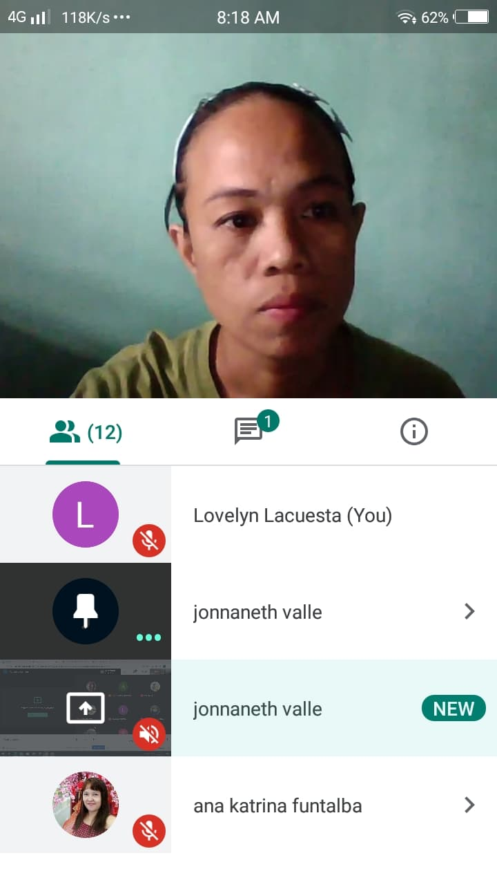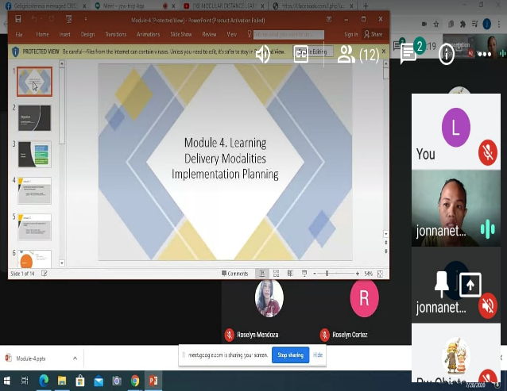

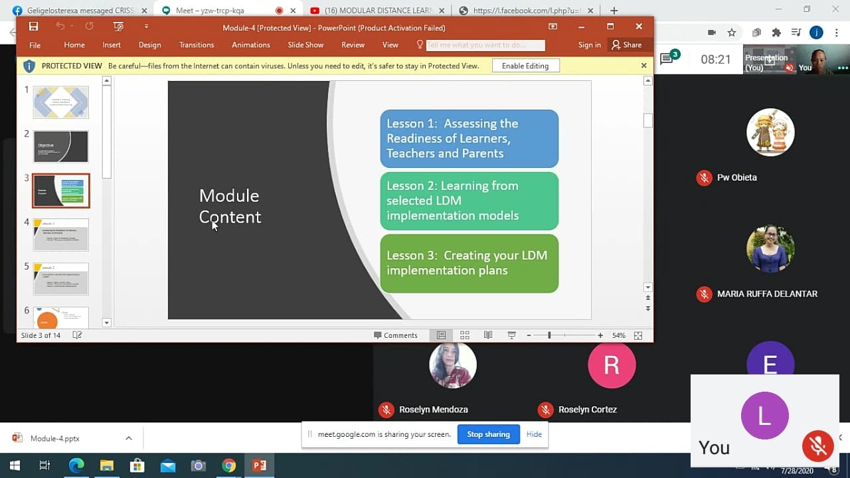

***Lesson 2: LEARNING FROM SELECTED LDM IMPLEMENTATION MODELS***

ACTIVITY 1:

Watch the Navotas video and read the briefs on the dry run of modalities. You may also consider searching the Internet for other implementation models. Write down your reflections on these models in your Study Notebook. Take note of the contexts of the Schools/Divisions in which these models are being implemented.

The Implementation Models are taken from Solomon Bediako’s paper titled “Models and concepts of curriculum implementation, some definitions and influence of implementation”, University of Cape Coast.

|  |  |  |
| --- | --- | --- |
| **Implementation Model** | **Description** | **Division/School Context** |
| ORC Model (Overcoming Resistance to Change) | This model rests on the assumption that the success or otherwise of curriculum implementation depends on the impact the developer makes on the users of curriculum such as teachers, students and the society in general. Change happens in addressing people’s misgiving, misapprehensions or other related factors. | Teaching staff  Students  Parents  Other School Stakeholders |
| LOC Model(Leadership-Obstacle Course Model) | This model treats staff resistance to change as problematic and propose that should collect data to determine the extent and nature of the resistance in implementing the curriculum. | School Principal  Subject Chairpersons  Teaching staff  Non-Teaching Staff |
| Linkage Model | This model recognizes that there are innovators in research and development centers. It has the link between the user system and the resource system. | Education Supervisors  School Principal  Subject Chairpersons  Teaching Staff |
| RCA Model (Rant Change Agent Model) | This model suggests that organizational dynamics seem to be the chief barriers to change. | Division Officer in Charge  Education Supervisor  School Principal |

ACTIVITY 2.

* + - 1. Of the implementation models that you reviewed, which can be a viable option for your School given your own context?

Since that the situation is very new for all concerns, ORC is very much applicable to the school wherein the success of the chosen LDM only depends through the continues efforts and initiatives of school, teachers, parents, students and other stakeholders involved.

1. Think about the model that you envision to use in your school. How will it look? Add captions or brief descriptions of the different elements of your diagram.

***Lesson 3: CREATING YOUR LDM IMPLEMENTATION PLAN***

**THE LEARNING DELIVERY MODALITY IMPLEMENTATION PLAN**

**PART I: LEARNING MANAGEMENT**

Objective: Establish the mechanism of organizing learners and managing learning

1. **LEARNER/CLASS ORGANIZATION**

|  |  |  |  |  |
| --- | --- | --- | --- | --- |
| ***ACTIVITIES*** | ***EXPECTED OUTPUT/ RESULTS*** | ***DATE OF IMPLEMENTATION / TIME FRAME*** | ***BUDGETARY REQUIREMENTS, IF ANY*** | ***PERSON-IN- CHARGE*** |
| Organize classes | Schedule of classes and sectioning | Per semester | Financial Assistance for the Internet Access/ Production of Modules | School Head, Admin and Teachers |
| Prepare weekly learning plan | Work Week Plan | Weekly | Financial Assistance for the Internet Access | Teachers |
| Prepare Individual Monitoring Plan | Schedule of Class Monitoring  Work Week Accomplishment Report | Weekly | Financial Assistance for the Internet Access | Teachers and parents  School Head and Teachers |
| Organize Teachers for Community Learning Sessions | LAC Sessions/ Webinars | Monthly | Financial Assistance for the Internet Access | School Head, Admin and Teachers |
| Organize/ Orient home and/or community learning facilitators | LAC Sessions/Webinars | Weekly | Financial Assistance for the Internet Access | School Head, Admin, Teachers and Parents |

1. **LEARNING PERFORMANCE MONITORING**

|  |  |  |  |  |
| --- | --- | --- | --- | --- |
| ***ACTIVITIES*** | ***EXPECTED OUTPUT/ RESULTS*** | ***DATE OF IMPLEMENTATION / TIME FRAME*** | ***BUDGETARY REQUIREMENT, IF ANY*** | ***PERSON-IN- CHARGE*** |
| Identify learner performance and progress monitoring reports | Work Week Accomplishment Report  Compilation of Learners’ Completed Modular/Online Activties | Weekly  Weekly | Financial Assistance for the Internet Access | School Head,Teachers and Parents  Teachers |
| Set schedule for learner progress report submission | Monitoring Plan on the Completion of Learners’ Modular/OnlineActivities  Schedule of Submission of Learners’ Completed Modular/OnlineActivties | Weekly  Weekly | Financial Assistance for the Internet Access | School Head, Teachers and Parents |
| Discuss reports and plans for actions to be taken on concerns and issues | Evaluation Reports consolidated after an online LAC | Monthly | Financial Assistance for the Internet Access | School Head, Admin and Teachers |

**PART II: LEARNING RESOURCES**

1. LEARNING RESOURCE MANAGEMENT

Objective: Improve availability of LR to reach 100% in all learning areas and grades across the quarters

|  |  |  |  |  |
| --- | --- | --- | --- | --- |
| ***ACTIVITIES*** | ***EXPECTED OUTPUT/ RESULTS*** | ***DEADLINE*** | ***BUDGETARY REQUIREMENTS, IF ANY*** | ***PERSON-IN- CHARGE*** |
| Setup inventory system of LRs | List of available LRs for each strand (SHS) | Before start of classes | N/A | LR Coordinator and Teachers |
| Acquire/ Request for LRs | List of unavailable LRs for each strand (SHS) and a Request for its availability | Before start of classes | Financial Assistance for the Internet Access | LR Coordinator and Teachers |
| Develop LRs | Self-Learning Kits, PowerPoint Presentations/Video Lectures | Before start of classes | Financial Assistance for the Internet Access | Teachers |
| Quality assure locally developed LRs | Evaluation Report of developed LRs | Before start of classes | Financial Assistance for the Internet Access | LR Evaluators |

1. LEARNING RESOURCE DISTRIBUTION AND COLLECTION MANAGEMENT

Objective: Ensure that all learners receive their learning materials and are collected for assessment

|  |  |  |  |  |
| --- | --- | --- | --- | --- |
| ***ACTIVITIES*** | ***EXPECTED OUTPUT/ RESULTS*** | ***DEADLINE*** | ***BUDGETARY REQUIREMENTS, IF ANY*** | ***PERSON-IN- CHARGE*** |
| Develop system of distribution and collection of LRs | Schedule of Distribution and Collection of LRs | Per Semester | N/A | LR Coordinator |
| Distribute and collect LRs | List of distributed and collected LRs | Per Semester | N/A | LR Coordinator and Teachers |
| Monitor and report distribution and collection | Online Report on the distribution and collection of LRs | Per Semester | N/A | LR Coordinator and Teachers |

**PART II: CONTINUING PROFESSIONAL DEVELOPMENT FOR TEACHERS AND OTHER SCHOOL PERSONNEL**

Objective: Improve PPST-based competencies of teachers in managing learning in the learning delivery modality

|  |  |  |  |
| --- | --- | --- | --- |
| ***ACTIVITIES*** | ***Timeline*** | ***Person-in- Charge*** | ***Budgetary Requirements*** |
| Planning, Assessment, Consolidation, Prioritization | Monthly | School Head | Financial Assistance for the Internet Access (Online LAC Sessions) of Teachers |
| Planning for PD interventions | Monthly | School Head | Financial Assistance for the Internet Access (Online LAC Sessions) of Teachers |
| Developing and Implementing School-based Interventions | Weekly | School Head | Financial Assistance for the Internet Access (Online LAC Sessions) of Teachers |
| Monitoring Teacher PD Activities | Weekly | School Head | Financial Assistance for the Internet Access (Online LAC Sessions) of Teachers |
| Assessing Teacher PD | Monthly | School Head | Financial Assistance for the Internet Access (Online LAC Sessions) of Teachers |

NOTE: You may need to consult the teachers on their professional development needs.

**PART III. RISK MANAGEMENT**

Objective: Identify risk to prevent it from happening or to mitigate its impact on the key implementation

|  |  |  |  |  |  |
| --- | --- | --- | --- | --- | --- |
| COMPONENTS OF LDM IMPLEMENTATION | RISK DESCRIPTION | LIKELIHOOD TO HAPPEN (High, Medium, Low) | SEVERITY OF RISK (High, Medium, Low) | PREVENTIVE ACTION | MITIGATING ACTION |
| Learning Management | Inaccessibility of Internet Connection for Learners’ Online Activities | High | Medium | Design modular activities to be distributed to learners who don’t have internet access | Set a weekly schedule or plan in the distribution of modular activities |
| Learning Resources | Unavailability of LRs | Medium | Low | Identify the lacking LRs | Create Self-Learning Kits and SIMs |
| Teacher CPD | Limited Knowledge on the Various Learning Modalities for the New Normal | Low | Low | Conduct webinars equipping teachers to have skills in administering various learning modalities | Monitor the teachers’ PD activities |

**PART IV: COMMUNICATION PLAN FOR THE IMPLEMENTATION OF LDM**

|  |  |  |  |
| --- | --- | --- | --- |
| AUDIENCE | KEY MESSAGES | COMMUNICATION MEDIA/ PLATFORM | TIMELINE |
| Learners | Despite the pandemic, you will still be provided with quality education through the implementation of LDM | TV/ Radio/Social Media | Weekly |
| Parents | To ensure your child’s learning, your guidance is necessary especially in monitoring their progress at home | TV/ Radio/ Flyers | Weekly |
| Teachers | We engage in seminars to be equipped with skills so as to fulfill our mission which is to provide quality education to our learners | Social Media  Telephone  Formal Meetings | Weekly |
| Community Stakeholders | The implementation of LDM needs a collaborative effort and support not only from school admin or teachers but also from the other members of the community | Social Media  Townhall | Weekly |

**MODULE 5B (FOR LAC LEADERS): ESTABLISHING AND MANAGING THE TECHNICAL ASSISTANCE MECHANISM FOR SCHOOL HEADS**

***Lesson 1: TECHNICAL ASSISTANCE AND COACHING: DEFINITIONS, FRAMEWORKS AND MECHANISM***

ACTIVITY 1.

Begin by articulating what you know and what you want to learn about the key concepts in this lesson. Use the Thought Organizers for Module 5B for this activity.

THOUGHT ORGANIZER FOR LESSON 1, ACTIVITY 1

|  |  |  |
| --- | --- | --- |
| **KEY CONCEPTS** | **WHAT I KNOW ABOUT THE KEY CONCEPTS BASED ON MY OWN EXPERIENCE AND PERSPECTIVES** | **WHAT DO I WANT TO LEARN ABOUT THESE KEY CONCEPTS** |
| **INSTRUCTIONAL SUPERVISION** | Developing teachers’ skills and strategies to make the students’ learning process meaningful | How to diagnose problems and provide objective feedback regarding teachers’ teaching difficulties |
| **COACHING** | Improving the clients’ performance and unlocking their potential | Techniques or styles in building rapport with the client |
| **TECHNICAL ASSISTANCE** | Providing professional help/training to achieve certain goals | How to strengthen organizational skills to meet the client’s specific needs |

ACTIVITY 2.

1. Download and read the Learning Delivery Modality Technical Assistance and Coaching Guidebook.

2. Read the following topics:

a. Definition of Technical Assistance and Coaching

b. Objectives of Technical Assistance and Coaching for the Learning Modality

c. Levels of Assistance

d. Principles

e. Technical Assistance and Coaching Process

f. Competencies of TA Providers and Coaches

g. Terms of Reference of TA Provides/Coaches

3. How can you enhance your instructional supervision using the processes of TA and coaching?

* Instructional supervision using the processes of TA and coaching can enhance by providing teachers and school leaders in relation to instructional component of the Learning Delivery Modalities. SDO and District Supervisors (called TA Providers – TAP) School leaders and teachers Instructional component of the Learning Delivery Modalities which covers TA and coaching.
* Teachers and education leaders are undergoing the training on the LDM course. Teachers apply what they have learned and build their teaching portfolio.

ACTIVITY 3.

1. Conduct LAC Session

a. Principles of TA and coaching

b. TA and coaching process

c. TORs and competencies of TA providers and coaches

|  |  |  |
| --- | --- | --- |
| **TA PROCESS STEPS** | **“KEY ELEMENT”** | **WHAT PRINCIPLE IS APPLIED IN THIS STEP** |
| **Step 1: TA NEEDS ASSESSMENT** | Assessment of the school’s, school head’s, teachers’, learners’ and parents’ readiness in the implementation of LDM | People are responsible for their own growth and development |
| **Step 2: TA PLANNING** | Identifying the needs of the teachers and learners and planning interventions in line with the school’s objectives | Technical assistance is aligned with the organization’s vision and mission and is based on the organization’s needs |
| **Step 3: IMPLEMENTATION** | Monitoring and providing objective feedback to the teachers and learners and adjusting plans based on their unique needs | Technical assistance is aligned with the organization’s vision and mission and is based on the organization’s needs |
| **Step 4: EVALUATION** | Analyzing gaps in the implementation of LDM and providing recommendations for its improvement | Learning is a cooperative and a collaborative process |

2. Based on your readings, discuss with your LAC the crucial element or “key message” in each of the four main steps of the TA and coaching process. Identify which TA principle is used in each of the steps. Use the Thought Organizers for Module 5B to guide the discussion.

***Lesson 2: TECHNICAL ASSISTANCE NEEDS ASSESSMENT AND PLANNING***

ACTIVITY 1.

Go through the Learning Delivery Modality Technical Assistance and Coaching Guidebook again, focusing on:

a. Needs Assessment part of the TA process

b. Grow model for Coaching

ACTIVITY 2.

With your Division Management Team, list the data that can help you determine the TA needs of schools in relation to the implementation of LDMs. Think about the coaching needs of the school heads in leading the schools through the new delivery modalities. Determine how the data can be obtained. Use the Thought Organizers for Module 5B for this activity.

THOUGHT ORGANIZER FOR LESSON 2, ACTIVITY 2

|  |  |  |  |
| --- | --- | --- | --- |
| **TARGET OF COACHING:** | **WHAT DATA SHOULD BE GATHERED TO UNDERSTAND THE COACHING NEEDS OF TEACHERS** | **HOW TO GATHER THE DATA** | **WHERE TO GET THE DATA** |
| **TEACHERs/ DEPARTMENT CHAIRS/ MASTER TEACHERS** | skills assessment on teachers / department chairs/ master teachers regarding the implementation of LDM | based on the PPST (with perspective of teaching in new LDM) | teachers/ department chairs/ master teachers |
| ***ACTIONS NEEDED TO FULLY UNDERSTAND THE COACHING NEEDS OF THE TEACHERS/DEPARTMENT CHAIRS/MASTER TEACHERS***  Engaging them through the process of (guided) self-reflection | | |
| *AS APPROPRIATE (e.g. schools with departments)* | | | |

|  |  |  |  |
| --- | --- | --- | --- |
| **TARGET OF TA:** | **WHAT DATA SHOULD BE GATHERED TO UNDERSTAND THE TA NEEDS OF THE DEPARTMENTS/ SUBJECT AREA GROUPS** | **HOW TO GATHER THE DATA** | **WHERE TO GET THE DATA** |
| **GROUPS IN SCHOOL SUCH AS DEPARTMENTS/ SUBJECT AREA** | assessment on department chairs regarding their skills in guiding their constituents | Based on their CPD (with perspective of teaching in new LDM) | Teachers / department chairs/ |
| ***ACTIONS NEEDED TO FULLY UNDERSTAND THE TA NEEDS OF THE GROUPS IN SCHOOL***  *For department chairs:* Engaging them through the process of (guided) self-reflection  *For teachers: surveys/focused group discussion on the skills assessment of their department chair.* | | |

ACTIVITY 3.

After your Division Management Team has gathered the data needed as identified in Activity 2:

**OUTPUT FOR MODULE 5: TECHNICAL ASSISTANCE PLAN FOR TEACHERS**

**MODULE 6B (FOR LAC LEADERS): MONITORING AND EVALUATION OF LEARNING DELIVERY MODALITY IMPLEMENTATION**

***Lesson 1: BASIC M&E CONCEPTS AND KEY RELATED FRAMEWORKS***

ACTIVITY 1.

1. Before we define what M&E is, let us first get familiar with some frameworks or guiding concepts and principles involved in M&E, specifically, Theory of Change and Kirkpatrick’s Levels of M&E of Training. Visit the following websites to read about Theory of Change and Kirkpatrick’s Levels of M&E. You may also check other websites to further understand these concepts and the related principles. a. Theory of Change: https://www.theoryofchange.org/what-is-theory-of-change/. b. Kirkpatrick’s Levels of M&E of Training: https://training.lbl.gov/Resources/TrainingEvaluation.html

2. Reflect on the following questions:

a. What are the similarities between Theory of Change and Kirkpatrick’s Levels of M&E?

Both Theory of Change and Kirkpatrick’s Levels of M&E address the processes in monitoring and evaluating the effectiveness and efficacy of LDM in yielding the intended outcome. The data collected would inform the necessary adjustments needed after assessing the teaching-learning process. Hence, these frameworks work hand in hand in determining the extent of the implementation of LDMs

Theory of Change and Kirkpatrick’s Levels of M&E have similarities for both have goal-setting as its initial step before learning can take place. The Theory of Change focuses on the desired long-term goal then checks the outcomes for better evaluation. This is somewhat similar to Kirkpatrick’s Levels that discusses the reaction, learning, behavior and results.

b. How are the two frameworks related? Use the Thought Organizer for Lesson 1, Activity 1 to help you correlate the key elements of the two frameworks.

|  |  |  |  |
| --- | --- | --- | --- |
|  | **THEORY OF CHANGE** |  | **KIRKPATRICK’S LEVELS OF MONITORING AND EVALUATION OF TRAINING** |
| What is the main interest of M&E in each framework | *focus of M&E*   * *filling in gaps based on a certain context* * *utilizing various platforms based on the implementation of LDM and on the learners’ needs* * *taking into action specific adjustments/enhancements on the utilization of various platforms based on the implementation of LDM and on the learners’ needs* |  | *focus of M&E*   * *evaluation of the efficiency and effectiveness of LDM* |
| M&E LEVELS | strategies | **⬄** | Reaction |
| Direct output | **⬄** | Learning |
| Expected outcome | **⬄** | Behavior |
| Direct impact | **⬄** | Evaluation |

ACTIVITY 2

1. Open the Thought Organizers for Module 6B file.

2. Read through the definitions of “monitoring” and “evaluation.” Search online for more definitions of these two concepts. Check out the common words among the:

(a) definitions of monitoring and

(b) definitions of evaluation. Connect the common words to write your own one-sentence definition/description of each of the following:

a. monitoring

b. evaluation

c. relationship between monitoring and evaluation

|  |  |
| --- | --- |
| ***MONITORING*** | ***EVALUATION*** |
| * Process of objective data collection and information gathering that will be used by management / leadership * Purposive gathering of pertinent information relative to how targets and the manner with which these targets were achieved * Systematic observation and documentation of information on the implementation of initiatives based on the plan. * “A continuing function that uses systematic collection of data on specified indicators to provide management and the main stakeholders of an ongoing development intervention with indications of the extent of progress and achievement of objectives and progress in the use of allocated funds. * Systematic and continuous collecting, analysis * Monitoring generates data that can be used in evaluations | * Analysis of information to make judgment that affects the institution/project/program. * Systematic investigation of the worth or merit of an object.” * Internal assessment of information (which is collected through monitoring) regarding the extent to which actual progress in implementation conforms to (or deviates from) the objectives set in the plan * The process of determining the worth or significance of a development activity, policy or program ….. to determine the relevance of objectives, the efficacy of design and implementation, the efficiency or resource use, and the sustainability of results. * Studies the outcome of a project (changes in income, benefits distribution, cost-effectiveness, etc.) * A periodic assessment of the efficiency, effectiveness, impact, sustainability and relevance of a project in the context of stated objectives. |
| ***Common Words from the***  ***definitions above*** | ***Common Words from the***  ***definitions above*** |
| * Collection of data * Objective * Systematic * Monitoring | * Analysis of information * Assessment |
| ***How I define Monitoring:***  Monitoring is a systematic collection of information and observation in an objective manner which ill be used as data of evaluation. | ***How I define Evaluation:***  Evaluation is the analysis of the data/information gathered through monitoring in order to see of objectives are met. |
| ***The relationship or link between Monitoring and Evaluation is:***  *Monitoring serves as the data gathering procedure in order to have informed decisions in evaluating.* | |

ACTIVITY 3.

Conduct LAC Session. In this LAC Session, lead the discussion of the questions in Activities 1 and 2 in this lesson.

1. What are the similarities between Theory of Change and Kirkpatrick’s Levels of M&E? How are they related? Use the Thought Organizer for Lesson 1, Activity 1 to guide the discussion.

2. What does “monitoring” mean? What about “evaluation?” Encourage LAC Members to share their own definitions.

3. How can you use Theory of Change and Kirkpatrick’s Level of M&E for the M&E of School LDM implementation?

**NARRATIVE REPORT**

**Topics**

* Monitoring and Evaluation of LDM Implementation
* Theory of Change, Kirkpatrick’s Levels of Monitoring and Evaluation

During the second day of LAC session, there were three activities answered. They started by differentiating Theory of Change from Kirkpatrick’s Levels of Monitoring and Evaluation. It also taught the participants how to evaluate the changes in the LDM chose in different levels. They made an LDM Implementation template to give as an idea on what could we do to make it effective. Afterwards, our English Coordinator, Mrs. Sieralyn S. Enriquez, elaborated the topics more and entertained some questions.

As Dep-Ed keep on saying, This Pandemic should not hinder the success of our future generations. With the cooperation and active participation of everyone from the agency down to the school faculty and staff, the support of the stakeholders and Divine Guidance, we will overcome these challenges that we are facing now…a living proof that Dep-Ed is a family, so as we in Minuyan National High School.

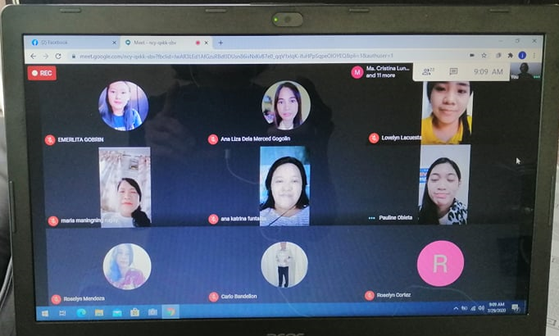

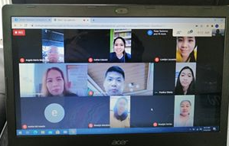

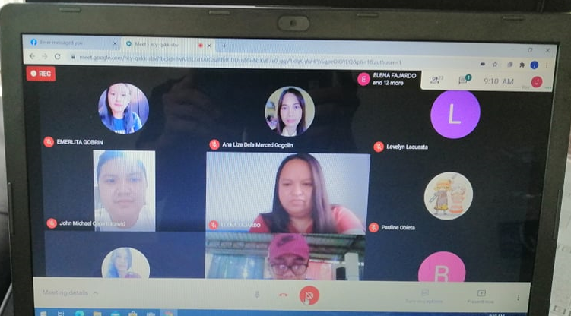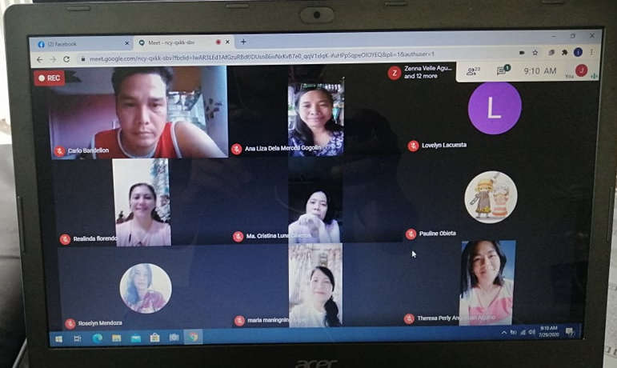

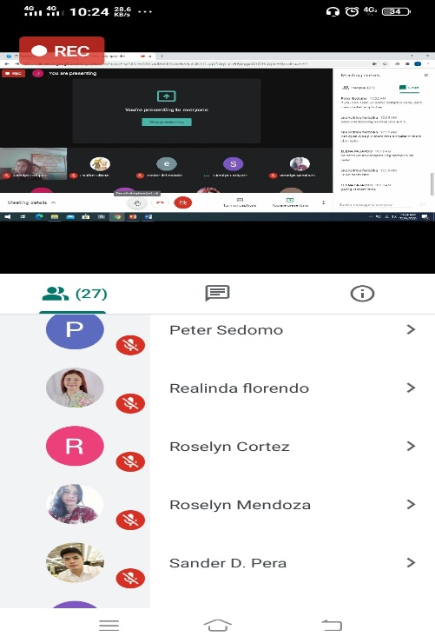

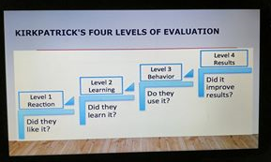

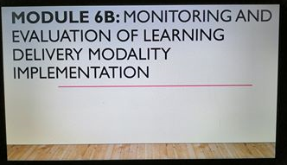

***Lesson 2: M&E FRAMEWORK AND PLANNING***

ACTIVITY 1.

Study the LDM Implementation M&E Framework. Reflect on this question:

What elements of LDM implementation do schools need to monitor and evaluate?

Answer:

It is very important that the TA and coaching Mechanisms be monitored and evaluated. Moreover, focusing on the learning competencies of teachers to deliver the MELCS using LDM is important as well. It is big thing that the teachers are well-equipped in the implementation of this learning mode. Through this, teachers will have more confidence and well-boosted morale in being the frontlines of learning. The school needs to monitor the aims and learning outcomes, the course content, the teaching methods and resources, and the assessment.

Specifically, the following elements need to monitored and evaluated;

* + Learner/class organization
  + Learning Performance Monitoring
  + Learning Resource Management
  + Continuing Professional Development for Teachers and other School Personnel
  + Risk management

ACTIVITY 2.

1. Study the M&E Plan Template.

2. Answer the following questions using the Thought Organizer for Lesson 2, Activity 2.

a. What developments or situations will make the schools in your Division change their LDMs?

b. What M&E data will they need to make this decision?

c. What issues or constraints do you foresee arising if the schools in your Division change their LDMs?

|  |  |  |
| --- | --- | --- |
| **QUESTION** | **YOUR ANSWER** | **ANSWERS FROM LAC MEMBERS** |
| What developments or situations will make the schools in your Division consider changing their LDMs? | The availability of Learning Resource  Students’ access to the internet | Sustainability of online classes  Availability of learning resource materials |
| What M&E data will the schools in your Division need to decide to change or make adjustments to their LDMs? | The appropriateness of the LDMs to the needs of the learners  The preparedness and knowledge of teachers, parents and learners | The extent of learning among learners |
| What issues or constraints do you foresee arising if the schools in your Division change their LDMs? | The lack of access to the internet and unavailability of the LRs | Preparedness of the teachers, students, parents in the conduct of the new LDMs |
| Personal Reflection | Since this is the first time that this learning modalities are used, there should be a collaborative effort among the school admin, faculty and stakeholders in order to provide what the students need. The continuous monitoring and evaluation are needed to make informed decisions in the implementation of LDM. | |

ACTIVITY 3.

Sample work of English Department for Monitoring & Evaluation Plan

|  |  |  |  |  |  |  |
| --- | --- | --- | --- | --- | --- | --- |
|  | **Indicator** | **Data Collection Method** | **Timing of Data Collection** | **Analysis Method** | **Who Will Collect & Analyze Data** | **Use of M&E Results**  **(This is the “Learning aspect of the M&E Framework)** |
| **LEVELS OF M&E INQUIRY** | **What indicators will be gathered to respond to the M&E Inquiry** | **How will you gather the indicator?** | **When will you gather the indicator?** | **How will you process the data gathered?** | **From whom will the data come from and who will collect?** | **Who are the users of the M&E Report?**  **What will they use it for (e.g., decision-making to adjust the LDM Plan)?** |
| **INPUTS AND ACTIVITIES:** |  |  |  |  |  |  |
| Learning Resources | * Setting inventory system of LRs and Modules * Requesting LRs * Developing LRs and Modules * Conducting Quality assurance of locally developed LRs and Modules | * LR Inventory * Request/s in Acquiring Lacking LRs and Modules * Compilation of developed LRs and Modules * Compilation of evaluated locally developed LRs and Modules | Two weeks before the start of every quarter | Evaluate the Submitted  and Consolidated Inventory Reports | School Head, LR Coordinator, Evaluators, Chairpersons and Teachers | * School Head- *to monitor the available and lacking LRs and modules; to provide technical assistance to teachers on the development of LRs and modules* * LR Coordinator- *to monitor the available and lacking LRs/modules* * LR Evaluator, Chairpersons - *to assure the quality of the locally developed LRs/modules* * Teachers- *to redesign or improve locally developed LRs/modules* |
| Learning Management | * Setting Schedule and Plan Learner/Class Organization * Monitoring Learners’ Performance * Discussing and Providing Feedback on Concerns/Issues of the LDM Implementation | * Work Week Plan and Accomplishment Reports * Evaluation Reports | Weekly  Weekly | * Evaluate the efficiency of the Class Schedule/Organization * Assess the Learners’ Progress * Appraise the Concerns/Issues on the LDM Implementation | School head, Admin, Faculty and parents/learners | * School head/admin- *to design monitoring plans, preventive and mitigating actions and provide technical assistance* * Faculty- *to gauge the efficiency and effectiveness of the LDM and address the arising concerns/issues* * Parents/Learners- *to provide suggestions on concerns/issues based on their context* |
| Teacher Capacity | * Planning, Assessment, Consolidation, Prioritization * Monitoring, Planning, Developing and Implementing School-based Interventions for Teachers’ Professional Development   (with the perspective of the implemented LDM) | * Accomplishment Reports * Reports on Teachers’ PD Activities, Self-Checklist and Reflection | Monthly  Monthly | Evaluate the Accomplishment Reports submitted | School Head. Chairpersons and Faculty | School Head – *to plan school-based interventions for Teachers;*  *Chairpersons*- *to provide technical assistance to concerned teachers*  Faculty- *to engage in Professional Development activities available online (webinars)* |
| Household and Community Capacity | * Planning and Collaborating with Parents and other Stakeholders | * Feedback from Parents and other Stakeholders on the LDM Implementation | Weekly | * Consolidate and Evaluate Feedback from Parents and other Stakeholders on the LDM Implementation | School Admin and Faculty, Parents, Stakeholders | *To design and conduct necessary adjustments to make the LDM more effective* |
| School Operations | Developing School-based Interventions regarding the LDM Implementation | Accomplishment Reports | Monthly | Consolidate and Evaluate Submitted Reports | School Head and Admin | School head/admin- *to plan and* d*evelop School-based Interventions on LDM Implementation* |
| **OUTPUTS** |  |  |  |  |  |  |
| Learning Resources | Learners’ Resources and Modules | Inventory Reports | Two weeks before the start of every quarter | Evaluate the Submitted  and Consolidated Inventory Reports | School Head, LR Coordinator, Evaluators, Chairpersons and Teachers | * School Head- *to monitor the available and lacking LRs and modules; to provide technical assistance to teachers on the development of LRs and modules* * LR Coordinator- *to monitor the available and lacking LRs/modules* * LR Evaluator, Chairpersons - *to assure the quality of the locally developed LRs/modules*   Teachers- *to redesign or improve locally developed LRs/modules* |
| Learning Management | * Schedule and Set-up of Modular Learning * Comprehensive Plan in the Implementation of Modular Learning | * Work Week Plan and Accomplishment Reports * Schedule of Class Monitoring * Evaluation Reports | Weekly | Evaluate the efficiency of Modular Learning | School head, Admin, Faculty and parents/learners | * School head/admin- *to design monitoring plans, preventive and mitigating actions and provide technical assistance* * Faculty- *to gauge the efficiency and effectiveness of Online Classes and Modular Learning concerns/issues* * Parents/Learners- *to provide suggestions on concerns/issues based on their context* |
| Teacher Capacity | * School-based Interventions (Webinars) for Teachers’ Pedagogical and Professional Development   (with the perspective of the implemented LDM) | * Accomplishment Reports * Reports on Teachers’ Professional Development activities, Self-Checklist and Reflection | Monthly  Monthly | Evaluate the Reports submitted | School Head. Chairpersons and Faculty | School Head – *to plan school-based interventions for Teachers’ Professional Development*  Chairpersons- *to provide technical assistance to concerned teachers*  Faculty- *to engage in Professional Development activities available online (webinars)* |
| Household and Community Capacity | Orientation-webinars for parents and other stakeholders | * Feedback from parents and other Stakeholders on the LDM Implementation | Weekly | Consolidate and Evaluate Feedback from parents and other stakeholders on the LDM Implementation | School Admin and Faculty, Parents, Stakeholders | *To design and conduct necessary adjustments to make Modular Learning more effective* |
| School Operations | * School-based Interventions on LDM Implementation * Technical Assistance on how to make Modular Learning Effective | * Accomplishment Reports | Monthly | Consolidate and Evaluate Submitted Reports | School Head and Admin | School head/admin- *to plan and* d*evelop School-based Interventions and Technical Assistance on LDM Implementation* |
| **MID-TERM RESULTS:** |  |  |  |  |  |  |
| Learning Resources | Sufficient LRs and Modules | * Inventory Reports | Throughout the school year | Evaluate the submitted  and consolidated Inventory Reports | School Head, LR Coordinator, Evaluators, Chairpersons and Teachers | Teachers |
| Learning Management | Progress of the Teaching-learning process | * Reports on Learners’ Progress | Quarterly | Evaluate Learners’ Progress | Teachers | Teachers- *to design and provide interventions for students who have learning difficulties* |
| Teacher Capacity | Skilled and equipped teachers in conducting Modular Learning | * Accomplishment Reports * Reports on Teachers’ Professional development activities, Self-Checklist and Reflection | Monthly  Monthly | Evaluate the Teachers’ LDM Implementation | School Head. Chairpersons and Teachers | School Head – *to plan school-based interventions for Teachers’ PD*  Chairpersons- *to provide technical assistance to concerned teachers*  Faculty- *to engage in PD activities available online (webinars)* |
| Household and Community Capacity | Strong Support System of Parents and Other Stakeholders | * Feedback from parents and other stakeholders on the LDM Implementation | Quarterly | Assess the stakeholders’ Participation in the LDM Implementation | School Admin and Faculty, Parents, Stakeholders | *To design and conduct necessary adjustments to make Modular Learning more effective* |
| School Operations | Continuous conduct of meaningful School-based Interventions and Technical Assistance on how to make Modular Learning Effective | * Accomplishment Reports | Monthly | Consolidate and Evaluate Submitted Reports | School Head, Admin and Teachers | School head/admin- *to plan and* d*evelop School-based Interventions and Technical Assistance on LDM Implementation*  Teachers- *to apply the provided Technical Assistance on how to make Modular Learning Effective* |
| **OUTCOMES:** | Learners will achieve mastery of competencies and skills based on their needs for life-long learning. | Assessment of Learners’ Progress | Year-end | Evaluate the Learners’ Progress | Teachers | Learners – *to apply learned knowledge and mastered skills in real-life situations* |