CSCI-GA.2270 Computer Graphics

Erica Peng

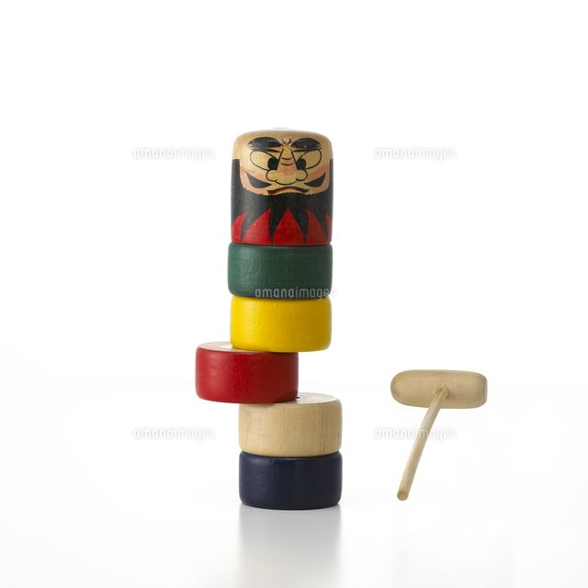**Final Project: Daruma Otoshi Simulation**

**Description**

Daruma Otoshi is a single-player game where the player is given a tower of cylindrical blocks and a hammer. The player then has to knock out all the blocks from underneath the top block one-by-one until the top block is on the table, without letting the tower fall over. Here is a video demonstration of how the game works: <https://www.youtube.com/watch?v=zlz0FY8XGig> . I plan to use physics and computer graphics to simulate this game.

**Technical Details**

The hammer is controlled by the mouse location. The speed of the moving mouse is calculated and used to determine the hammer’s force on a cylindrical block. Because the speed of the mouse is relative to the proportion of the tower displayed in the viewport, the possibility to zoom in and out has been added so that the user can have more control of the speed at which they hit the blocks.

**Controls**

* Space bar
  + Resets the game
* C
  + Turns on cheat mode, in which every hammer swing will be the perfect amount of force from keeping the tower from toppling over.

**Computer Graphics Details**

Use rasterization to render the scene. I used a darumaotoshi triangle mesh from Turbo Squid and then rendered the objects with texture mapping on the top block and hammer, and phong shading on the remaining blocks. Some screenshots have been included below. The first image shows a game in progress, the second shows a lost game, and the last shows a game in which the user has won.

