 | Department of Computer Science  Meet the faculty

  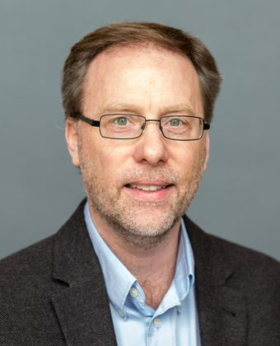 | Derek Schuurman  Professor · Chair · NH 296  Focus: Faith and technology, embedded systems and IoT, robotics and computer vision  Email: derek.schuurman@calvin.edu
  – PhD, McMaster University
  – BASc and MASc in Electrical Engineering, University of Waterloo
  – Writes on the ethics and philosophy of technology
  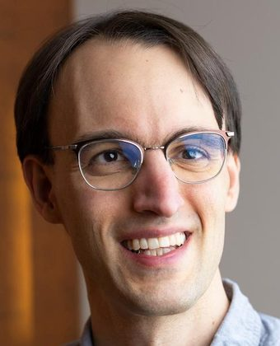 | Ken Arnold  Associate Professor · NH 298  Focus: Data science, artificial intelligence and Christian faith  Email: ken.arnold@calvin.edu
  – PhD in Computer Science, Harvard University, 2020
  – SM, MIT Media Lab; BS in Electrical and Computer Engineering, Cornell
  – Language models for writing, and public understanding of what AI can and cannot do
  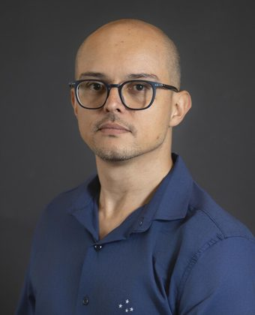 | Eric Araújo  Associate Professor · NH 293  Focus: Agent-based modelling, complex networks, computational social science  Email: eric.araujo@calvin.edu
  – PhD in Computer Science, Vrije Universiteit Amsterdam
  – MS, Federal University of Minas Gerais; BS, Federal University of Viçosa, Brazil
  – Studies how behaviour, health and misinformation spread
  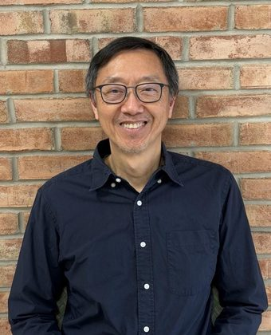 | Rocky Chang  Professor · NH 299A  Focus: Network security, internet infrastructure, computational thinking  Email: rocky.chang@calvin.edu
  – PhD in Computer and Systems Engineering, Rensselaer Polytechnic Institute
  – More than 30 years teaching computer science
  – Leads the cybersecurity certificate
  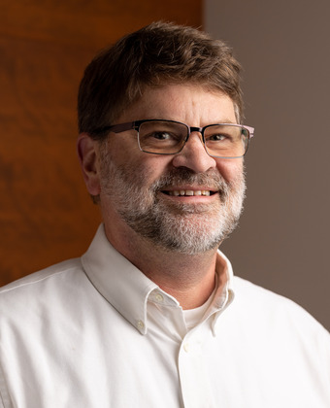 | Victor Norman  Associate Professor · NH 297  Focus: Computer science education, K-12 outreach, computing for Christian missions  Email: victor.norman@calvin.edu
  – PhD and MS, Purdue University; BS, Calvin College
  – 14 years in industry as a principal software engineer before teaching
  – Works on applying the virtues to how we write programs
  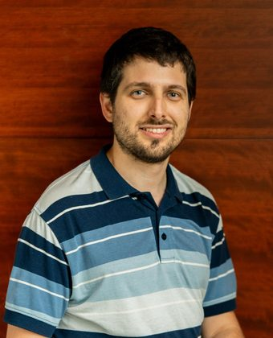 | Fernando Santos  Assistant Professor · NH 291  Focus: Data science, computational modelling, human-computer interaction  Email: fernando.santos@calvin.edu
  – PhD in Computational Science, University of São Paulo
  – Also works on the philosophy of technology
  – Originally from Poços de Caldas, Brazil

 |  | Also teaching with us  Rob Bobeldyk Information Technology rob.bobeldyk@calvin.edu  Stacy DeRuiter Mathematics and Statistics stacy.deruiter@calvin.edu  Monica Groenenboom Engineering monica.groenenboom@calvin.edu  David Meyer Adjunct faculty david.meyer@calvin.edu  Jim Momeyer Contributing faculty jim.momeyer@calvin.edu  Brian Paige Contributing faculty brian.paige@calvin.edu  Michael Poff Contributing faculty michael.poff@calvin.edu
  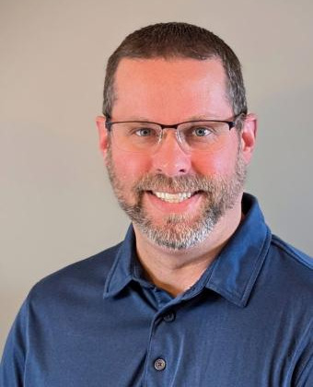 | Chris Wieringa  Systems Engineer · SB 319  Focus: The labs, the servers and the systems every course here runs on  Email: chris.wieringa@calvin.edu
  – Runs the labs, servers and systems behind every computer science course

