class04.R
ericayuehu
2026-01-16
x <- 1:50
plot(x)
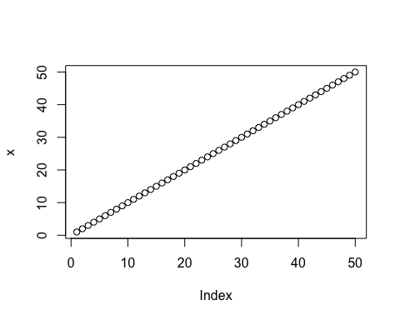
plot(x,sin(x), typ="l", col="pink",lwd=3,xlab="is it time")
