After Creating Post Section

https://rails.devcamp.com/trails/rails-bdd-tdd-course/campsites/creating-posts

1) Post Creation can be created

Failure/Error: expect(@post).to be_valid

expected #<Post id: nil, date: "2017-11-26", rationale: "Anything", created_at: nil, updated_at: nil, user_id: nil> to be valid, but got errors: User must exist

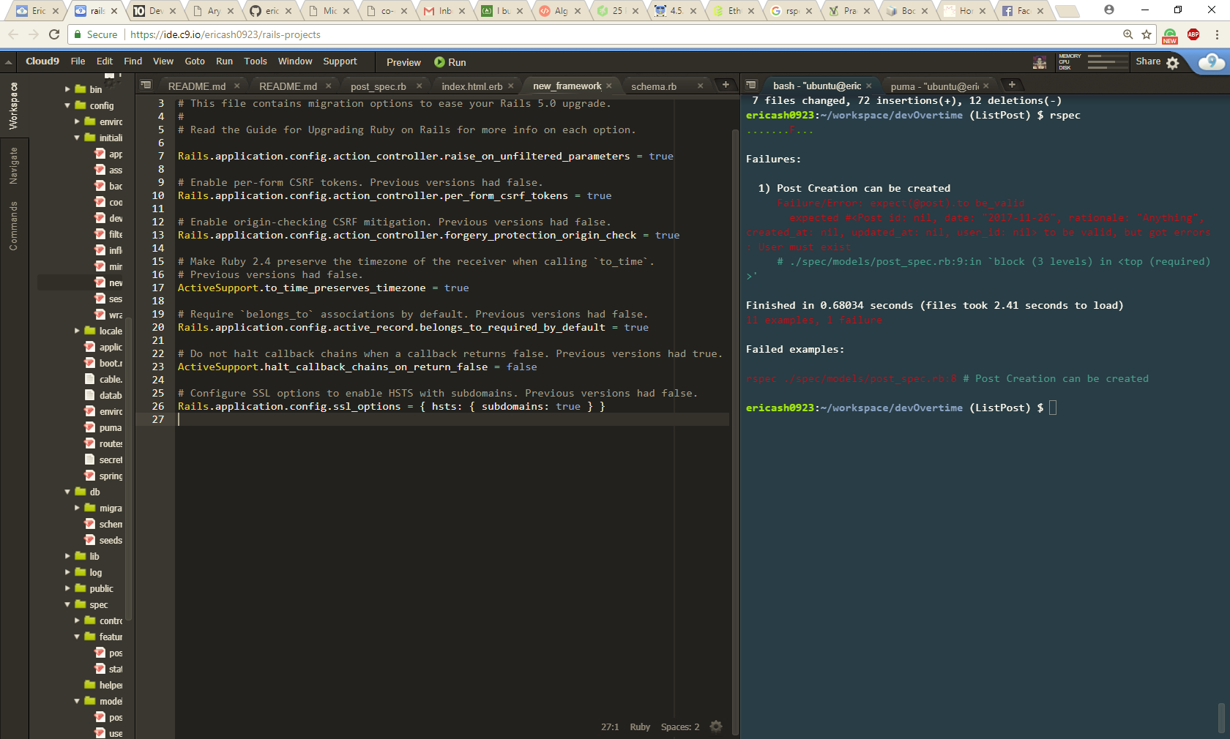

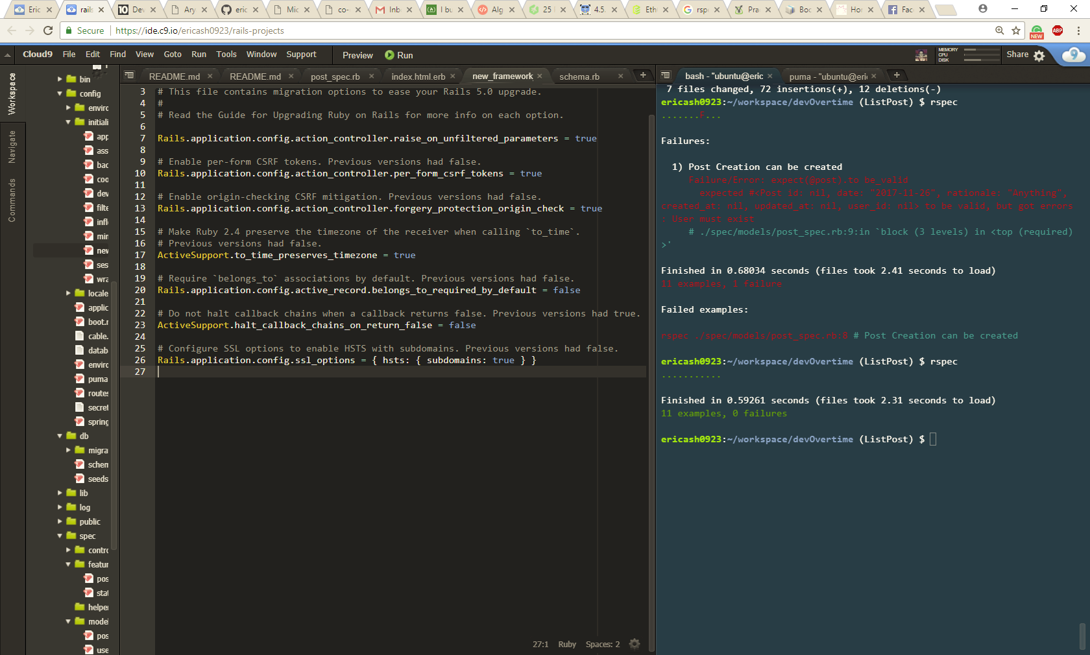

Rails 5 makes belongs_to association required by default

Config/initializers/new_framework.defaults.rb

Rails.application.config.active_record.belongs_to_required_by_default = true

To

# Require `belongs_to` associations by default. Previous versions had false.

Rails.application.config.active_record.belongs_to_required_by_default = false