# **Useability and Session Based Testing**

**Charter Name:**

Web Application character for filtering user inputs.

**Areas:**

Evens and Odds

Filter Object

Sum

**Start Time/Date:**

1:00 PM/December 20, 2021

**Tester:**

Erica

**Task Breakdown:**

* 1. Navigate to the app: <https://devmountain-qa.github.io/Automation-Basics/build/>
  2. Enter the numbers or objects for each section to determine if the expected results are displayed in the targeted section.

**Duration**:

Short(40 min)

**Bugs Reported/Investigated:**

* No instructions or tip tools for any of the sections.
* Evens and Odds: entered 1234 and 1234 displayed in the Odds portion. The split button is misleading, the intuitive understanding is that the numbers would be split up in both the evens and odds portions.
* Evens and Odds: entered 1 2 and 1 was displayed in the Odds portion.
* Filter Object: (Sensitive to capitalization) entered Name (vs name as an property) and no results were filtered.
* Sum: There is no character limit on the numbers that can be entered on the entry lines.

**Data Files: (**Screenshots or documents that we have found during our session-based testing)

Screenshot of the Evens and Odds section not splitting up the numbers between the evens and odds portions of the section:

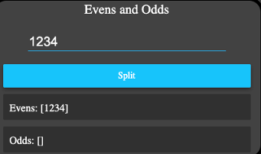

Screenshot of the Evens and Odds section not capturing all the numbers entered and splitting up the numbers between the evens and odds portions of the section:

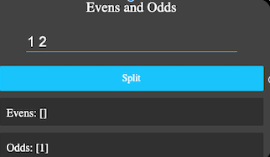

Screenshot of the Filter Object section displaying case sensitivity for an entered object property:

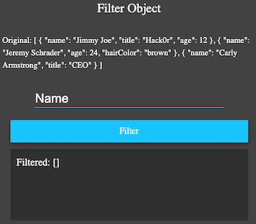

Screenshot of the Sum section results when decimal numbers were entered:

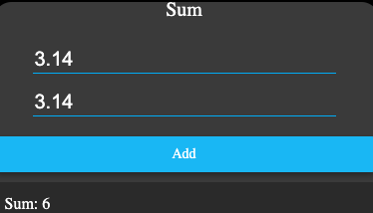

Screenshot of the Sum section when the number 2 was entered 30 times:

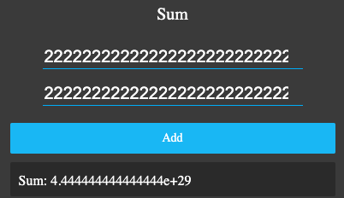

**Test Notes:**

* Evens and Odds: seems to be more intuitive. Enter an even or odd number on the entry field and click on the Split button. Based on the entry, the number will display in either the even or odd filtered out section/display. The last digit in a string of numbers determines if the number is even or odd and where it will display within the evens and odds portion of the section.
* Filter Object: enter the object (name, title, age, hair Color) and the results will return all the properties for that object.
* Sum: enter the two values on separate entry lines, click the Sum button and the summation between the two entries should be displayed.
* Sum: user cannot enter anything other than a positive and negative numbers.

**Bugs:**

Bug:

Steps to Reproduce for Instructions

1. Navigate to <https://devmountain-qa.github.io/Automation-Basics/build/>
2. No user instructions are displayed on the screen.

Bug:

Steps to Reproduce for Evens and Odds

1. Navigate to <https://devmountain-qa.github.io/Automation-Basics/build/>
2. Enter 1234 (note: with no spaces between the numbers)
3. Click the Split button
4. The numbers 1234 was displays in the Evens portion.

Bug:

Steps to Reproduce for Evens and Odds

1. Navigate to <https://devmountain-qa.github.io/Automation-Basics/build/>
2. Enter 1 2 (note: with a space between the numbers)
3. Click the Split button
4. The number 1 was displays in the Odds portion.

Bug:

Steps to Reproduce for Filter Objects

1. Navigate to <https://devmountain-qa.github.io/Automation-Basics/build/>
2. Enter Name (Capitalize only the letter N)
3. Click the Filter Button
4. The Filter object results returns blank.

Bug:

Steps to Reproduce for Sum

1. Navigate to <https://devmountain-qa.github.io/Automation-Basics/build/>
2. Entered the number 1 (note: entered 30 times)
3. The sum 2.222222222222222e+29 was displayed in the Sum portion.

**Issues**:

* Sum: it is not clear if numbers need to entered (typed) or if the entry numbers should be selected from the up and down options.
* Sum: it is not clear if the number has to be only a whole number.
* Sum: both upper and lower case for the letter E can be entered on the input lines.
* Sum: a delay in displaying the number entered.

**Testing Summary**

For the sections (Evens and Odds, Filtered Object, and Sum) that were targeted for this charter, the sections returned inconclusive (or inconsistent) results. Not having documentation that instructed on how to use each section would have help the user’s initial understanding of what was expected to be entered. In addition, if complexities is not a factor in the input the results were properly returned. An example of the this is shown with Evens and Odds when entering the number 2 for the input, clicking on the Split button, the results is the number 2 in the Evens portion of the section.

For the sections that were not targeted for this charter, the Filter String and Palindrome sections also lack the proper instructions for guiding the user on the how to use those sections. During exploratory testing, the Filter String section returned the string entered, but if multiple strings were entered, the results would be blank. For Palindrome section, there appears to be an bug with this section because every entry returned a false results. When, “The quick brown fox jumps over the lazy dog” (with and without quotes), it returned false, this should have returned “true”.

**Test Plan**

**Overview:**

Test each section in the web application.

**Link**: <https://devmountain-qa.github.io/Automation-Basics/build/>

**Test Criteria**

* Ensure that the Odds and Evens section take a string of numbers and sort them into odd and even outputs.
* Ensure that the Filter Object section can be filtered by entering any of their properties. Only objects with that property will appear in the results.
* Ensure that the Filter String section the string entered only contains the string the user inputs will return as the result.
* Ensue that for the Palindrome section returns true or false based on the string entered being a palindrome or not a palindrome.
* Ensure that the Sum section for the numbers entered on both entry line will return a sum of the entered numbers.

**Manual Testing for the Sum Section:**

Test Case Steps:

1. Navigate to <https://devmountain-qa.github.io/Automation-Basics/build/>
2. Locate the Sum section
3. Enter 3.14 on the first entry line
4. Enter 3.14 on the second entry line
5. Click the Add button.

Expected Results: 6.28

Actual Results: 6

**Boundary testing for the Filter Object section:**

**name title age hairColor**

|  |  |  |  |  |
| --- | --- | --- | --- | --- |
| **Invalid** | **Invalid** | **Invalid** | **Invalid** | **Invalid** |
| **Partition 1** | **Partition 2** | **Partition 3** | **Partition 4** | **Partition 5** |

**Decision table testing for the Filter String section**

**Note: No spaces, quotes, or commas before or after the name entered**

|  |  |  |  |  |  |  |  |  |
| --- | --- | --- | --- | --- | --- | --- | --- | --- |
|  | **T1** | **T2** | **T3** | **T4** | **T5** | **T6** | **T7** | **T8** |
| **Enter James** | **N** | **Y** | **N** | **N** | **N** | **N** | **N** | **N** |
| **Enter Jessica** | **N** | **N** | **Y** | **N** | **N** | **N** | **N** | **N** |
| **Enter Melody** | **N** | **N** | **N** | **Y** | **N** | **N** | **N** | **N** |
| **Enter Tyler** | **N** | **N** | **N** | **N** | **Y** | **N** | **N** | **N** |
| **Enter Blake** | **N** | **N** | **N** | **N** | **N** | **Y** | **N** | **N** |
| **Enter Jennifer** | **N** | **N** | **N** | **N** | **N** | **N** | **Y** | **N** |
| **Enter Mark** | **N** | **N** | **N** | **N** | **N** | **N** | **N** | **Y** |
| **Return James** | **N** | **Y** | **N** | **N** | **N** | **N** | **N** | **N** |
| **Return Jessica** | **N** | **N** | **Y** | **N** | **N** | **N** | **N** | **N** |
| **Return Melody** | **N** | **N** | **N** | **Y** | **N** | **N** | **N** | **N** |
| **Return Tyler** | **N** | **N** | **N** | **N** | **Y** | **N** | **N** | **N** |
| **Return Blake** | **N** | **N** | **N** | **N** | **N** | **Y** | **N** | **N** |
| **Return Jennifer** | **N** | **N** | **N** | **N** | **N** | **N** | **Y** | **N** |
| **Return Mark** | **N** | **N** | **N** | **N** | **N** | **N** | **N** | **Y** |

**State transition diagrams for the Filter String section**

Enter a Enter the 26 letters

Non-Palindrome of the alphabet

Third Attempt

Second Attempt

Start

Click

Check

Enter a

Palindrome

Display Filtered Name

Display Filtered as Blank

**Test Summary:**

After executing multiple test techniques for testing the functional, non-functional, and flow of the web application, the findings have determined that the sections are not performing as intended based on the provided requirements. Overall, a good user experience is at risk due to limited documentation on how to use each section of the web application. The site has a flow, in the sense that it is clearly display that there is distinct functionality in each section. What is not clear about the flow, is the intended purpose of the sections on one page in connection with each other. Not having all of the requirement rules with the initial exploratory testing made it unclear to fully understand what the expected results should be. The load performance for the Sum section was delayed after selecting an input for both entry lines. A demonstration of the incorrect answer being displayed was persistently represented in the Palindrome section.

Based on the QA findings, clearly stated documentation is required to ensure that end-user is properly entering the intended inputs to gain the expected results.