**HONOURS DISSERTATION TOPICS IN ORDER OF PREFERENCE**

EITHER select your preferred project(s) from the list circulated OR suggest your own topic.

Complete this form and have it signed by your proposed supervisor before submitting it to Programme Administrator Nicola Clark ([nicola.clark@ed.ac.uk](mailto:nicola.clark@ed.ac.uk)), by the deadline below.

**YOUR NAME:** Erica Zaja

1. **FIRST PREFERRED TOPIC: SUPERVISOR NAME AND TOPIC NUMBER/TITLE:**

**Supervisor signature**:

1. **SECOND CHOICE TOPIC: SUPERVISOR NAME AND TOPIC NUMBER/TITLE:**

**Supervisor signature**:

1. **THIRD CHOICE TOPIC: SUPERVISOR NAME AND TOPIC NUMBER/TITLE:**

**Supervisor signature**:

**OR STUDENT’S OWN TOPIC:**

**Proposed title:**

Shrubification in the Western Arctic and its Effects on habitat of the Porcupine Caribou Herd

**Please give some further details:** Mapping out areas within the Porcupine Caribou herd range that are the most affected by shrubification and inferring how this might influence caribou diet with future migration patterns.

**Proposed Supervisor:** Dr Isla Myers-Smith

**

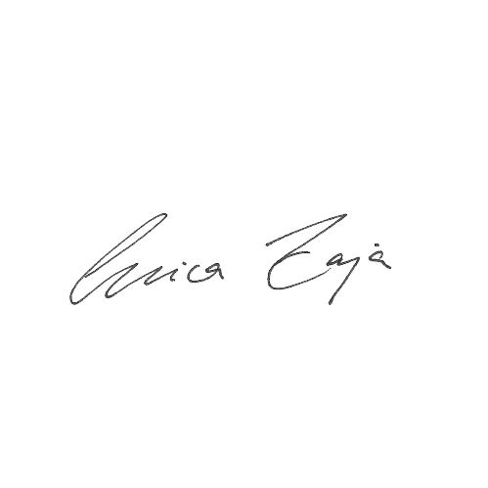

**Your signature**:

**Date: 21/05/2021**

**PLEASE RETURN TO Programme Administrator** [**nicola.clark@ed.ac.uk**](mailto:nicola.clark@ed.ac.uk)

**BY EITHER**

**Summer Project: FRIDAY 21 May 2021**

**OR**

**Winter Project: Monday 4 OCTOBER 2021**