**Shrubification in the Western Arctic and its Effects**

**on the Porcupine Caribou Herd Habitat**

**Introduction**

The **Arctic is warming more than twice as fast** as the global average: since the late 19th century, the Earth has warmed by approximately 0.8°C, while the Arctic has warmed by 2-3°C (Post et al., 2019; IPCC, 2013). Increasing temperatures have **altered snow regimes,** **accelerated decomposition rates and extended the growing season,** with **leaves senescence** happening later in time (Bjorkman et al., 2019). Periodic seasonal phenomena have also been altered by increasing temperatures, with **plant spring phenology events such as flowering and seed maturation advancing** in time (Bjorkman et al., 2015). Concurrent with Arctic warming, **deciduous shrubs have expanded in relative abundance and cover** with variability across the region, outcompeting other plant groups such as forbs and lichens (Elmendorf et al., 2012; García Criado et al., 2020). This phenomenon - also known as Arctic shrubification *-* occurs in the form of infilling of existing patches, increased growth, and advancing of shrublines (Myers-Smith et al., 2011)*,* with woody species (*Betula*, *Alnus*, *Salix),* starting to dominate the Arctic landscape (Mekonnen et al., 2021). **Such changes in vegetation community composition and phenology influence the abundance and distribution of Arctic herbivores** (Mallory & Boyce, 2018).

Caribou (*Rangifer tarandus*) are among the most abundant long-range migratory herbivores in the Northern Hemisphere (Mallory & Boyce, 2018). Due to an observed 40% decline over three generations across the Arctic, caribou was classified as **vulnerable** by the IUCN red list in 2015 (Gunn, 2015). The **causes of this decline remain uncertain**, but likely include habitat change, with caribou **population size responding negatively to vegetation change since caribou require late successional habitats** (APPS et al., 2001)and tend to browse in areas containing abundant lichen cover (Joly et al., 2003). Caribou are generalists (with diets including sedges, forbs, lichens, and shrubs) and seasonally selective: in the winter, caribou prefer to forage on slow-growing lichens (Russell, Martell & Nixon, 1993). Being migratory, caribou populations are highly susceptible to landscape change and seasonal habitat degradation, disrupting migration routes. Some known mechanisms causing disruption include anthropogenic barriers, unregulated hunting, and habitat fragmentation. The possible interactions of climate change with caribou population dynamics are highly complex and still under-studied. It is likely that warming temperatures will increase effects of disease and parasite loads (Gunn, 2015), but how migratory behaviour may be affected still remains unclear.

Distributing across the U.S-Canadian border, the **Porcupine Caribou Herd (PCH)** is one of the largest herds in North America (Severson et al., 2021). The PCH plays a key role in the ecosystem by supporting predator populations (MUSIANI et al., 2007) and via grazing effects on vegetation (Wal, 2006). The PCH also has irreplaceable economic and cultural value, being crucial for the livelihoods of Indigenous peoples such as the Inuit and Tlicho (Kerber, 2015). **Arctic shrubification could deteriorate the herd’s pasture quality**, **with shrubs outcompeting lichen and mosses - caribou’s preferred diet** in winter and spring - resulting in potential declines in PCH populations (Fauchald et al., 2017). In particular, high-quality summer forage is critical for female body condition during lactation, with females having a window of 2 months over the summer to restore their fat reserves and gain enough fat to reproduce the following year (Barboza et al., 2018). Increased summer temperatures have indeed been found to **decrease nitrogen concentration in plant species due to increased net carbon production and dilution effects (Turunen et al., 2009)**, endangering caribou’s nutritional health and reproductive success. It is important to note that the PCH has had the lowest capacity for growth among Alaska barren-ground herds, indicating it has the lowest tolerance to anthropogenic and climate-change driven stressors (Douglas et al.).

Like most caribou populations, the **PCH undertakes annual long-distance migration between summer and winter ranges**, to **track emergent vegetation** and to **decrease predation risk** during the calving season (Mallory & Boyce, 2018). The herd currently moving in spring from the Yukon and Northwest Territories to its calving grounds in Alaska (Kerber, 2015). Changes in plant phenology have been found to affect PCH spatial distribution, with caribou tracking protein-rich vegetation in early growth stages and **predominantly using Alaskan habitat in years of accelerated phenology** (Severson et al., 2021). These phenological shifts could affect the present PCH migrationroute. Migration is an ecologically fundamental behaviour, ultimately determining herd abundance (Gunn et al., 2009). Since herds are a prey base for large carnivores, the consequences of changes in PCH migratory behaviour could have cascading effects across food webs (MUSIANI et al., 2007).

While human-driven threats to caribou such as land-use change and energy production are well documented (Gunn, 2015), the impacts of climate change on caribou population dynamics are still unclear. Understanding how the PCH distribution may respond to shrubification is therefore crucial to inform habitat conservation commitments across the Alaska-Yukon border. The effectiveness of protected areas in landscape management is contentious since such conservation actions havenot slowed down caribou decline (Johnson, Ehlers & Seip, 2015). Given the migratory nature of caribou, conservation efforts should aim to provide a network of protection for annual ranges, across international borders.  Warming temperatures and improved access to resources in the northern Arctic are likely to increase industrial activity and development (Severson et al., 2021), increasing disturbance within the PCH habitat. It is therefore crucial to **understand how suitable habitat may be distributed in the future in order to protect the PCH range and to support its role in the ecosystem and ensure the subsistence of Indigenous communities** (Severson et al., 2021).

**Objectives**

To **identify which areas within the PCH range are the most vulnerable to shrubification** and understand how such vegetation change may affect their nutritional health. Ultimately, the objective of this research is to **predict how shrubification might affect the PCH distribution pattern and future migratory behaviour.**

**Research Questions & Hypotheses:**

1. **Which areas within the PCH range are most vulnerable to shrubification?**

* Warmer temperatures enhance soil microbial activities that supply nutrients for shrub uptake (Myers-Smith et al., 2011) facilitating shrub growth in particular regions of the PCH summer range.

**H1**: Shrub cover will be **greater in warmer and wetter areas** of the PCH summer range.

**H0**: Shrub cover will not be associated with variation in temperature and moisture in the PCH summer range.

1. **How will changes in vegetation influence the nutritional health of the PCH?**

* Shrubs could outcompete lichens and mosses, deteriorating nutritional health of the PCH, since shrubs have **strong anti-browsing defences** (toxins) (Fauchald et al., 2017).

**H1**: **Increased shrub cover will be associated with decreased lichens and mosses** cover and thus **decreased forage quality.**

**H0**: Increased shrub cover will not affect lichens and mosses cover, with forage quality remaining unaffected.

1. **Will shrubification affect the PCH migratory behaviour?**

* In spring and early summer, caribou will seek out vegetation in early phenological stages, higher in protein (Severson et al., 2021). **Advances in plant phenology and shrubification will increase use of ranges westward and northward** **(Alaskan coastal plain**, with mottled snow protecting from predation and high-quality plants’ early emergence) and decrease use of the eastern range (Yukon) (Severson et al., 2021).

**H1**: Increased shrub cover will be associated with increased use of ranges westward and northward and decreased use of the eastern range.

**H0**: Increased shrub cover will not affect range use.

**Proposed methods of working**

1. **Map shrub cover** (aboveground biomass (AGB): ecologically meaningful measure encompassing a 3D aspect. AGB reflects energy stored in vegetation, quantifies forage availability and determines habitat quality) **within the summer** (and winter) **range of the PCH**, using total caribou annual range data 1983 - 2001 (Griffith, 2002) (U.S Department of the Interior, from Griffith et al., 2002) and **shrub map of North Slope of Alaska 2007-2016** (Berner et al., 2021). Crop shrub map to caribou range to know where shrubs are within the range.
2. **Map out changes in NDVI** (or other vegetation indices) **within the PCH range, using Landsat** NDVI data over time (Berner et al., Nature Communications, 2020).
3. Test whether **increasing spectral greenness corresponds with shrub cover**.
4. Compile **forage quality and preferred summer forage information** for caribou from the literature (pers. comm. Libby Ehlers, 2021).
5. Analyse **vegetation change (cover of moss, lichen, shrubs) from long-term plot-based vegetation monitoring** in or near the PCH summer range using the Arctic Vegetation Archive data.
6. **Map out areas within the PCH range that are most vulnerable to shrubification** and infer how that might change diet with future migration patterns.
7. Add **management recommendations** on how the PCH habitat can be managed to ensure high pasture quality and avoid caribou population declines. I will include present conservation actions (Gunn, 2015) and suggest future actions.

**Datasets:**

* Aboveground biomass measurement: Shrub map of north slope Alaska<https://arcticdata.io/catalog/view/doi%3A10.18739%2FA25Q4RN03>
* Porcupine Caribou Herd movement data <https://catalog.data.gov/dataset?q=porcupine+caribou+herd&sort=score+desc%2C+name+asc&as_sfid=AAAAAAVkyuEO6_imG5g3XShopgdatMrb4oxngePMAutcoIVz3ASylYJjWYpD6RDzHFYR7TU6p8EQPOMpUnfy0wIO5RNYjwVv-lUbSPUr6GM3EjK8UKRhsj1oKIz_dnsIy3BxCC8%3D&as_fid=ac32b54adbfcdcdf8dbd1bed5ffe7f3a2be82a89>
* Long-term plot-based vegetation monitoring from the Arctic Vegetation Archive (<https://uaa-geomatics.maps.arcgis.com/apps/webappviewer/index.html?id=863b68ed2b85402fbbe9a90e57f3438e> )

**Proposed methods of data analysis**

**Statistical analysis:**

* All analyses will be carried out in ArcGIS and RStudio.
  + - 1. I will import the caribou movement data into ArcGIS
      2. I will overlay the shrub cover map onto the caribou movement map
      3. I will test whether increasing spectral greenness corresponds with shrub cover using …..

1. I will test whether shrub cover is associated with variation in temperature and moisture in the PCH summer range using …..
2. I will test whether shrub cover increase corresponds with lichens and mosses cover decrease over time using …..
3. I will test the relationship between shrub cover and range use ….
4. I will carry out a predictive analysis on the expected range use change with the current climate change projections (shrubification) for the next TOT years.

**Expected results:**

* Shrubification will be happening mainly at wetter and warmer areas of the PCH summer range (Myers-Smith et al., 2011).
* Shrubs will outcompete caribou’s preferred forage elements (lichen, moss) undermining forage quality (Bernes et al., 2015) and caribou nutritional health.
* **PCH will make temporal and spatial adjustments to adapt to changes in phenology and shrubification**. PCH migration between summer and winter ranges will happen earlier (e.g. barren ground caribou changed migration and calving dates by up to 0.5 days/year (Libby Ehlers, 2021) and the Alaskan coastal plain will become an increasingly important habitat (Severson et al., 2021).

**Schematic diagram of relationships between variables:**

Changes in pasture quality

Increased Arctic temperatures

Shrubification outcompeting lichens and mosses

Plant phenological shifts

Migratory behaviour change: early migration to track emergent vegetation

**Figures:**

Mapping shrub cover, I will create a map similar to the LANDSAT-derived vegetation map of PCH habitat vegetation classes (Douglas et al.).

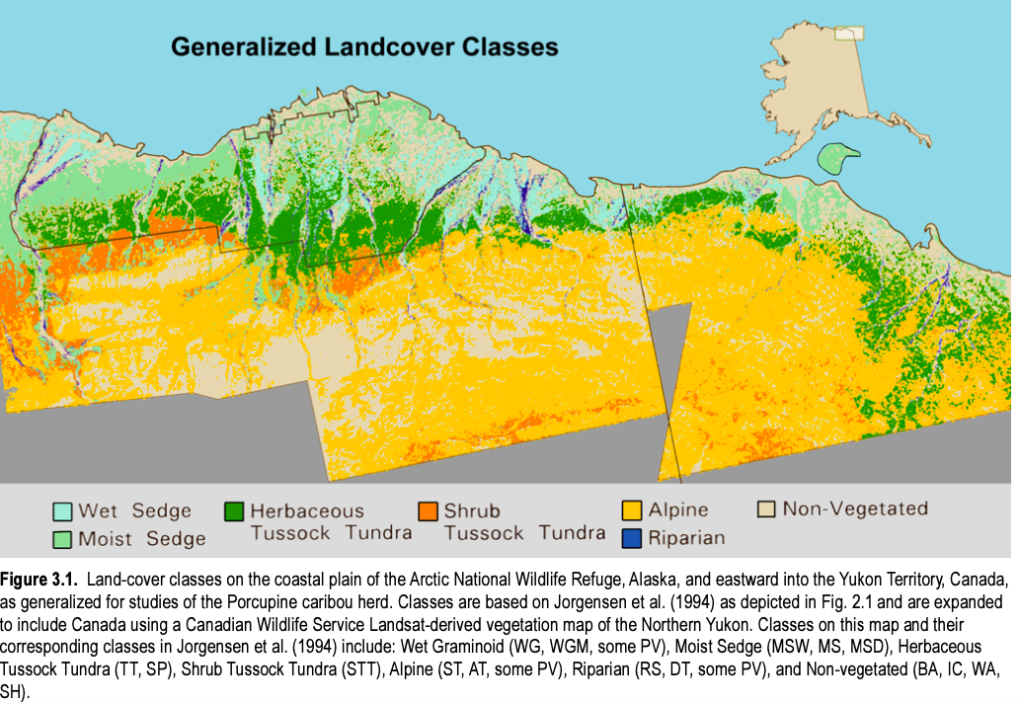

Other figures I plan on making:

* Temperature/moisture map
* Vegetation cover change map
* **Predicted future range use map** based on predicted vegetation cover changes
* Caribou migration moving model

**Risk mitigation**

I do not anticipate having many risks arise from my research project, since it is a data science-based dissertation. The only challenges or risks will be associated with screen time, which I will try to overcome by taking regular breaks.

Ethical implications include how the research findings will be disseminated.

**Proposed timetable**

* **August**: start literature review of nutritional health of caribou and familiarise myself with mapping using ArcGIS tools, trying to visualise the datasets I intend to use.
* **September**: review and develop the dissertation plan. Meet with supervisor and ask for Team Shrub feedback on project proposal.
* **October 18th**: Prepare a powerpoint to present the project plan to the class in ‘Professional Skills’ course. Practice presentation to Team Shrub.
* **February 28th:** Official start of dissertation work. Meet with supervisor.
* **March and April**: literature review, mapping, data analysis, write-up of final report. Meet with supervisor and ask for Team Shrub feedback.
* **April**: refining of write-up and preparation of presentation. Practice presentation with Team Shrub.
* **April 20th noon**: Thesis submission.
* **May 5th**: Oral Presentation.

**Additional Research Avenues**

**Possible collaboration with Dr. Mark Suitor,** North Slope and Migratory Caribou Biologist for the Yukon, on the following subjects:

* A comparison of caribou, muskox, and moose habitats on the Yukon North Slope based on literature-derived forage data and existing habitat maps and new data I could synthesize (muskox collar data).
* Pivot my project from caribou to muskox, using the collar data and keeping roughly the same structure/methods as written in my present pitch.

**Reference list**

APPS CD et al. (2001). Scale-Dependent Habitat Selection by Mountain Caribou, Columbia Mountains, British Columbia. *The Journal of wildlife management*, 65(1):65–77.

Barboza PS et al. (2018). The nitrogen window for arctic herbivores: plant phenology and protein gain of migratory caribou (Rangifer tarandus). *Ecosphere*, 9(1):e02073.

Berner LT et al. (2021). ABoVE: Gridded 30-meter Aboveground Biomass, Shrub Dominance, North Slope, Alaska, 2007-2016. (https://arcticdata.io/catalog/view/doi%3A10.18739%2FA25Q4RN03, accessed 25 September 2021).

Bernes C et al. (2015). What are the impacts of reindeer/caribou (Rangifer tarandus L.) on arctic and alpine vegetation? A systematic review. *Environmental evidence*, 4(1).

Bjorkman AD et al. (2015). Contrasting effects of warming and increased snowfall on Arctic tundra plant phenology over the past two decades. *Global change biology*, 21(12):4651–4661.

Bjorkman AD et al. (2019). Status and trends in Arctic vegetation: Evidence from experimental warming and long-term monitoring.

Douglas DC et al. Arctic Refuge coastal plain terrestrial wildlife research summaries. :90.

Elmendorf SC et al. (2012). Global assessment of experimental climate warming on tundra vegetation: heterogeneity over space and time. *Ecology letters*, 15(2):164–175.

Fauchald P et al. (2017). Arctic greening from warming promotes declines in caribou populations. *Science advances*, 3(4):e1601365–e1601365.

García Criado M et al. (2020). Woody plant encroachment intensifies under climate change across tundra and savanna biomes.

Griffith (2002). BLM REA CYR 2013 Total Annual Range of Porcupine Herd. (https://catalog.data.gov/dataset/blm-rea-cyr-2013-total-annual-range-of-porcupine-herdb0bcf, accessed 27 September 2021).

Gunn A et al. (2009). Facing a Future of Change: Wild Migratory Caribou and Reindeer. *Arctic*, 62(3):iii–vi.

Gunn A (2015). IUCN Red List of Threatened Species: Rangifer tarandus. *IUCN Red List of Threatened Species*. (https://www.iucnredlist.org/en, accessed 25 September 2021).

IPCC (2013). AR5 Climate Change 2013: The Physical Science Basis — IPCC. (https://www.ipcc.ch/report/ar5/wg1/, accessed 25 September 2021).

Johnson CJ, Ehlers LP, Seip DR (2015). Witnessing extinction – Cumulative impacts across landscapes and the future loss of an evolutionarily significant unit of woodland caribou in Canada. *Biological conservation*, 186:176–186.

Joly K et al. (2003). Winter habitat use by female caribou in relation to wildland fires in interior Alaska. *Canadian journal of zoology*, 81(7):1192–1201.

Kerber J (2015). Caribou, Petroleum, and the Limits of Locality in the Canada-US Borderlands. *The American review of Canadian studies*, 45(3):332–345.

Mallory CD, Boyce MS (2018). Observed and predicted effects of climate change on Arctic caribou and reindeer. *Environmental reviews*, 26(1):13–25.

Mekonnen ZA et al. (2021). Arctic tundra shrubification: a review of mechanisms and impacts on ecosystem carbon balance. *Environmental research letters*, 16(5).

MUSIANI M et al. (2007). Differentiation of tundra/taiga and boreal coniferous forest wolves: genetics, coat colour and association with migratory caribou. *Molecular ecology*, 16(19):4149–4170.

Myers-Smith IH et al. (2011). Shrub expansion in tundra ecosystems: dynamics, impacts and research priorities.

Post E et al. (2019). The polar regions in a 2°C warmer world. *Science advances*, 5(12):eaaw9883–eaaw9883.

Russell DE, Martell AM, Nixon WAC (1993). Range Ecology of the Porcupine Caribou Herd in Canada. *Rangifer*, 13(5):1-.

Severson JP et al. (2021). Spring phenology drives range shifts in a migratory Arctic ungulate with key implications for the future. *Global change biology*, 27(19):4546–4563.

Turunen M et al. (2009). Does climate change influence the availability and quality of reindeer forage plants? *Polar biology*, 32(6):813–832.

Wal R van der (2006). Do herbivores cause habitat degradation or vegetation state transition? Evidence from the tundra. *Oikos*, 114(1):177–186.