1st 2nd
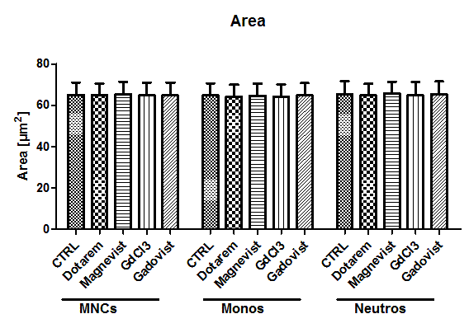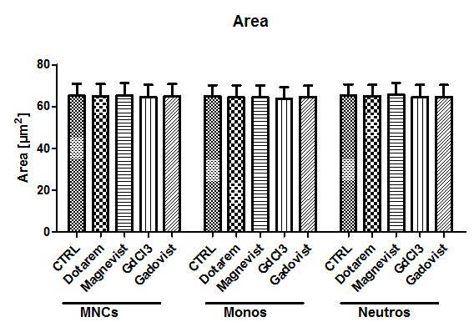

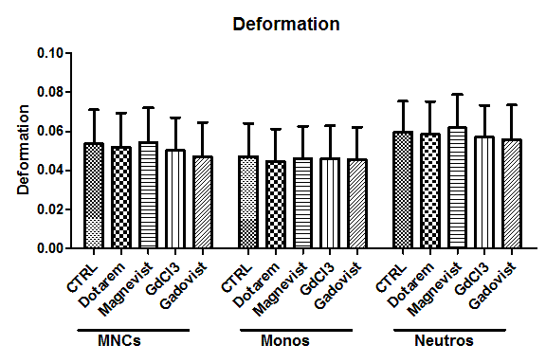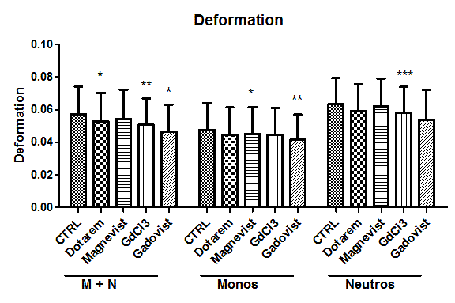
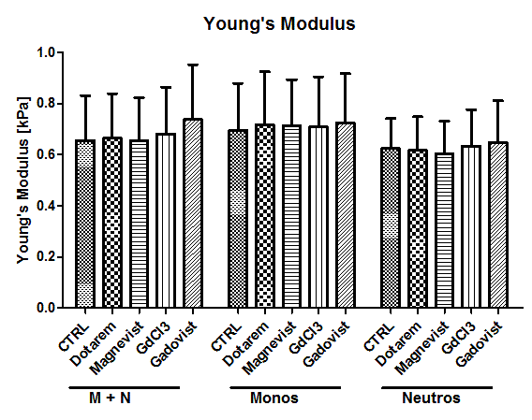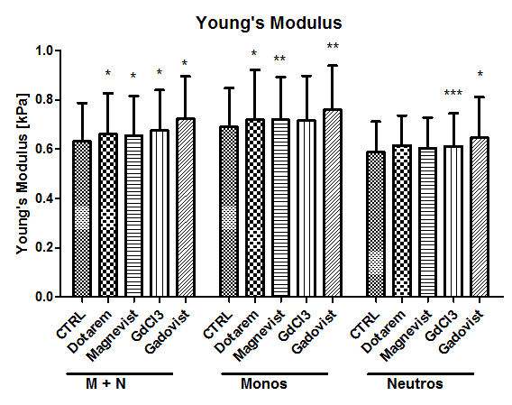

1st type of analysis: 2nd type of analysis:
Dotarem: N=8 independents measurements; 5 donors Dotarem: : N=7 independents measurements; 4 donors
Magnevist: N=8 independents measurements; 5 donors Magnevist: N=7 independents measurements; 4 donors
GdCl3: N=6 independents measurements; 4 donors GdCl3: N=4 independents measurements; 3 donors
Gadovist: N=6 independents measurements; 4 donors Gadovist: N=4 independents measurements; 3 donors

Statistical comparison of RT-DC acquired parameters was carried out with 1-dimensional linear mixed model analysis. One fixed and one random effect was considered, in order to analyse the difference between subsets of cells and to consider the replicate variance, respectively. P-values were determined by a likelihood ratio test, comparing the full model with a model lacking the fixed effect term.
(* p<0.01; **p<0.001; ***p<0.0001)

