Does the market price the central bank’s own rule?
USD and GBP policy paths, 2014–2026

Summary
Is the market pricing the central bank’s own rule? The market persistently prices the policy path below the central bank’s own rule, but even with this, the gap is not a tradable signal. Once that gap is standardized (z) it does not forecast rate changes within USD and is the wrong direction. In GBP, the story is different, it does forecast them, but the gains are concentrated into a specific window (2021 – 2023). The book loses money before costs, and about half of that cost comes from rolls and re-strikes.
Measurement for each currency was the implied path the market was pricing vs. what the rules said they would be. This difference was taken at the 4th meeting for each central bank and used a z score on a trailing 2-year window. Z is scored by its rank IC against the policy-rate change over the next h sessions (5, 21, 63). All of these are after a year of history and outside the ELB.
The four findings of the paper are:
- The market prices the policy path persistently below the central bank’s own rule
- The gap does not forecast at the book level and in USD it points the wrong way (IC (21) -0.12)
- A carry filter that skips entries would improve the net Sharpe Ratio by 0.10 (paired SE 0.05); the book still loses (-0.51), and the filter is off in the headline
- Roll maintenance is 46% of the cost and rolls alone are 33% which are forced by trading the 4th meeting ahead

The headline numbers
- Sample: 1/13/2014 to 10/01/2026, 2,978 sessions with 104 trades
- Book: Sharpe Ratio -0.14, net of costs -0.60. -3.19% of capital per year
- GBP Outright: net +0.50, but +0.04 excluding the best period (2022 – 2023)
- Costs: 2.47% of capital per year with 46% of that coming from maintenance

Why this question
The paper draws from the market the implied policy path and uses one of the rules the Fed publishes in its Monetary Policy Report. This paper’s model is derived from this rule and creates a strong foundation.
There is significant value in testing a rule of this nature. If the market ignored a rule the Fed itself publishes, that would say something about how much the rule guides policy. The answer runs the other way: the gap closes because the Fed moves toward the market.

Definitions
Term | Definition
USD r* | SEP (Summary of Economic Projections) longer run median; Taylor’s 2% before the first SEP (226 Sessions)
GBP r* | Constant -1.6% which is the average real Bank Rate from 2009 – 2026. This is a hindsight number; however, it moves the bp gap and mostly leaves z unchanged
z | The gap (market minus rule) at the 4th meeting ahead, standardized against its trailing 2-year window after 1 year of history
IC | Rank correlation of z with the rate change over the next h sessions (5, 21, 63) outside the ELB State
ELB State | Policy rate and rule both at the floor, book is flat there
Hysteresis Rule | Enter at |z| ≥ 1, exit at 0; fixed before results
Book Construction | Inverse-vol weights, shrunk covariance, 5% vol target on the whole book, no drawdown control

Construction

USD: the path from fed funds futures
Each ZQ contract settles to the arithmetic average of every calendar day of its delivery month. Due to this, each contract month is one linear equation in the regime rates equal to the share of the month’s days. These contracts are priced across months and regimes using joint least squares, which is necessary as a regime spans several contract months and each month mixes several regimes. To address this, they must be solved together to ensure consistency. However, an issue arises in how information is captured by these contracts. Mid-month, part of the contract is already history. To reflect this, days whose EFFR is published enter this as known numbers. This process of substituting in known days creates an additional challenge. When the next meeting is days away, the rate from today until then lives in a few days of the front contract, and price noise in that contract is multiplied by days-in-month over days-left. To address this, contracts below a threshold are pinned to the last fixing. Measured against the actual decision on 46 announcement days since 2021, the error in the implied steps fell sharply, from 5.8 bp to 0.5 bp on average, and from 34 bp to 1.6 bp at worst.
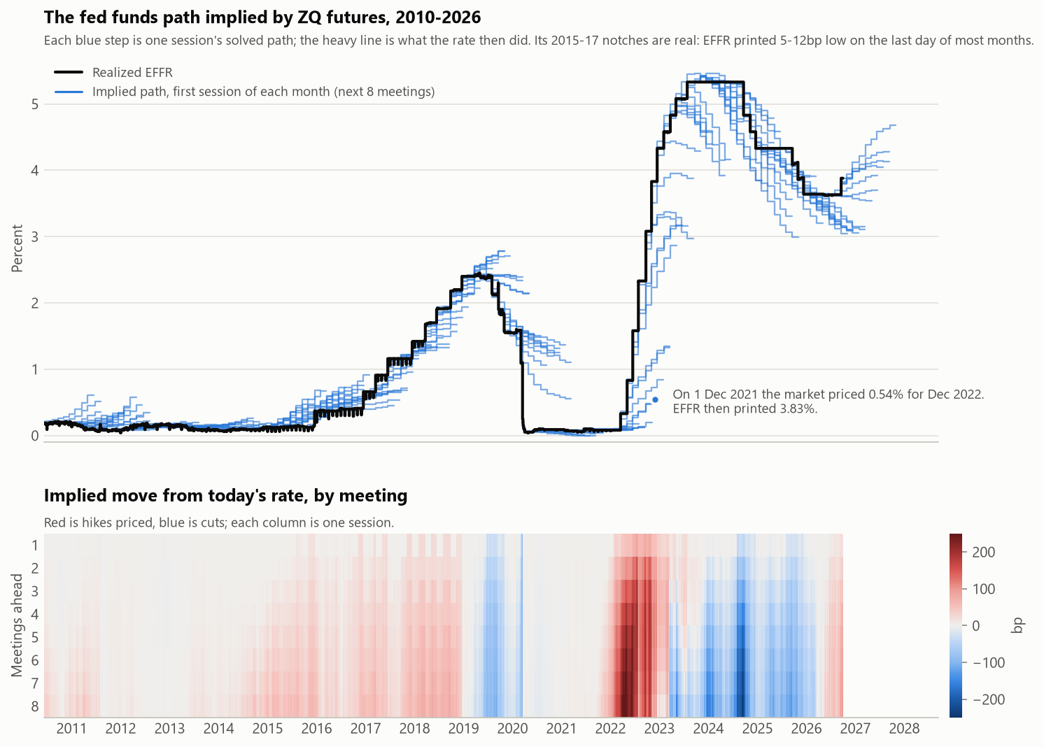
Figure 1. The fed funds path implied by ZQ futures, and the move priced at each meeting.
To validate the results, the paper uses a SR1 cross-check. For each session, compute the ZQ implied EFFR and average this over the SR1 month. Then, solve for the constant spread that reprices the SR1 settlement. From here, it is compared against the basis later realized over 2,116 sessions the implied basis misses the realized one by +0.52 bp on average, mean absolute 1.86 bp, within 3 bp on 80%. What this communicates is that two independent futures markets agree with what they each imply, to within 2 bp. This demonstrates that the ZQ path is not an artefact of the solver.
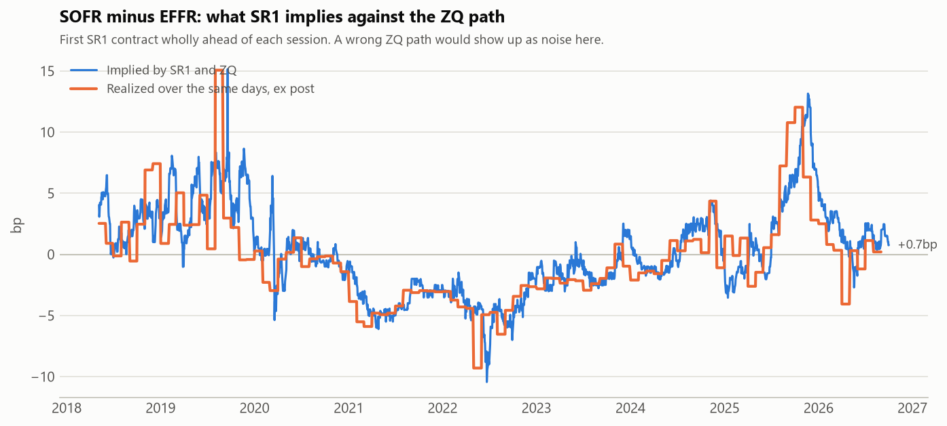
Figure 2. The SOFR − EFFR basis implied jointly by SR1 and the ZQ path

GBP: the path from the Bank of England’s OIS curve
There is no ZQ outside the US. For GBP, leverage a fitted OIS spot curve published from the BoE (Bank of England). Once fitted, expected rates between two meetings is the forward over that window. The log discount factor is interpolated from these.
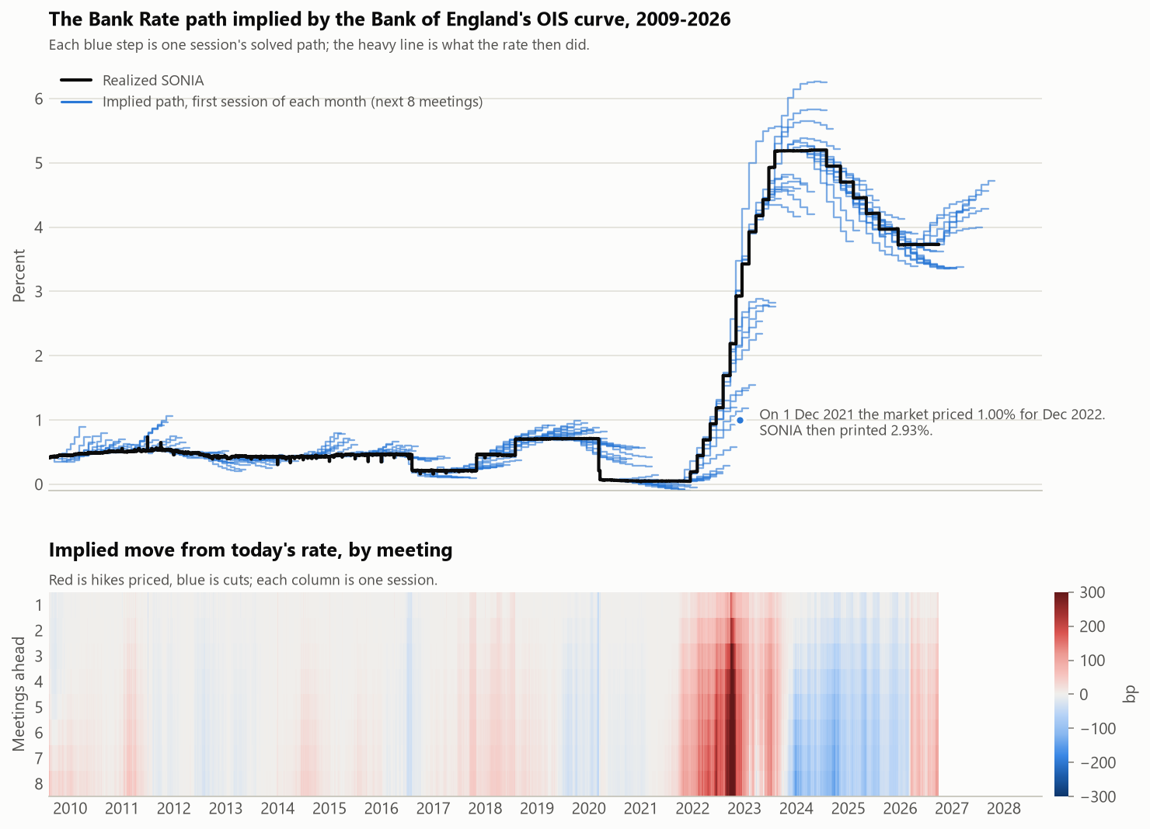
Figure 3. The Bank Rate path implied by the Bank of England’s OIS curve, and the move priced at each meeting.
This is validated against the MPR conditioning path. The GBP path built is a step function that moves on each meeting’s effective date. The Bank of England averages its smooth instantaneous forward curve, which prices prior to the meeting. In a quarter where there is a hike priced, the Bank’s average ends higher and with a cut, lower. The differences correlate -0.59 with the move priced inside the quarter. Across 29 reports (or 87 quarters), there is a mean absolute difference of 1bp, mean signed difference of -0.46 bp, and worst 7.2 bp. This leaves a known definitional difference, not an error.

Rule, r*
One of the rules that the Fed publishes in its Monetary Policy Report is the balanced approach rule. The balanced approach rule takes a very similar approach to policy setting that the Taylor rule would suggest. The key difference is an increase in the coefficient associated with resource differences; this creates a more explicit emphasis on labor market divergence in comparison to the traditional Taylor rule. It carries a 2 on the unemployment gap which is double the Taylor Rule and is symmetric. R* = r* + π + 0.5(π − 2) + 2(u* − u). The MPR’s inertial rule uses 0.85 per quarter, which is the weight on the last period’s rate: 0.922 per meeting (sqrt (0.85)). Hold today's inputs as flat across the path and ask: where does the rule take policy?

Real-time inputs
With the balanced approach rule in mind, estimate the variables. Beginning with π, which is the 12-month core PCE, bridged from CPI for months PCE hasn’t printed yet. The paper tested the accuracy of this bridge and returned a RMSE of 0.075% pp against PCE’s first print over 185 months. u* is CBO’s estimate as vintaged on that day, from ALFRED. Further, the paper seeks to address lookahead bias. A test reruns the whole chain cut off on day D, then appends the deliberately corrupted data and checks that nothing on or before D moves. Lastly, GBP’s u* is a constant 4.5%, not a real-time estimate.
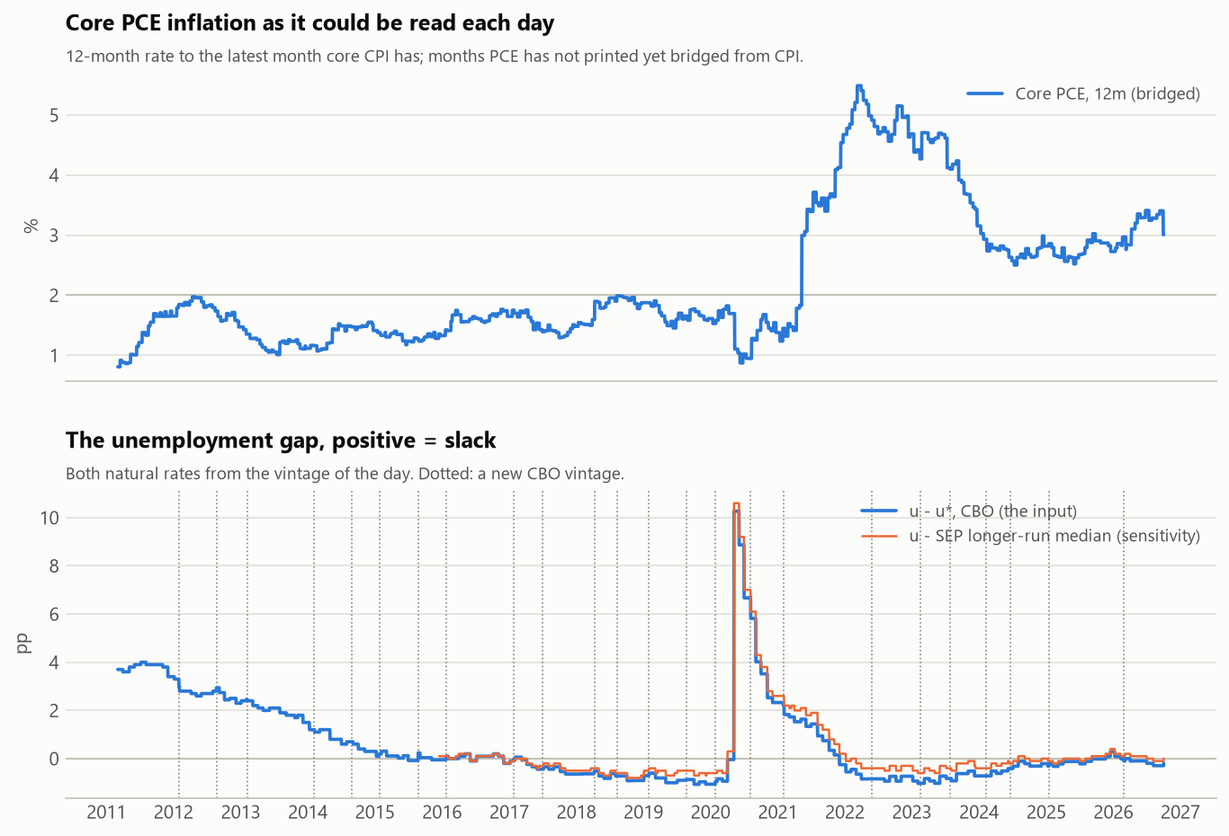
Figure 4. Real-time USD rule inputs: core PCE inflation as it could be read each day, and the unemployment gap.

r* choices
A key benefit of using SEP is how it is at a moment in time. There is no revision, and so it’s real time with no vintage. This isn’t the same for GBP, which uses a constant -1.6%, the average real Bank rate. Both values are tested later in Robustness using HLW in real time for USD and constants for GBP.

The level
The market trades persistently below the rule. For the USD, that’s 13 out of 13 years outside the ELB, by -25 bp to -86 bp. By regime that is -37 bp hiking, -53 bp on hold, and -62 bp cutting. In effect, this matches the pattern of the market pricing below the FOMC’s dots.
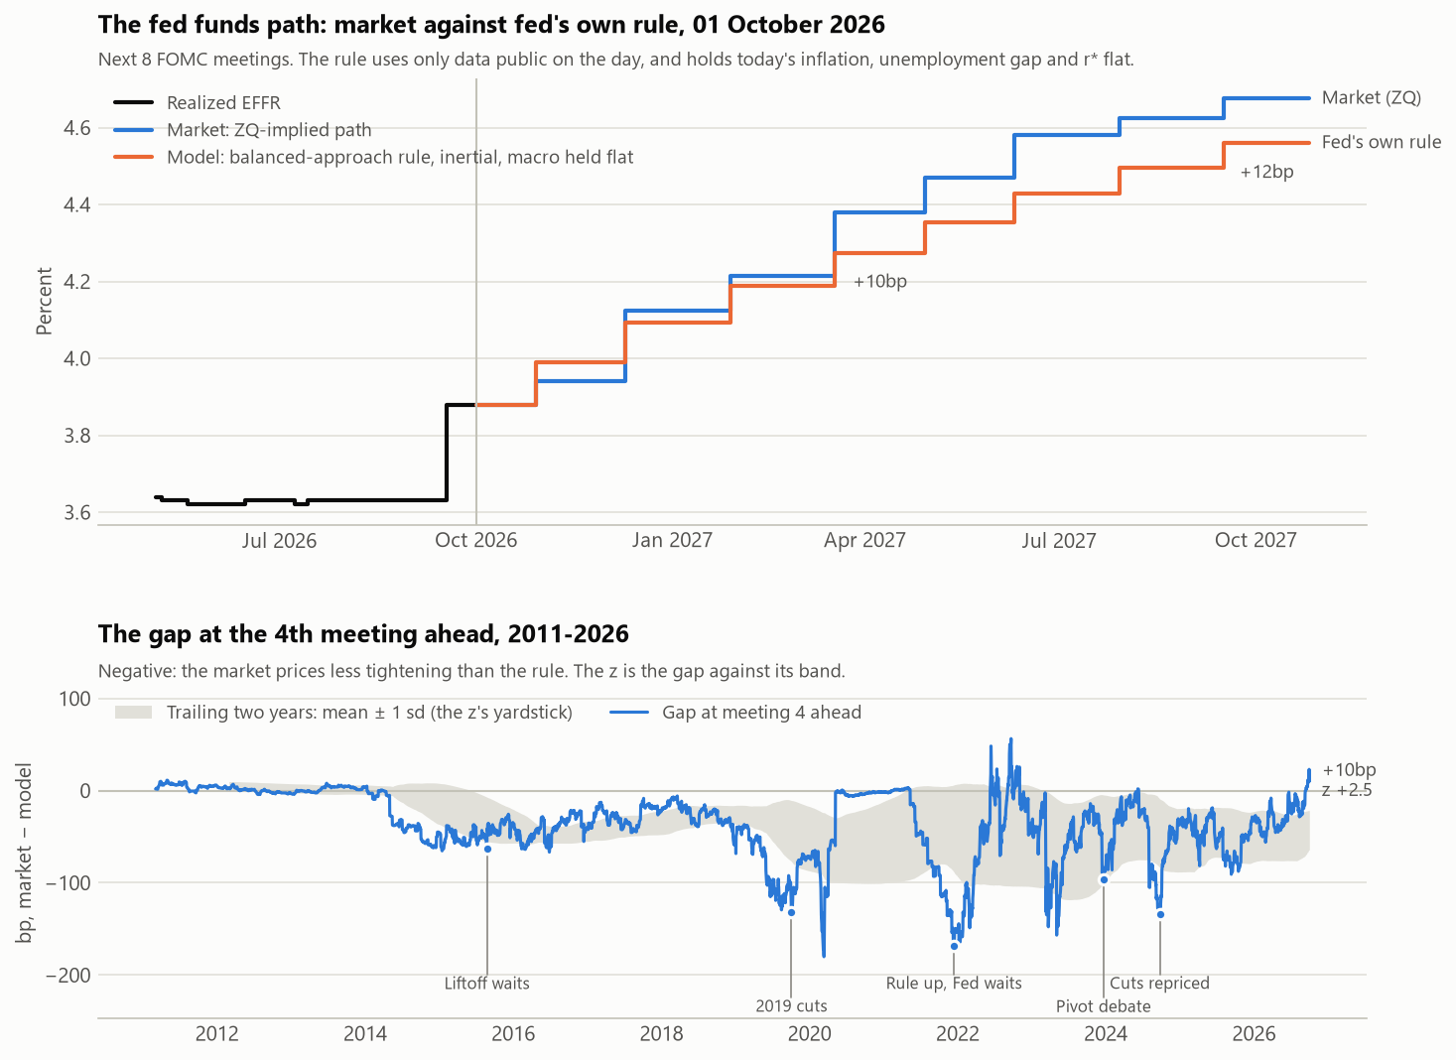
Figure 5. USD: the market path against the balanced-approach rule, and the gap at the fourth meeting ahead.
The gaps are larger for GBP (-122 to +102 bp). However, they change signs throughout cycles, -81 bp when hiking and +28 bp while cutting. This isn’t persistent but depends on regime. That can be seen as 8 of the 11 years remain below the rule, and above from 2024 (+36 bp, +19 bp, +102 bp). With a fixed r*, the post 2024 flip is consistent with r* being wrong as with the market repricing, and this measurement can’t separate them.
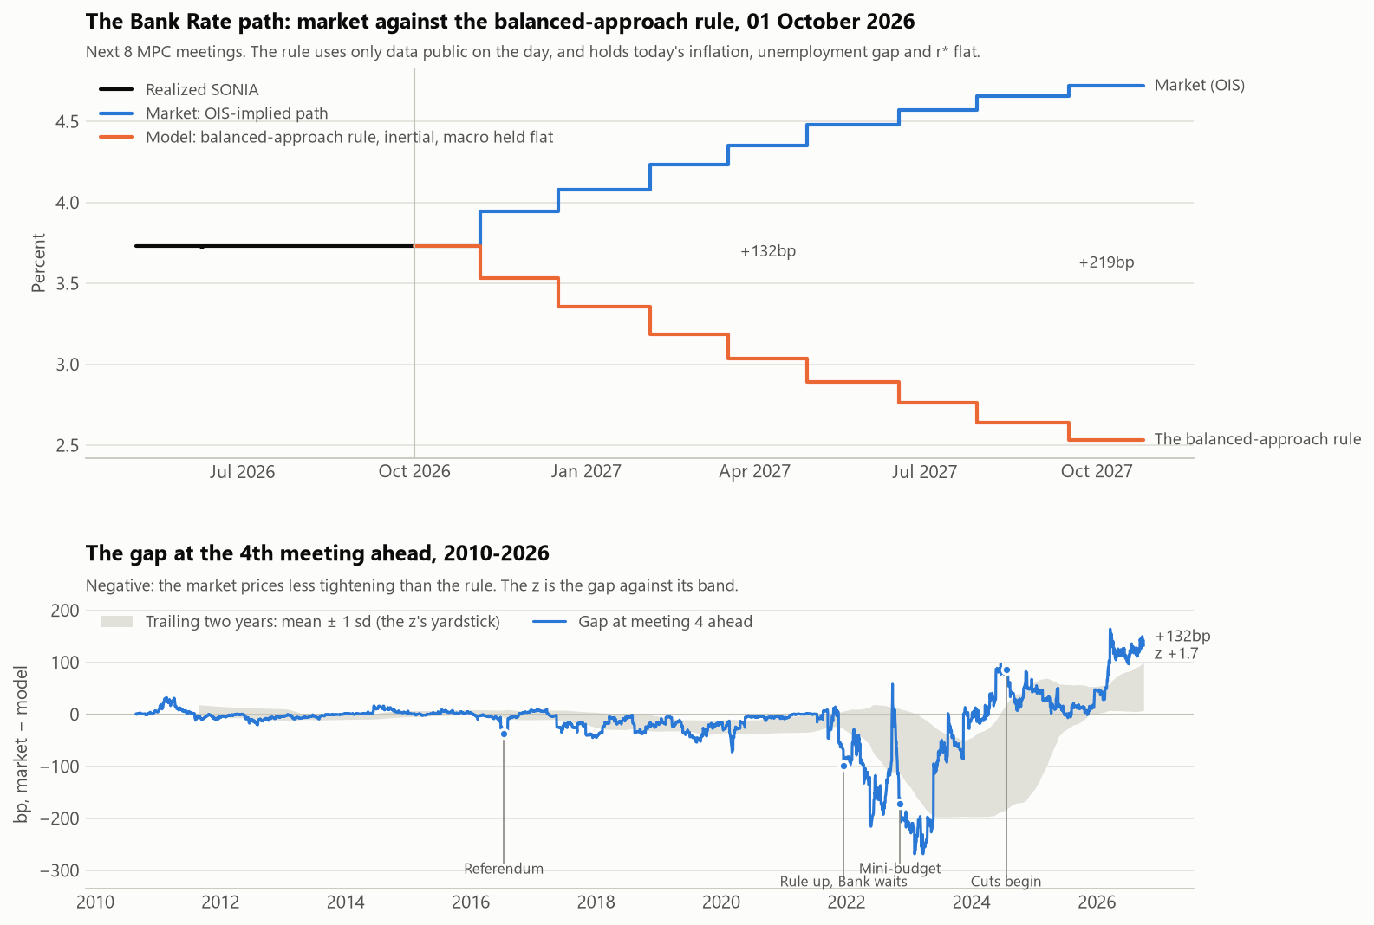
Figure 6. GBP: the market path against the balanced-approach rule, and the gap at the fourth meeting ahead.
63% of the variance of the daily gross P&L is the exposure to the front-end, so the book is closer to a duration timer than it is to a relative value trade. In fact, for the gross P&L, the level exposure earned 0.05% of capital per year, where the rest lost -0.77%. The level sleeves earn +0.22% per year gross and -1.20% net; costs (1.43%) alone turn the level negative.
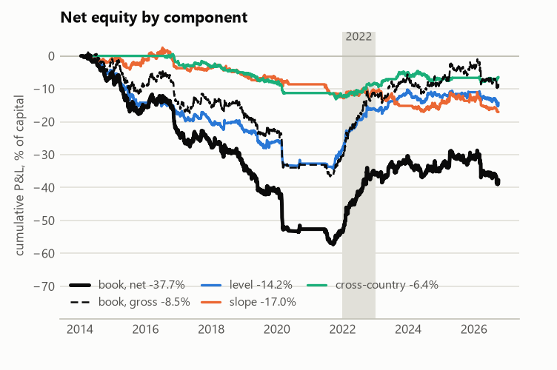
Figure 7. Net equity by component: level, slope and cross-country, with the book gross and net.

The signal and the null
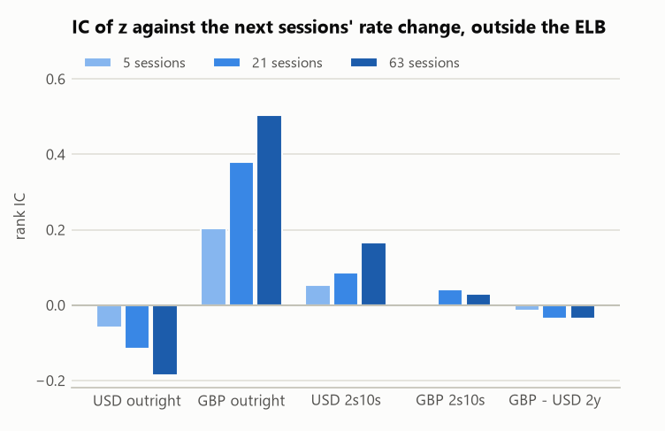
Figure 8. IC of z against the next 5, 21 and 63 sessions’ rate change, outside the ELB.
Table 1. IC of z against the rate change over the next h sessions, outside the ELB. Newey-West t in parentheses; the non-overlapping range in brackets.
Sleeve | IC(5) (t) | IC(21) (t) | IC(63) (t) | Sessions (21) | Non-overlapping IC(21) [range]
USD outright | −0.059 (−1.7) | −0.116 (−1.7) | −0.185 (−1.5) | 2,930 | −0.115 [−0.18, −0.06]
GBP outright | +0.203 (+4.7) | +0.380 (+4.7) | +0.505 (+4.1) | 2,273 | +0.378 [+0.32, +0.43]
USD 2s10s | +0.055 (+1.6) | +0.088 (+1.3) | +0.167 (+1.4) | 2,930 | +0.088 [+0.02, +0.17]
GBP 2s10s | −0.001 (−0.0) | +0.043 (+0.6) | +0.029 (+0.3) | 2,273 | +0.043 [−0.05, +0.13]
GBP − USD 2y | −0.015 (−0.4) | −0.035 (−0.4) | −0.036 (−0.3) | 2,195 | −0.033 [−0.11, +0.01]

The USD gap has no forecasting value and instead points the wrong way. USD outright is not successful, with a -0.12 for IC (21) across 2,930 sessions. The GBP is the exception to this, not the rule. The results are solid in its case, with GBP outright seeing a solid +0.38 in IC (21). This result is across 2,273 sessions and carries a t-stat of 4.7. The remaining results for the three curve and cross sleeves carry little information as is present from their t stats trailing small.
Additionally, it is important to mention that the t is Newey-West to lag h, but z is persistent, and due to this they stay autocorrelated past h. That results in t overstating the precision. The non-overlapping check gives GBP +0.32 to +0.43, clear of zero, and USD -0.18 to -0.06.
The interpretation from these results is that the market leads the Fed. A negative IC means that when the market sits below the rule, the rule falls towards the market over the following weeks, because the Fed’s rate moves; the market doesn’t rise toward the rule. The dots move towards the market (+0.68 per bp of gap over 63 sessions (t+4.7) against +0.09 (t +0.5) the other way).

Performance
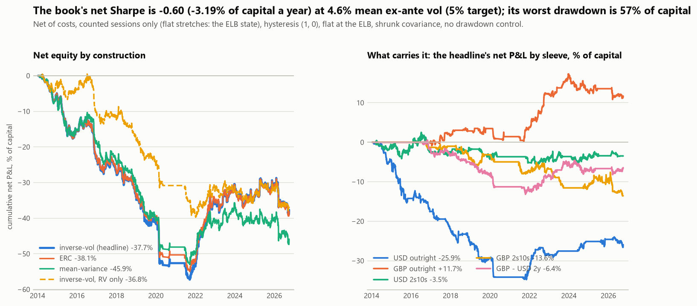
Figure 9. Net equity of the book by construction, and the headline book’s net P&L by sleeve.
Table 2. Sharpe ratios (SE), gross and net of costs, and net with 2022 and 2022–23 left out.
 | Gross SR | Net SR | Net a year | Ex-2022 | Ex-2022–23
Book | −0.14 (0.29) | −0.60 (0.32) | −3.19% | −0.98 (0.37) | −1.11 (0.40)
USD outright | −0.50 (0.31) | −0.88 (0.34) | −2.19% | −1.09 (0.38) | −1.23 (0.42)
GBP outright | +0.73 (0.33) | +0.50 (0.31) | +0.99% | +0.15 (0.31) | +0.04 (0.32)
USD 2s10s | +0.01 (0.29) | −0.12 (0.29) | −0.29% | −0.15 (0.31) | −0.19 (0.32)
GBP 2s10s | −0.36 (0.30) | −0.62 (0.32) | −1.15% | −0.73 (0.34) | −0.58 (0.34)
GBP − USD 2y | −0.15 (0.29) | −0.27 (0.30) | −0.54% | −0.48 (0.32) | −0.62 (0.34)

Gross -0.14, net -0.60 (standard error 0.32), -3.19% of capital per year. The worst drawdown was fierce, but more reflective of a grind than of a break, 57.5%: April 2014 to September 2021. The worst 21 session loss is only 10.8%. The losses in the book are concentrated in the USD outright, which accounts for -25.9% cumulative.

GBP outright is the only sleeve that earns, and it earns in one window: net Sharpe Ratio +1.76 while hiking, on 4 trades; excluding this winning period (2022 – 2023) it nets +0.04. GBP outright’s success depends on this window, a hindsight r* constant, and is sensitive to the coefficients (+0.67 -> +0.13).

Reaction
Nothing was re-tuned in response. The hysteresis pair was set in config before the grid ran. Similarly, the ELB treatment and construction were fixed before the results.

Costs, rolls and breakeven

Costs and the roll
Gross is already -0.72% per year. No cost treatment makes the book pay. Even charging rolls at half prices, which saves 0.40% (-3.19% -> -2.78%), is insufficient to change to the outcome. There is no breakeven for the portfolio.
Turnover explains the costs exactly. Reconciliation of the costs deals with turns, DV01, and 1-way costs. In this way, you can take 19.8 turns x 284,000 gross DV01 x 0.44bp to arrive at the 2.47% capital per year.
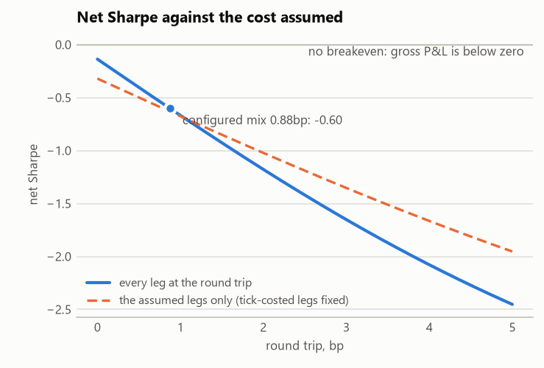
Figure 10. The book’s net Sharpe against the round-trip cost assumed.
Maintenance is a consistent and large piece of the cost, accounting for 46%. Rolls alone contributed to 33%. With rolls, the actions are forced as each outright trades the 4th meeting ahead, so every time a meeting passes the position moves to a new contract.

Breakeven
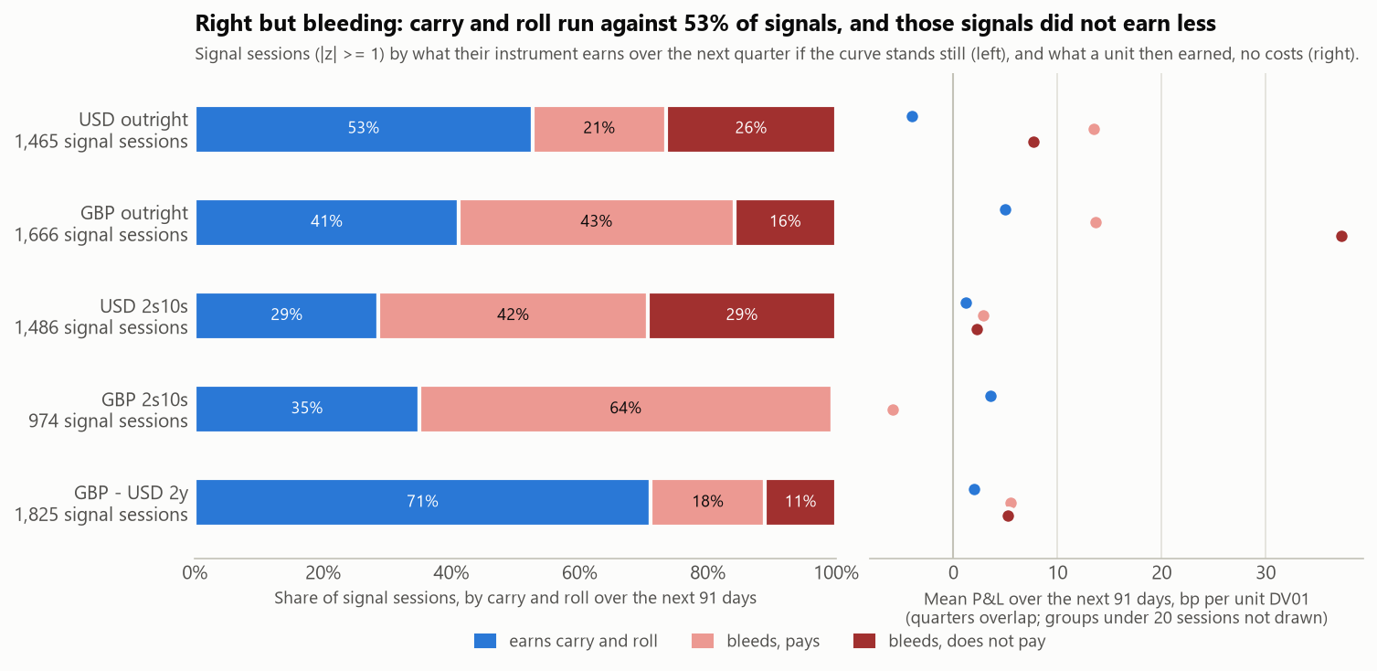
Figure 11. Carry and roll against the side held, by sleeve, and what those signals earned.
In order for the book to net zero, the bets that the rules take need to overcome the costs less carry and roll. Unfortunately, that isn’t the case. They earned 1.36% per year against the required return of 4.55%. This is a significant shortfall and is a theme that crosses strategies, although to varying effects.
In fact, looking through sleeves, only GBP outright clears. Its position has a correlation of +0.036 with the daily rate move, against a needed +0.022.
The figure shows that carry and roll ran against 53% of the signals. The right but bleeding moniker best applies to GBP outrights and USD 2s10s. For others, such as USD outright and GBP 2s10s, they are wrong and bleeding. Only GBP – USD 2y collected carry.

Carry filter
One of the tested beliefs was the carry filter. The filter screens bet to see if the expectation of holding the position is too significant for the expected return. In testing, 16 of the 104 entries do just that, and if they are omitted then this improves the Sharpe Ratio of the book by 0.10. Although this doesn’t create a winning book, this is an improvement to outcomes. The headline numbers do not include this filter.

Robustness
Varying the strategy or choices does not change the outcomes of the study. In fact, the Sharpe Ratio remains well maintained at -0.70 to -0.29. No single choice turns the loss into a gain: across 13 rows the net Sharpe Ratio runs from -0.70 to -0.29. Even focusing on the best performing choice, GBP outright’s sensitivity moves Sharpe from +0.67 to +0.13.
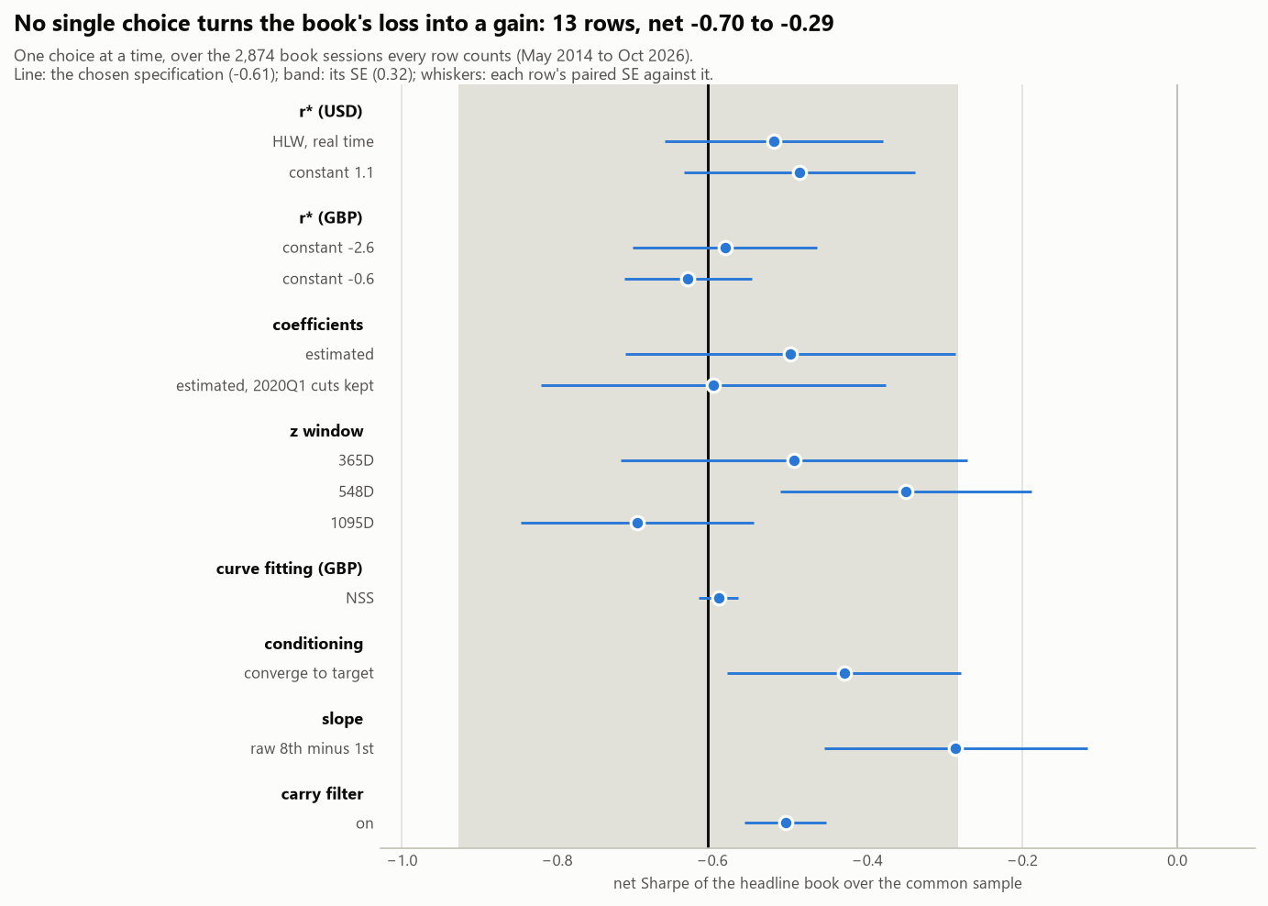
Figure 12. The headline book’s net Sharpe with one choice at a time moved off the chosen specification.

What would change my view
There are several details that would change the paper’s view on this matter. In no order:
- GBP outright holding up outside 2021 – 2023
- Quote-based ZQ costs, or calendar-spread roll pricing, that turn GBP net clearly positive
- A USD trade that has the sign flipped demonstrating that the market leads the Fed, crucially registered before it is judged
- A more harmonized r* across currencies or calendar-anchored signal which would remove the forced roll
- More currencies such as EUR or AUD

Limitations
- GBP’s u* is a constant 4.5%, not a real-time estimate.
- There is no bid-offer data, ZQ’s cost is its tick
- Settlements may be preliminary
- Only 2 currencies currently and 2 hiking cycles
- Overlapping windows inflate t-stats

Appendix
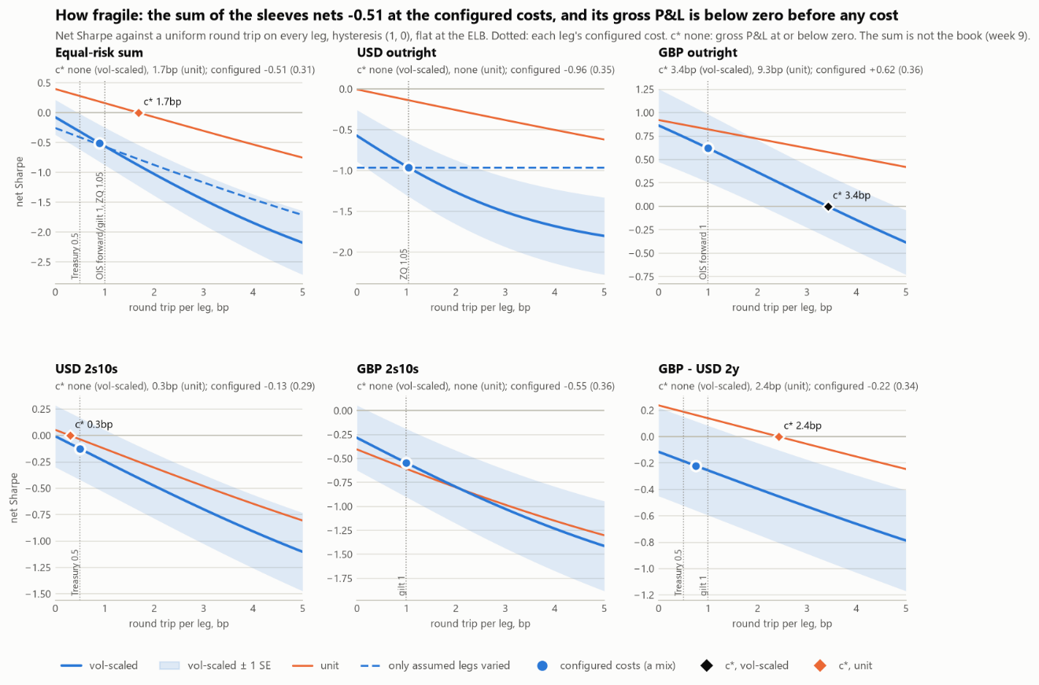
Figure 13. Net Sharpe against a uniform round-trip cost, by sleeve (the sum of the sleeves, not the book).
Coverage: ZQ 99.68% of Fed business days. 0 solver failures in either currency

