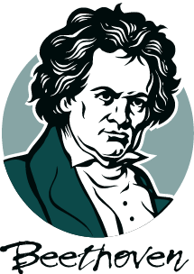
Stanford Symphonic Chorus

Winter Quarter, 2013

NEW MEMBER?___RETURNING? ____NEW CONTACT INFO?___NO CHANGE? _____

***!! EVERYONE !!***!! CHECK YOUR VOCAL PART !!***

Soprano 1 _______ Soprano 2_________ Alto 1_________ Alto 2_________

Tenor 1_______ Tenor 2_________ Bass 1_________ Bass 2_________

***!! EVERYONE !! – I NEED YOUR EMAIL!! (PRINT CLEARLY)***

EMAIL___________________________________________________________

NAME____________________________________________________________________

PHONE___________________________________________________________________

AFFILIATION

Stanford Student ____ Stanford Faculty____ Stanford Staff ____ Community ______

COST FOR BEETHOVEN SCORE INCLUDING TAX $ 9.00

COMMUNITY/STANFORD STAFF PARTICIPATION FEE: $ 40.00

FINANCIAL COMBINATIONS

Total cost for Community/Stanford Staff w/out score $ 40.00
Total cost for Community/Stanford Staff with score $ 49.00

Total cost for Stanford Student/Faculty w/out score $ 0.00
Total Cost for Stanford Student/Faculty with score $ 9.00

PAYING CASH? PLEASE BRING CORRECT CHANGE. THANKS!

PAYING CASH? _____ Indicate CASH Amount: $______________________

WRITING CHECK? ____ Indicate CHECK Amount: $_____________________

PLEASE MAKE YOUR CHECK OUT TO STANFORD UNIVERSITY!

