Parameters for the IFA mitigation scenario:

- ndnSIM version 1.0 -- downloaded from git://github.com/cawka/ns-3-dev-ndnSIM.git (ns-3 fork) and git://github.com/NDN-Routing/ndnSIM.git (ndnSIM source). See build-instructions.txt for more details.
- Data rate: 10Mb/s
- Transmission delay through each channel: 10 ms
- Max PIT size: 200
- Topology: Small binary tree (4 consumer nodes, 1 producer node)
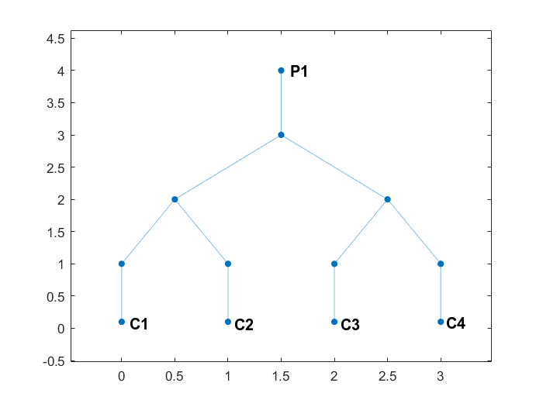
- Consumer nodes: C1, C2, C3, C4 (bottom, left to right)
- Producer nodes: P1 (top)
- All other nodes act as routers
- IFA on consumer node: C1
- IFA packet name: /forged
- IFA packet frequency: 100 per second
- IFA packet time interval distribution: Probably uniform from 0 to 20 ms (not sure)
- IFA packet lifetime: 1s
- Legitimate packets delivered on consumer nodes C2, C3, C4
- Legitimate packet name: /fine
- Legitimate packet frequency: 50 per second
- Legitimate packet time interval: 20 ms (constant)
- Legitimate packet lifetime: 1s
- Legitimate packet name distribution: Zipf-Mandelbrot Distribution (q = 0.7, s = 0.7, frequency = 50, randomize = uniform)
- Produce payload size: 1100
- Produce packet name: /fine

