Parameters for the IFA mitigation scenario:

* ndnSIM version 1.0 -- downloaded from git://github.com/cawka/ns-3-dev-ndnSIM.git (ns-3 fork) and git://github.com/NDN-Routing/ndnSIM.git (ndnSIM source). See build-instructions.txt for more details.
* Data rate: 10Mb/s
* Transmission delay through each channel: 10 ms
* Max PIT size: 200
* Topology: Small binary tree (4 consumer nodes, 1 producer node)

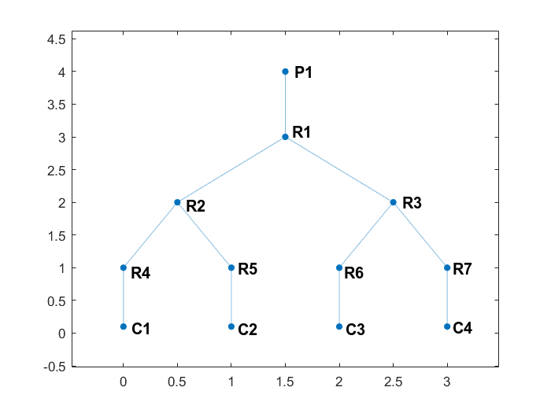

* Consumer nodes: C1, C2, C3, C4 (bottom, left to right)
* Producer nodes: P1 (top)
* All other nodes act as routers
* IFA on consumer node: C1
* IFA packet name: /forged
* IFA packet frequency: 100 per second
* IFA packet time interval distribution: Probably uniform from 0 to 20 ms (not sure)
* IFA packet lifetime: 1s
* Legitimate packets delivered on consumer nodes C2, C3, C4
* Legitimate packet name: /fine
* Legitimate packet frequency: 50 per second
* Legitimate packet time interval: 20 ms (constant)
* Legitimate packet lifetime: 1s
* Legitimate packet name distribution: Zipf-Mandelbrot Distribution (q = 0.7, s = 0.7, frequency = 50, randomize = uniform)
* Produce payload size: 1100
* Produce packet name: /fine