Your Domain: <http://stonehousebuildersllc.com/>

Developer site: <http://shbllc.net2sky.com/>

Note: How to use the admin panel and edit pages/houses/galleries will be gone over in the “How To” Section. I can also go over this information in person if anything does not make sense.

**Site Overview**

Currently is home to just your landing page, upon completion of the developer site, the entire developer site will be transferred to this domain. By following the link to the Developer site you will come to our home page. The navigation bar is on every page and includes the following: Home, About Us, Building With Us, Gallery, Available Lots, News, Contact Us

**Homepage Contents:**

Picture Slider - I can change pictures whenever you like.

Why We Custom Build – Editable in the Admin Panel

Realtor Incentive Program – Editable in the Admin Panel

Houses We Have Created- This is automatically populated with houses you have listed.

Referral Gift Certificate Program – I can change or remove if you ever need me to.

Contact Info – I can change if you ever need me to.

**About Us Contents:** All contents are fully editable

**Biography:** Why Build With Us, Our Mission, What We Do

**Client Testimonials**

**Build With Us:**

Building Process, Stone House Difference, Build on Your Lot

**Gallery/Available Lots:**

Gallery automatically populates by putting every house that you have created in the admin panel here to be viewed. The first photo from the houses’ gallery is shown as well as the Houses’ Name. Available Lots does the same thing but only for houses that you have set as “Available.” After clicking on a house you will be redirected to view the entire gallery for that house as well as the houses “information” that you have given it.

**News:**

All information here are posts that you have written. This page shows the title of the post, the date it was made, and the information from it. Along the left hand side of this page shows a list of all posts so a potential customer/client can quickly navigate between posts.

**Contact Us:**

This page has all your contact information and a working contact us form. If there are any sections you need me to add please let me know. **Example: Reason for Contact, etc.** Currently this form sends an email to my Net2Sky email, but when the site is released I will change that to your [info@stonehousebuildersllc.com](mailto:info@stonehousebuildersllc.com) account.

**How To**

**Admin Panel Login**

By navigating to <https://shbllc.net2sky.com/admin> you will be directed to the Admin Panel and asked to log in. Mike currently has an account and the ability to log in. After logging in you will be able to navigate “Webpage Management” and “Users.”

**Webpage Management:**

After clicking “Webpage Management” a dropdown will show with “View/Edit Content”, “View/Edit News”, and “View/Edit Galleries.”

**View/Edit Content:**

From here you will be able to view all editable webpage content as well add/remove houses to your Gallery/Available Pages. Currently Sections are hard coded to your page so they can be edited, but if they are removed or new ones are added they will not show up on the site. Hovering over any buttons will show a description of what they do.

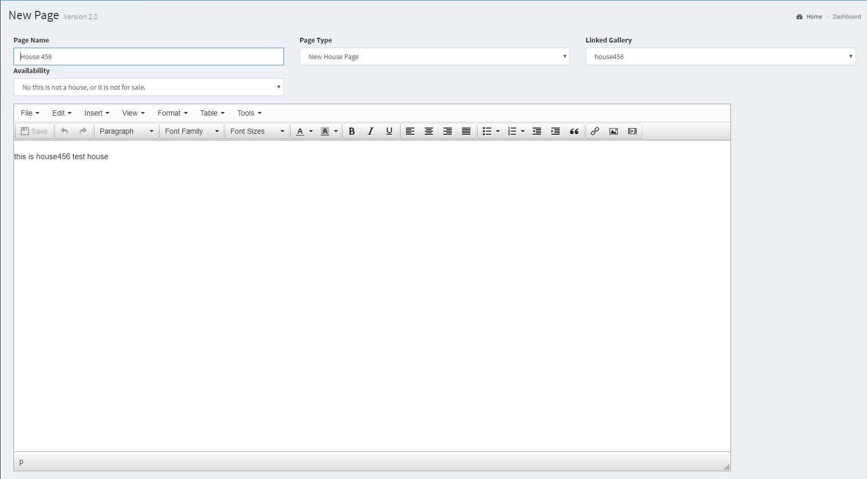

**Adding Houses:**

You will see two posts in “View/Edit Content” called “House 456” and “House123”, these are both example houses. To add another house click on “Create New Post” in the bottom left of the page. From here change “Page Type” from “Content Page” to “New House Page.” You will notice an “Availability” dropdown which, if set to yes, will allow you to set a house to be on the “Available Lots”. page. You will also be able to link a Gallery to a house by clicking on the “Linked Gallery” dropdown.

**View/Edit News:**

After navigating to “View/Edit News” you can Add/Edit/Delete new and old posts. This is very straight forward to add a new click on “Create New Post” and fill out the post name and information. To edit and existing post, simply click on “Edit.” (Same with Delete) Hovering over any buttons will show a description of what they do.

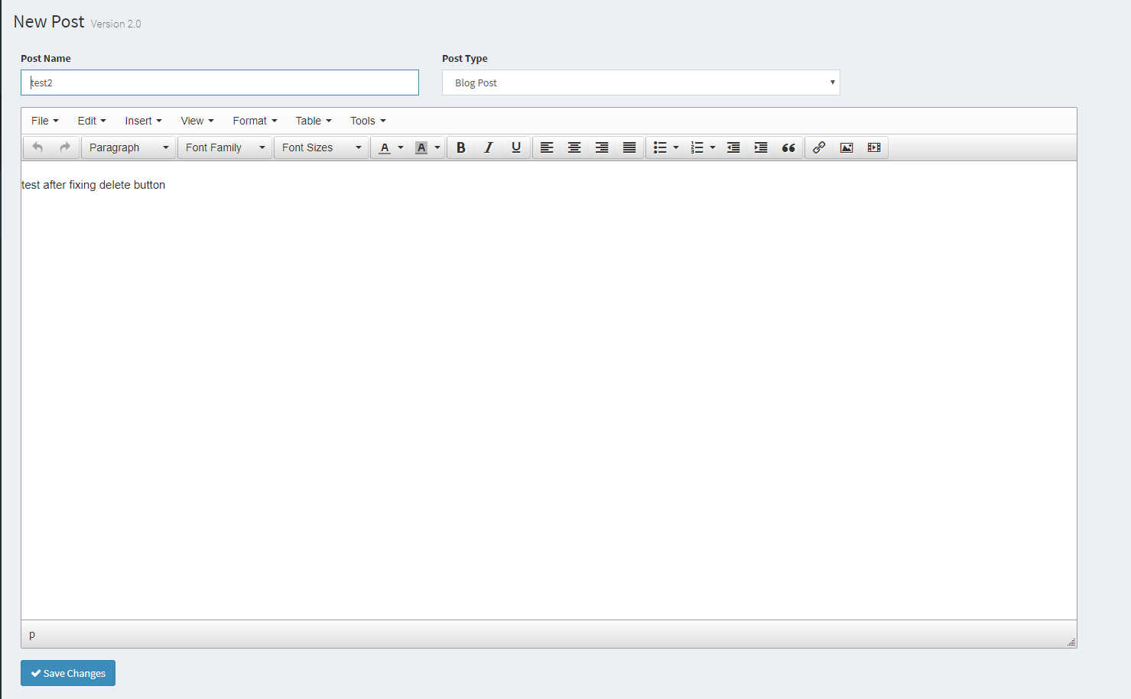

**View/Edit Gallery:**

Clicking upon View/Edit Gallery will open a separate box that is our File Uploader. You can create any folders here you want and any files you upload for News Posts or for Page Contents will go here. **DO NOT** delete the “galleries” as this is a designated folder the code in the site looks for to link galleries to you “House Pages.” Inside of “galleries” you will see two test folders “house456” and “house123.” When creating new galleries please make sure to name them the same as the house they will go to so that it is easy for you to link to the house that you want. After creating the folder “house123” in the “galleries” folder I am able to add any photos that I want to “house123.” This “house123” will now show up as one of the linked galleries that we mentioned in the “View/Edit Content” section. Hovering over any buttons will show a description of what they do

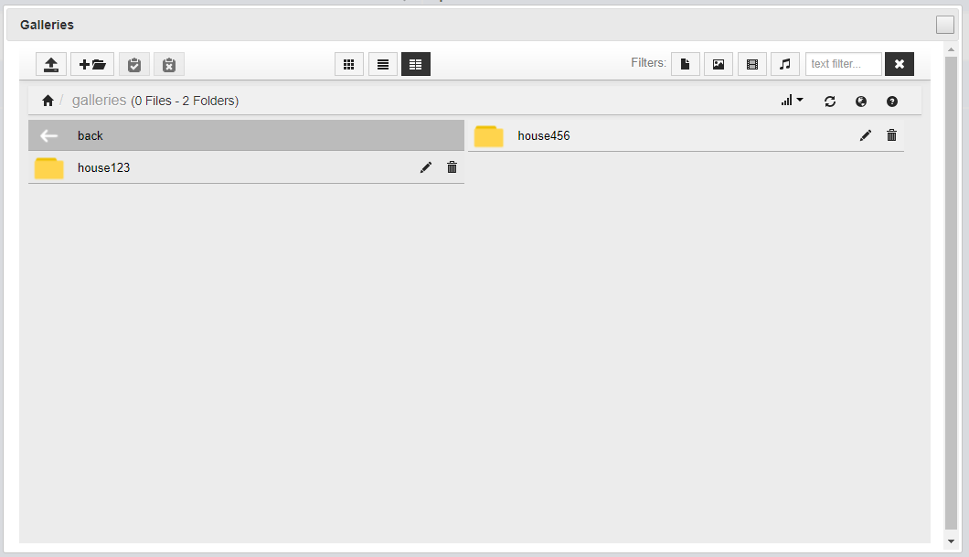

**Users:**

After clicking “Users” and on “View All Users” you will see a list of all current users. From here you will be able to add/edit/delete users.