Project Skylight

Project Proposal

Eric Brauer

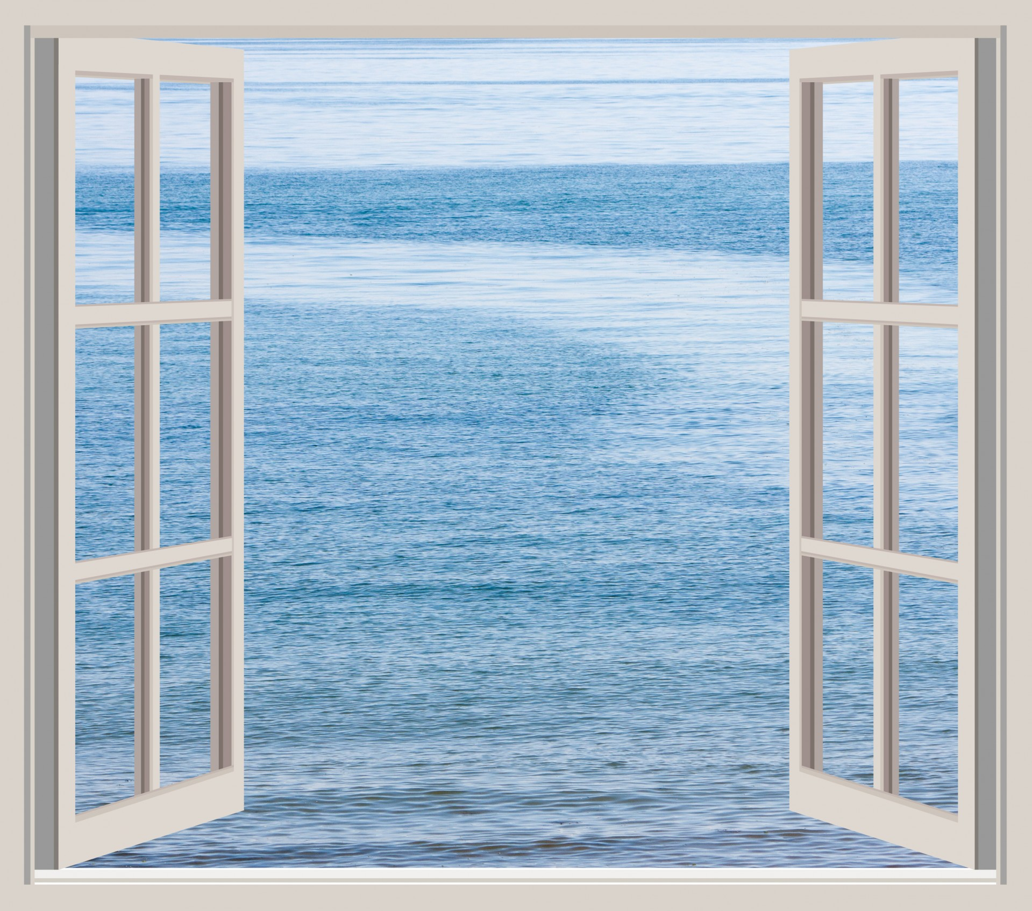

Subject: Technology Project - TPJ655

Program: Computer Engineering Technology

Instructor: B. Shefler, rm. A4022, ext. 26429

Date: 29/1/2017

SENECA COLLEGE OF APPLIED ARTS AND TECHNOLOGY

School of Electronics and Mechanical Engineering Technology

1750 Finch Ave East, Toronto, Ontario, M2J 2X5. Tel. 416-491-5050 Fax 416-490-9839

www.senecacollege.ca

**Introduction** **2**

**Product Requirements** **2**

**Product Specifications** **3**

Some pertinent specifications of the ESP-12F: 3

Some Pertinent Specifications of Proposed NeoPixel Strip: 3

Overall Product Specifications: 4

**Hardware Block Diagram** **4**

**Project Plan** **4**

**Software Flow Chart** **5**

**Bill Of Materials** **6**

**Contact Information** **6**

### 

### 

### Introduction

In Toronto and in many densely-populated areas, people often and work in rooms without exterior windows. With no visual reference to the time of day, it can be easy to lose track of time: whether it’s daytime, evening, or night. This leads to feelings of disorientation and can exacerbate sleep disturbances.

Project skylight is meant to address this problem. The device being proposed is an Internet-connected light that simulates the time of day. The time of day is simulated with an appropriate colour and brightness of light. Daytime, nighttime, and transitional periods ie. dawn and dusk would have different characteristics which would give people the same quick visual reference that one usually gets by glancing out the window.

This is a viable project because the constituent parts are relatively straightforward, but the functionality could easily be expanded upon. There are three major aspects to the project: internet connectivity, a web-based user interface, and lights with controllable colour and brightness levels. In addition, the device would be easy to set up for a layperson. The information required from a user would be limited: first, wifi credentials, then location. Beyond that, the device would be able to function independent of the user, and the hardware inputs would be limited: simply a dial for adjusting brightness. The effect would be pleasing without further input. The cost for components, I believe, would be reasonable. The microcontroller can be bought for around $2 CAD, and the addressable LEDs can be bought for around $1 CAD each. The rest of the components, ie. resistors, potentiometer, USB port, PCB, would not add up to much beyond this.

My strategic objective, first and foremost, is to become familiar with a particular component: the ESP-12F. The ESP-12F is a wifi module that also integrates an ESP8266, which is an arduino-compatible microcontroller. The ESP-12F is becoming popular as the foundation of many Internet of Things (IoT) devices, and it would benefit me greatly to gain some experience programming this device.

In addition, I would also like to indicate that my interest in this particular project is a personal one. When I sleep in a bedroom with no external windows, I often wake up feeling very disoriented, waking up as I am in the same darkness that I went to bed in. I have often thought about how something like ‘project skylight’ would be beneficial.

### Product Requirements

The product requirements, as envisioned, are as follows:

* Project Skylight (PS) will ask for WiFi credentials, and connect to a WiFi router.
* PS will synchronise with an NTP server.
* PS will ask for the user’s location, and store this information.
* PS will use the user-inputted location to determine time zone, and latitude/longitude. The easiest way to do this would be to communicate with a web server, post the user input, and get timezone/latitude and longitude information.
* PS will set the timezone, and post the latitude/longitude information to a web server. The web server will return times for sunrise and sunset.
* PS will change the colour and brightness of LEDs based on current time in reference to sunrise and sunset times.
* PS will monitor a potentiometer, which will be used to dim or turn off the LED light.
* PS will also serve a web interface from which the user can further control the device.

The following features are not defined as requirements, but are further enhancements that would be implemented if time allows:

* *Themes:* Instead of time of day, the user could select themes from the user interface. Some possibles themes include: fireplace, aquarium, lava lamp, and possibly others.
* *Alarms:* Instead of simulating actual time of day, the device could be set to simulate a sunrise at a specific time. This would be a subtle, light-based alarm clock.
* *Light timers:* People often buy light timers to protect their homes when they are on vacation. The timers turn on lights at set times, in order to fool potential burglars. PS would have the same functionality.
* *Brightness monitor:* By including a brightness monitor, the PS could detect when the user has turned off their other bedroom lights. From this information the PS could monitor how late the user is staying up past ‘sunset.’ This information could be uploaded to a database, and made accessible to the user for perusal.
* *Go To Sleep:* There are applications available for your computer that tint the display based on time of day. The theory behind these applications is that blue light from an LED can ‘fool’ the body’s circadian rhythms into staying awake longer. In response, the application will tint the monitor’s display to become warmer, ie. with less blue. The PS could emulate this behaviour.

### Product Specifications

#### Some pertinent specifications of the ESP-12F:

* Operating Voltage: 3.0~3.6V
* Operating Current Average value: 80mA
* SDIO 2.0, (H) SPI, UART, I2C, I2S, IRDA, PWM, GPIO
* 802.11 b/g/n
* Integrated low power 32-bit MCU, 80 MHz clock speed
* 36 kB RAM, 2 MB flash
* Integrated 10-bit ADC

Datasheet here: <https://www.elecrow.com/download/ESP-12F.pdf>

#### Some Pertinent Specifications of Proposed NeoPixel Strip:

* Integrated RGB LEDs
* Voltage VCC: +6.0~+7.0V
* Operating current: 60mA
* 256 brightness levels per colour

Datasheet here: <https://cdn-shop.adafruit.com/datasheets/WS2812B.pdf>

#### 

#### Overall Product Specifications:

* Powered from either USB port, or standard 9V DC power adapter (TBD)
* Operates at nominal indoor temperatures, not for outdoor use
* Luminosity of around 200 - 400 Lumens
* WiFi range of around 20m
* Current consumption no higher than 1.5A

### Hardware Block Diagram

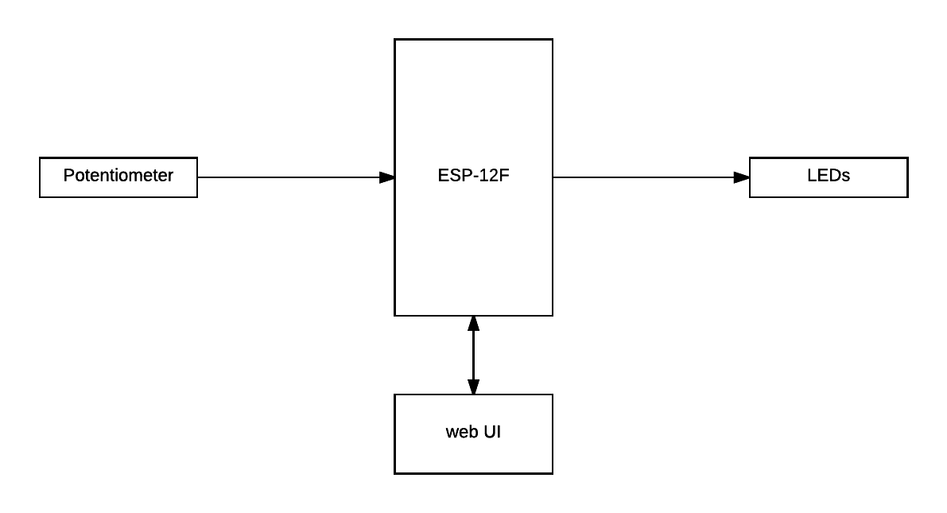

### Project Plan

1. Procure development board, and potential LEDs
2. Evaluate parts, ensure that they fulfill requirements of the project
3. Program proof-of-concept functions, ensure that the MCU can perform the required functions, become familiar with Arduino libraries
4. Integrate proof-of-concept modules into a single program that fulfills basic requirements
5. Build prototype of hardware on breadboard, ensure proper function of the hardware and software
6. Evaluate hardware design based on heat, power, efficiency, visual design and any other factors
7. Design a PCB and order it, or print it at the college
8. Procure materials for finished product
9. Make changes to the code to improve performance, or to enhance features
10. Final assembly and demonstration

### Software Flow Chart

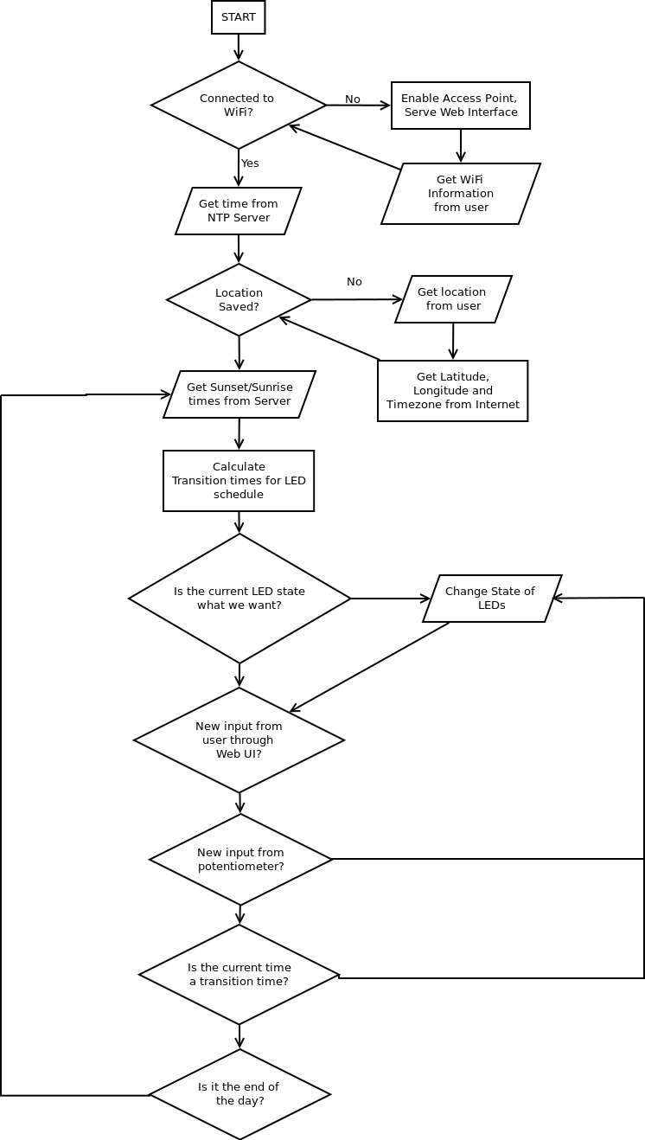

### Bill Of Materials

|  |  |  |  |
| --- | --- | --- | --- |
| **Component** | **Name** | **Source** | **Cost** |
| WiFi/MCU | ESP-12F | Ebay | $2.45 |
| LEDs | NeoPixel Strip | Creatron | $6.95 x 2 |
| Potentiometer | TBD | TBD | $~1.50 |
| 9V DC Jack / USB | TBD | TBD | $~2.00 |
| Regulator: 3.3V out | LD-1117 | Creatron | $1.75 |
| PCB | N/A | Oshpark/Seneca | $0~20[1] |
| Diffusion panel[2] | N/A | TBD | $~20 |
| **Total** |  |  | **$24 ~ $47[3]** |

### Contact Information

Eric Brauer 647-235-6609 [eric.m.brauer@gmail.com](mailto:eric.m.brauer@gmail.com)

1. Oshpark charges $5.00 per square inch. This price assumes a board of 2 square inches, plus shipping. I’m not sure how it would work to get Seneca to print a PCB, it will require investigation.
2. This may not be required, but will be added if it increases the visual appeal. Most likely would be a piece of plexiglass, rubbed with fine sandpaper in order to ‘bleed’ the light of the LEDs together.
3. Includes HST.