In Class Activity Plan

Week 10: Investigating Frictional Forces

20 min **Whiteboard - #1 from A Few More Problems on Newton’s Second Law (**[**Word**](a_few_more_problems_on_newtons_second_law.docx)**,** [**Pdf**](a_few_more_problems_on_newtons_second_law.pdf)**)**

PURPOSE: Provide a contrasting case of a force situation that can be modeled with whole vectors, which can then be contrasted with a component approach.

*Technical Notes:*

* Hopefully students will try to do this with triangles and vector sums, the only reason they can is that Fnet­­ = 0.
* ***SEED****:* Solve the problem using components

20 min **Board Meeting**

PURPOSE: Introduce component approach; contrast whole vector and component approaches to modeling situations with forces.

Video Example: ([Boarding](../../video/week10_1b_1.html))

*Notes on Problem 1:*

* Correct system schemas & force diagrams
* Have the vector people go first and explain how they found the each of the forces
* Then have the components seed present their method
  + They can solve this problem with vectors, but we want them to consider solving it with components
  + The components will be **parallel** and **perpendicular** (to the surface) NOT x and y, so that we can change the angle of the surface and components won’t be confusing
* May have to return to the box being pushed across the floor to convince them they’ve already been doing this

20 min **Whiteboard - #2 from A Few More Problems on Newton’s Second Law (**[**Word**](a_few_more_problems_on_newtons_second_law.docx)**,** [**Pdf**](a_few_more_problems_on_newtons_second_law.pdf)**)**

PURPOSE: Practice using component approaches to modeling situations with forces.

*Notes on Problem 2:*

* The second problem will focus on practicing using components, don’t let them use energy

20 min **Board Meeting**

PURPOSE: Build consensus on using component approaches to modeling situations with forces.

Video Examples: ([Discusion1](../../video/week10_2d_1.html), [Discusion2](../../video/week10_2d_2.html), [Discusion3](../../video/week10_2d_3.html))

*Whiteboard of Problem 2:*

* Emphasize the use of **parallel** and **perpendicular** components
* System schema and force diagrams

**Homework: Practice with Components (**[**Word**](practice_with_components.docx)**,** [**Pdf**](practice_with_components.pdf)**)**

150 min total **Investigating Frictional Forces (**[**Word**](investigating_frictional_forces.docx)**,** [**Pdf**](investigating_frictional_forces.pdf)**)**

*Note: While Investigating Frictional Forces comes as one large document, it actually works best when broken into three distinct parts. The first part involves including friction in our models. The second, designing and doing experiments to investigate what friction depends upon. The third part can either be a second experiment or a demonstration to find that static friction and kinetic friction are different.*

20 min **Whiteboard - Investigating Frictional Forces pg 1**

(20 of 150) PURPOSE: Create models of two situations that correspond to static and kinetic friction which will be investigated in this lab; introduce contradiction where the rule of 1 interaction = 1 force seems to be violated.

*Technical Notes:*

* There is no equipment for the first part, only a thought experiment
* Split the class in two and have them each put one of the models on a whiteboard
* They will put friction in their models, this is good

15 min **Board Meeting**

(35 of 150) PURPOSE: Resolve issue of coordination of system schema with force diagrams, contact interaction leads to contact force which can be resolved into normal and frictional components; prompt students to consider what are the factors that affect frictional component.

* Find that friction is just a component of the contact force
  + What interaction in the system schema describes the friction force? (*The contact force of course!*)
  + But isn’t the normal force the contact force?
  + So the force of friction and the normal force must both be the contact force. So they must be components!
    - Show vector diagram:

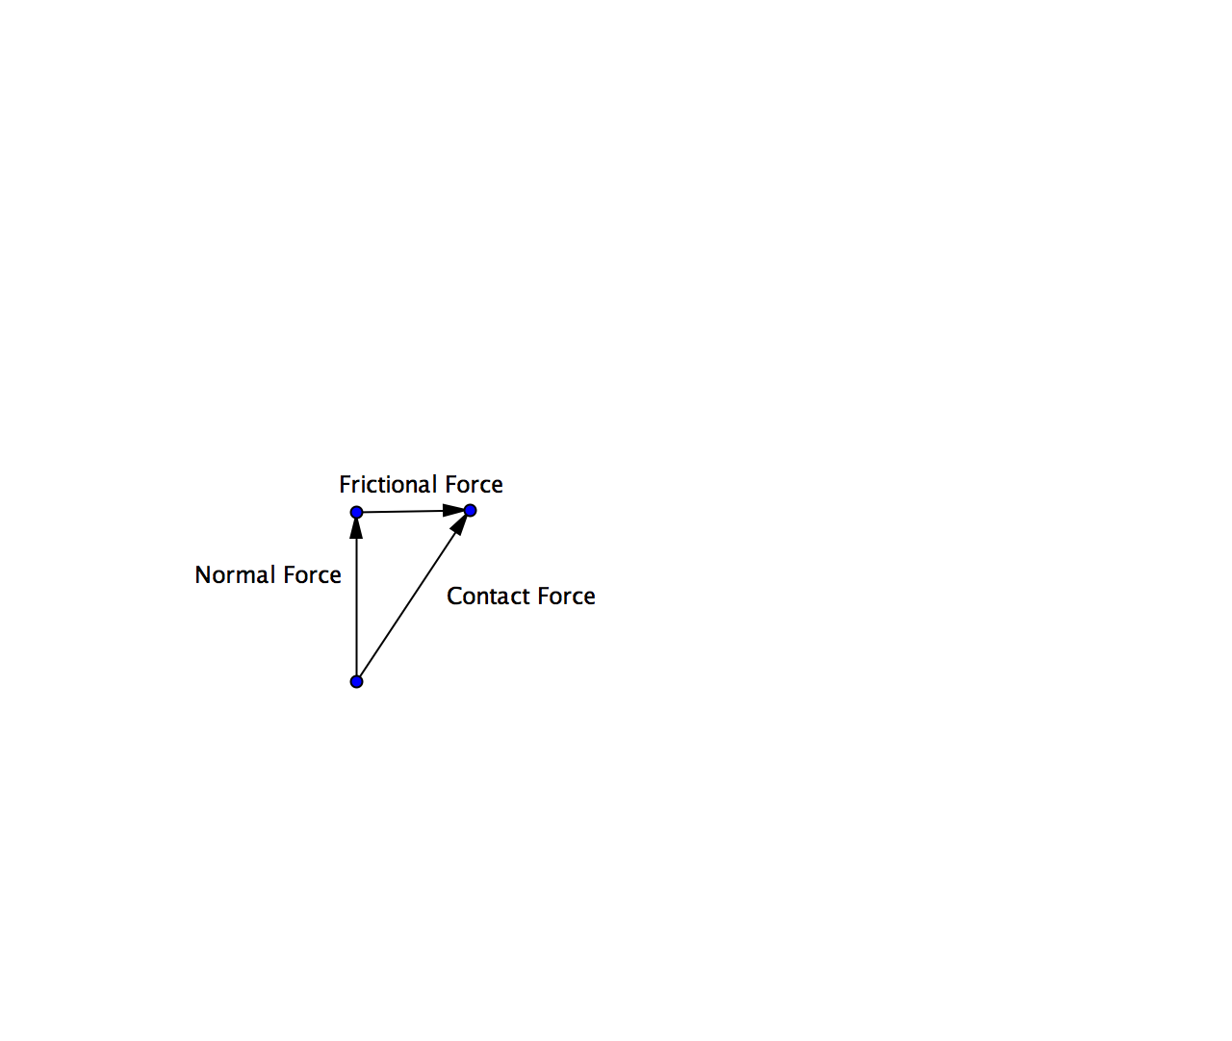

* What do you think affects friction?
  + Expect answers like:
    - Surface area
    - Different surfaces
    - Weight of the object
    - Angle
  + Assign each group to investigate a different thing they think will affect friction
* Have them go design experiments

60 min **Investigating Frictional Forces pg 2 – 5: Doing Experiments**

(95 of 150) PURPOSE: Design and carry out investigations of factors proposed to affect frictional forces.

*Technical Notes:*

* Try to get them to use the pulleys and weights for forces in their set-up so they can have a constant force
* For the groups doing the effect of the mass of the cart on the friction force
  + ***Seed:***Graph Ffriction versus FNormal so that they can see it makes a line, and extract the slope to be the μk

15 min **Whiteboard pg 5**

(110 of 150) PURPOSE: Summarize the investigation each group carried out.

*Note: Remind the different groups that each of them investigated different factors, so they need to be very clear in their claims and evidence.*

30 min **Board Meeting**

(140 of 150) PURPOSE: Build consensus about factors that affect friction forces.

Video Examples: ([Discussion1](../../video/week10_4d_1.html), [Discussion2](../../video/week10_4d_2.html), [Discussion3](../../video/week10_4d_3.html))

* Factors that affect friction
  + Mass of the object pulled
  + The angle we’re pulling with
  + The surface
* Use the graph made by the weight group to discuss the normal force
* Arrive to the conclusion  *Note: Don’t worry about the “kinetic friction” part at this point.*
* Ask them to consider how adding in the surfaces group would change the graph from the mass of the object group
  + Should look like:

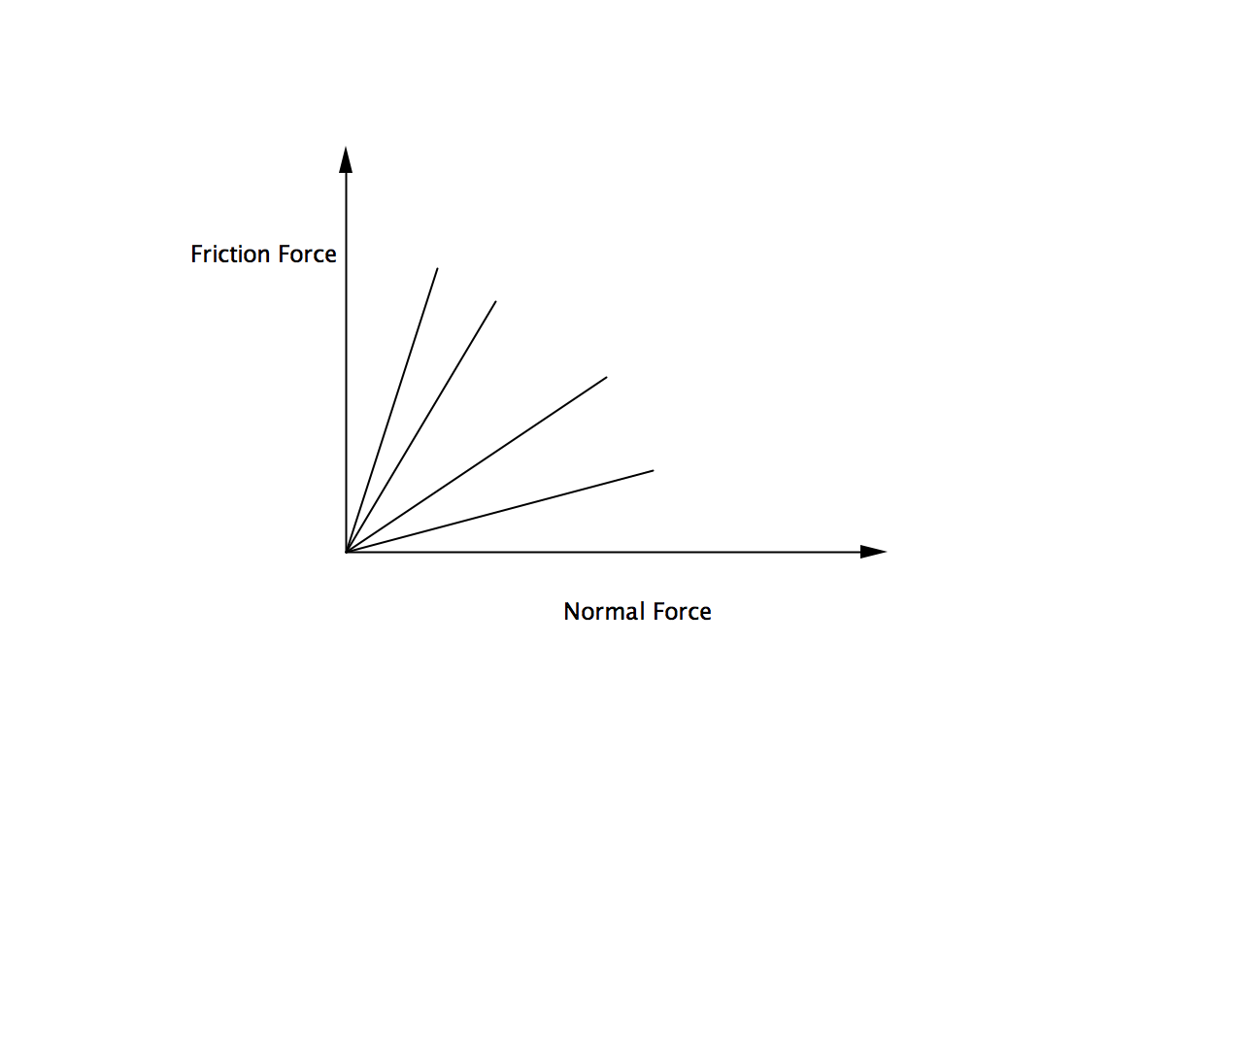

* So changing the surface would change the slope of the line, suggest naming the slope “coefficient of friction”

10 min **Instructor led discussion - Coordinating information**

(150 of 150) PURPOSE: Compile current understanding of frictional forces, introduce coefficient of friction; relate to relationship between normal and frictional components of contact force.

*Note: Give students some time to write down what others found from this lab experiment. You can lead a WB discussion or a discussion from the front of the room about this WB, depending on time.*

**Directions:** Make sense of how the representation of the graph of friction force vs. normal force works with the representation showing the friction force and normal force are just components of the contact force.

**Goal:** Have all the students arrive at the conclusions that:

|  |  |
| --- | --- |
|  |  |

* So μ can never be greater than 1, and it represents a ratio of the components of the contact force

30 min **Whiteboard - Investigating Frictional Forces pg 6 -7**

PURPOSE: Introduce differences between kinetic and static friction.

*Note: You can do this last part as a demonstration if you’re short on time.*

*Technical Note:*

* The goal is to get a nicely peaked graph. To get this you might need the object being pulled to have a large mass (1-2 kg).

20 min **Board Meeting**

PURPOSE: Compare equations governing models with static and kinetic friction.

* Static friction force is greater than kinetic friction force
* Static friction isn’t constant, but kinetic friction is during a constant velocity
* The two friction equations:
  + 
* Remind them of what the coefficients represent