Force Problems

1) A box of textbooks of mass 25.9 kg rests on a loading ramp that makes an angle  with the horizontal. The coefficient of kinetic friction is 0.25 and the coefficient of static friction is 0.37. (a) As the angle  is increased, find the minimum angle at which the box starts to slip. (b) At this angle, find the acceleration once the box has begun to move.

Force Problems

2) A block is placed against the vertical front of a cart as shown in the figure. What acceleration must the cart have so that block *A* does not fall? The coefficient of static friction between the block and the cart is **s

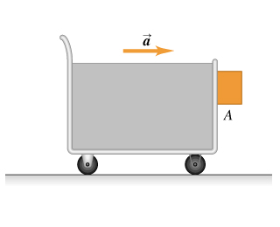

Force Problems

3) Consider the system shown in the figure. Block *A* weighs 49.4 N and block *B* weighs 26.7 N. Once block *B* is set into downward motion, it descends at a constant speed.

