**Ferris Wheel Centripetal Force**

An amusement park has several Ferris wheels (rotating circular structures) of varying size. The radii, R, of these wheels, as well as the mass, M, of different passengers, are listed below.

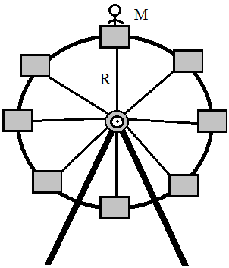

|  |  |  |
| --- | --- | --- |
| Scenario | M | R |
| A | 75 kg | 26 m |
| B | 60 kg | 52 m |
| C | 100 kg | 13 m |
| D | 120 kg | 26 m |
| E | 60 kg | 13 m |
| F | 80 kg | 40 m |

For each scenario, rank the minimum velocity necessary for the passenger to momentarily lose contact with their seat when they reach the top of the Ferris wheel.

Largest 1. 2. 3. 4. 5. 6. Smallest

Justify your ranking: