**Rotating Ranking Task**

A pulley system is shown below, whose string does not stretch. In the system there are two masses, with mass M = 15 kg, and mass m = 10 kg. The pulley’s angular velocity, ω, angular acceleration, α, and its radius, R, are provided in the table below. (Recall that positive angular quantities are counterclockwise.)

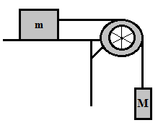

|  |  |  |  |
| --- | --- | --- | --- |
| Scenario | R | ω | α |
| A | 0.3 m | 10 rad/s | 1 rad/s2 |
| B | 0.1 m | 12 rad/s | 0 rad/s2 |
| C | 0.2 m | 12 rad/s | 2 rad/s2 |
| D | 0.1 m | 20 rad/s | -4 rad/s2 |
| E | 0.6 m | 15 rad/s | 0 rad/s2 |
| F | 0.5 m | 5 rad/s | -2 rad/s2 |

Rank each scenario based on the speed of block M:

Fastest 1. 2. 3. 4. 5. 6. Slowest

Justify your ranking:

Rank each scenario based on the magnitude of block M’s acceleration:

Greatest 1. 2. 3. 4. 5. 6. Least

Justify your ranking: