**Ranking Theta vs. Time Graph**

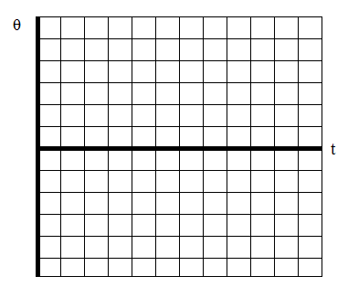A graph of an angular position vs. time graph is located below, as well as a chart that describes six scenarios and the corresponding angular positions at different times. On the graph, plot each scenario and then answer the following questions. (Each unit represents 1 second and 10°)

|  |  |  |  |  |
| --- | --- | --- | --- | --- |
| Scenario | t = 2 s | t = 4 s | t = 6 s | t = 8 s |
| A | 10° | 20° | 30° | 40° |
| B | 50° | 50° | 50° | 50° |
| C | 5° | 10° | 15° | 20° |
| D | -10° | -20° | -30° | -40° |
| E | -15° | -30° | -45° | -60° |
| F | -60° | -60° | -60° | -60° |

A. Rank each scenario based on its average angular velocity. Rank positive angular velocites as greater than negative angular velocities.

Largest 1. 2. 3. 4. 5. 6. Smallest

Justify your ranking:

B. Rank each scenario based on its average angular acceleration. Rank positive angular accelerations as greater than negative angular accelerations.

Largest 1. 2. 3. 4. 5. 6. Smallest

Justify your ranking: