**Centripetal Force Ranking**

A group of six kids are riding their mountain bikes across a bumpy trail that contains an unavoidable semi-circular hill. For the instant when the bikes are at the peak of the hill, the speed of each bike, v, as well as the force of the hill on each bike, F, is provided below. The radius of the hill, R, is 5 m.

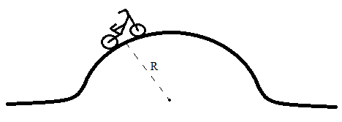

|  |  |  |
| --- | --- | --- |
| Bike | v | F |
| A | 4.0 m/s | 400 N |
| B | 2.0 m/s | 400 N |
| C | 5.0 m/s | 500 N |
| D | 3.0 m/s | 300 N |
| E | 3.0 m/s | 600 N |
| F | 1.5 m/s | 600 N |

Rank the mass of each bike (including the kid) from most massive to least massive:

Most 1. 2. 3. 4. 5. 6. Least

Justify your ranking: