**Vector Analysis**

1. Label the head and tail of the vector shown below.

1. On the graph below:
   1. Starting at the X, a student walks 5 paces to the East. Draw a displacement vector for this motion and label the vector 1
   2. Next the student turns left and walks 5 paces to the North. Draw a displacement vector for this motion and label the vector 2
   3. Finally, Draw the vector representing the total displacement starting at the X and ending at the final position of the student using a dashed line, and label the vector total

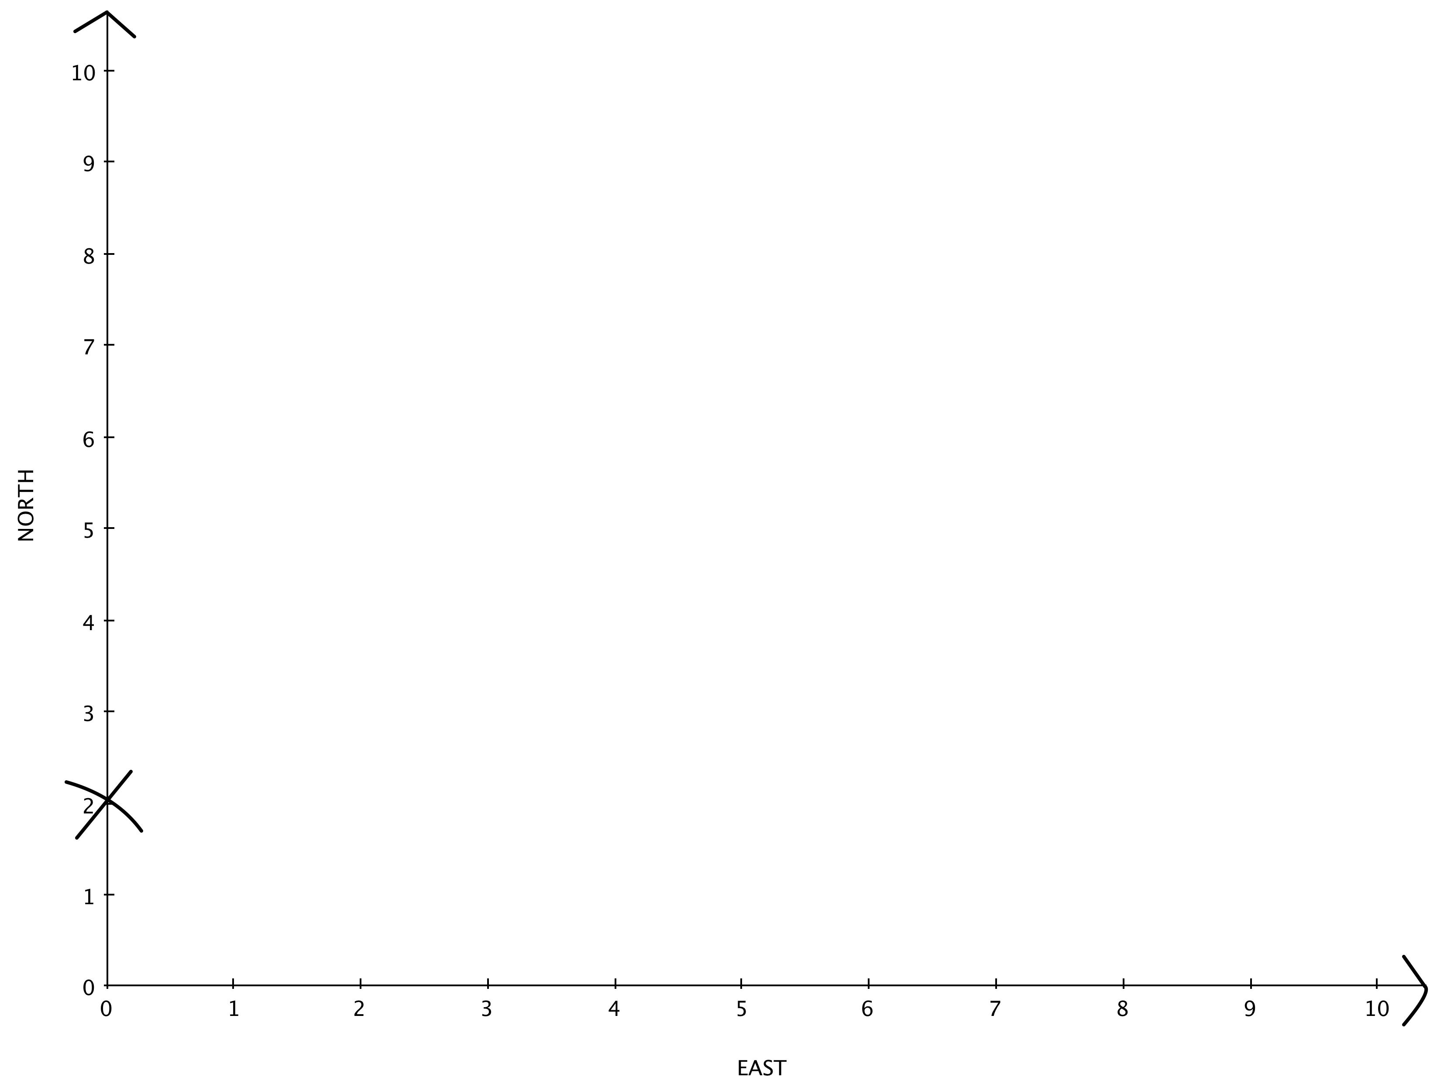

**The arrangement of vectors you just drew can be represented by the equation:**

1 + 2 = total

1. Using the formula above, in terms of the vectors heads and tails and based on their physical arrangement, write the rules for:
   1. How to draw two vectors being added:
   2. How to drawing the resultant vector of two vectors being added: