Construct force diagrams and schemas for the objects described below

1. *When throwing a key vertically upward, my hand moves through a distance of about 0.75 m before the key leaves my hand. The .05 kg key reaches a maximum height of about 21 m above my hand.*

*While the key is in my hand after the key leaves my hand*

*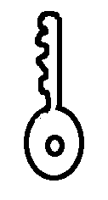 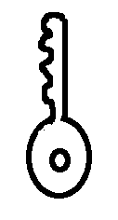*

1. *A 4 kg squirrel misses his step while running across a tree branch and falls 15 m straight down to the ground below.*

*While falling through the air While being stopped by the ground*

*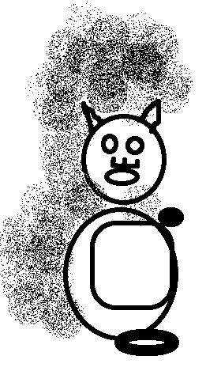 *

*c. An 80 kg rock climber is suspended by a rope from a rock ledge 125m above the ground with his 3 kg bag of tools suspended below him by a rope from his belt.*

*The rock climber The bag of tools*

*