**Why Use Whole Vector Addition?**

In Modeling Instruction, we strongly believe in introducing new tools only when the current tool set is unsuccessful at describing the current phenomena. As a result, we do not worry about vector analysis until 2-dimensional motion (in other words, we do not spend the first week of class reviewing trigonometry with the students). Furthermore, when dealing with 2-dimensional motion as a result of a single acceleration, it is not necessary to introduce an analysis of components. Instead, we can use whole vectors to describe the motion.

Consider the motion map below:

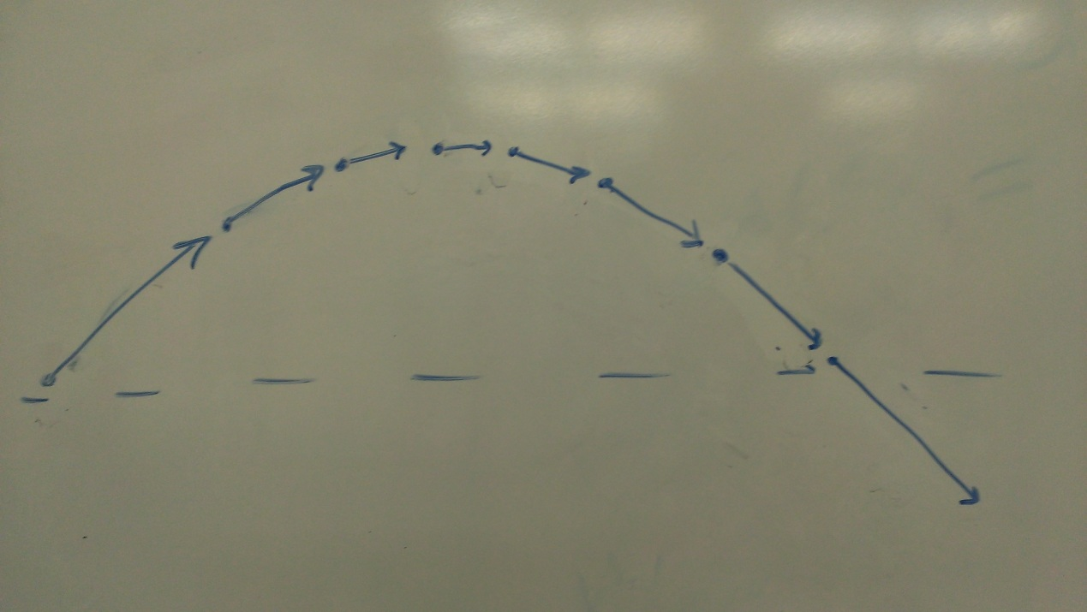

This motion map contains all sorts of useful information about the motion of the object. There is the initial velocity vector (which can be scaled by time), the final velocity vector, and the position at several points including the final. When we analyze this situation using whole vectors, we find that actual motion of the object is consistent with the vector addition triangles we draw.









In other words, these triangles represent the *actual motion* of the object. Contrast this with the more traditional version of taking the initial velocity vector and splitting it into the x and y components. What does v0x and v0y represent? The object does not move first along the x direction and then along the y direction. Using whole vector addition is a powerful tool for thinking about what actually happens to the object without the unrealistic breakdown and rebuilding of components.

It is not true that in Modeling Instruction we completely forgo the use of components. In fact, when we arrive at the point of forces and adding forces together that are not in equilibrium, we find that the tools of whole vector addition break down. Instead of having easy to work with triangles, we end up with odd geometric shapes like trapezoids and polygons. At this point components become a *useful* tool for analysis, and thus it is introduced to students.

Note, however, that we return to whole vector addition with the discussion of momentum, as most often we are considering the collision of two object which can easily be described using vectors that create geometric triangles. For more discussion on the momentum vectors see [Whole Vectors](http://tpt.aapt.org/resource/1/phteah/v36/i5/p274_s1)

In all truth, you probably don’t yet believe the argument that whole vector addition is a particularly useful tool. I didn’t either, at first. So here’s my suggestion: suspend your disbelief for now, and work out a few of the problems that are in the curriculum using both components and whole vector addition. In fact, I am willing to bet that you will quickly find that whole vectors are a useful tool for analysis.