**Pushing Boxes**

Six different boxes with various masses are resting on the floor, as shown below. The boxes remain at rest the entire time. A horizontal force, F, is being applied to each box, as shown. This horizontal force varies for each box. The boxes also have varying coefficients of friction with the floor, μ, as well as varying masses, M.

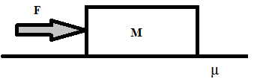

|  |  |  |
| --- | --- | --- |
| Box | M | μ |
| A | 40 kg | 0.7, 0.6 |
| B | 40 kg | 0.5, 0.4 |
| C | 15 kg | 0.3, 0.2 |
| D | 80 kg | 0.4, 0.2 |
| E | 30 kg | 0.7, 0.4 |
| F | 35 kg | 0.9, 0.6 |

Rank the magnitude of the horizontal force, F, acting on each box:

Largest 1. 2. 3. 4. 5. 6. Smallest

Justify your ranking: