In the diagram shown below, there is an object moving with constant speed in a circle. So |v1| = |v2| and |r1| = |r2|.

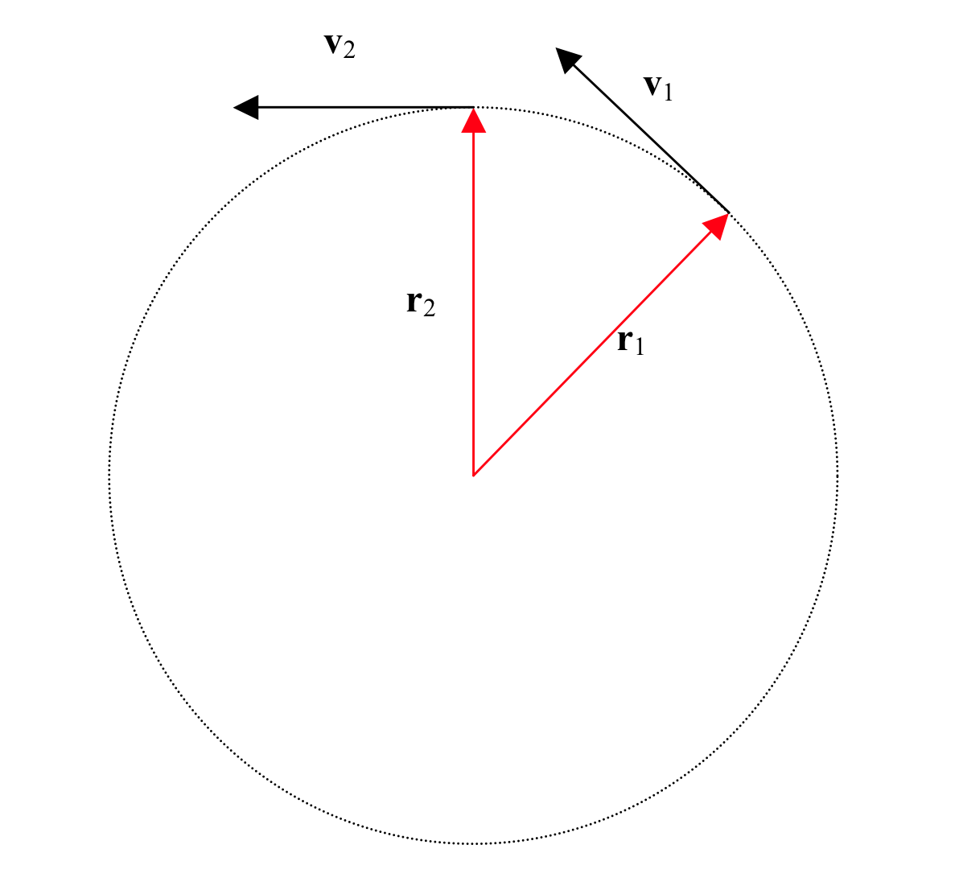

Δ**v** = **v**2 – **v**1, so subtracting vectors, as we see on the diagram shown below, the triangle with the Δ**v** is a similar triangle with the triangle with the two radii and the Δ**r**.

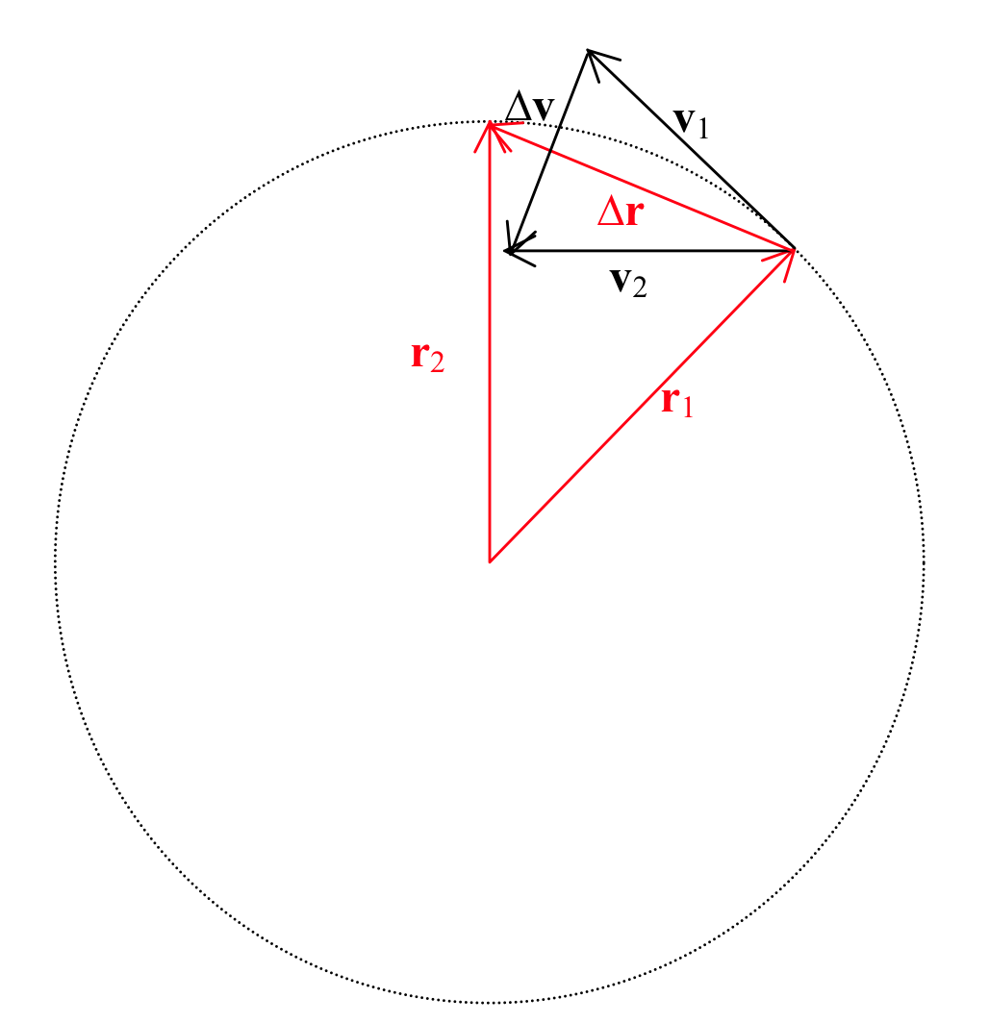

1. The length of the path from t1 to t2 can be written as **v**Δt.

Since these are similar triangles, you can say, **Δv**/Δ**r** = v/r = **Δv**/vΔt.

2. Then by algebra, Δ**v/**Δt= (v/r)*v.

3. We are left with |a| = v2/r.