**Spring Ranking Task**

A bungee cord can be modeled as if it were a spring. There are six people, each of different mass, who are hanging upside down from their bungee cords after completing a jump. Each cord has a natural length, x0, its length without any stretching or compressing, and a current length, x, its length after being compressed or stretched. Additionally, each bungee cord has a different stiffness, k. The force listed below, F, is the force of the bungee cord on the person.

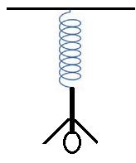

|  |  |  |  |
| --- | --- | --- | --- |
| Person | F | X0 | X |
| A | 500 N | 8 m | 12 m |
| B | 600 N | 7 m | 10 m |
| C | 1000 N | 9 m | 13 m |
| D | 800 N | 10 m | 15 m |
| E | 800 N | 15 m | 25 m |
| F | 500 N | 12 m | 18 m |

A. Rank the values of the spring constant, k, from greatest to least:

Greatest 1. 2. 3. 4. 5. 6. Least

Justify your ranking:

B. Rank the mass of each person, m, from most massive to least massive:

Most 1. 2. 3. 4. 5. 6. Least

Justify your ranking: