**Satellite Centripetal Force Ranking Task**

The planet Jupiter has 63 moons in orbit. Six of those moons have masses similar enough to be considered equal. The orbits of those moons are all nearly circular. The speed of each moon, v, as well as the distance between Jupiter and each of those moons, R, are listed below.

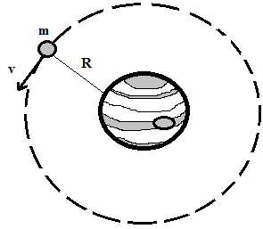

|  |  |  |
| --- | --- | --- |
| Moon | R | v |
| A | 700 km | 100 km/s |
| B | 700 km | 200 km/s |
| C | 1,400 km | 200 km/s |
| D | 2,800 km | 150 km/s |
| E | 350 km | 400 km/s |
| F | 1,200 km | 100 km/s |

Rank the net force acting on each moon from greatest to least:

Greatest 1. 2. 3. 4. 5. 6. Least

Justify your ranking: