**Sledding Centripetal Force**

A little girl rode her sled up and down several hills, sledding over six semi-circular dips with varying radii of curvature. Sledding over each dip would change her speed. Her different speeds at the bottom of the dip, v, are listed below, along with the radius of curvature, R, of the corresponding dip.

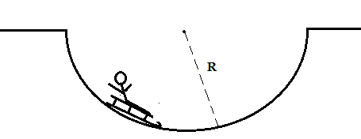

|  |  |  |
| --- | --- | --- |
| Dip | R | v |
| A | 4 m | 12 m/s |
| B | 8 m | 12 m/s |
| C | 2 m | 6 m/s |
| D | 4 m | 3 m/s |
| E | 2 m | 9 m/s |
| F | 6 m | 3 m/s |

Rank the force of the ground on the sled at the bottom of each dip:

Largest 1. 2. 3. 4. 5. 6. Smallest

Justify your ranking: