Star Trek

The Card Game

Goal of the game

Have a total of 25 Experience Counters (XC) in the Change Player Phase of your turn

Setup

1. Put 3 XC from the Ship’s Stores in front of each player as their starting Power Base.
2. Put one set of the Core Crew Cards between each player as the starting Bridge Crew.
3. Have each player take one set of the Default Episode Cards and their information card
4. Put 1 XC for each player on the Enterprise Crew Card
5. Shuffle each deck and place it as a draw pile for each player
6. Randomly determine the starting Current Player
7. Each player draws an initial hand of 7 cards

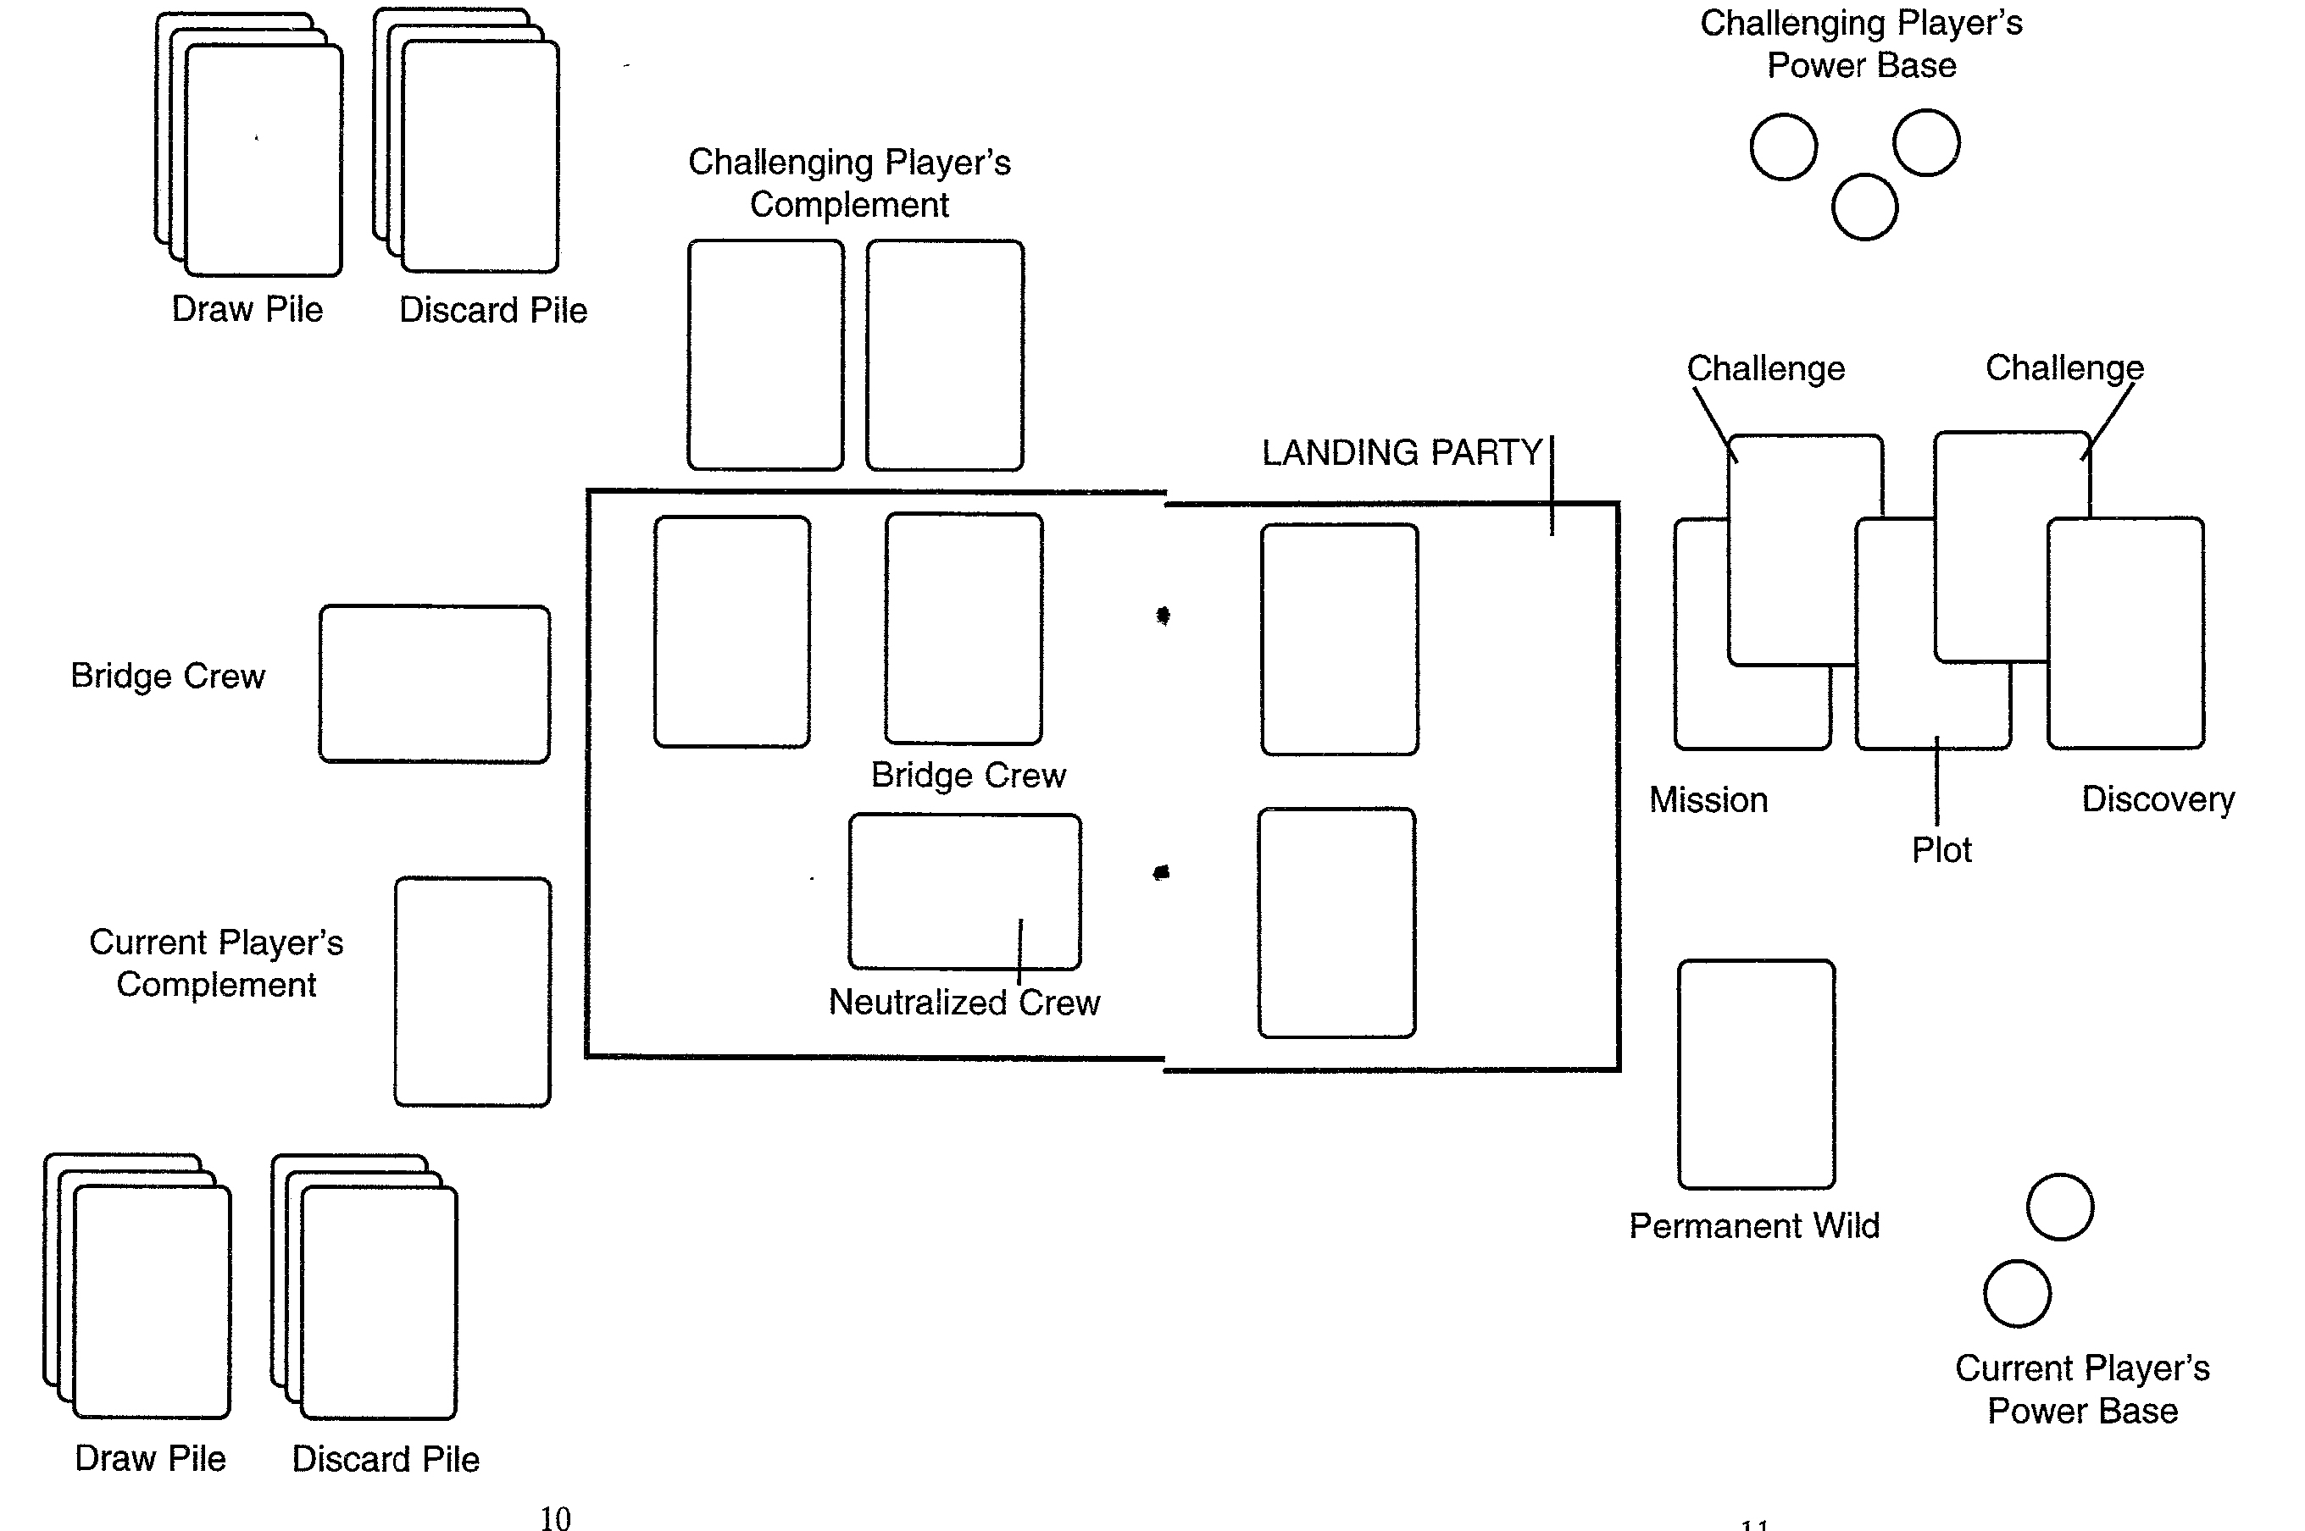

Playing the game

1. Discard phase- Current player discards from hand
2. Draw phase- Current player draws back to hand limit, normally 7 cards
3. Crew phase- Current player may add 1 crew card to his complement- if that crew is part of opponent’s complement, remove the card from the game and put the opponent’s card with the Bridge Crew, taking half (rounded down) of any XCs on it. Only 1 card of a particular Crew Member can be in play at any time.
4. Episode phase (Note: The current Player may voluntarily abandon an Episode at any point-receiving no XCs for the Episode- in this phase unless specifically prohibited from doing so. If Episode is abandoned go to Challenger XC segment, then Change Player phase)
   1. Mission segment- Current player plays Mission card from hand or default mission card. If default is played, challenging player can play Mission card.
   2. Landing Party segment- Current player chooses Landing Party (up to 5 crew unless modified) from his complement and/or the Bridge Crew. The USS Enterprise cannot be chosen as a Landing Party member and only becomes one when an Episode, Challenge, or Wild Card with the Enterprise symbol is played.
   3. Initial XC Segment- Current player adds one XC from his Power Base to each Landing Party member he wishes. Crew Cards (and Permanent Wild Cards) may not have more than 5 XCs on them at any time. Any XC over 1 left in Power Base go back to Ship’s Stores
   4. Initial Challenge segment- Challenging player may play 1 challenge card on the Mission card, paying any required cost in XC from his Power Base.
   5. Resolve Challenge segment- If Challenge card is played, resolve the challenge. If challenger wins, card remains. If not, it is discarded.
   6. Plot segment- Current player plays Plot card from hand or default Plot card. If default is played, challenging player can play Plot card.
   7. Second Challenge segment- Challenging player may play 1 challenge card on the Plot card, paying any required cost in XC from his Power Base. Challenge card must be different from any played in the Initial Challenge segment.
   8. Resolve Challenge segment- Resolve all Challenge cards in play, one at a time, starting with any leftover on the Mission card. If challenger wins, card remains. If not, it is discarded.
   9. Repeat segment- The Current Player may play additional Plot cards, one at a time, as long as each one is different (including the Default Plot Card) and steps f-h are repeated for each Plot card played.
   10. Discovery phase- Once all Plot cards have been played and resolved, Current player plays Discovery card from hand or default Discovery card. If default is played, challenging player can play Discovery card.
5. Resolution phase
   1. Challenger XC segment- The Challenging Player receives 1 XC from the Ship’s Stores for each Challenge and Episode card he played still on the Episode, plus the cost of any Challenge cards still on the Episode. These XC go to his Power Base. Note that if an Episode is abandoned before getting to this phase, the Challenging Player will still receive XCs according to this formula.
   2. Final Resolve Challenge segment- All remaining Challenge Cards are resolved, one at a time in order played until they are all defeated, the Current Player abandons the Episode voluntarily or all of the Landing Party are Killed, Neutralized or Converted.
   3. Final XC Segment- If all Challenge cards are gone, the Current Player receives XC XC based on the amount on the Mission card, added to or subtracted from by Reward Modifiers on Plot Cards, Discovery Cards, Wild Cards, Crew Cards and/or Challenge Cards. If all of the Episode Cards are from the same Star Trek Episode, then ignore all negative modifiers and add one additional XC for each Plot Card in the Episode. Each particular Episode can only give the Episode bonus once per game.
   4. These XC can be distributed to surviving Landing Party crew, Permanent Wild Cards (both subject to the XC limits), or his Power Base. There is no limit to how many XCs a player can have in his Power Base. Crew members who are neutralized may only receive 1 XC (if not at the limit).
   5. Any Permanent Wild Cards belonging to the Current Player that have no XCs on them are removed from the game.
6. Change Player phase
   1. Turn all crew that were neutralized or converted back to Current Player’s control
   2. Any Default Episode cards are set aside
   3. All other Episode cards and Wild Cards played are discarded into the discard pile of the player who played them. Challenge cards go to the discard pile of the Challenging Player.
   4. Crew cards from the Landing Party return to where they came from, either the Bridge Crew or the Current Player’s complement.
   5. If the Current Player has 25 or more XC among the Bridge Crew and his Complement, he wins, regardless of how many XC the Challenging Player has. If he doesn’t, then the Challenging Player becomes the new Current Player and a new turn begins.

Resolving Actions

1. Challenging Player chooses which action to take (if there is a choice)
2. Target is determined based on type of action
3. Action is resolved by an Icon Draw. This involves drawing cards (the number of which is stated on the target and Challenge cards) and consulting the icons on each card. Effect cards can be played to add to the number of icons drawn. Whoever has the most icons of the type for this action wins, with ties going to the Current Player.
4. If the Current Player wins, the Challenge card is discarded. If the Challenging Player wins, then the effect listed on the information card for that Action happens
   1. Neutralize- Crew Member is ignored for the rest of that Episode but can receive XC if Episode is completed
   2. Convert- Crew Member is ignored for rest of Episode and cannot receive XC if Episode is completed
   3. Icon Flip- Current Player draws a card. If it is a Combat Icon, Crew Member is killed and removed from the game (unless the target is the Enterprise, in which case it just loses 1 XC, unless it has no XC on it, in which case the Current Player loses). All XC on that crew go to Ship’s Stores. If it is a Humanity Icon, the Crew Member is neutralized. If it is a Logic Icon there is no effect.
5. If all members of a Landing Party are Neutralized, Converted and/or killed, the Episode is involuntarily abandoned

Miscellaneous Rules

Permanent Wild Cards and Wild Cards

Wild Cards and Permanent Wild Cards may be played at any time except during an Icon Draw.

Wild Cards take effect as soon as they are played. Only one of each specific Wild Card can be played per turn.

Permanent Wild Cards take effect when their cost is paid, and only once per turn, during the Episode Phase. Only One Permanent Wild of each type may be in play in the game at any one time. Only the player controlling the Permanent Wild Card may use its abilities.

Crew Abilities

Only the Current Player can use Crew Abilities and then only from the Landing Party and only in the Episode Phase.

Abilities that require XC expenditure can only be used once per turn.

XC costs are paid from that Crew Card directly into the Power Base of the Challenging Player.

Abilities that affect other Crew Members cannot be used on the Crew Member using that ability.

Common Abilities

Engineering- Pay 1 XC to prevent the loss of 1 XC form the Enterprise or a Permanent Wild

Medical- Pay 1 XC to reduce the effect of an Icon Flip from Kill to Neutralize or Neutralize to no effect

Navigation- Pay 1 XC to search through your Draw Pile for a Plot or Discovery Card. Show that card to your opponent and add it to your hand. Reshuffle your Draw Pile.

Helm- Pay 1 XC to draw 2 cards, up to your hand limit

Security- Discard this Crew card in place of another Crew Member who was killed. Put any XC on the Security Crew card into the Ship’s Stores.

Reward- Adds XC gained. Does not apply if the Crew Member is Killed, Neutralized or Converted.

Multiplayer rules

Other than an faq reference to having the Challenging Player role rotate during each Episode Phase (meaning that no more than one challenge can be played per Episode card) I can’t find any finalized multiplayer rules. They were promised in the faq, but evidently never delivered.