Sailing Past the Cargo: Would Foreign Ships Carrying Domestic Cargo Lower Hawaiʻi’s Westbound Freight Rate?
Eric Carmichael
BUS 620 — Individual Research Paper
Shidler College of Business, University of Hawaiʻi at Mānoa
10.09.2026

Would Foreign Ships Carrying Domestic Cargo Lower Hawaiʻi’s Westbound Freight Rate?
Almost everything sold in Hawai’i depends on ocean freight. The Hawai’i Department of Transportation estimates that 85% of goods are imported and that 91% of those goods arrive through commercial ports (Hawaiʻi Department of Transportation [HDOT], 2024). Freight therefore affects the landed cost of foods and household goods and by extension, the price on shelf. The West Coast – Hawaii route is dominated by Matson and Pasha. Federal cabotage law prohibits foreign-flagged vessels from transporting domestic goods between two U.S ports (46 U.S.C. § 55102). CMA CGM (foreign) already operates a route that includes both LA and Honolulu on the same rotation, making the counterfactual less theoretical (CMA CGM, 2025).
For Hawai’i’s congressional delegation, the most useful question would be whether or not passing an exemption to the Jones Act for Hawai’i cargo would increase the competition beyond the oligopoly of Matson and Pasha. I expect that an exemption would create downward pricing pressure in both directions, with the greatest opportunity on the westbound leg. The decision hinges on whether the current restrictions exclude plausible competitors, whether past market entries have changed behavior and whether route economics explain current prices.
The Current Jones Act Restrictions Limits the Potential Competitive Set
Ocean transport has substantial fixed costs and economies of scale, which means removing a single legal barrier to entry would not create perfect competition. Instead, a viable market entrant would still need sustainable volume, port access, containers, crews and a competitive sailing schedule. Matson identifies Pasha as its primary U.S competitor in Hawai’i and foreign carriers like ONE and CMA CGM as competitors for international cargo (Matson, Inc 2026). The coastwise exemption is relevant here as it completely limits the foreign carriers from even considering domestic Honolulu – West Coast cargo as part of their route-network.
CMA CGM’s 2025 Eagle Express X schedule listed Los Angeles and Honolulu on the same rotation, with Honolulu only bi-weekly (CMA CGM, 2025). In 2025, Los Angeles handled 5.3 million import TEUs but only 1.4 million export TEUs while 3.5 million TEUs were exported empty (Port of Los Angeles, 2025). A vessel that is already heading westbound could use otherwise empty capacity for Honolulu cargo, putting more pressure on the westbound rates. Entry is still not guaranteed as a Honolulu stop would add time for carriers that do not currently have it routed and Matson’s frequency is much higher with five weekly departures. Lower rates may be retained by shippers or retailers or passed to households, while losses would mainly be concentrated among the incumbent shipping companies and possibly domestic shipyards.
Competition Has Changed Pricing Behavior Previously
Matsons response to Pasha provides a solid example of competition influencing freight pricing. The factual record in American President Lines, LLC v Matson Inc. (2025) describes a loyalty program debuted by Matson in 2016 to customers shipping household goods designed to compete with Pasha. Customers who shipped at least 90 % of their household goods through Matsons were granted a 15% discount with later revisions offering up to 25%. These were economically meaningful price reductions directly tied to retaining customer volume in a market where Pasha was an alternative carrier. However, this evidence cuts both ways as this competition lowered realized prices, but loyalty pricing could make entry more expensive. More substitutes make demand facing an incumbent more elastic and reduce its ability to maintain a markup over marginal cost, the logic behind the Lerner index (Figure 2; Stauffer, 2026)
Guam provides a second example of the mechanism. After APL entered the U.S – Guam trade end of 2015, Matson’s market share fell from around 94% in 2016 to 82% in 2017 and 74% in 2018; 2025 court record show that it has continued to hover around 70% (Figure 1). Post APL entry, Home Depot initially allocated only 10% of its Guam volume to APL even though APL was about 40% cheaper because transit was roughly seven days longer. Matson’s former Vice President of Pricing also testified that Matson sometimes adjusted Pacific Northwest prices in response to APL’s Oakland pricing. Guam is imperfect evidence, but share loss, switching and incumbent price adjustment all support the mechanism.
Westbound Pricing Discrepancy is Counterevidence, Not Necessarily a Jones Act Premium
Matson’s household goods rates show a large directional discrepancy for Hawai’i. In 2025, the base rate for a 40ft container was $7,276 westbound and $4,254 eastbound. In 2026, the same rates were $7,476 and $4,354 respectively (Matson Navigation Company, 2025, 2026). The westbound rate was 71% higher in both years. Both directions operate under the same coastwise laws and carrier market, so the gap cannot be identified as a Jones Act premium.
HDOT’s freight data shows Hawai’i importing far more domestic tonnage than it exports, consistent with unused eastbound backhaul capacity (HDOT, 2019). The gap fits normal round-trip cost pricing with or without market power, limiting how much competition alone can lower westbound rates. GAO (2022) also reported generally stable rates and that seven of nine industry entities interviewed viewed carrier numbers as adequate. The interviews were not generalizable, but they are real counterevidence
The Strongest In-Scope Objection Is That Foreign Carriers May Not Enter
The strongest objection is that removing the legal restriction may not change the market at all. Foreign carriers still face added transit time, service-frequency disadvantages, switching costs and the basic economics of serving Hawaiʻi. The Guam evidence reinforces that limitation: even with materially lower prices, customers did not immediately shift large volumes to APL. If no carrier enters, or if entrants cannot attract meaningful cargo, there is no reason to expect incumbent pricing to change. For that reason, the case for an exemption depends on actual entry and competitive response rather than legal eligibility alone.
National security remains a real cost of policy. The Jones Act is also defended on merchant-marine and military-sealift grounds (GAO, 2022),but valuing U.S.-flag capacity in a crisis is outside this paper’s freight-rate question. Hawaiʻi’s delegation would still need to weigh that cost separately; my recommendation is limited to freight-rate grounds.
Decision Rule and Recommendation
On freight-rate grounds, I would recommend against an exemption if a credible entrant showed neither meaningful customer volume nor a measurable incumbent pricing response, or if foreign carriers had no economic reason to compete for domestic Hawaiʻi cargo after becoming eligible. In that case, changing eligibility would have no effect on rates. The evidence does not meet those failure criteria: Pasha competition produced material Matson discounting in Hawaiʻi, while APL’s Guam entry coincided with lost Matson share and documented pricing responses.
For Hawaiʻi’s congressional delegation, the likely outcomes are more useful than one savings estimate. If a carrier adds or uses a West Coast – Honolulu leg, pressure should be greatest on non-urgent westbound cargo where empty capacity exists. If no carrier enters the market, nothing changes. If Matson or Pasha respond to competition with loyalty pricing, large shippers may pay less but the cost of switching becomes higher, and market entry may become less durable. Scale, service frequency, and the directional gap remain. On freight-rate grounds, I would support a narrow Honolulu – West Coast container exemption followed by measurement of entry, realized prices and sailing frequency. The size of any savings, however, is uncertain.

Figures
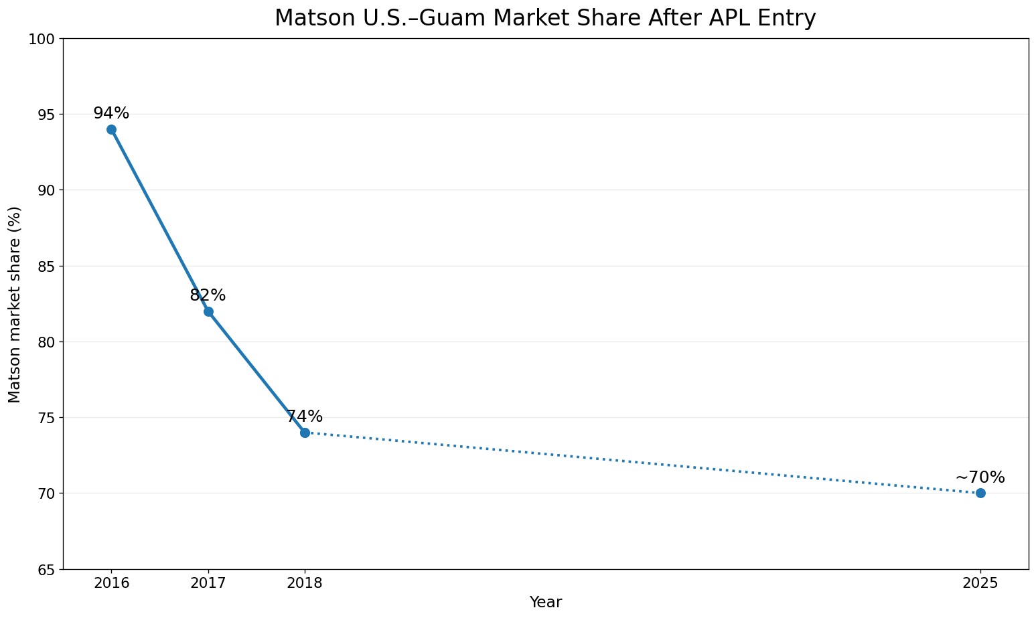
Figure 1. Matson U.S.–Guam market share after APL entry.
Note. Matson’s U.S.–Guam market share fell from approximately 94% in 2016 to 82% in 2017 and 74% in 2018 after APL entered the trade. A 2025 federal court opinion describes Matson as currently handling roughly 70% of U.S.–Guam shipping volume. The dotted segment indicates that annual observations between 2018 and the latest public figure are not plotted. Guam is comparator evidence for the competition mechanism, not a causal estimate for Hawaiʻi.
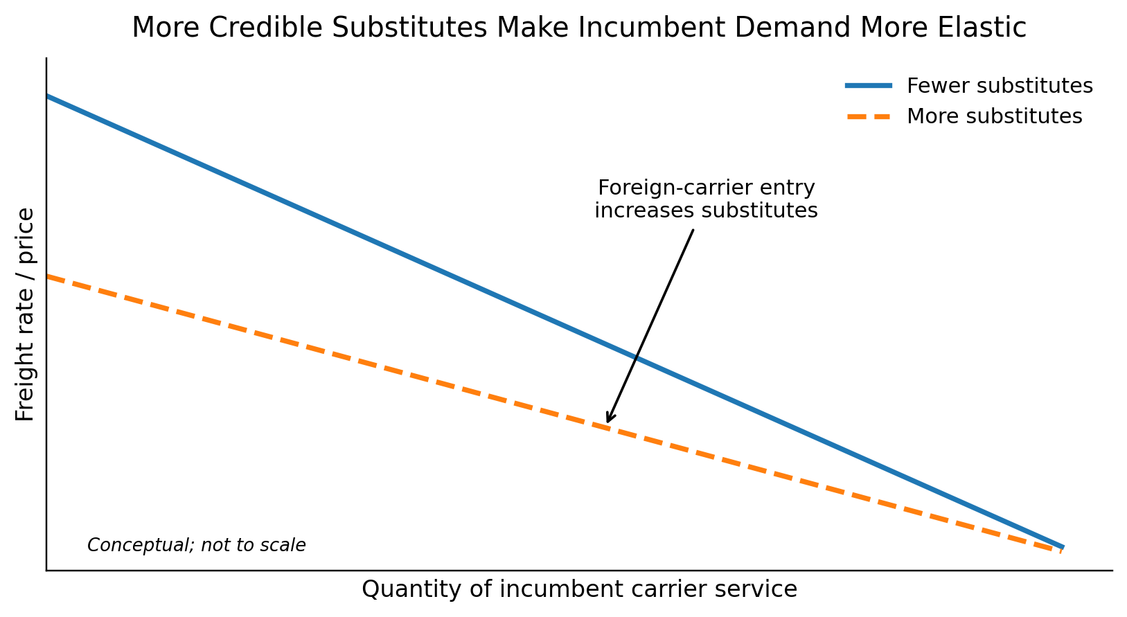
Figure 2. More credible substitutes make incumbent demand more elastic.
Note. Conceptual illustration. Allowing additional carriers to compete increases the number of credible substitutes available to shippers. The residual demand facing an incumbent therefore becomes more elastic, reducing pricing power. The figure shows the expected direction of the mechanism, not the magnitude of any Hawaiʻi rate reduction. Source: Author illustration based on the BUS 620 pricing-power framework

References
American President Lines, LLC v. Matson, Inc., No. 1:21-cv-02040 (D.D.C. 2025). https://law.justia.com/cases/federal/district-courts/district-of-columbia/dcdce/1:2021cv02040/233910/195/
Hawaiʻi Department of Transportation. (2024). Hawaiʻi Statewide Freight Plan. https://hidot.hawaii.gov/highways/files/2024/04/HDOT-Freight-Plan-Final-Report-2024-03-01.pdf
Matson, Inc. (2026). Annual report on Form 10-K for the year ended December 31, 2025. U.S. Securities and Exchange Commission. https://www.sec.gov/Archives/edgar/data/3453/000110465926020944/matx-20251231x10k.htm
Matson Navigation Company. (2025). Hawaiʻi household goods tariff, effective June 1, 2025. https://www.matson.com/others/Hawaii_Service_June_1_2025.pdf
Matson Navigation Company. (2026). Hawaiʻi household goods tariff, effective June 1, 2026. https://www.matson.com/others/HHG_Hawaii_6.26.pdf
United States Code, 46 U.S.C. § 55102, Transportation of merchandise. https://uscode.house.gov/view.xhtml?req=granuleid:USC-prelim-title46-section55102&num=0&edition=prelim

TEU = twenty-foot equivalent unit
Two each from Los Angeles and Oakland, and one from Seattle

