SDG Hackathon
Idea Guide & Judging Notes
Ten candidate builds, judging criteria, and pitch structure — Waikato region

Judging
Criterion | What it covers
Inspiration | A clear problem with real impact
Technology | Feasibility, quality, how you use AI
Design | Usability and originality
Presentation | Clear, structured, within 5 minutes

Local winners go through to national judging.

What scores well
Judges reward execution over novelty. Working software aimed at a specific group beats a clever idea that only half runs. A plain LLM wrapper no longer stands out. Health and education chatbots are the most common entries, so they are the hardest lane to win in.
One thing separates entries reliably: producing a number that maps to an official UN indicator. It gives judges something concrete to check.

Context
Only 16% of SDG targets are projected to be met by 2030. The UN's own count puts 36% of 139 targets on track or progressing moderately. Four years left.
Two of the three problems suggested in the event PDF — Facilities Helpdesk and Peer Support — are chatbot-shaped. Choosing one means competing mostly on presentation.

Idea 1 — Cold-Chain Monitor for Last-Mile Clinics
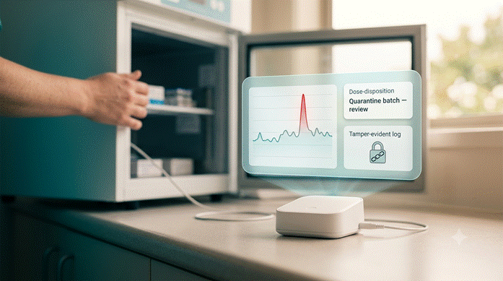

Problem
Vaccines and insulin spoil quietly when a fridge fails or a transport box warms above 8 °C. Rural clinics often find out only when the stock is already unusable.

SDG
SDG 3 (Good Health). Protects the potency of health supplies reaching underserved patients. Indicator 3.b.1, vaccine coverage.

Worth knowing first
This device already exists commercially. Nexleaf ColdTrace X is WHO-prequalified and does everything an ESP32 rig would: ±0.5 °C accuracy, BLE sensors, cellular or WiFi sync, five-year warranty, and a backend running 15,000+ devices. Berlinger Fridge-tag is the standalone equivalent.
But research on why cold chains fail points somewhere else. In one field study, 91.7% of facilities had no cold chain policy and none had an equipment contingency plan. The alert fires and nobody knows who is meant to act. That gap is open.

Approach
Keep the ESP32 and temperature sensor, but treat it as the input, not the product. The product is what happens after an excursion is detected.
1. Dose disposition. The system reads the excursion — how long, how hot or cold, which fridge — and checks it against vaccine stability rules to recommend use, quarantine, or discard for each product, showing its reasoning. Today this decision is made manually.
2. Escalation. Identifies who is on call, whether the immunisation coordinator has been contacted, and drafts the incident record.
3. Tamper-evident log. Events are hash-stamped so a flagged batch cannot be quietly un-flagged.

New Zealand angle
• The local process is CCA (Cold Chain Accreditation), run by the Ministry of Health and valid up to three years. Pharmacies are audited separately by Medicines Control.
• The 2017 National Standards are under review by Health NZ right now.
• Current interim rule: fridges over ten years old are allowed only with continuous real-time monitoring and out-of-hours alarming. That is existing demand for this, today.
• Freezing, not overheating, causes most vaccine damage in NZ.
• New Zealand's cold chain programme cut vaccine wastage from 17% to 2% between 2002 and 2008, saving an estimated $4M a year.

Build and demo
• Offline-first — buffers locally, syncs on reconnect.
• Why 48 hours works — the firmware is a read-sensor, append-log loop. The web layer is standard CRUD with a time-series chart. The decision layer is a prompt over a rules table, not a model you have to train.
• Demo — put the probe in a cup of ice and pull it out mid-pitch. The dashboard flags the excursion, then the system produces a disposition recommendation and a drafted incident report on screen.

Risks
• Venue WiFi is unreliable. Use BLE-to-phone or a local access point as the main sync path.
• Frame output as decision support pending coordinator sign-off, not as a clinical ruling.
• Record a video of the excursion firing as a fallback.
Solid if you pitch the decision layer. Weak if you pitch the logger.

Idea 2 — Surplus Matching for Growers
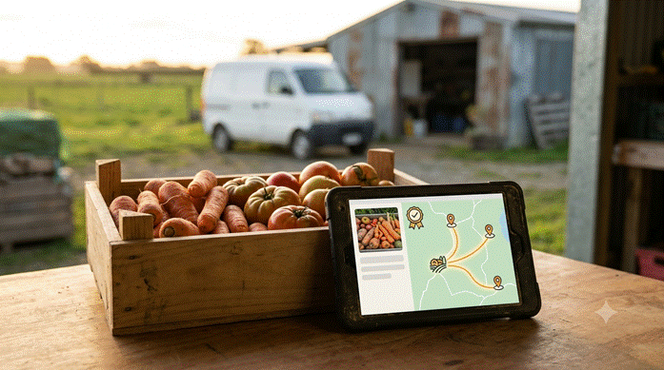

Problem
Produce is culled before packing for cosmetic reasons and sold by the bin, not the bag. It never enters a retail inventory system, so no existing food-waste platform can see it. Meanwhile household food waste in NZ is already falling — 12.2% to 10.9% of food bought, $3.2B to $3.0B — so the consumer end of the problem is shrinking while this end is not.

SDG
SDG 12.3 (halve food waste) and SDG 2.1 (end hunger). Two indicators, one build.

The numbers
• NZ Food Network and Lineage redirected over 1,000 pallets — about 635,000 kg — of frozen vegetables rejected only for cosmetic irregularities.
• One in three NZ households faced food insecurity in the past year (Hunger Monitor 2025, published March 2026).
• The burden is uneven: Pacific peoples 64%, Māori 51%, ages 18–24 50%.
• Only 44% of food-insecure households have ever accessed food relief.

Why this is open
NZ food rescue matching is route-based and manual. NZFN's stated approach for bulk surplus is to act as a single point of contact — a human broker. Regular donors sit on fixed recurring routes.
The existing apps solve adjacent problems: Olio is neighbour-to-neighbour, Too Good To Go and Flashfood work off retail shelves, Spoiler Alert handles packaged goods and inventory. Imperfect Foods and Misfits Market turned cosmetic rejects into a subscription box rather than a matching layer. None of them can see stock that is culled before it becomes inventory.

Approach
1. Grader. A grower photographs a bin. A vision model grades the reject class and estimates volume. Manual data entry is what stops growers participating, so removing it matters more than it sounds.
2. Matcher. Scores allocations against shelf life, cold storage availability, hub capacity, travel time, and need severity. This is a scoring function, not a chatbot.
3. Impact ledger. Tracks kg diverted, meal equivalents, and CO₂e avoided, mapped to SDG 12.3.

Domain detail and scale
• The Food Act 2014 excludes food with compromised sanitary seals unless it is heated. Naming a real constraint like this shows you looked at the sector.
• 64 food hubs, 2,000+ frontline groups, and roughly 28 million meal equivalents a year are already moving. You would be adding a layer to an existing network rather than building one.

Build and demo
• Why 48 hours works — vision grading is one API call with a rubric. A greedy allocator demos the same as an optimal one at this scale. The dashboard is CRUD, a map, and a chart.
• Demo — photograph a crate of misshapen carrots. It gets graded, the matcher allocates across three mock hubs, and the ledger updates. Then mark a hub's chiller offline and let it reallocate.

Risks
• A two-sided marketplace with thin supply fails. Pitch it as a tool for one broker who already has both sides, not as a marketplace.
• Position it as complementary to NZFN rather than competing.
The best-balanced option: local data, a real gap, AI that is not a chatbot, two indicators, and a mechanism that works beyond NZ.

Idea 3 — Disability Funding Reassessment Tool


Problem
NZ's disability support funding is changing now, and the people affected cannot work out what it means for them. From 1 April 2026 existing NASC users get a set budget with a limit. From 1 October 2026 reassessments run under the new system. Budgets are based on past spending, so anyone who underspent during a restrictive period risks being held to that lower figure.

SDG
SDG 10.2 (social and economic inclusion regardless of disability).

Why the timing matters
• Waikato is an EGL site. EGL Waikato and Mana Whaikaha whānau keep direct funding. The event is inside the affected region and the judges are local.
• Reassessments start two months after the hackathon.
• The policy is actively contested. Blind Low Vision NZ has flagged clauses 7 and 8 of the Disability Support Services Bill 2026 as a step away from EGL principles, framing support as “within available funding” and putting family and community ahead of State support.
• CCS Disability Action says Budget 2026 squeezes community-based support while protecting residential care.

Approach
1. Budget simulator. Enter current supports, model the allocation under the new past-spending rule, and show the difference — flagging where the old March 2024 purchasing restrictions may have artificially lowered someone's baseline. That is the specific harm advocates are warning about.
2. Evidence pack generator. Retrieval over the National Standards, the February 2026 fact sheet, and EGL principles, producing a reassessment submission with citations.
3. Plain-language layer. Turns clause text into readable summaries, and works the other way too — putting a whānau's account into the assessor's terms.

Accessibility
This is the one idea where accessibility is the product rather than a requirement to satisfy. WCAG 2.2 AA, screen-reader first, fully keyboard navigable. You have an accessibility skill installed with reference material.

Build and demo
• Why 48 hours works — the simulator is arithmetic over a rules table. The evidence pack is retrieval over roughly 40 pages of public PDFs. No training, scraping, or authentication.
• Demo — two personas side by side — one whose budget holds, one whose baseline was suppressed by the 2024 rules. Same tool, different outcomes, both explained. Then generate the second persona's evidence pack.

Risks
• You are modelling contested policy. Label outputs as indicative, not determinations, and cite every rule to its source.
• Use synthetic personas only.
• Get the rules right or do not ship. A wrong number here affects real people, and saying so in the pitch is worth more than hiding it.
Strongest local resonance, and the only idea where the accessibility brief and the technical work are the same thing.

Idea 4 — E-Waste Routing
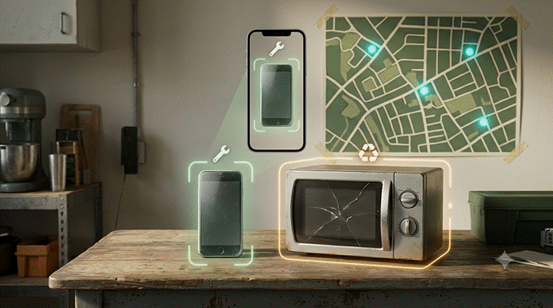

Problem
New Zealand produces about 99,000 tonnes of e-waste a year under voluntary schemes only. It is the OECD outlier — producer participation is not mandatory and there is no extended producer responsibility framework, unlike every other OECD country. The AS/NZS recycling standards exist but are not binding.

SDG
SDG 12.5 (reduce waste generation). Indicator 12.5.1 is the national recycling rate, which NZ largely cannot report — and that is part of the story.

The gap
E-waste was designated a priority product requiring mandatory stewardship in 2020. TechCollect NZ ran the co-design between 2020 and 2023. As of mid-2026 the regulations are still not in force and no implementation date is set. All six 2020 priority product groups remain in consultation or drafting. Six years, and 99,000 tonnes a year continues to flow.

Approach
1. Drop-off guidance. Photograph a device; a vision model identifies the type and hazardous components, then finds the nearest point that actually accepts it. Right now this is confusing enough that people give up and landfill it.
2. Repair before recycle. Route repairable devices to repair cafés and refurbishers first. Recycling is the last step in the waste hierarchy, but most tools skip straight to it.
3. Reporting ledger. Aggregate anonymised flows into the shape a regulated scheme will eventually require, so the data model exists when regulations land.

Build and demo
• Low bandwidth — an SMS path that assumes no smartphone makes it usable in places where informal collectors do this work, which is where 12.5 is weakest globally.
• Why 48 hours works — vision identification is one API call. The list of accepting points is small enough to assemble by hand. The ledger is a schema and a chart.
• Demo — photograph an old phone and a dead microwave. One routes to repair, one to a named recycler, and one is refused by the voluntary scheme entirely — that refusal gets logged as evidence of the policy gap.

Risks
• Frame the regulatory angle as a scheme-ready data model, not a claim to influence policy.
• Curate the accepting-points list manually rather than building a scraper.
Best reporting story of the five. Weakest emotional hook, so the pitch has to carry it.

Idea 5 — Neighbourhood SDG Indicator Generator
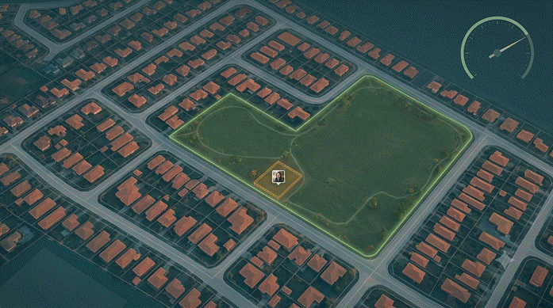

Problem
The main gap in SDG 11 is measurement. Fewer than a third of sustainable-cities indicators have data at all, and coverage is worst at neighbourhood level and for vulnerable groups. HLPF 2026 called for urban data systems as a public good.

SDG
SDG 11.7, access to safe and inclusive public space. Indicator 11.7.1 is the average share of built-up area that is open public space.

The numbers
• Access to open public space fell from 48.0% to 45.9% between 2020 and 2025 across 414 cities in 126 countries. It is going backwards.
• About 1.1 billion people live in slums or slum-like conditions, with another 2 billion projected over 30 years.

Approach
1. Compute rather than survey. Free satellite imagery, OpenStreetMap, and a segmentation model estimate open public space share for a neighbourhood, output in the form UN-Habitat's methodology expects.
2. Ground-truth layer. Residents contribute phone photos and a vision model checks whether mapped public space is actually accessible — fenced, locked, paved over, or usable. Satellites cannot see this.
3. Validate publicly. Run it on a city UN-Habitat has already measured and show your estimate next to theirs. Judges can check you on the spot, which few teams offer.

Build and demo
• Why 48 hours works — a pre-trained segmentation model, OpenStreetMap via the Overpass API, one city, one indicator. The discipline is keeping it to exactly that.
• Demo — run it on a Hamilton suburb and show the computed figure. Then show the resident photo layer downgrading a park that turns out to be fenced off, and explain why the satellite reading was wrong.

Risks
• Highest technical risk here. Segmentation quality is unpredictable and hard to debug late on day two.
• Pre-compute the demo results and keep a cached fallback.
• Skip this unless someone on the team has done geospatial or computer vision work before.
Highest technical ceiling, highest chance of a broken demo.

Idea 6 — Patient Health Literacy and Informed Consent
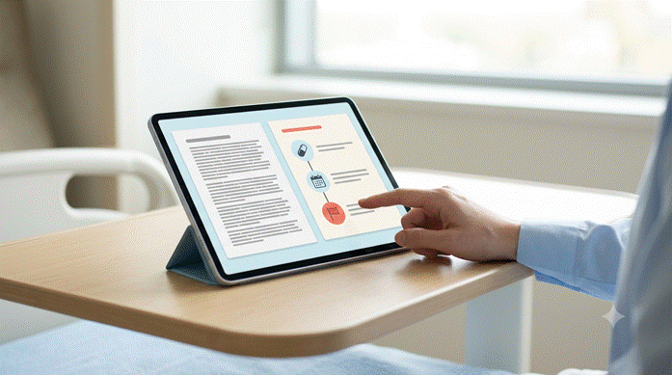

Problem
Discharge notes, surgical consent forms, and diagnostic reports are written in clinical language. Patients sign and leave without understanding what was decided, what to watch for, or what happens next.

SDG
SDG 3 (Good Health), and SDG 10.2 where low literacy tracks with ethnicity and deprivation. Indicator 3.8.1, coverage of essential health services — care a patient cannot act on is not effective coverage.

The numbers
• More than 56% of New Zealand adults — over 1.6 million people — cannot obtain and understand basic health information well enough to make informed decisions.
• Around 90% of Pacific people aged 15 and over have low health literacy. Māori and Pacific rates are lower than non-Māori, though the largest group by headcount is Pākehā.
• 16.1% of acute medical admissions among over-65s are readmitted within 30 days, with higher risk for Māori, Pacific people, and those in deprived areas.

Two corrections to the framing
Both of these make the pitch stronger, not weaker.
• It is a legal right, not a service improvement. Right 5 of the Code of Health and Disability Services Consumers' Rights gives every consumer the right to effective communication “in a form, language, and manner that enables the consumer to understand the information provided,” including a competent interpreter where necessary and reasonably practicable. Right 6 covers being fully informed. A consent form the patient did not understand is arguably not compliant. That reframes the tool from helpful to required.
• Avoid the word compliance. New Zealand research consistently frames post-discharge failure as system-side: inadequate support, medication problems, unpreparedness for community living, limited whānau support, and poor access to culturally responsive services. Readmission signals unmet need rather than patient fault. Saying “poor patient compliance” in front of NZ health judges will cost you.

What already exists
Epic's patient-facing assistant, Emmie, already answers patient questions inside MyChart and produces plain-language summaries of lab and procedure results. Do not pitch a generic medical-jargon translator as though nothing exists.
Two things remain genuinely open. Epic has no shipped feature that rewrites the full inpatient discharge summary, and New Zealand's public hospitals do not run on Epic, so none of that reaches a patient at Waikato Hospital. The evidence is also strong: an LLM-transformed discharge summary moved from an 11th-grade to a 6th-grade reading level, with measured understandability rising from 13% to 81%. In the same study some errors were introduced, which is why the design below puts a clinician gate in the middle rather than shipping straight to the patient.

Approach
1. Ingest and structure. Take a PDF discharge summary or consent form and pull out the parts a patient actually acts on: medicines and changes, warning signs, follow-up appointments, activity limits, and who to call.
2. Rewrite with a clinician gate. Generate a plain-language version at a target reading level, then show it beside the original for a nurse or clinician to approve or edit before release. The gate is the safety design, and it is worth saying out loud in the pitch.
3. Visual breakdown. A medication timeline, a red-flag card of symptoms that mean call someone now, and a follow-up calendar. Most of the comprehension gain comes from structure, not from prose.
4. Questions on the document. A question box scoped strictly to the patient's own record, answering only from the approved text and saying so when the answer is not there. This is the smallest part of the build and should be the smallest part of the pitch.
5. Language and format options. Te reo Māori, Pacific languages, large print, and audio. This is where Right 5 is actually met, and it is the part no overseas product covers for New Zealand.

Positioning
Health chatbots are the most crowded category at SDG hackathons. If you lead with the chat box you will look like several other teams. Lead with the consent form and the legal right, treat the question box as a supporting feature, and the entry reads differently.

Build and demo
• Why 48 hours works — PDF text extraction, one structured extraction call, one rewrite call against a reading-level target, and a review screen. No training and no integration with any hospital system. The review interface is ordinary CRUD.
• Demo — put a real consent form on screen beside the rewritten version, with the reading grade shown for each. Then have the clinician view catch and correct one generated line — demonstrating the gate working is more convincing than pretending the model is always right.

Risks
• Never use real patient records. Use synthetic or published sample documents only, and say so.
• The model will occasionally introduce errors. Do not claim otherwise — build the review step and make it part of the demo.
• Translation into te reo Māori and Pacific languages needs care. Show it as a designed pathway with human verification rather than claiming machine translation is sufficient.
• Position it as supporting the consent conversation, not replacing it.
Strong legal hook and clear evidence behind it. The risk is presentation — pitched as a chatbot it blends in, pitched as a Right 5 tool it does not.

Idea 7 — Disaster Recovery & Sudden Financial Shocks
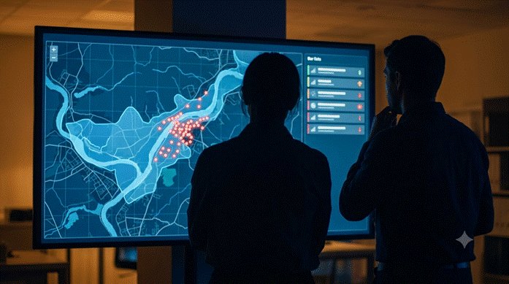

Problem
When extreme weather events or localized economic shocks hit vulnerable communities, relief agencies take weeks to identify who needs immediate emergency micro-grants. Financial assistance is delayed by manual hardship intake, overloaded call centers, and fragmented municipal data. Households in high-deprivation zones face immediate cash-flow collapse for essential expenses (shelter, food, power, and medical supplies) long before insurance or formal disaster claims settle.

SDG
SDG 11.5 (reduce disaster impacts on human lives and livelihoods) and SDG 1.5 (build resilience of the poor and vulnerable). Indicator 11.5.2, direct economic loss attributed to disasters relative to GDP.

The numbers
• During the 2023 North Island Floods and Cyclone Gabrielle, the Ministry of Social Development (MSD) processed over 101,000 Civil Defence Payment applications worth $56.6M, facing phone volumes of up to 9,000 calls per day.
• Total insurance payouts for the two events exceeded $3.75 billion across 117,000+ claims, leaving thousands waiting months for final residential settlements.
• A Department of Internal Affairs (DIA) climate study identified 44 communities in New Zealand combining high socio-economic vulnerability (NZDep bottom 10%) with severe flood exposure — concentrated heavily in Northland, Tairāwhiti, Waikato, and the Bay of Plenty.

Why this is open
Current emergency response platforms focus either on physical infrastructure (sandbags, evacuation routes) or passive phone/web intake forms. Standard civil defense tool-s do not dynamically intersect physical hazard layers with socio-economic vulnerability indicators in real time as an event unfolds. Existing hardship funds rely on post-event application processing, leaving whānau without high digital literacy or administrative bandwidth at the back of the queue.

Approach
1. Multi-layer shock mapping. Ingest open spatial hazard boundaries (LINZ, NIWA, or regional council flood/power outage maps) and overlay them with census meshblock deprivation data (NZDep2018) to automatically highlight high-vulnerability, high-impact zones.
2. Automated micro-grant eligibility engine. Run a transparent, rules-based priority scoring algorithm (household size, localized infrastructure damage duration, proximity to hazard center, income threshold) to auto-flag households for prioritized emergency micro-disbursements.
3. Disbursement & transparency ledger. Generate an auditable, aggregated payout manifest (exportable for bank batch processing like ABA/CSV) while tracking diverted funds, meal/shelter equivalents funded, and average time-to-disbursement.

New Zealand angle
• Severe weather events across Aotearoa continuously highlight administrative bottlenecks in distributing Civil Defence Emergency Payments and Mayoral Relief Funds.
• Regional councils maintain open spatial flood-hazard mapping (e.g., Waikato Regional Council, Bay of Plenty Regional Council), but these GIS systems remain completely disconnected from social sector grant channels.
• Strong regional relevance: rural towns across Waikato and Tairāwhiti frequently suffer isolated road access and power loss, making physical intake centers inaccessible.

Build and demo
• Why 48 hours works — flood/hazard inundation can be modeled using static GeoJSON polygons over Mapbox or OpenStreetMap. Priority scoring is a weighted arithmetic function over census meshblock CSVs, and the dashboard is a standard frontend built with web mapping components.
• Demo — simulate a 100-year flood catchment event over a Waikato river basin. Watch the spatial map highlight affected meshblocks, automatically identify the top 15% highest-vulnerability households based on socio-economic weighting, and generate an approved emergency relief payout manifest ready for agency release.

Risks
• Data privacy: ingesting exact household financial data carries severe privacy risks. Mitigation: aggregate vulnerability scores to the census meshblock or suburb level and use synthetic demographic data for the live demo.
• Integration claims: pretending to integrate live with banking core APIs or MSD systems in 48 hours is unrealistic. Frame the output as an agency-facing decision and verification layer that pushes to standard bank file specs.

Idea 8 — Surplus Allocation & Safety-Triage Layer for Food Rescue
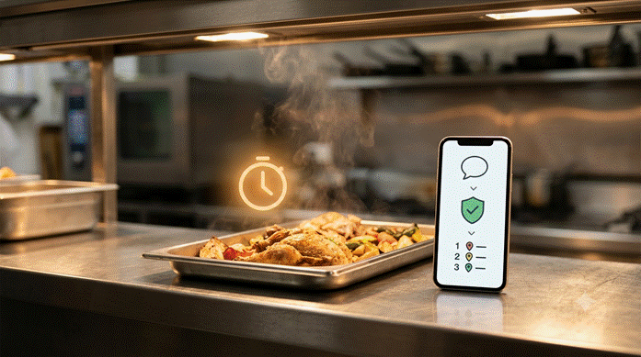

Problem
A cafe, supermarket, or event caterer ends the day with edible surplus that is perishable and time-boxed — good for hours, not days. Getting it to the right community group requires a human coordinator deciding, fast: is this safe to redistribute, which charity can actually use it (dietary, cultural, capacity, distance constraints), and can it get there before it spoils. Today that decision is made by phone, text, and gut feel by overworked volunteers. The narrow, addressable slice is the 10-minute allocation decision at the moment surplus appears.

SDG
SDG 12 (Responsible Consumption, target 12.3 — halve food waste). Secondary SDG 2 (Zero Hunger). Indicator 12.3.1b (Food waste index) — diverted-from-landfill tonnage maps to it.

Worth knowing first
The “list surplus, match to a nearby group” app has been built many times over. Live B2C products like Too Good To Go (operates in NZ), Olio, and Foodprint handle consumer surprise bags and neighbor sharing. Charity logistics layers like KiwiHarvest (~300,000 kg/month), Fair Food, and the Aotearoa Food Rescue Alliance (AFRA — 29M+ meals/year to 1,000+ charities) already handle bulk pickup. Listing and marketplace logistics are not the gap. Two voids remain where AI is novel:
• The Safety Go/No-Go Call: rescued surplus falls under the Food Act 2014. Damaged seals, broken cold chains, and ambiguous date labels require fast, defensible decisions per item.
• The Allocation Decision: matching specific surplus against client dietary/cultural needs (halal, allergen, texture-modified), capacity, hours, distance, and remaining safe window.

Approach
Reframe the product as the decision engine rather than the listing form (which acts as the demo prop):
1. Messy intake to structured data. Free-text NLP turns “Half a tray of butter chicken, made ~1pm, in warmer since” into structured JSON ({dish, protein, allergens, cook_time, holding_temp, safe_until}).
2. Safety triage. An LLM reads the item against a Food Act 2014 / food-safety rules table and returns a disposition (redistribute / reheat-first / hold / discard) with cited reasoning. Framed as decision support pending human sign-off.
3. Smart allocation. Vector embeddings match surplus to charity client needs — e.g., matching “butter chicken” to a group serving hot halal meals, even with zero keyword overlap. Ranked by fit × capacity × distance × remaining safe window.
4. Tamper-evident ledger. Hash-stamped hand-off records prevent a rejected/spoiled batch from being quietly un-flagged, providing audit integrity for corporate donor liability.

New Zealand angle
• Legal spine: the Food Act 2014 gives donors good-faith protection when donating in good condition — the safety layer provides the audit trail to support this.
• National scale: Aotearoa generates 1.2 million tonnes of food waste annually (~237 kg/person; MfE 2025 report), with ~190,000 tonnes binned by households while still edible. Supermarkets generate ~60,500 tonnes/year.
• Methane impact: 18% of wasted food ends up in landfill, generating methane (~28x CO₂ equivalent).
• Social gap: 1 in 5 NZ children live in food-insecure households. The barrier is not supply, but the rapid allocation decision in the hours food stays good.

Build and demo
• Time-window-first — every item carries a live “safe-until” clock; allocation ranking decays as the window closes.
• Why 48 hours works — intake is one LLM parse call. Safety triage is a prompt over a rules table. Allocation uses off-the-shelf embeddings and a weighted sort over static JSON charity profiles.
• Demo — type a messy surplus sentence live. Watch it become a structured item with a ticking safe-until clock. The safety agent renders a disposition and cited reasoning. The allocator returns a ranked shortlist of mock charities, explaining why the top match fits (“hot-meal service, halal, open now, 4 min away”) without keyword overlap. Confirm hand-off to produce a hash-stamped record.

Risks
• Do not pitch a two-sided marketplace/listing app — center the pitch on the safety triage and allocation decision layer.
• Output must be framed as “decision support pending coordinator sign-off,” not legal/clinical clearance.
• Use synthetic charity data to avoid handling real client dietary records.
• Flag any item with ambiguous allergen disclosures as “Hold” by default.

Idea 9 — Crisis Response & Emergency Resource Allocation Engine
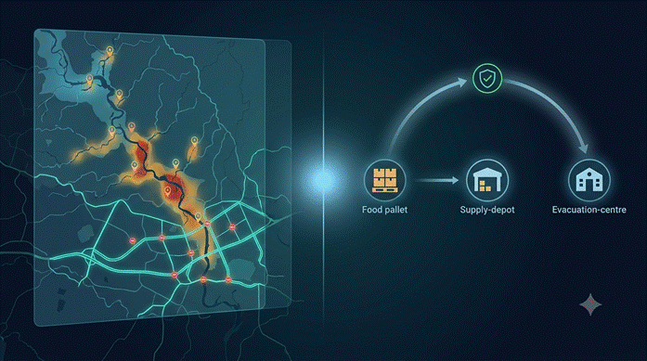
This idea combines the shock-mapping engine of Idea 7 with the safety-triage and allocation logic of Idea 8 into a single integrated platform. It is not included in the comparison table below, which scores Ideas 1–8 individually.

Problem
During sudden disasters (severe weather, regional flooding, infrastructure failures), relief agencies face a double crisis: weeks to identify vulnerable whānau needing direct hardship payouts, alongside perishable food and emergency supplies spoiling because manual coordination cannot match available supplies to urgent hub needs fast enough. Current civil defence mechanisms rely on overloaded call centres, manual paper forms, and static spreadsheets.

SDG
SDG 11.5 (reduce disaster impacts) and SDG 12.3 (halve food waste / divert emergency surplus). Secondary SDG 1.5 (resilience of vulnerable groups) and SDG 2.1 (end hunger). Indicators 11.5.2 (direct economic loss relative to GDP) and 12.3.1b (food waste index).

Worth knowing first
Emergency response apps usually split into two flawed categories: map-only visualisations or basic B2C surplus-listing marketplaces (like Too Good To Go or Olio). In actual disaster scenarios, neither works. Existing Civil Defence Emergency Management (CDEM) channels and social relief networks (AFRA, KiwiHarvest, MSD) operate in silos — spatial flood mapping is completely disconnected from donor supply chains and social welfare grant channels. The gap is an integrated decision and resource routing layer that evaluates risk, verifies compliance, and routes physical resources and direct aid in real time.

Approach
Combines predictive spatial shock mapping with automated safety triage and semantic resource allocation:
1. Spatial threat & vulnerability mapping. Ingests open GIS hazard boundaries (LINZ flood zones, regional council inundation maps) overlaid with census meshblock deprivation data (NZDep2018) to identify isolated, high-risk communities automatically.
2. Messy intake & safety triage. Ingests free-text surplus/supply logs (“2 pallets chilled dairy, cook time 10am, warmer offline 2hrs”) and evaluates them against Food Act 2014 rules to return an automated disposition (redistribute / reheat-first / hold / discard) with cited safety reasoning.
3. Semantic matching engine. Vector embeddings match verified supplies directly to nearby evacuation centers or community hubs based on real-time client constraints (halal, allergens, infant care, storage capacity, distance, and remaining safe window).
4. Direct grant manifest & audit ledger. Priority-scores affected households for emergency micro-disbursements (ABA/CSV output) while maintaining a hash-stamped audit ledger of diverted resources to ensure complete transparency and prevent double-dipping.

New Zealand angle
• Disaster bottlenecks: during Cyclone Gabrielle and the 2023 North Island Floods, MSD handled 101,000+ Civil Defence Payments ($56.6M) at peak call volumes of 9,000/day, while tons of perishable relief food spoiled due to fragmented local logistics.
• Deprivation exposure: DIA climate studies identify 44 NZ communities combining severe flood risk with top-tier socio-economic vulnerability (NZDep bottom 10%), concentrated across Waikato, Tairāwhiti, Northland, and Bay of Plenty.
• Legal spine: integrates the Food Act 2014 donor liability protections directly into the emergency dispatch pipeline, enabling corporate donors to supply crisis hubs defensibly.

Build and demo
• Time-window-first — emergency supplies carry a live decay clock; routing priority automatically re-ranks as physical access or shelf life closes.
• Why 48 hours works — hazard zones use static GeoJSON polygons over Mapbox; priority scoring uses weighted arithmetic over meshblock CSVs; intake and safety triage rely on standard structured LLM schema prompts over a rules table; allocation uses lightweight vector embeddings.
• Demo — simulate a major flood event over a Waikato catchment. Watch the spatial map highlight impacted high-deprivation meshblocks. Enter a messy text batch of emergency caterer surplus: the system parses it, runs the Food Act safety check, and semantically matches it to a nearby isolated evacuation hub without keyword overlap, while generating an approved emergency grant manifest.

Risks
• Data privacy: avoid using live personal financial records — use synthetic population data and aggregate vulnerability scores to the meshblock/suburb level.
• Liability & authority: frame output strictly as an “agency-facing decision support engine pending coordinator sign-off” rather than a legal or clinical ruling.
• API failures: use cached local GeoJSON maps and recorded video fallbacks for the intake-to-ledger routing flow.

Idea 10 — Universal Jargon & Handwriting Interpreter
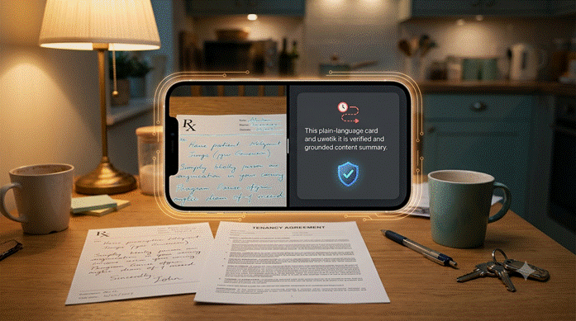
Extends Idea 6. Same rewrite-and-visualise engine, generalised past healthcare to any dense or handwritten document, plus a direct answer to “why not just use Google/ChatGPT?”

Problem
The comprehension gap in Idea 6 is not unique to hospitals. People hit the same wall with tenancy agreements, insurance policy wording, IRD and WINZ letters, engineering and building-consent specs, and handwritten documents — a doctor's script, a lawyer's marginal note, a scanned historical record. Right now the workaround is pasting text into a generic chatbot, which creates three problems at once: the document (often sensitive — medical, financial, legal) leaves the person's device to a third-party cloud; the model has no domain-specific rules table to ground jargon in, so it paraphrases with no citation back to the source clause; and handwriting is simply not something a text box handles.

SDG
SDG 10.2 (inclusion) and SDG 4.6 (functional literacy for youth and adults), the same legal-access logic as Idea 6's Right 5 and 6 argument, extended to non-health documents via the right to access information in a usable form.

Why “just use Google” isn't the answer
• Privacy. Sensitive documents — medical results, tenancy contracts, benefit letters — get typed into a general-purpose chatbot with no guarantee of where that data is processed or retained. On-device inference is now genuinely viable: WebGPU ships enabled by default in Chrome, Edge, Firefox, and Safari as of mid-2026, and browser-based engines such as WebLLM can run a quantised small model entirely in the tab, with nothing leaving the device.
• Accuracy on jargon. A generic assistant has no domain-specific rules table, so it paraphrases confidently even when it is wrong about a specific legal or clinical term. This tool grounds every rewrite in a per-domain glossary and cites the source clause, the same clinician-gate logic Idea 6 already uses for discharge summaries.
• Handwriting. Prescriptions, clinical notes, and older government correspondence are often handwritten or scanned. This is a distinct and harder OCR problem from typed-text simplification, and it is the piece a copy-paste chatbot workflow cannot touch at all.
• Legitimate datasets. Rewrites are grounded against real, named sources — the Residential Tenancies Act, IRD guidance, insurance PDS documents, the same public-PDF retrieval pattern used for the National Standards in Idea 3 — rather than an ungrounded model guess.

Approach
1. Domain-routed intake. A document or photo is classified into a domain (health, legal, financial, government, technical) and matched to that domain's rules table and glossary, reusing Idea 6's ingest-and-structure pipeline.
2. Handwriting and jargon interpreter. OCR handles handwritten and scanned text; a rewrite pass simplifies dense or archaic wording to a target reading level, with every simplified term traceable back to a cited definition rather than a free paraphrase.
3. Visualising agent. The same structure-over-prose principle from Idea 6 — timelines, flowcharts for conditional clauses (“if you miss a payment, this happens”), and decision trees — generalised across domains instead of being medication-specific.
4. Local-first privacy mode. A WebGPU-detected small model runs the simplification entirely in-browser for sensitive documents; the interface falls back to a cloud model only for longer or more complex documents, with the trade-off shown to the user rather than hidden.
5. Confidence and review gate. Low-confidence handwriting reads or ambiguous clauses are flagged for human review rather than silently guessed, the same safety pattern as Idea 6's clinician gate.

New Zealand angle
• Te Mana Raraunga's Māori Data Sovereignty principles — Rangatiratanga (authority and control over data) in particular — make the on-device, nothing-leaves-the-device mode a genuine sovereignty answer for Māori users dealing with government or health paperwork, not just a generic privacy feature.
• Te Kāhui Raraunga's 2026 Te Pā Tūwatawata initiative is pushing the same principle at infrastructure level — Māori-controlled data storage so sovereignty “doesn't stop at the server door” — which this idea's local-first mode is aligned with rather than competing against.
• The same glossary-and-citation grounding used for the National Standards PDFs in Idea 3 and the Code of Rights in Idea 6 extends naturally to Tenancy Services, IRD, and WINZ guidance.

Build and demo
• Why 48 hours works — the rewrite-and-visualise engine already exists as Idea 6's build. The new work is a domain router, two or three additional glossary tables, and a WebGPU feature-detect that switches between a small in-browser model and the cloud API.
• Demo — feed a photographed handwritten prescription and watch it become a structured medication list. Then feed a dense tenancy-agreement clause and watch it become plain language plus a small consequence flowchart. Toggle “local mode” on and off live to show the privacy trade-off happening in real time, not just claimed in the pitch.

Risks
• Handwriting OCR is still imperfect in 2026. Show the confidence flag and human-review gate as part of the demo rather than implying the reading is always correct.
• On-device models are smaller and weaker than the cloud model. Cap local mode to simplification and summarisation, not generation of legal or clinical advice.
• Frame it as a literacy aid pending professional sign-off, not a replacement for a lawyer, pharmacist, or WINZ case worker — the same positioning discipline as Idea 6.
• Don't overclaim Māori data sovereignty compliance from a 48-hour prototype; frame local-first as aligned with those principles, not certified against them.
Directly answers the panel's likely “why not just Google it” question with a real architectural difference — on-device privacy plus cited, domain-grounded rewrites — while reusing almost the entire Idea 6 build.

Comparison
# | Idea | SDG | Novelty | 48h risk | Emotion | Tech
1 | Cold-chain decisions | 3.b.1 | Medium * | Low | High | Med
2 | Grower surplus matching | 12.3 + 2.1 | High | Low | High | Med
3 | Disability funding tool | 10.2 | High | Low | Highest | Med
4 | E-waste routing | 12.5 | Med–high | Low | Low | Med
5 | Indicator generator | 11.7.1 | High | High | Medium | High
6 | Health literacy and consent | 3.8.1 + 10.2 | Medium † | Lowest | High | Low
7 | Disaster recovery & shock grants | 11.5.2 + 1.5 | High | Medium | High | Med–high
8 | Surplus safety & allocation triage | 12.3.1b + 2.1 | High ‡ | Low | High | Med
10 | Universal jargon & handwriting interpreter | 10.2 + 4.6 | High § | Low–Med | Medium | Med

* Medium only if pitched as the decision layer. Low if pitched as a logger, since ColdTrace X already covers that.
† Medium because Epic already ships plain-language result summaries. The open ground is the full discharge summary, the consent form, and te reo Māori and Pacific language output, none of which overseas products cover for New Zealand.
‡ High because the safety triage and semantic allocation layers are genuinely novel even though surplus-listing apps are common.
§ High because the on-device privacy mode and domain-grounded citation are a real architectural answer to “why not just use a generic chatbot,” not a cosmetic difference. Idea 9 is a combined variant of Ideas 7 and 8 and is not separately scored here.

Suggested Picks
Strength | Pick
Best all round | Idea 2 — Grower surplus matching
Best local resonance | Idea 3 — Disability funding tool
Best technical showing | Idea 5 — Indicator generator
Best spatial / crisis response | Idea 7 — Disaster recovery & shock grants
Best decision/triage build | Idea 8 — Surplus safety & allocation triage
Safest hardware demo | Idea 1 — Cold-chain, reframed
Easiest to finish well | Idea 6 — Health literacy and consent

Idea 6 is the lowest-risk build on the list and the easiest to demo convincingly, but it sits in the most crowded category. It rewards a team that is stronger on presentation than on engineering, provided the pitch leads with the Code of Rights rather than the chat box.
Worth weighing: the probe-in-ice moment in Idea 1 is the most memorable few seconds available to any team in the room, and a web app cannot match it. If someone on the team does embedded work, keep the prop — just make sure the software behind it is the decision layer.

Not Included
Rural volunteer transport matching was considered and dropped. Road XS, Spedsta, and Assisted Rides already do it, and Hato Hone St John and the Cancer Society already run the NZ services. Where it has been studied, the bottleneck is human coordination, nolt the matching software.

Practical Notes
Teams split at noon on day two — half keep building, half prepare the pitch. Agree who is on which side beforehand. The 30 minutes between the end of the hack and the start of pitching is the only window to regroup.

Pitch structure, from the official template
Time | Section | Content
0:30 | Connect | Who you are, what you care about
1:00 | Problem | Who is affected, made human, with data
2:00 | Big idea | How it solves the problem, plus the prototype
1:30 | Impact | What changes, what you need, what it means longer term

The template notes: describe the problem you are solving, which may not be the one you set out to solve

Sources

SDG
• UN SDG Report 2026 — https://unstats.un.org/sdgs/report/2026/
• SDSN Report 2026 — https://dashboards.sdgindex.org/
• UN-Habitat SDG 11 Report 2026 — https://unhabitat.org/sdg-11-global-report-2026-housing-at-the-centre-of-sustainable-cities-and-communities

Cold chain
• Health NZ cold chain standards — https://www.tewhatuora.govt.nz/health-services-and-programmes/vaccine-information/vaccine-service-delivery/cold-chain-standards-for-vaccines/
• National Standards 2017 (2nd ed) — https://www.tewhatuora.govt.nz/assets/For-the-health-sector/Health-sector-guidance/Vaccine-information-for-healthcare-professionals/National-Standards-for-Vaccine-Storage-and-Transportation-for-Immunisation-Providers-2017-2nd-edition.pdf
• IMAC cold chain — https://immune.org.nz/vaccines/cold-chain
• Nexleaf ColdTrace — https://www.nexleaf.org/work/vaccines/

Food
• NZFN Hunger Monitor 2025 — https://www.nzfoodnetwork.org.nz/wp-content/uploads/2026/03/NZFN-Hunger-Monitor-2025-Digital.pdf
• NZFN impact stats — https://www.nzfoodnetwork.org.nz/our-impact/
• NZFN and Lineage partnership — https://www.nzfoodnetwork.org.nz/food-rescue-partnership-nz-food-network-lineage-grant/
• Rabobank food waste — https://www.rabobank.co.nz/community/food-waste
• PMCSA food rescue evidence — https://www.pmcsa.ac.nz/topics/food-rescue-food-waste/

Disability
• DSS February 2026 fact sheet — https://www.disabilitysupport.govt.nz/disabled-people/improvements-to-disability-support-services/february-2026-fact-sheet
• NZ Disability Strategy 2026–2030 — https://www.whaikaha.govt.nz/assets/NZDS-26-30-Documents/NZDS-2026-2030.pdf
• CCS Disability Action, Budget 2026 — https://www.ccsdisabilityaction.org.nz/news/budget-2026-statement
• Blind Low Vision NZ submission — https://blindlowvision.org.nz/news/submission-on-the-disability-support-services-bill-2026/

E-waste
• TechCollect NZ stewardship — https://techcollect.nz/e-waste-product-stewardship-new-zealand/
• Electronic waste in New Zealand — https://en.wikipedia.org/wiki/Electronic_waste_in_New_Zealand

Data and tooling
• data.govt.nz APIs — https://data.govt.nz/catalogue-guide/using-data-govt-nz-apis
• NZ AI Strategy — https://www.mbie.govt.nz/assets/new-zealands-strategy-for-artificial-intelligence.pdf

Health literacy and consent
• HDC Code of Rights (Rights 5 and 6) — https://www.hdc.org.nz/your-rights/about-the-code/code-of-health-and-disability-services-consumers-rights/
• Code of Rights, full PDF — https://www.hdc.org.nz/media/550hs5ih/code-of-rights_online_5-sept-2022.pdf
• HQSC health literacy background — https://www.hqsc.govt.nz/assets/Consumer-hub/Partners-in-Care/Publications-resources/health-literacy-background-info-Sep-2013.pdf
• Health literacy and Pacific peoples review — https://ojs.aut.ac.nz/pacific-health/article/view/4
• NZ Society of Anaesthetists on health literacy — https://anaesthesia.nz/news/health-literacy-in-aotearoa-new-zealand-remains-a-critical-challenge/
• AI-generated patient-friendly discharge summaries — https://www.medrxiv.org/content/10.1101/2025.07.04.25330804.full.pdf
• NYU Langone discharge summary trial — https://clinicaltrials.gov/study/NCT06711458
• Epic Emmie, patient-facing AI — https://www.epic.com/software/emmie/
• Acute readmissions to hospitals, MoH — https://www.health.govt.nz/statistics-research/system-monitoring/planning-and-performance-data/acute-readmissions-to-hospitals

Universal jargon & handwriting interpreter
• Browser-based on-device AI, local LLM overview 2026 — https://www.sigmabrowser.com/blog/browser-with-on-device-ai-best-local-ai-browsers-in-2026
• WebGPU in-browser LLM inference, no server — https://localaimaster.com/blog/run-llm-in-browser
• WebLLM: high-performance in-browser inference engine — https://arxiv.org/html/2412.15803v2
• Te Mana Raraunga, Māori Data Sovereignty Network — https://www.temanararaunga.maori.nz/
• Principles of Māori Data Sovereignty, October 2018 — https://www.otago.ac.nz/__data/assets/pdf_file/0014/321044/tmr-maori-data-sovereignty-principles-october-2018-832194.pdf
• Te Pā Tūwatawata, Māori-owned data storage network — https://www.rnz.co.nz/news/te-manu-korihi/596199/maori-owned-data-storage-network-hailed-as-significant-step-towards-data-sovereignty

Judging
• GitLab AI Hackathon 2026 winners — https://about.gitlab.com/blog/gitlab-ai-hackathon-2026-meet-the-winners/

Technical notes
data.govt.nz documentation references CKAN 2.7, which is old. Check /api/3/action/status_show before coding against those docs. The DataStore API only exists where a clean CSV was supplied; many listings are metadata-only links to agency sites.
Claude Sonnet 5 pricing rises to $3/$15 per million tokens after 31 August 2026.

Slides: https://docs.google.com/presentation/d/179g-GP7-diqvUoH1fbE0l8aEhKgJLFiN/edit?usp=sharing&ouid=108672569518938533757&rtpof=true&sd=true

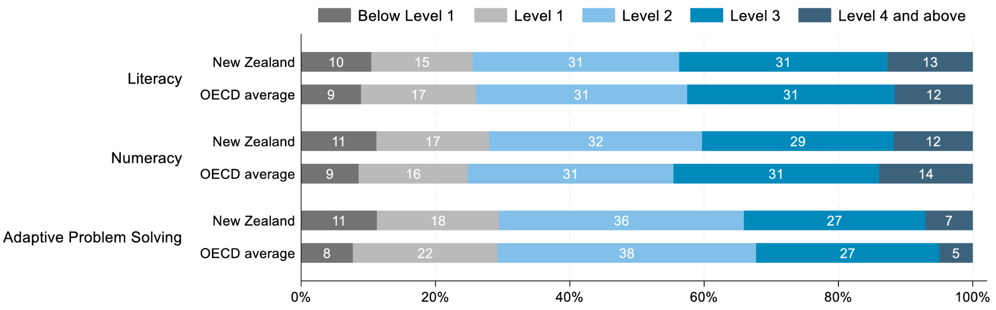

Doctor’s notes, reports, discharge papers: Level 3 and higher

Average patient ability: Level 2

Non-native english speakers: Level 1 and below

https://globalgoals.org/goals/3-good-health-and-well-being/
https://www.hdc.org.nz/your-rights/about-the-code/code-of-health-and-disability-services-consumers-rights/

https://www.hqsc.govt.nz/assets/Consumer-hub/Partners-in-Care/Publications-resources/health-literacy-background-info-Sep-2013.pdf
1:30 – 3:30 · BIG IDEA + LIVE DEMO — C drives, B narrates
Slide 5, then switch to the app
Here we present an example clinical record. This is the medically dense, jargon heavy view of things. Take a second and read it. Would anyone here be able to play nurse and figure out what's actually required of this patient?
[C loads the document into the app]
[B] So our solution is Nurse Notes. It takes in a clinical document like this and presents it in a way that's readable and easy to understand.
[C clicks "Generate", plain-language text streams in]
[B] Using a prompt as pre-context for our LLM, we can get it to parse this kind of document with reasonable accuracy and present it in a clean, consistent format, highlighting what's actually important for the patient to know.
As context can be limited, it may be important for a nurse to add relevant details, such as level of activity permitted, or intensity, that the source document doesn't cover.
[C adds a note on activity level]
[B] For confirmation and legitimacy, a nurse is still the last point of approval. They may check for accuracy before the simplified report is released to the patient.
[C clicks "Approve for release"]
[B] Now it's been sent out. The patient has access to the plain-language version and the original medical notes, side by side, on their phone.
[C switches to phone view]
[B] As an additional feature for accessibility and inclusion, it uses the device's own text-to-speech to read the report out, no extra setup required.
[C taps read-aloud]
[B] Lastly, for convenience and for anyone who wants a physical copy, the simplified document can be downloaded and exported as a PDF.
[C clicks "Download PDF"]
[B] This isn't just useful for discharge summaries. Any time a clinical document gets handed to a patient and they're expected to just understand it, this is where it fits.

