COEN 161 Web Programming 1 Fall 2015
Lab 6 - Part 2 (50 pts)
-------------------------------------------------------------------------------------------------------------------------------------
A quick reference to
PHP: http://www.w3schools.com/PHP/
----------------------------------------------------------------------------------------------------------------------
In Part 2, you will
- Process the input submitted via a client side form.
- The processing includes reading data from a file and displaying the output as required.
In Exercises 1-2, you will use 2 PHP files, areagyms.php and findgyms.php, a text file, gyms.txt, and findgyms.html.

Exercise 1 (20 pts)
Use the program in areagyms.php. Open the file in the text editor. Now type in the url of the areagyms.php file in the browser window and check what is displayed. Read the comments in the program using the text editor.
This program is reading in the data from the gyms.txt file, where each line gives the name of a gym/exercise center and its phone number. The program displays all the gyms with a 408 area code.

Modify the program to generate the output as shown below:
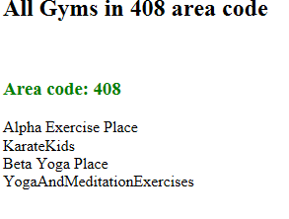
Hints: When you add a gymname to the array, $all408Gyms, you may want to concatenate each gymname with a delimiter (a comma, for example). Now you can use the same delimiter to split the $value in the foreach loop where you are displaying the output.

Exercise 2 (30 pts)
In this exercise, you will use findAreaGyms.html that invokes the server-side script, findgyms.php. Open the files in the text editor.

Open the file, findAreaGyms.html in a browser.
- Enter a number, 4082, in the field labeled, Area Code. Does it say the number is valid?
- Fix the regular expression given to match an area code. Now enter 4082 and make sure that the message says “invalid”.
- Write the url of the file findgyms.php in the action attribute of the form.

Open the file, findAreaGyms.html, in the browser and type in the area code 408 (or 415 or 510).

You will see the output displayed.
Modify the code in findgyms.php so that it generates output as shown below. Test it with all the 3 area codes given and make sure the program works correctly.

Modify the code such that for an area code that is not found, an appropriate error message is displayed.

